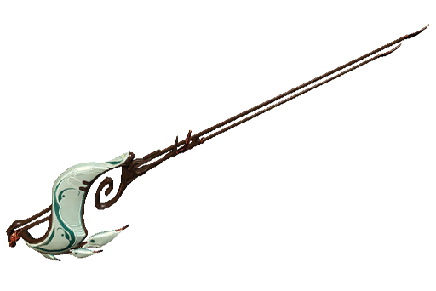

**Overall Grade: A**

Endura is the 2nd Rapier introduced into Warframe after Destreza. Unlike the Destreza, Endura is a status focused weapon and I have to admit that I like the Endura over the Destreza.

This weapon is not a 1 hit wonder, plus it have a slow attack speed, low crit chance and crit multiplier but it makes up with it's Stance (due to guaranteed slash procs), is Puncture focused and high status chance. Making it usable on almost all situations. Slap on Condition Overload and you have a monster of a weapon.

**No Forma & Event mods Build: 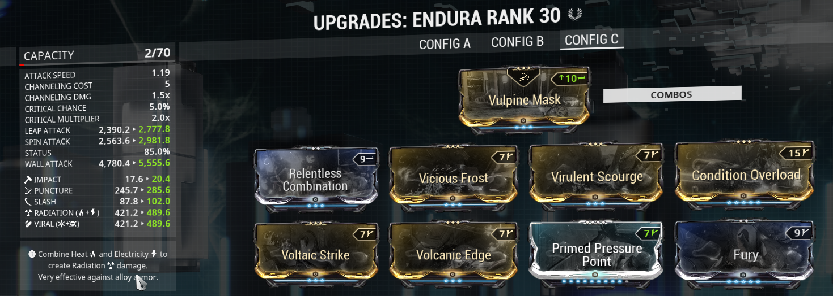**

**My current Builds:**

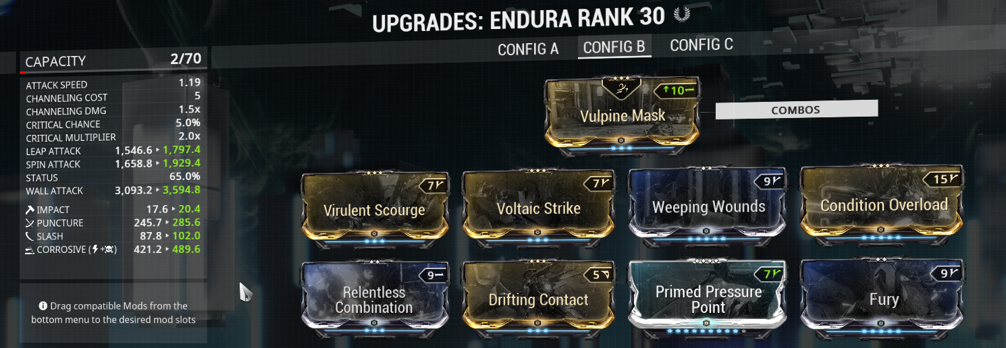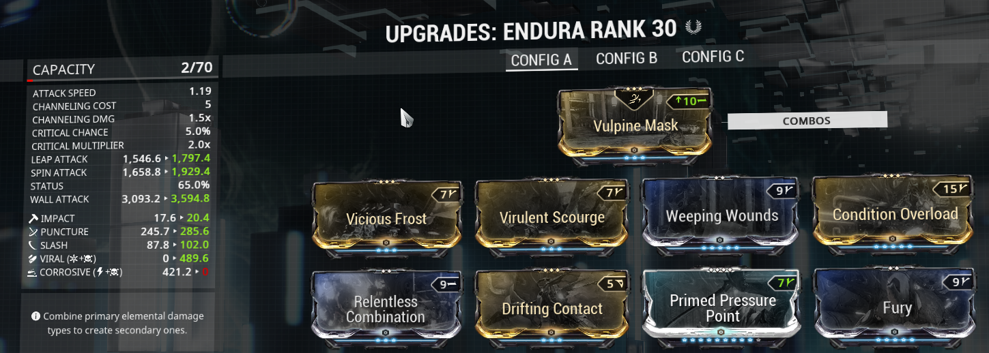

Fun tip: Since Vulpine Mask guarantees slash procs, I used Condition Overload to deal more damage along with Relentless Combination that increases my Melee Combo Counter when a slash proc ticks. Furthermore, I used Weeping Wounds to increase my status chance based on my melee counter. With Relentless increasing my counter, I will deal more status. More status procs on Viral/Corrosive, easy kills.