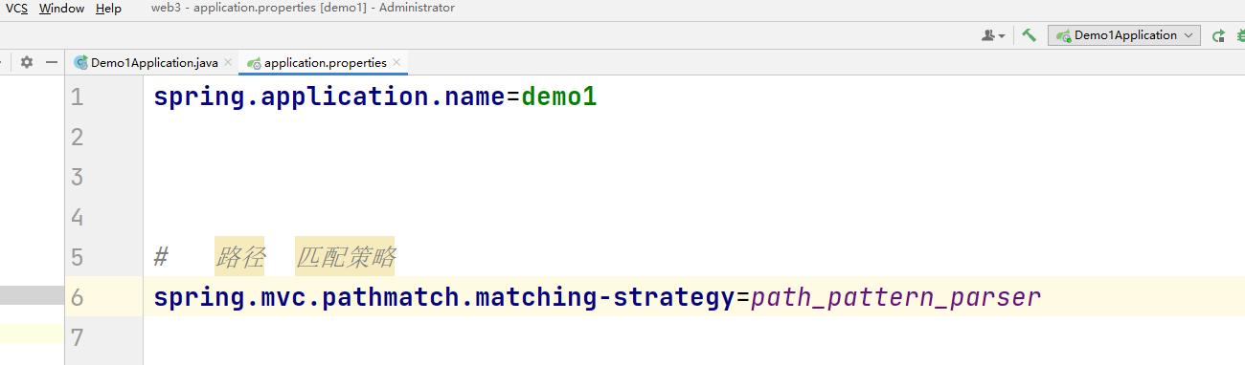

控制器
package com.example.demo1.controller;import jakarta.servlet.http.HttpServletRequest;import jakarta.servlet.http.HttpServletResponse;import org.springframework.web.bind.annotation.RequestMapping;import org.springframework.web.bind.annotation.RestController;@RestControllerpublic class Demo1 {// 请求路径 以 .png 结尾 @RequestMapping("/demo1/img/*.png") public String getPng(HttpServletRequest request, HttpServletResponse response){ return request.getRequestURI();// 读取 请求的路径 }}

请求测试：
