Data Insight: Philippines - Food Prices
Dataset Source: Philippines - Food Prices - Humanitarian Data Exchange (humdata.org)

Overview of Dashboard:
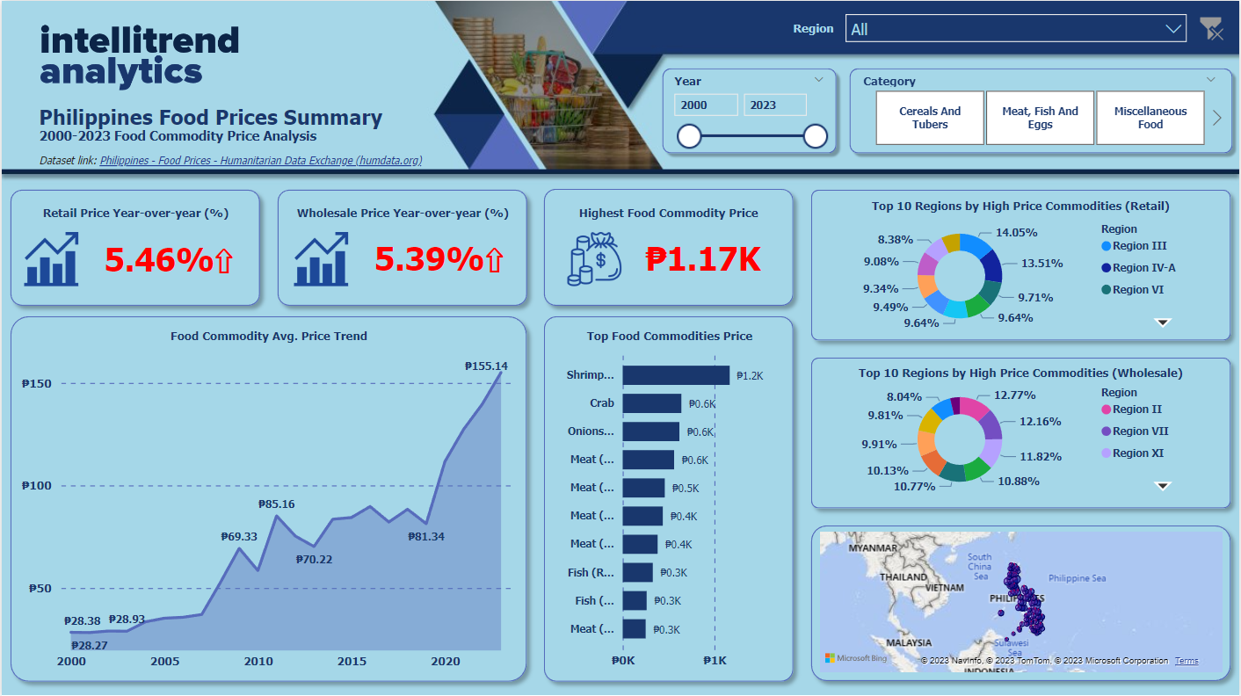

Overall Insight:
The data used shows the changes on the prices of food commodities in the Philippines.
So, for the visuals, first is I used the card visualization: for this I showed the changes on the Retail price and Wholesale price changes year-over-year (YOY) in percentage.
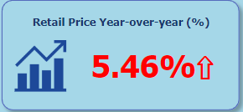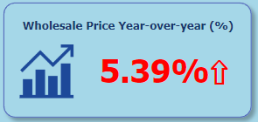
Here we can see that there was an increase of 5.46% price for the Retail and 5.39% price for the Wholesale (price changes comes from all the items).
As for the Highest Food Commodity Price, we can see that the price of the highest food is PHP 1.17k
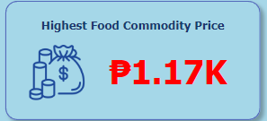
Next is I used the line graph chart to show the Average price trend of the Food Commodities.
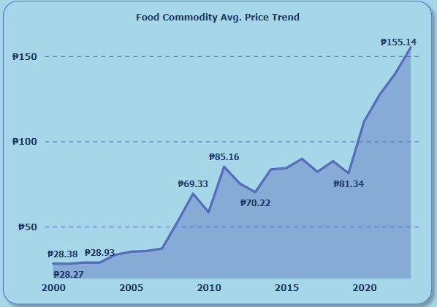
For the last 23 years, we can see that a big change happened on the food prices. From an average price of PHP 28.38 for the year 2000 to an average price of PHP 155.14 for the year 2023. With this, we can see that mostly of the food price trend gone up.
And for the third visual, I used the clustered bar chart to see the top commodity price.
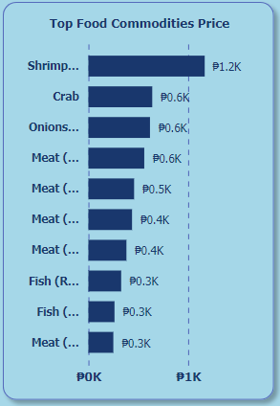
In this visual, we can see that most of the price changes comes from the Meat, Fish and Eggs category while there is also a vegetable category for the top 3. The highest price comes from the Shrimp (PHP 1.2k).
For the 4th visual, I used the donut chart for the top 10 regions that has high price on their commodities (retail & wholesale).
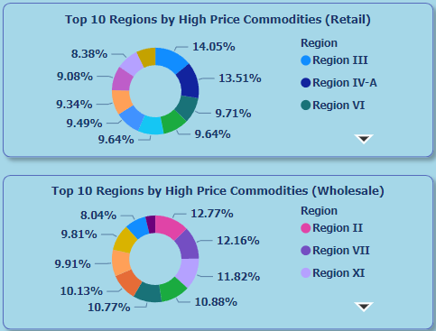
For the retail price, regions III and IV-A has <10% of the high price commodities while the rest of the regions has >10%.
For the wholesale price. 6 regions (Region II, VII, XI, and so on) has <10% of the high price commodities.

