
CSC 431
Acacia
System Architecture Specification (SAS)

Team Number :
Chase Morell | Team Leader/Back End Developer
Christopher Duarte | App Designer/Developer
Kevin Padron | App Designer/Developer
Enrique Grijalva | Developer
Alison Cohen | Front End Designer/Developer
Emily Silvershein | Front End Designer
Ava Grossman | Project Manager

Version History
Version | Date | Author(s) | Change Comments
.5 | 3/23 | Acacia Team
1.0 | 3/28 | Chase Morell
2.0 | 3/31 | Ava Grossman | description in various diagrams

Table of Contents

1. System Analysis 6
1.1 System Overview 6
1.2 System Diagram 6
1.3 Actor Identification 6
1.4 Design Rationale 6
1.4.1 Architectural Style 6
1.4.2 Design Pattern(s) 6
1.4.3 Framework 6
2. Functional Design 7
2.1 Diagram Title 7
3. Structural Design 8
4. Behavioral Design 9

Table of Tables

Table of Figures
System Diagram – Page 6

Sequence Diagram – Page 8

Structural Diagram – Page 9

System Analysis

System Overview
The system will be compromised of 4 main parts: a mobile front-end client, a user authentication system, a database, and a notification system. The front-end GUI will connect to the authentication system, database, and notification system.
The three-tier architecture will be used for this project. The client tier will be the mobile app. This presentation tier will have a rich user interface with the Acacia brand and styling. The logic tier will run on Firebase, which allows for cloud functions. When the client tier submits a request, it is handled by the logic tier. The logic tier analyzes the request and interacts with the third tier which is the storage model to 1) retrieve data from the database or 2) make changes to the database. The logic tier passes the data received from the storage model back to the client tier. The client tier takes the information received and represents it in a graphical user interface.

System Diagram

Figure 1
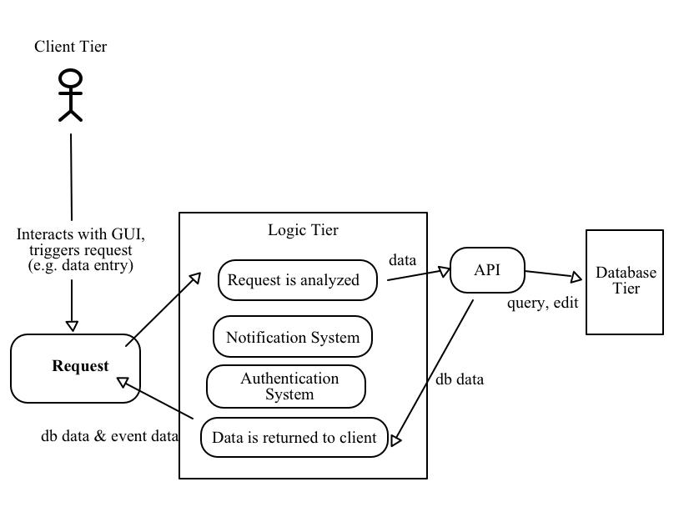

Actor Identification
There are 2 types of human actors: unauthorized users and authorized users. Unauthorized users can download the app and can create an account but are not allowed past the login page of the app. To access any of the functionality of the app, a user must be authorized. To become authorized, a human user must create an Acacia account. Authorized users can access app functionality that queries the database, makes changes to the database, schedules notifications, as well as a number of client-side features, such as data visualization.

Design Rationale

Architectural Style
The Acacia project naturally fits a 3-tier architectural style. The first tier is the client tier. Human actors interact directly only with the client tier, which not only receives user input, but also presents data and information graphically based on user requests. The logic tier handles requests made by the client tier by communicating between the storage model tier and the client tier. The logic tier is located in the cloud on a server. Client tier requests are handled as events and analyzed. The logic tier will fetch data from the database located in the storage model. Information is sent back to the logic tier and then back to the client.

Design Pattern(s)
Flutter is a powerful Dart framework that provides a robust set of features. We predict that the following design patterns will be primarily used in the following ways:
- Façade: To provide a simpler, unified interface to the often complex underlying code of both the logic and database tiers.
- Singleton: To maintain a single, consistent reference, such as a database reference
- Adapter: To allow 2 components with incompatible interfaces to talk to each other without modifying the source code in either component (ex. Let the client tier talk to the notification system).

Framework
The main framework used is Flutter. Flutter is a cross-platform UI software development kit that allows for full application development. Flutter uses the Dart programming language for both front and back-end development. Another framework used is the Firebase API. The Firebase API provides many features for the application, chiefly: authentication of user accounts and providing the database.

Links:
https://flutter.dev/
https://firebase.google.com

Functional Design
Here we present the sequence diagram for the Acacia app. This outlines the core functionality for this system.
- 2.1 Acacia App Sequence Diagram

Figure 2
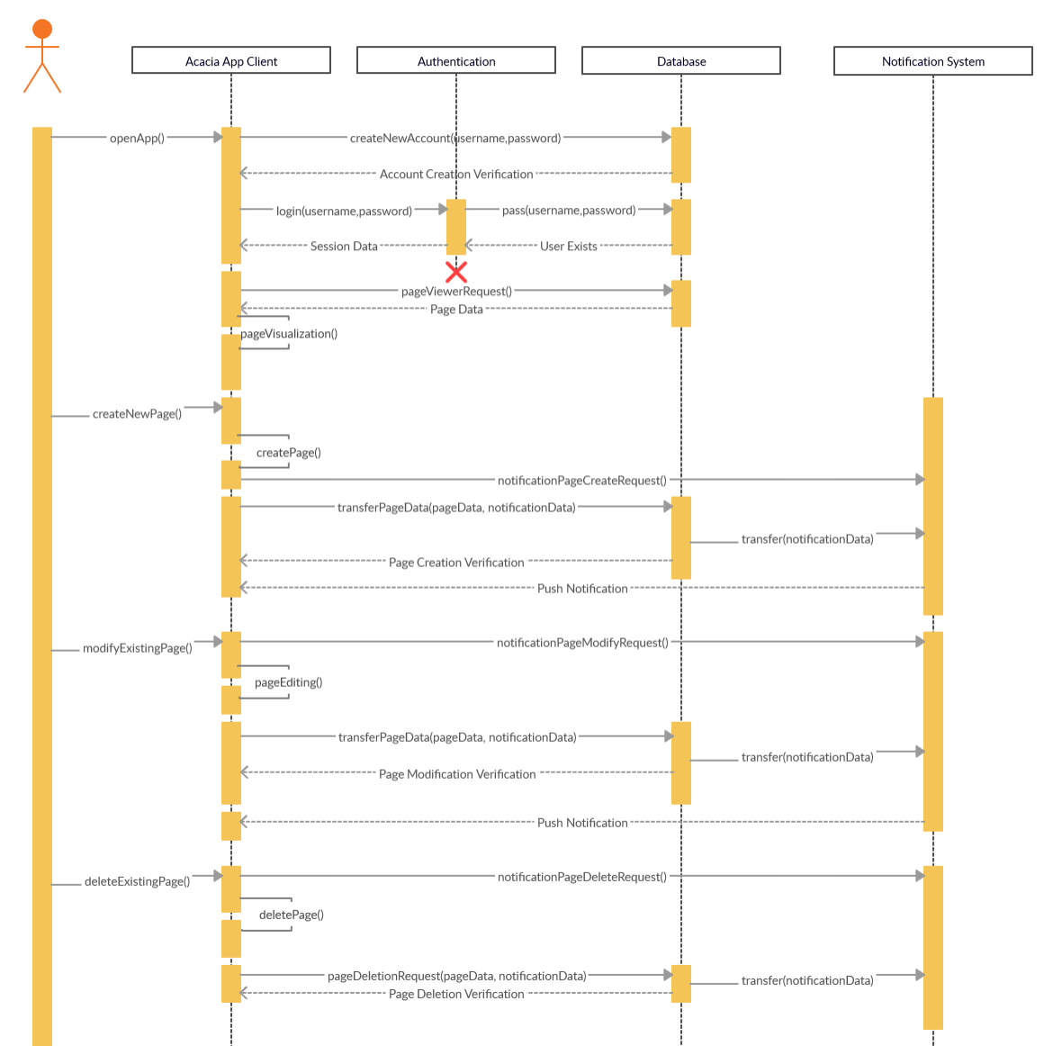

Structural Design
The following class diagram represents an overview of the component breakdown in our system. A primary focus for this design is modularity.

Figure 3
