Breast Cancer Diagnostic Analysis
F.Y. BCA Semester I • Project Group 12
UCI Breast Cancer Wisconsin (Diagnostic) Dataset

1. Introduction & Objective
Analyze the UCI Breast Cancer Wisconsin (Diagnostic) dataset.
Inspect and assess data quality before analysis.
Use descriptive, univariate, bivariate, grouping and correlation analysis.
Present findings using clear Python-generated visualizations.
2

2. Dataset Description
569 observations and 30 real-valued diagnostic features.
Target variable: Diagnosis — B = Benign, M = Malignant.
Measurements cover radius, texture, perimeter, area, smoothness, compactness, concavity, concave points, symmetry and fractal dimension.
Each measurement is available as mean, standard error and worst/largest value.
Source: UCI Machine Learning Repository.
3

3. Data Types & Variables
4

4. Tools Used for Analysis
Python — programming language for analysis.
Pandas — data loading, cleaning, grouping and statistics.
NumPy — numerical calculations.
Matplotlib — charts and visualization.
Scikit-learn — optional dataset/analysis workflows.
Excel — prepared dataset with column headings.
5

5. Data Quality Assessment
6

6. Descriptive Statistics
Representative variables are summarized using count, mean, median, standard deviation, minimum and maximum.
Mean radius: 14.127; mean texture: 19.290.
Mean perimeter: 91.969; mean area: 654.889.
Mean smoothness: 0.096.
7

6A. Descriptive Statistics — Representative Variables
8
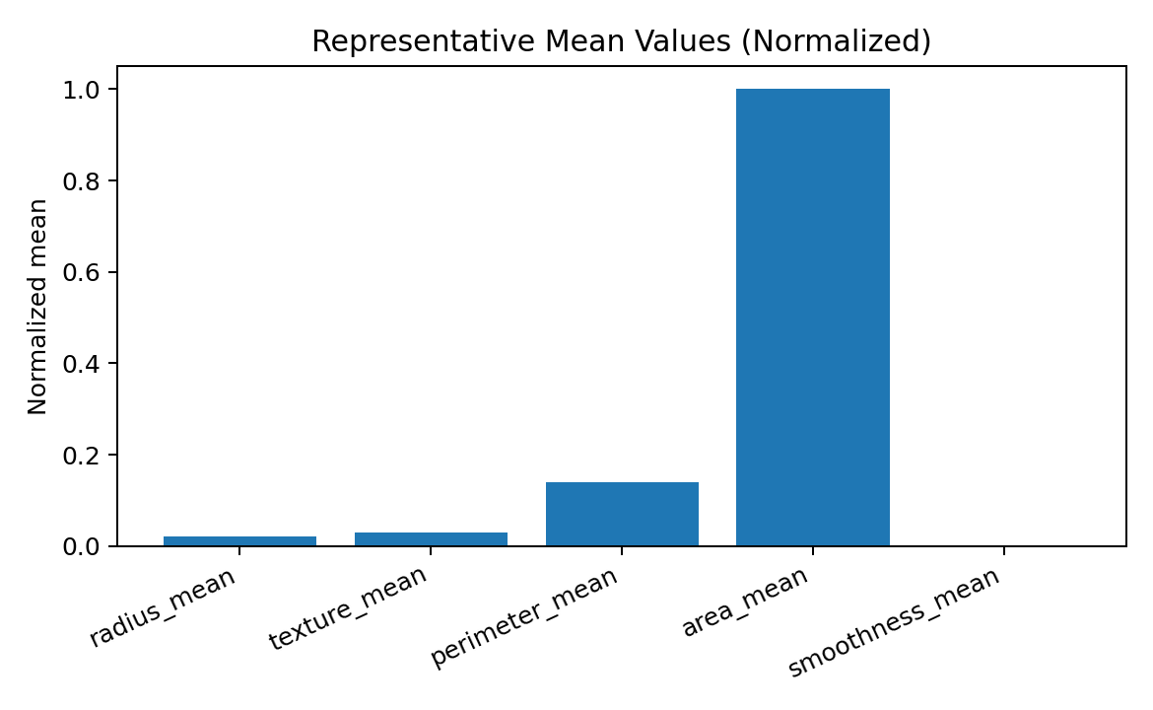
Figure: Representative mean values shown on a normalized scale because the variables use different units.

7. Univariate Analysis — Diagnosis Distribution
9
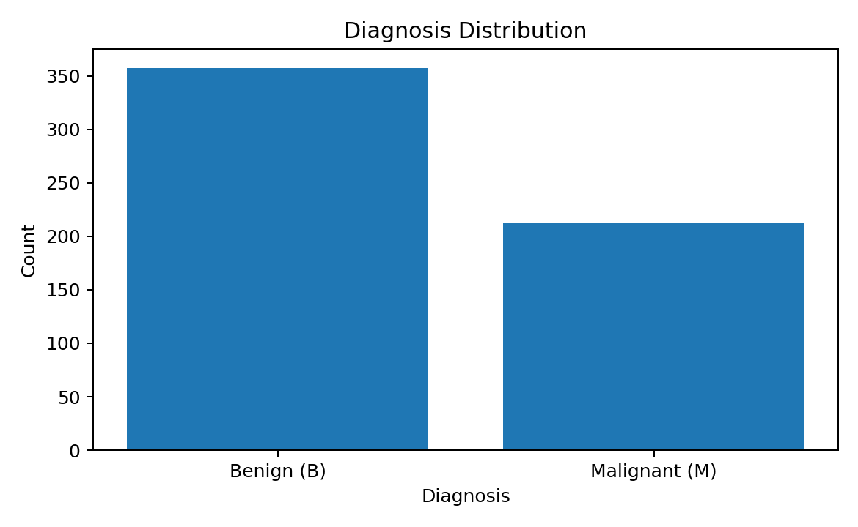
Figure: Diagnosis distribution based on the supplied project values (357 benign, 212 malignant).

7A. Univariate Analysis — Mean Radius
10

8. Bivariate Analysis — Mean Radius by Diagnosis
11
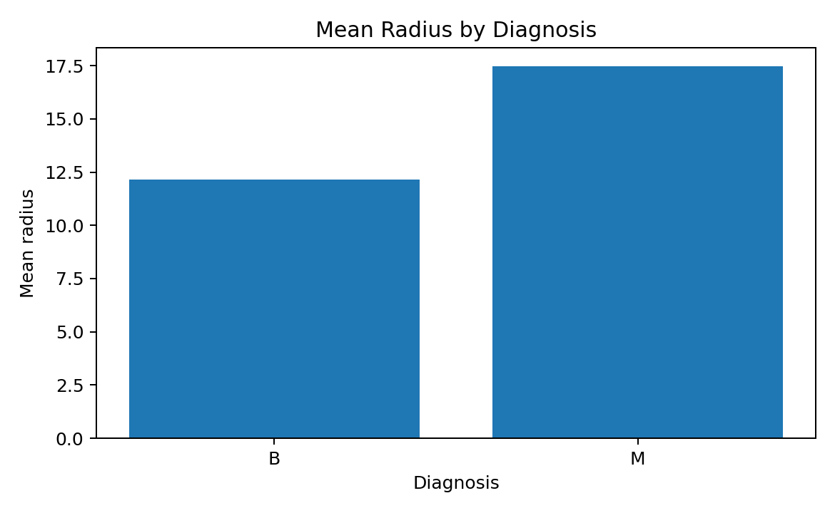
Figure: Mean radius comparison for benign and malignant records.

8A. Bivariate Analysis — Radius vs Area
12

9. Grouping & Aggregation
Grouping by diagnosis allows average measurements to be compared between B and M records.
The supplied dataset shows higher average size-related measurements for the M group.
13
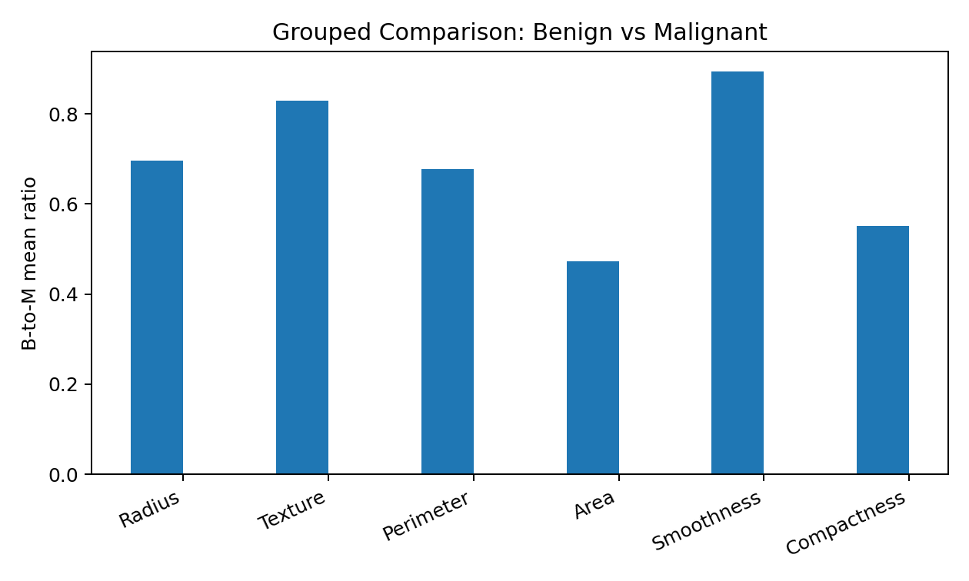
Figure: Benign-to-malignant mean ratios for grouped representative variables.

10. Correlation Analysis
radius_mean: 1.0000
perimeter_mean: 0.9979
area_mean: 0.9874
radius_worst: 0.9695
perimeter_worst: 0.9651
area_worst: 0.9411
14
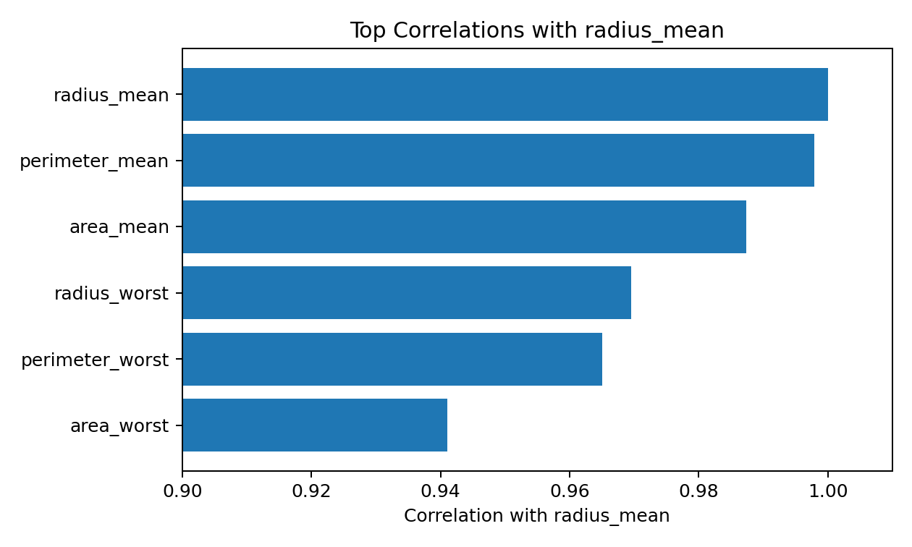
Figure: Strongest supplied correlations with radius_mean.

11. Visualization — Combined Output
15

12. Key Findings
The dataset contains 569 observations and 30 numerical diagnostic features.
Diagnosis contains 357 benign and 212 malignant records.
Size-related measurements such as radius, perimeter and area show strong positive relationships.
Grouping by diagnosis shows differences in average measurements.
Visualizations make distribution and relationship patterns easier to inspect.
These are descriptive patterns in a historical dataset, not a clinical diagnosis.
16

13. Conclusion
Python provides a systematic workflow for loading, cleaning, summarizing and visualizing the dataset.
Descriptive, univariate, bivariate, grouping and correlation analyses provide different views of the data.
The project demonstrates practical use of Pandas, NumPy and Matplotlib for data analysis.
Interpretation is kept descriptive and should not be treated as medical advice.
17

14. References
UCI Machine Learning Repository — Breast Cancer Wisconsin (Diagnostic), Dataset ID 17.
Project Details_Div A.pdf — F.Y. BCA Semester I project format.
Wolberg, W., Mangasarian, O., Street, N. & Street, W. (1993). Breast Cancer Wisconsin (Diagnostic).
Python / Pandas / NumPy / Matplotlib documentation.
18

15. Python Code — Data Loading
import pandas as pd
import numpy as np
import matplotlib.pyplot as plt
file_path = "wdbc.data"
columns = [
"id","diagnosis","radius_mean","texture_mean","perimeter_mean","area_mean",
"smoothness_mean","compactness_mean","concavity_mean","concave_points_mean",
"symmetry_mean","fractal_dimension_mean","radius_se","texture_se",
"perimeter_se","area_se","smoothness_se","compactness_se","concavity_se",
"concave_points_se","symmetry_se","fractal_dimension_se","radius_worst",
"texture_worst","perimeter_worst","area_worst","smoothness_worst",
"compactness_worst","concavity_worst","concave_points_worst",
"symmetry_worst","fractal_dimension_worst"
]
df = pd.read_csv(file_path, header=None, names=columns)
print(df.head())
print(df.shape)
19

16. Python Code — Data Quality & Statistics
# Data quality
print(df.info())
print(df.isnull().sum())
print("Duplicate rows:", df.duplicated().sum())
df = df.drop_duplicates()
print(df["diagnosis"].value_counts())
# Remove identifier from analysis
df_analysis = df.drop(columns=["id"])
# Descriptive statistics
print(df_analysis.describe())
summary = pd.DataFrame({
"mean": df_analysis.select_dtypes("number").mean(),
"median": df_analysis.select_dtypes("number").median(),
"std": df_analysis.select_dtypes("number").std()
})
print(summary.head(10))
20

17. Python Code — Univariate & Bivariate Analysis
# Univariate analysis
plt.figure(figsize=(8,5))
plt.bar(df["diagnosis"].value_counts().index,
df["diagnosis"].value_counts().values)
plt.title("Diagnosis Distribution")
plt.xlabel("Diagnosis")
plt.ylabel("Count")
plt.show()
plt.figure(figsize=(8,5))
plt.hist(df["radius_mean"], bins=30)
plt.title("Distribution of Mean Radius")
plt.xlabel("Radius Mean")
plt.ylabel("Frequency")
plt.show()
# Bivariate analysis
plt.figure(figsize=(8,5))
plt.boxplot([
df.loc[df["diagnosis"]=="B", "radius_mean"],
df.loc[df["diagnosis"]=="M", "radius_mean"]
], labels=["B","M"])
plt.title("Mean Radius by Diagnosis")
plt.show()
plt.figure(figsize=(8,5))
for label in ["B","M"]:
d = df[df["diagnosis"] == label]
plt.scatter(d["radius_mean"], d["area_mean"], alpha=0.6, label=label)
plt.title("Radius Mean vs Area Mean")
plt.xlabel("Radius Mean")
plt.ylabel("Area Mean")
plt.legend()
plt.show()
21

18. Python Code — Grouping, Correlation & Save
# Grouping and aggregation
group_summary = df.groupby("diagnosis")[[
"radius_mean","texture_mean","perimeter_mean",
"area_mean","smoothness_mean","compactness_mean"
]].mean()
print(group_summary)
# Correlation analysis
numeric_df = df.select_dtypes(include="number")
corr = numeric_df.corr()
plt.figure(figsize=(11,8))
plt.imshow(corr, aspect="auto", vmin=-1, vmax=1, cmap="coolwarm")
plt.colorbar(label="Correlation")
plt.title("Correlation Heatmap")
plt.xticks([])
plt.yticks([])
plt.show()
print(corr["radius_mean"].sort_values(ascending=False).head(10))
# Save cleaned dataset
df.to_csv("wdbc_cleaned.csv", index=False)
22

