**VISVESVARAYA TECHNOLOGICAL UNIVERSITY**

**JNANA SANGAMA, BELGAUM-590018**



**RNS Institute of Technology**

Channasandra, Uttarahalli-Kengeri main Road,

Bengaluru-560 098



**DEPARTMENT**

**of**

**COMPUTER SCIENCE & ENGINEERING**

Synopsis

On

**“**A Responsive Music Website**”**

**INTERNSHIP PROJECT WORK TITLE**: **“**A Responsive Music Website**”**

|  |  |  |  |  |
| --- | --- | --- | --- | --- |
| **Batch No: 22** | | | | |
| **Sl No** | **USN** | **Name** | **E-mail id** | **Contact number** |
| 01 | 1RN17CS042 | Karthik C | karthikc.1rn17cs042@gmail.com | 9113666176 |

**Online Platform :** Coursera

**Contact number :** (800) 952-5210

**Email_ID :** press@coursera.org

**Internal Guide Details:** Dr. G T Raju

**1. Objective /Aim of the Internship project work:**

This project aims to build a responsive music website which is the best solution for creating a centralized location where music fans can listen to their favorite artist songs, check the latest albums, popular artists and find out about their upcoming concerts and new releases.

**2. Introduction:**

Music is an art of sound in time that expresses ideas and emotions in significant forms through the elements of rhythm, melody, harmony, and color. This responsive music website is an HTML website, fully responsive, flexible, optimized and cross-browser compatible. It has a modern web design with a zoom-in slideshow, loads content on the scroll and includes an audio player. The users can explore a large community of artists, bands, podcasters and creators of music and audio. Bootstrap is the most popular, HTML, CSS, and JS framework for developing responsive, mobile first projects on the web.

**3. Technical details/flaws about existing system**

The responsive music website can be an open upload platform where Artists can sign up and upload or showcase their own with the audience. The design/style of the website can be modified depending upon the developer interests.

**3. Technical details about the project details**

**a. Block Diagram:**

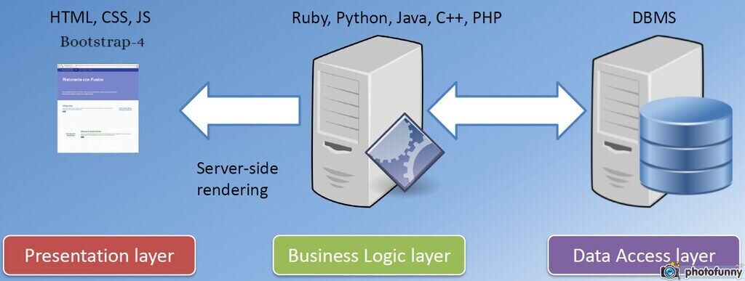

**b. Architecture/Flow chart:**

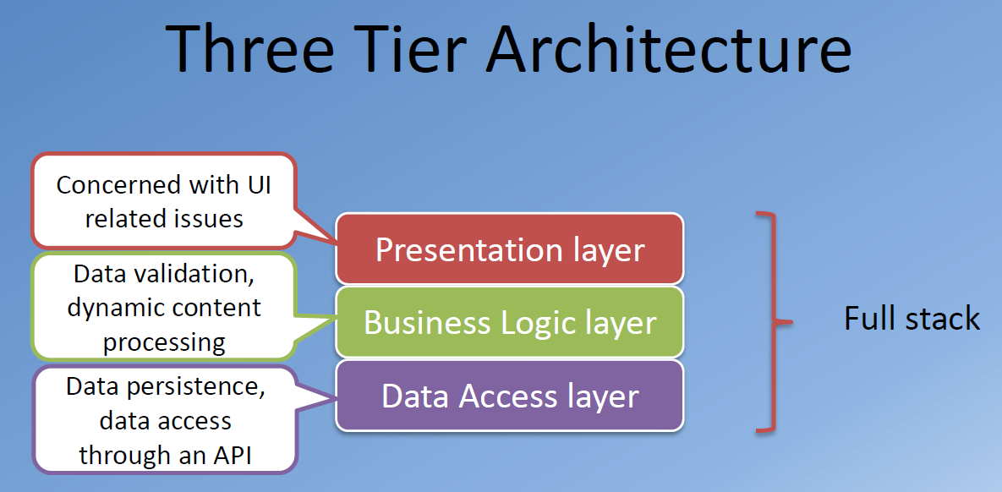

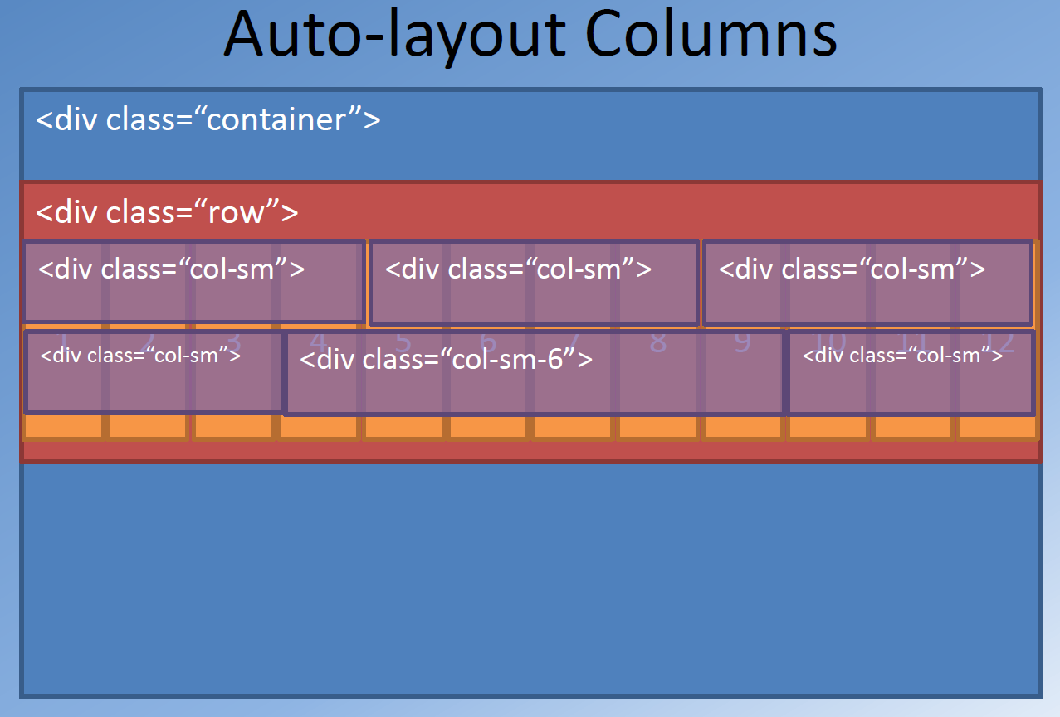

Bootstrap grid system

**5. Requirements specification.**

* **Minimum Hardware & Software Requirements**
  + Latest Bootstrap, jQuery-2.2.4 js, Plugins js, Active js.
  + Atom – A hackable text editor.
  + Bootstrap 4 framework.
  + Operating​ ​System​ ​used: Windows/ubuntu
  + Processor: Pentium4​ ​processor.
  + RAM: 2GB.
  + Storage​ ​Space: 40​ ​GB.

**6. Current Status of Development**

Front end of the project is completed with Bootstrap-4 framework, html, CSS and JavaScript.

**7. Innovativeness and Usefulness**

Owning a responsive music website provides artist/music agency with the opportunity to curate their personal brand more carefully than social media and provide their fans with a space dedicated to their favorite artists. It gives artists control of their content, brand and future development of their online space.

The users/music fans can listen to their favorite artist songs, check the latest songs, latest albums, popular artists and find out about their upcoming concerts and new releases.

**8.Current Market Potential & Competitive advantage**

Highly scalable, easy to use and maintain and has the potential to generate high revenue through ads on the site.

9. **Any other information to be highlighted**

The website is completely responsive which enables the users to browse the website on devices of various screen sizes. **Responsive web design** (**RWD**) is an approach to web design that makes web pages render well on a variety of devices and window or screen sizes. Content, design and performance are necessary across all devices to ensure usability and satisfaction.

SD/- SD/-

**Coordinators HOD**

Dept of CSE, RNSIT Dept of CSE, RNSIT