[Click here to Find all Project related files here](https://drive.google.com/drive/folders/1KxJr0xhzXmtzbaUcSZFr9fUr6I0EL5Sp?usp=sharing)

Project-1:

**Project done by: Sayan Sarkar**

**Project Number**: 1

**Project Name:** Extract data from PDF & write to excel file & mail that excel file as an attachment.

**Batch:** October

**Name**: Sayan Sarkar

**Project Summary:**

* Extracting data from several PDF files & collected data is being written on an Excel &

that Excel file is being sent on the desired Email-ID.

**Project Timeline:**

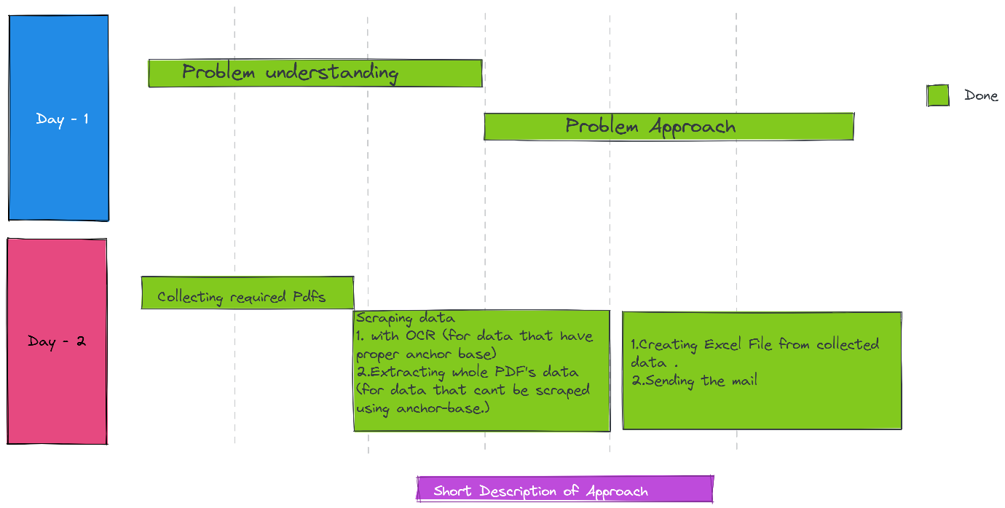

**Working Video:**

[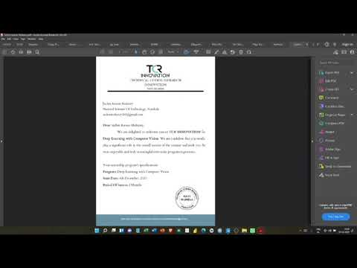](https://www.youtube.com/embed/C45r_6UurZU?feature=oembed)

**Project Results:**

* *I went on asking people about sharing their invitation letters, few people shared few didn't. So, due to the lack of invitation letters, I only collected data from 31 people.*
* *In the letter what I saw was, few people even wrote their name instead of giving the*

*organization's name and some people went for the short term of their colleges. For me*

*it was quite unnecessary to include those colleges as conditions so, instead of having*

*NULL values, I went for not having their name in the table at all.*

* *My first RPA project. It's been a quite fun journey for me to learn all these new things and apply them. I faced some issues but all of them got successfully debugged.*