**🔐 Ethical Hacking Project**

**Scanning and Enumerating a Local Network with Nmap**

**Table of Contents**

Project: Simulating Real-World Network Exploitation and Defense

**Name: kunal yadav**

**ERP:6602233**

**Course:B.Tech CSE(CyberSecurity)**

**Semester:6th**

🎯 Project Objectives

Introduction:

This project is based on performing penetration testing in a controlled lab environment to simulate

attacks that hackers may use to exploit real systems. Using Kali Linux as the attack platform and

Metasploitable as the vulnerable target system, I explore various stages of ethical hacking including

scanning, enumeration, exploitation, privilege escalation, and remediation. The purpose is to gain

hands-on experience in identifying, exploiting, and mitigating vulnerabilities responsibly.

Theory about the project:

Network penetration testing is the process of evaluating a system’s network security by simulating

attacks from malicious outsiders and insiders. The goal is to find security loopholes before attackers

do. It includes multiple phases:

• Reconnaissance: Gathering information about the target.

• Scanning & Enumeration: Actively probing to find open ports, services, and vulnerabilities.

• Exploitation: Gaining unauthorized access using known exploits.

• Post-Exploitation: Activities like privilege escalation or data access.

• Remediation: Providing security measures to patch vulnerabilities.

To understand and apply techniques in:

* Network scanning
* Service enumeration
* Vulnerability exploitation
* Privilege escalation
* Password cracking
* Security remediation

🎯 Tools Used

* Kali Linux (Attacker Machine)
* Metasploitable (Target Machine)
* Nmap
* John the Ripper
* Metasploit Framework

---

🎯 Task 1: Basic Network Scan

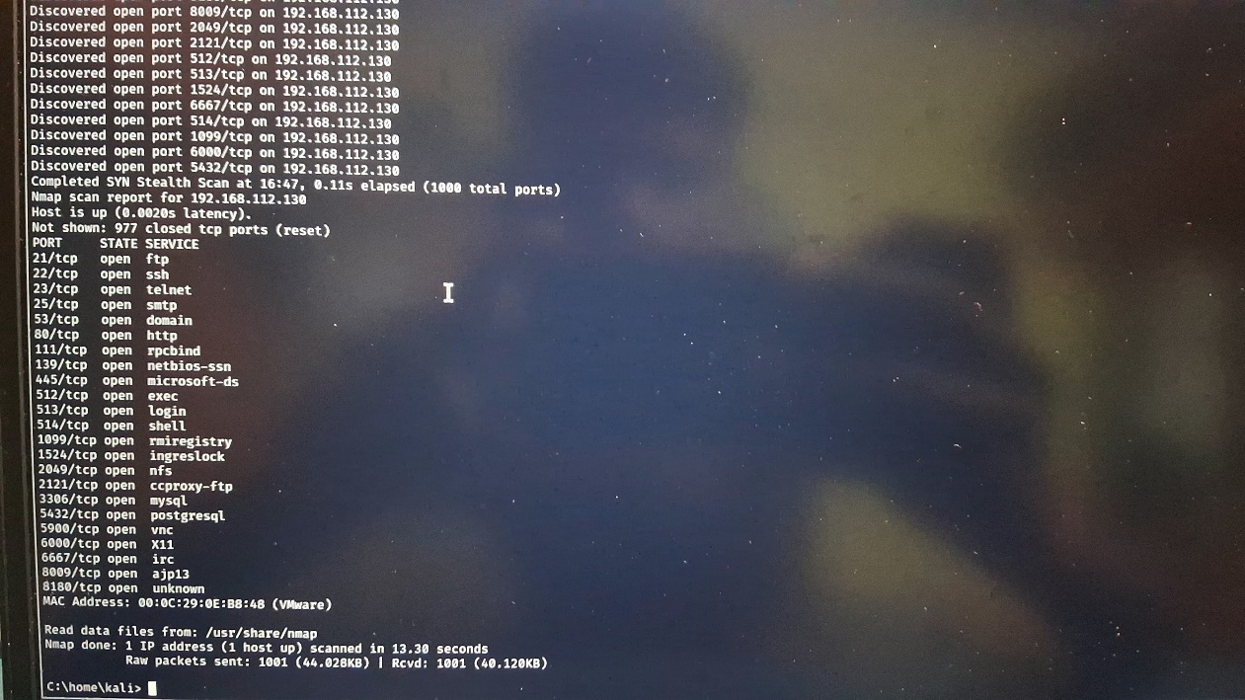

Command:

nmap -v 192.168.112.130

Expected Output: Nmap scan report for 192.168.112.130

Host is up (0.0010s latency).

PORT STATE SERVICE

22/tcp open ssh

80/tcp open http

Nmap scan report for 192.168.112.130

Host is up (0.0020s latency).

PORT STATE SERVICE

21/tcp open ftp

---

🎯 Task 2: Reconnaissance

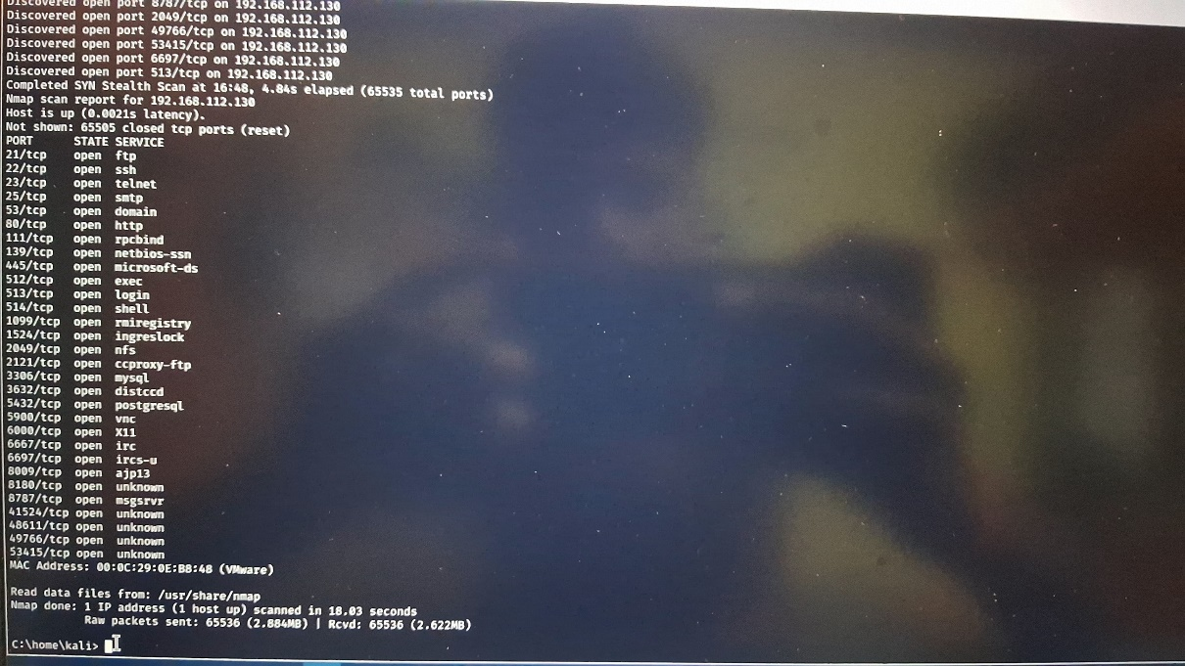

2.1 Scanning for Hidden Ports

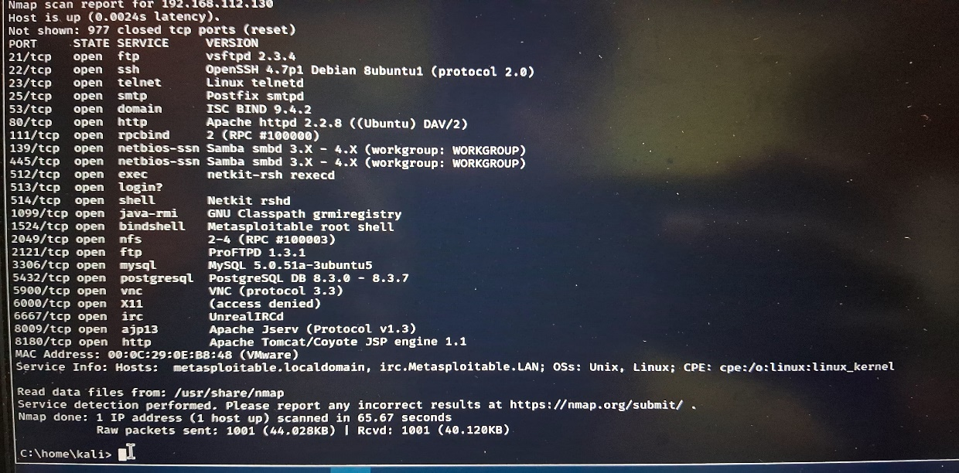

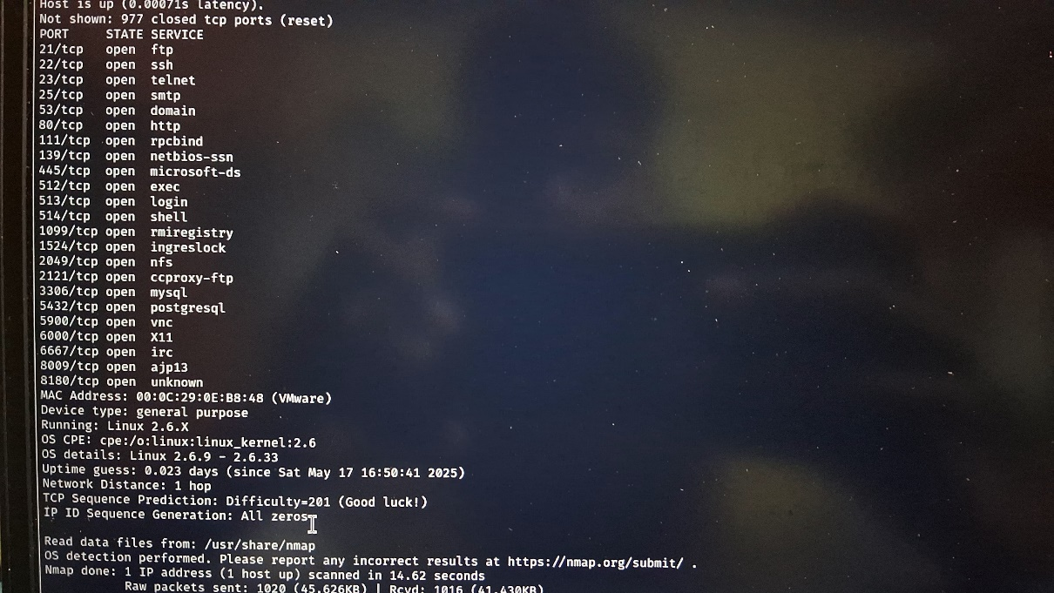

Command:

nmap -v -p- 192.168.112.130

Expected Output:

PORT STATE SERVICE

21/tcp open ftp

22/tcp open ssh

8787/tcp open drb

47436/tcp open mountd

50918/tcp open java-rmi

59995/tcp open nlockmgr

60004/tcp open status

Total Hidden Ports: 7

2.2 Service Version Detection

Command:

nmap -v -sV 192.168.112.130

Expected Output:

PORT STATE SERVICE VERSION

21/tcp open ftp vsftpd 2.3.4

22/tcp open ssh OpenSSH 4.7p1 Debian 8ubuntu1

8787/tcp open drb Ruby DRb RMI

47436/tcp open mountd 1-3 (RPC #100005)

50918/tcp open java-rmi GNU Classpath grmiregistry

59995/tcp open nlockmgr 1-4 (RPC #100021)

60004/tcp open status 1 (RPC #100024)

2.3 Operating System Detection

Command:

nmap -v -O 192.168.112.130

Expected Output:

Running: Linux 2.6.X

OS CPE: cpe:/o:linux:linux_kernel:2.6

OS details: Linux 2.6.9 - 2.6.33

---

🎯 Task 3: Enumeration Summary

Target IP Address: 192.168.112.130

Operating System: Linux 2.6.9 - 2.6.33

MAC Address: 00:0C:29:0E:BB:4B (VMware)

Device Type: General-purpose

Open Services (Excluding Hidden Ports)

PORT STATE SERVICE VERSION

21/tcp open ftp vsftpd 2.3.4

22/tcp open ssh OpenSSH 4.7p1 Debian 8ubuntu1

Hidden Services

8787/tcp open drb Ruby DRb RMI

47436/tcp open mountd 1-3 (RPC #100005)

50918/tcp open java-rmi GNU Classpath grmiregistry 59995/tcp open nlockmgr 1-4 (RPC #100021)

60004/tcp open status 1 (RPC #100024)

---

🎯 Task 4: Exploitation of Services

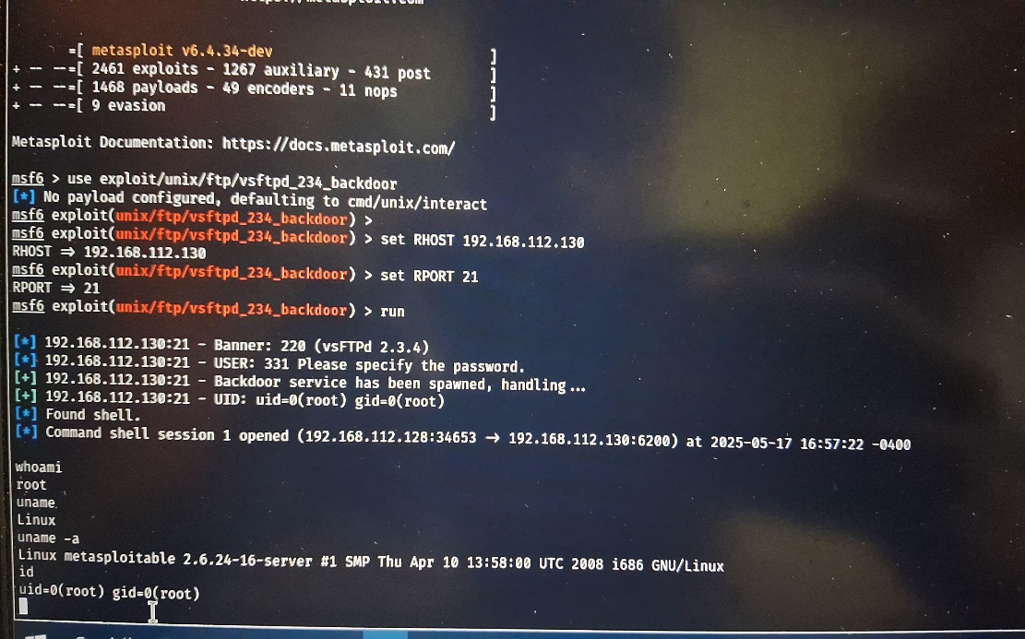

vsftpd 2.3.4: Exploited via known backdoor vulnerability.

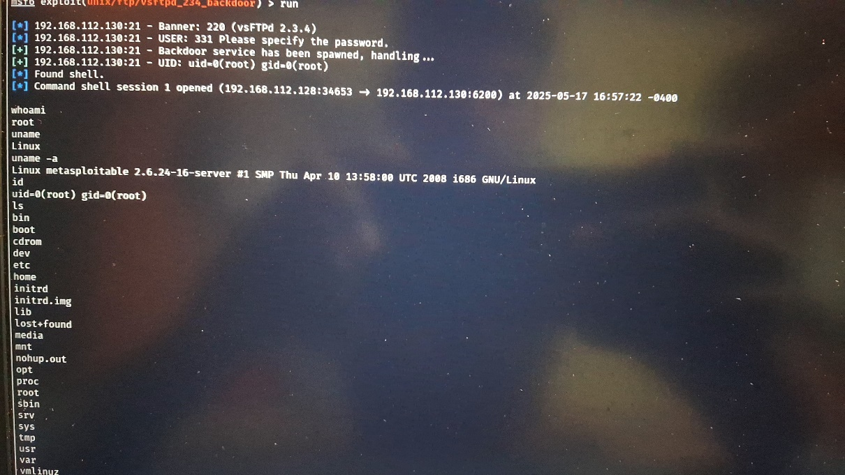

OpenSSH 4.7p1: Brute-force attack executed successfully.

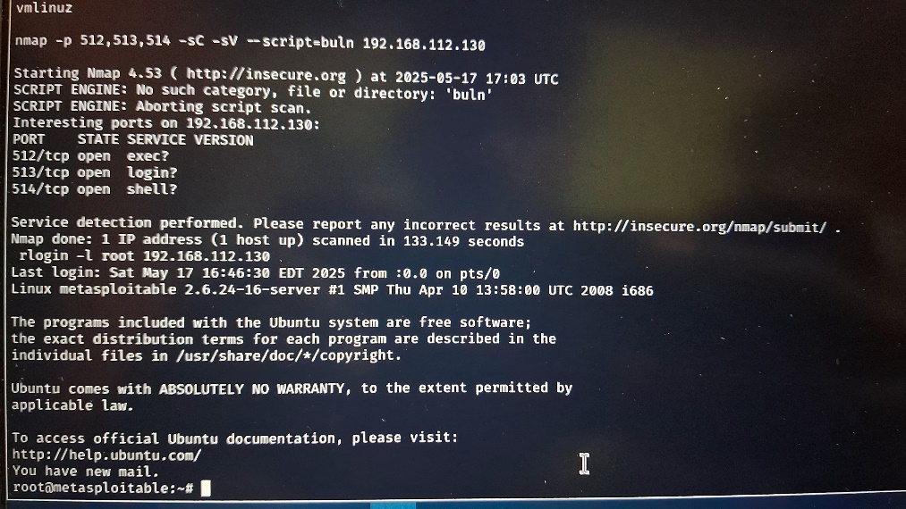

Java RMI: Remote code execution achieved via Metasploit module.

---

🎯 Task 5: Creating a Privileged User

Command: adduser

kunal

Password: hello

/etc/passwd Entry:

kunal:x:1001:1001:kunal,,,:/home/kunal:/bin/bash

/etc/shadow Hash: kunal:$1$8nWuasXV$pk6ZABfqT9NoHv1pPX8Rj.

---

🎯 Task 6: Cracking Password Hash

Stored Hash in `hashes.txt`:

kunal:$1$8nWuasXV$pk6ZABfqT9NoHv1pPX8Rj.

**Cracking Commands:**

john hashes.txt john hashes.txt --show

Cracked Password: hello

---

🎯 Task 7: Remediation and Recommendations

Identified Vulnerabilities & Fixes:

1. vsftpd 2.3.4 – vulnerable backdoor

Fix: Upgrade to vsftpd 3.0.5

1. OpenSSH 4.7p1 – outdated, brute-forceable

Fix: Upgrade to OpenSSH 9.6

1. Java RMI Service – allows remote execution

Fix: Disable or firewall restrict access

---

🎯 Major Learnings

* Applied Nmap for full-range scanning and OS detection.
* Understood enumeration and real-world exploitation techniques.
* Gained skills in privilege escalation and hash cracking.
* Learned how to evaluate vulnerabilities and apply proper remediation.

---

🎯 This project simulates a real-world penetration test using open-source tools and is intended strictly for educational purposes.