WEEK 1:

student Performance Prediction and Analysis Using Python

SUBMITTED BY:
Krishna Yadav

COURSE:
Bachelor of Computer Applications (BCA)

INTERNSHIP:
Data Science Internship

TASK:
Week 1 – Project Planning and Strategy Design

INTRODUCTION & BACKGROUND
Data Science helps us analyze data and find useful patterns for better decision-making. Python provides powerful tools for data analysis, visualization, and
machine learning.
This project focuses on Student
Performance Prediction and Analysis Using Python. The aim is to analyze
factors such as attendance, study hours, previous marks, and assignment
performance that may affect students' academic results.
The project will follow a complete data science process, including data collection, cleaning, analysis, modeling, and evaluation.

PROBLEM STATEMENT
Educational institutions have student data but may not always use it
effectively. This project proposes a data-driven approach to identify important

factors and predict student academic performance.

PROJECT OBJECTIVES & SCOPE



  - Analyze factors affecting student performance.
  - Study attendance, study hours, previous marks, and assignments.
  - Identify patterns using data analysis.
  - Plan suitable machine learning models.
  - Evaluate model performance.
  - Generate useful insights for educators.

SCOPE



    - Data collection
    - Data cleaning
    - Data analysis and visualization
    - Feature selection
    - Machine learning
    - Model evaluation
    - Final reporting



- Real-time student monitoring
- Commercial application development
- Collection of sensitive personal information.

- Predicting a student's long-term career.
- Large-scale production deployment.
- Continuous monitoring after deployment.
- Integration with third-party educational platforms.
- Actual implementation of the
machine learning model during Week 1.
- Handling real student data during the planning phase.

- METHODOLOGY AND STRATEGY

The project will follow a structured data science workflow to analyze and predict student performance.



- Problem Definition – Understand the student performance problem.
- Data Collection – Collect relevant student information.
- Data Cleaning – Handle missing, duplicate, and incorrect data.
- Data Analysis – Find patterns and relationships using EDA.
- Feature Engineering – Select and prepare important features.

- Model Building – Plan suitable machine learning models.
- Model Evaluation – Compare model performance.
- Reporting – Present insights and final results.

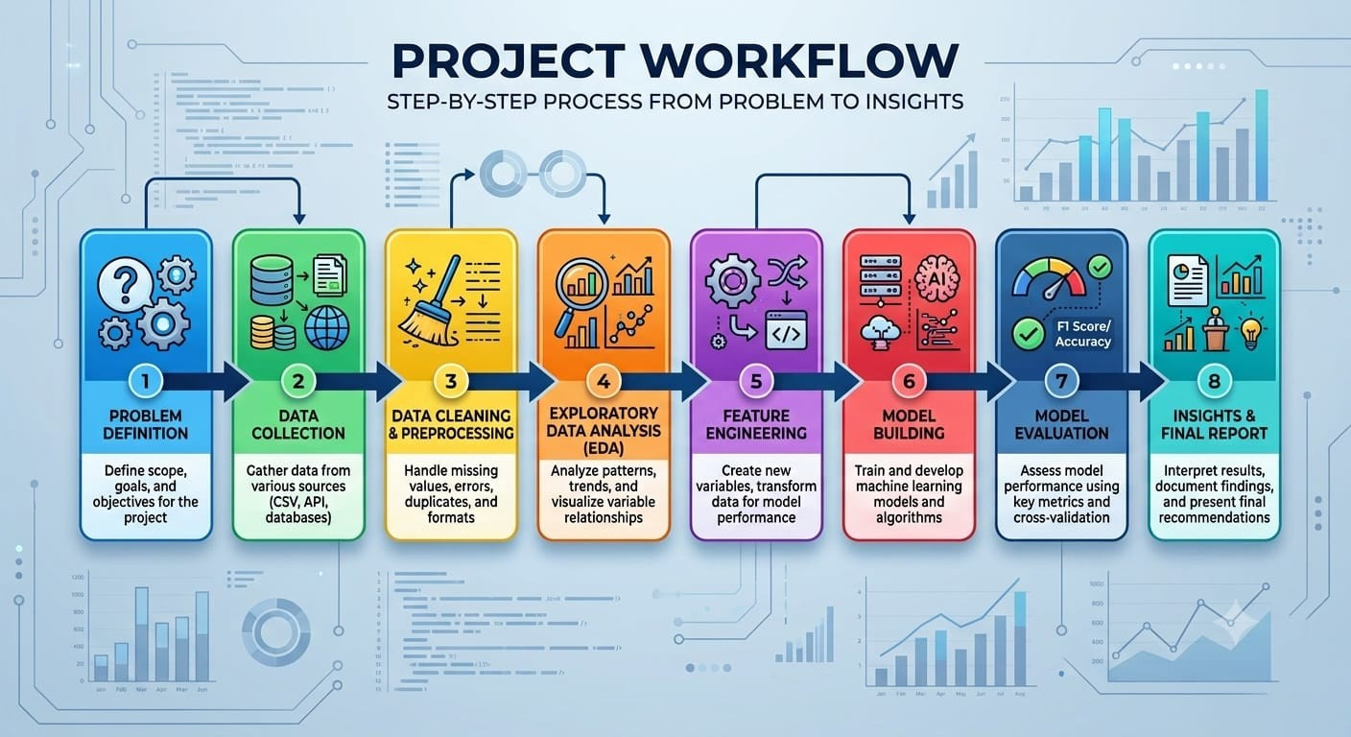

TIMELINE AND TOOLS

The project is planned for approximately 32 hours.

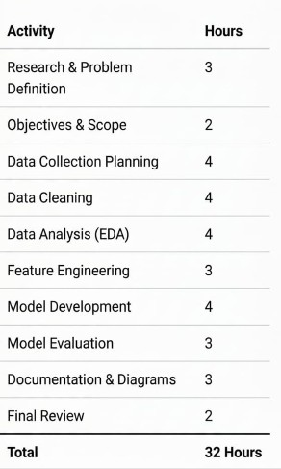

CHART:

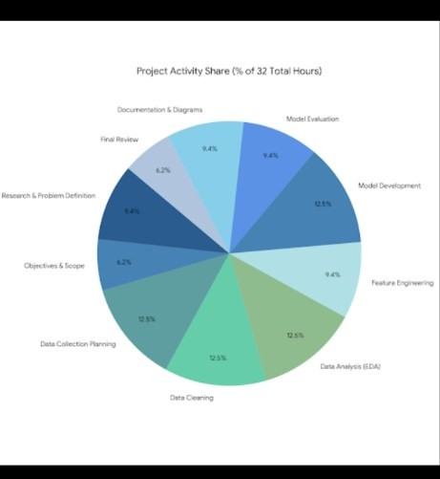
programming language
Main

TOOLS AND TECHNOLOGIES
Python – Pandas – NumPy – Numerical calculations

Matplotlib – 
Seaborn –  Scikit-learn – 


Jupyter Notebook / Google Colab – Microsoft Word

EXPECTED OUTCOMES AND CHALLENGES


- Identify factors that may affect student performance.
- Find useful patterns in student data.
- Develop a clear strategy for performance prediction.
- Understand the complete data science workflow.
- Provide useful insights for educators.

- Prepare a structured plan for future technical implementation.



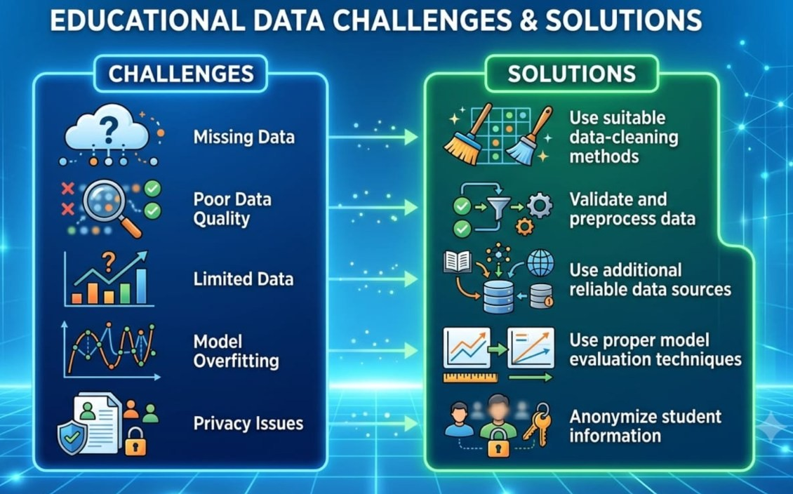


The project will provide a clear
and systematic plan for analyzing student performance using data science. It will also create a

strong foundation for the future
technical and coding phase of the
PROJECT

EVALUATION STRATEGY & CONCLUSION



The planned project will be evaluated based on the quality and
effectiveness of the proposed data science strategy.

- Clear definition of the problem.
- Proper project objectives and scope.
- Logical data science workflow.

- Suitable data collection and preprocessing strategy.
- Appropriate machine learning approach.
- Proper selection of evaluation methods.
- Clear documentation and presentation.



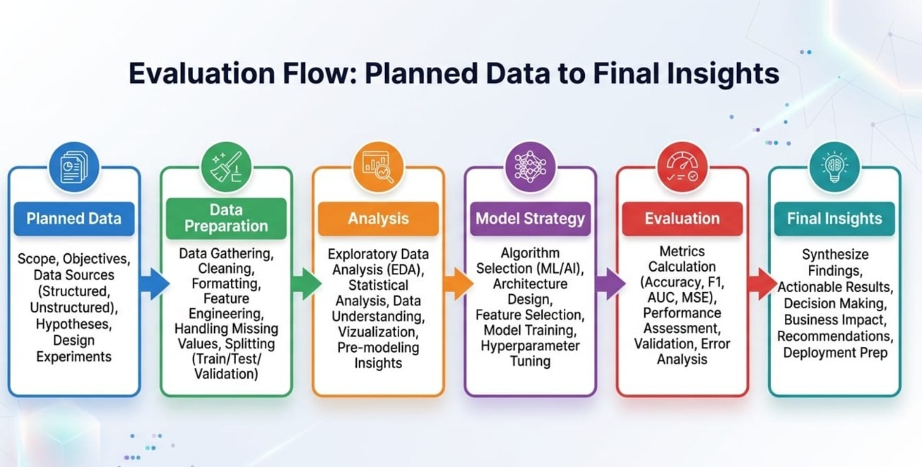

CONCLUSION
This Week 1 project provides a complete strategic plan for Student Performance Prediction and Analysis Using Python.
The project explains how student-related data can be collected, cleaned,
analyzed, and used for future machine learning applications. The plan also
defines the required tools, timeline, expected outcomes, and possible challenges.
Since this is a planning phase, no actual coding, dataset, or model
implementation is required. The
prepared strategy will provide a strong foundation for the upcoming technical phase.

