Report2

* A description of the languages
  + Prime number and not in the language any other number
* Why did you think the language will be hard to distinguish?
  + The prime number is a number which can be divided only by 1 and itself and there are no patterns which can fit it.
* Did you manage to fail the LSTM acceptor? (including, train and test set sizes, how many iterations did you train for, did it manage to learn the train but did not generalize well to the test, or did it fail also on train?)
  + We train the model the same as we did it on part1 with set size of 1000 and 50 epochs. The model learn training set and succeeded with 92.5 on it, but it doesn’t find the pattern which will match the validation set also. As we can see on the graphs the loss on test is rising over epoch.

With all possible numbers:

Loss

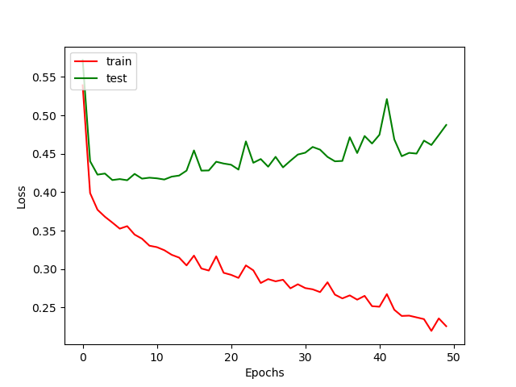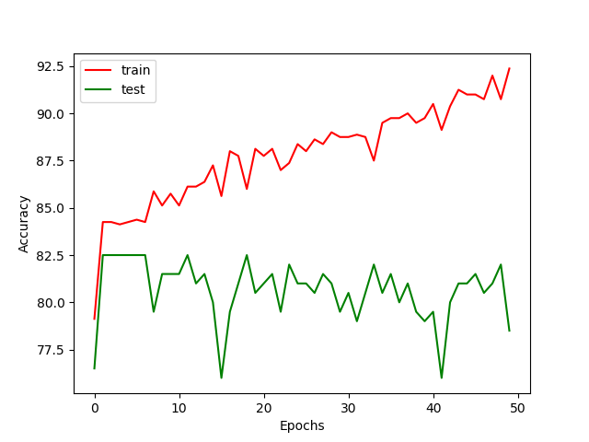

Accuracy

With only odd numbers:

Accuracy

Loss

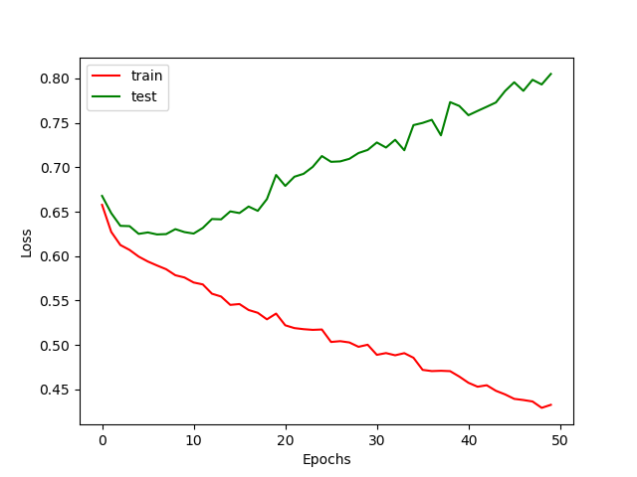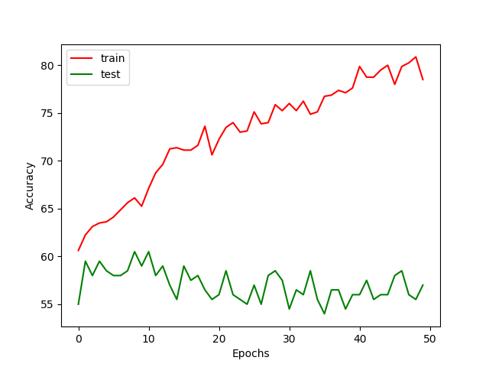

The second language

* A description of the languages
  + Every number which can be divided by 9
* Why did you think the language will be hard to distinguish?
  + Because there is no pattern which can generalize it and it hard to predict if number divided by 9 if we start to watch from left to right
* Did you manage to fail the LSTM acceptor? (including, train and test set sizes, how many iterations did you train for, did it manage to learn the train but did not generalize well to the test, or did it fail also on train?)
  + 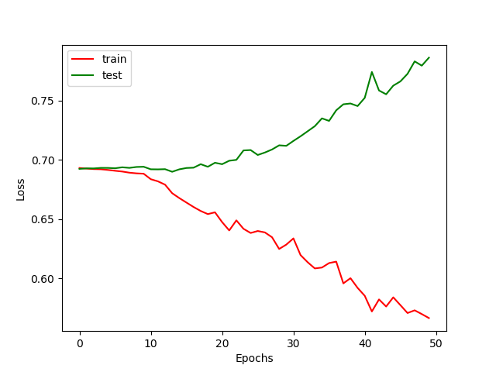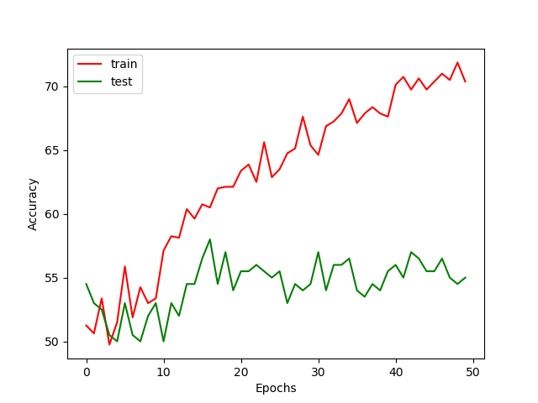We train the model the same as we did it on part1 with set size of 1000 and 50 epochs, but in different to the first language it takes more time to learn the training set with 70% accuracy.