MAKERERE UNIVERSITY

Drown Detection System

By
BSE 22-27
EMBEDDED SYSTEMS
DEPARTMENT OF NETWORKS
SCHOOL OF COMPUTING AND INFORMATICS TECHNOLOGY

A Project Report Submitted to the School of Computing and Informatics Technology
for the Study Leading to a Project in Partial Fulfillment of the
Requirements for the Award of the Degree of Bachelor of
Science in Software Engineering of Makerere University.

Supervisor
Mr. Odong Stephen
Department of Networks
School of Computing and Informatics Technology, Makerere University
mailto:odongoste@gmail.com, +256-775199511,

August, 2022.

Declaration
We, group BSE 22-27, hereby declare that the work presented is original and has never been submitted for an award to any university or institution of higher learning. We can confirm that where we have done consultations either from published material or the works of others, it has been attributed in this report.

# | Names | Registration Number | Signature
1 | Lwanga Darline | 17/U/5836/EVE
2 | Kisa Jeremiah | 17/U/5250/EVE
3 | Kyadondo Solomon
4

Approval

This project report titled Drown Detection has been submitted for examination with my approval as the supervisor of group BSE 22-27.

Mr. Odong Stephen

Department of Networks

School of Computing and Informatics Technology;

College of Computing and Information Sciences,

Makerere University

Signature: ................................................... Date: ............................

Supervisor

Dedication
To the learners and those who aren’t courageous enough to swim and to our parents who have supported us through all the hardships.
To Ms. Mary Nsabagwa whose spirit to teach through such university condition and her resilience to make sure each student gets the best they need.

Acknowledgements
We thank God for the life and favor he has handed over to us through out these past years and kept us together from high school.
We thank Emmanuel for his guidance during our research, he helped us find the best way in which to develop a system he introduced us to other swim academies.
We also acknowledge with great appreciation our supervisor Dr. Steven Odong Eyobu who guided us throughout the conception, realization, design and completion of this project. He has been very supportive and present whenever we needed him
We extend a special dedication to Dr Mary Nsabagwa for her continued guidance during this period that had been difficult, she has availed resources to enable us to finish

Abstract
This report is an implementation of the drown detection system, it is an embedded system that provides its users real time services to swimmers and lifeguards at pools to prevent the disaster of drowning. The system will enable administrators monitor their swimmers more dynamically, the system helps track the behavior of the swimmer under water so that it can detect any abnormalities.

It uses an oximeter to track the pulse and oxygen levels in a swimming environment. If the values are out of range, an alarm goes off.

Table of Contents
Table of Contents
Declaration 2
Dedication 4
Acknowledgements 5
Abstract 6
Table of Contents 7
List of Figures 8
List of Tables 9
Abbreviations/Acronyms 10
Chapter 1: Introduction 11
1.2 Overview of the document 11
2. System Specifications 11
2.1 Version of requirements and Version Control 11
2.2 Input 11
2.3 Output 12
2.4 Functionality 12
Chapter 3: Design output 13
3.1 Implementation 13
3.4 Documentation 15
Chapter 4: Inspection and testing 16
4.1 Introduction 16
4.2.2 Scope and Relevancy of tests 17
4.2.3 Levels of tests 18
4.3 Precautions 18
4.3.1 Anomalous conditions 18
Chapter 5: Installation and system acceptance test 18
5.1 Input files 18
Chapter 6: Performance, servicing, maintenance, and phase out 20
6.1 Service and maintenance 20
6.2 Performance and Maintenance 20
Chapter 7: Conclusion and Recommendations 21

List of Figures

List of Tables

Abbreviations/Acronyms
AI | Artificial Intelligence
DDS | Drown Detection System
LED | Light emitting diode

Chapter 1: Introduction
  - Background and scope of the project
This report contains the design specifications and implementation details for the DDS. The system is a project BSE22-27 group proposed to address the drowning catastrophe faced by some swimmers in Uganda described in our concept paper.

1.2 Overview of the document

This document describes the implementation, testing and validation findings for the drown detection system. It is divided into the following sections:
Section 1: This section gives an overview of the document and the scope of the system; it specifies its functions.

2. System Specifications
The drown detection system consists mainly of a transmitter that a swimmer wears and a receiver on the main end system that will be used to get data from different transmitters available in the swimming pool.

2.1 Version of requirements and Version Control

The requirements specification was change based on the changing requirements as shown below;
Version | Date | Changes made | Author | Requested by
1.0 | 30-March-2022 | Documentation of collected requirements | Kisa Jeremiah, Lwanga Darline, Kyadondo Solomon
1.1 | 28-April-2022 | - Document formatting  - Addition of more functionality  - Addition of camera-based systems | Lwanga Darline | Coordinator

Git was used for version control of the files.

2.2 Input
Input 1: Oxygen levels
The oximeter captures percentage of oxygen in the blood of the swimmer. This is used to verify whether the swimmer is in health conditions. The inputs here are numerical
Input 2: Trigger
This is a Boolean signal from each swimmer in the event of an emergency that enables them send out an alert in the event of panic or a near drowning that has not been detected by the system. This is an additional pre caution.
Input 3: Pulse
This is the pulse rate obtained from the peripheral of a swimmer that enables the capture of the heart rate of a swimmer in the pool.

2.3 Output
Output 1: Alarm
This is the alerting sound. There are different sounds produced for each case(a pulse fall or rise and oxygen rise or fall)
Output 2: coordinates
These will be the intersection of the X and Y positions of the swimming pool that will enable the administrator locate the position of a swimmer in a pool.

2.4 Functionality

2.5 Limitations and safety
The system will only be accessible in a still water environment, irregularities in the water levels will lead to falsified results
The entire system must have a constant power supply without fail, a power failure will lead to a system crash.
System users should always insulate the system from water damage. The oximeters are not water proof and need to be shielded from the water at all times.

2.6 Default settings
At power-up the system tests that all the alarms are functional by doing a sound test, the system then displays okay if everything is working normally.
The system then pings to see active transmitters in the area.
2.7 Special requirements
Radio frequencies are not allowed close to the pool area as they might interrupt with the receiver of the system

2.8 Errors and alarms
- Invalid inputs

Chapter 3: Design output

3.1 Implementation
Oximeter sensor
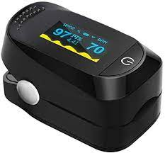
Arduino Nano AT16
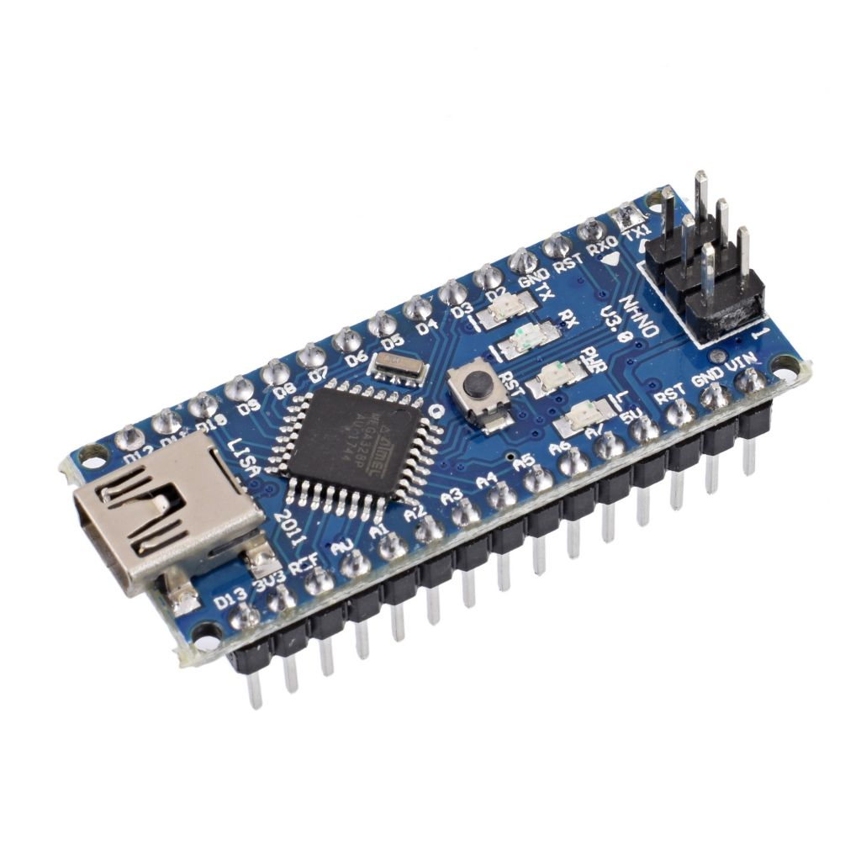

RC Transimiter and Receiver
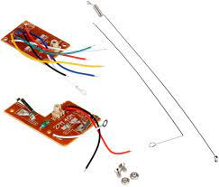

Alarm/ buzzer
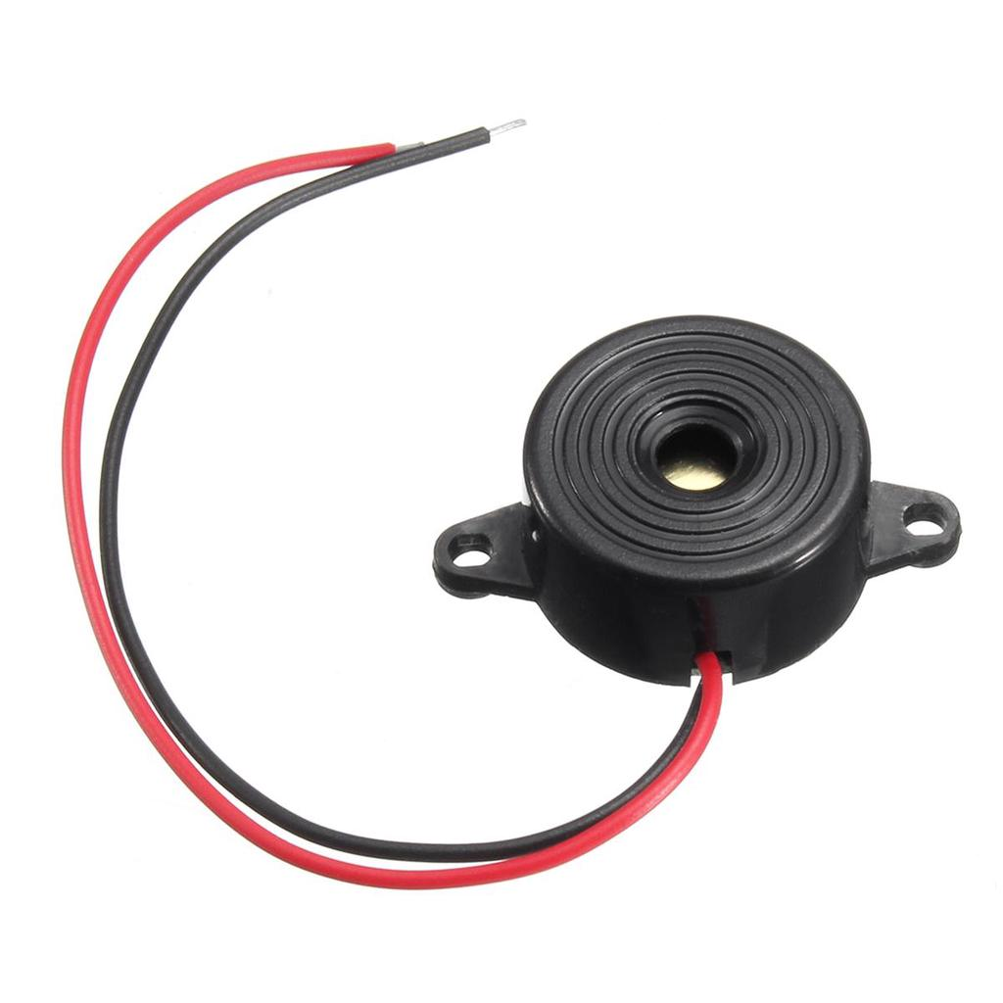

3.4 Documentation
Software Design Document
The design phase of the software development lifecycle produced a software design document for the Drown Detection System which enabled the software developers of group BSE22-27 to easily develop the system. It provided the architecture of the system which simplified the development process since the system layout was laid out.
User Manual
During the implementation of the DDS System, a user manual was developed to provide information of how to use the system. It contains the precautions to take and the limitations of the system

Table No: Design details

Topics | Design output
Good programming practice | Source code is... | Source code contains...
Dynamic testing | Comments:

Chapter 4: Inspection and testing

4.1 Introduction
The inspection and testing of the computer system is planned and documented in a test plan. The extent of the testing is in compliance with the requirements, the system acceptance test specification, the approach, complexity, risks, and the intended and expected use of the computer system.
Table No: Inspection plan and performance
Topics | 3.3.1 Inspection plan and performance | Date / Initials
Design output  Results from the Design Output section inspected... | Comments: | 07-08-2022 /KS
Documentation | Comments: | 16-07-2022/KJ
Software development environment | Comments: | 16-07-2022/DL

4.2 Test plan and performance
Id | Type | Objective | Author | Reviewed | Priority
FC1 | Functional correctness | Ability to transmit signals from the transmitter to the receiver | Kisa Jeremiah | Reviewed | High
FC2 | Functional correctness | Trigger an alarm when the distress button is pressed | Kyadondo Solomon | Reviewed | High
FC3 | Functional correctness | Measure correct result from the oximeter | Lwanga Darline | Reviewed | High
4.2.1 Test objectives

4.2.2 Scope and Relevancy of tests
The tests were developed to validate and verify the system's functionality. The system functional requirements were verified through Code Reviews, Walkthroughs, and Inspection
Testing has been relevant during this project because of the following;
- Testing has helped the team to achieve and assess the quality of the system.
- It has enabled us to ensure that the system is usable by the swimmer
It helped the development team uncover system errors and provide solutions to the error.

4.2.3 Levels of tests
- Verification testing
- Verification testing was carried out during the development process of the system to uncover defects earlier. This was carried out during the requirements and programming phases.
- Purpose: To discover software anomalies earlier from the requirements. This testing focused on making sure that the various requirements were implemented without misinterpretation and misunderstanding. It also verified that the requirements stated earlier were possible to implement by the team.
- Scope: Functional and non-functional requirements of the system.
- Testers: Group members of BSE 22-27
- Methods: Walkthroughs, and Inspection
- Timing: It was carried out at the end requirements collection and during the coding process.

- Functional testing
- This was carried out on the oximeter to make sure that it gave correct readings. Test execution and defect resolution are carried out throughout this testing to ensure correct functionality. The team was engaged in the defect tracking process and calibration to manage quality.
- Purpose: To validate the oximeter readings.
- Scope: System functionality.
- Tester: Group members of BSE 22-27
- Methods: Unit tests, module test and data entity.

4.3 Precautions

4.3.1 Anomalous conditions
The DDS is an embedded system which means it has a problem of power supply.
4.3.2 Precautionary steps taken
We use a device to keep track of the battery levels so as a user can know how much power is left.

Chapter 5: Installation and system acceptance test
The validation of the installation process ensures that all system elements are properly installed.

5.1 Input files

5.2 Supplementary files

5.3 Installation qualification

Chapter 6: Performance, servicing, maintenance, and phase out

6.1 Service and maintenance
The system will be monitored regularly so as to check if all components are functioning properly or need replacement.

6.2 Performance and Maintenance
Table no: Performance and maintenance details
Topics | Performance and maintenance | Date / Initials
Problem / solution | Water damages the oximeter pulse reader | 25th/08/2022 DL
Functional maintenance | Wrapping the oximeter in a polythene bag that is not too trhick
Functional expansion and performance improvement | Creation of water-resistant oximeters  Use of infrared scanners to detect such changes

Chapter 7: Conclusion and Recommendations
The purpose of this project was to implement a system that can be used at swimming pools to detect and be able to prevent drowning. The system develop is a prototype of how a finished system can be implemented.
We would like to recommend all swimming pool owners to implement such a system so that accidents can be avoided.

Appendix A: User Manual
Give details on how the system can be used, where to go for help etc accompany your explanations with screenshots
(For those doing embedded systems, please add your assembled diagram, those doing other projects can add some screenshots to their manual. The screenshots must appear in a logical order)

Final approval for use
Identification:
Responsible for validation:
Remarks:

Date: | Signature:

