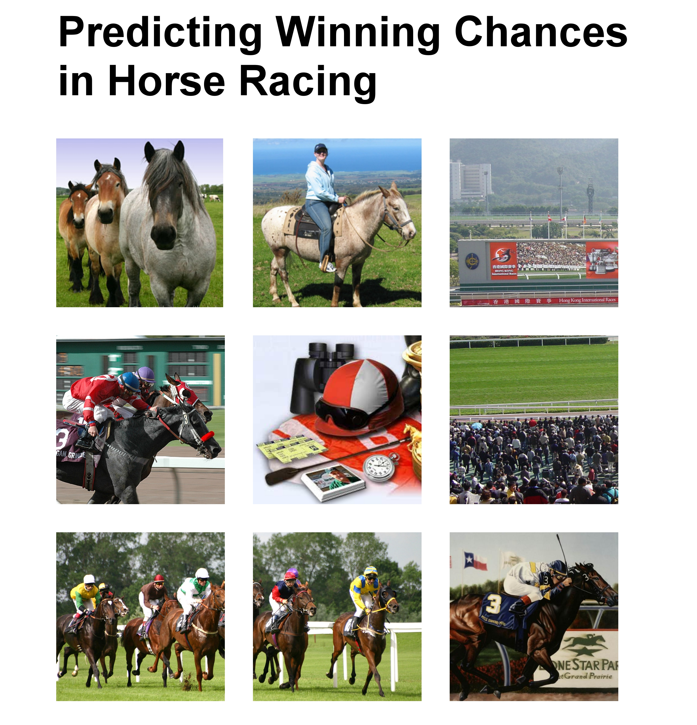
Content

- Introduction

- Investigation of Kelly’s Criterion
  - Introduction to Kelly’s Criterion
  - Properties of Kelly’s Criterion
  - Comparison with other betting system
  - Comparison in Logistic Regression Model

- Predictive Model
  - Introduction to Multinomial Logistic Regression Model
  - Model Building
  - Methodology of Variable Selection
  - Model Diagnostics

- Application
  - Simulation in betting and horse racing
  - Suggested Capital Optimization Method

- Conclusion

- Appendix
6.1 References
6.2 Contributions
6.3 Tables
6.4 SAS Programs
1. Introduction
I. Objective
In this project, we are asked to study the Kelly’s Criterion and investigate the capital change under this betting system. In order to achieve this, we have to conduct simulation studies on Kelly’s formula with estimated probabilities using logistic regression model. We have to find the best model to fit the predictive model so as to make the estimated probability as accurate as possible. Besides, we need to create and select variables to build a good model from the data set provided. Finally, we need to propose the best strategy to maximize the capital growth based on the estimation

II. Dataset
The dataset recorded horse races in Hong Kong during 3/9/2000 - 2/7/2007. In each year, around 600 – 700 races were held. In this dataset, there are 67 variables and altogether 60434 data. It contains all sort of information about the horse like odds, rank etc.

III. Data for validation
The dataset is divided into two parts:
 | Session | Uses
Training dataset | 2000 – 2005 | - For building the model  - for obtaining the winning probability so as to create investment strategy
Testing dataset | 2006 | - for running the simulation for our strategy  - for model validation

2. Investigation of Kelly’s Criterion
2.1 Introduction to Kelly’s Criterion
I. Definition and Notation
Before studying this Kelly system, some terms and notations should be introduced:

1. Edge
It represents how much gambler expects to win, on the average, assuming he could make this wager over and over with the same probability because profit is directly proportional to how much he wager
Edge = 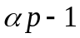
where 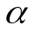= the money you receive if our betting horse wins for each $1 bet
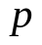 = P (The horse wins)

2. Odds
It measures the profits if the gambler wins. It is set by market forces, by everyone else’s belief s about the chance of winning which might be wrong
Odds = 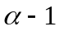

II. Kelly’s Formula
Kelly’s Formula states that the equation is:
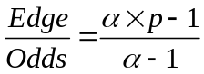
Gambler should wager this fraction of bankroll on a favorable bet by apportioning his money according to his superior estimates of probabilities for some cases.
III. Kelly’s Betting System
Now, we should consider when we should use this formula to maximize our capital growth. If 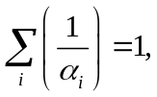 where 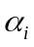= the money you receive if the i^{th} horse wins for each $1 bet, then there exists a “no arbitrage betting system” which means neither the gambler nor the house can win money in long run.

But in reality, will not follow the above case, so there are three different cases:
1) If 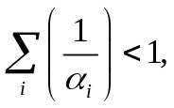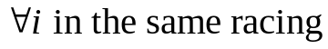, then bet with its probability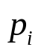
2) If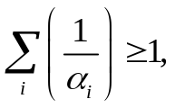and 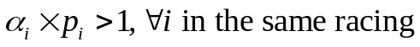, bet with Kelly’s formula
3) Otherwise, we don’t bet due to the expected value for all horses is less than or equal to 0.
With this betting system, the gambler hopes if he keeps repeating this strategy over a long period of time, his bankroll increases at its maximum rate.

IV. Limitation of Kelly’s Criterion
In practical, it is hard to find those rare situations where gambler has an advantage. Therefore, we seldom have a chance to implement this Kelly’s Formula. Also, regarding the part of “inside information”, the Kelly gambler must stop when his private information becomes public knowledge.

2.2 Properties of Kelly’s Criterion
In this part, we have a demonstration to show the properties of Kelly’s strategy, which fails in short term, but maximizes the capital growth in long term.

I. Demonstration of Kelly’s property
The simplest of these strategies was designed for a game in which the gambler wins his stake if a coin comes up heads and loses it if the coin comes up tails, with
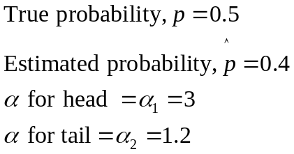
where 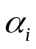= the money you receive if we wins for each $1 bet.
As 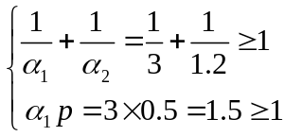, We decided to bet with Kelly’s formula.
Result is shown as the following graph:
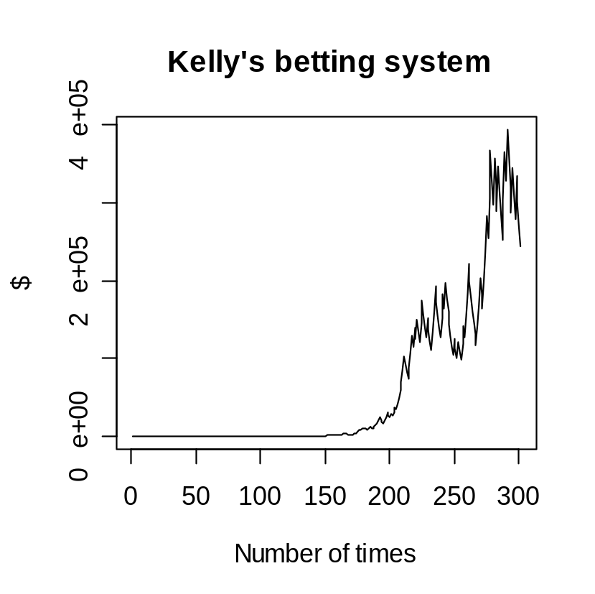
The Kelly bettor is making optimal use of capital so he takes a while for the Kelly strategy to get off the ground and then swoops upwards. His wealth grows exponentially from 1 to a maximum of 394527.2.

II. Comparison of Kelly system between true p and estimated p
For further investigation, different values of estimated probability, 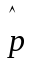 are used for simulation.
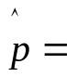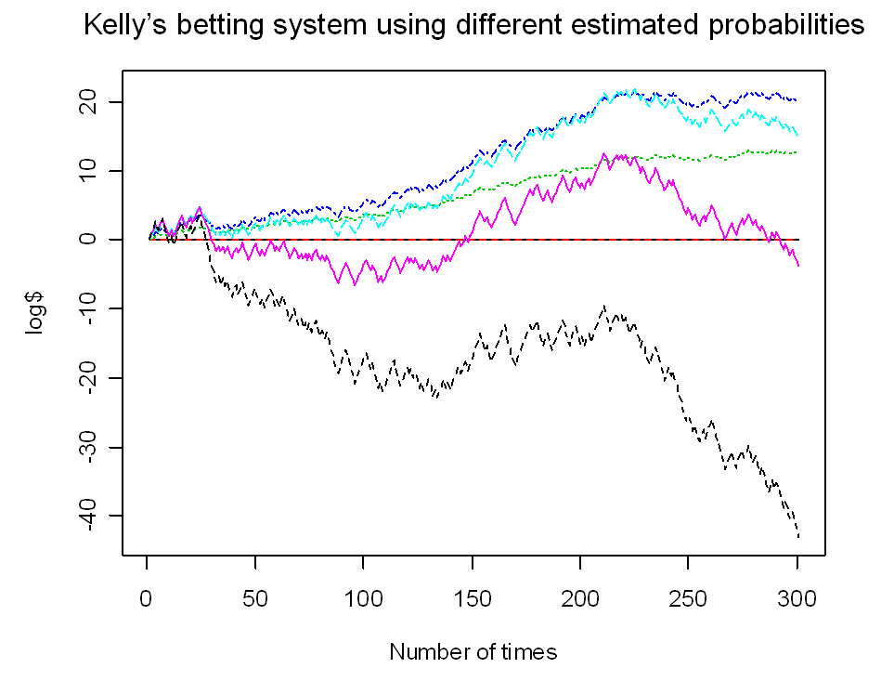
0.6
0.7
0.5
0.4
0.3
0.8
0.2
The above graph is shown… As the estimated probability deviates more from the true probability (p=0.5), the bettor’s wealth grows more slowly, or even lead to ruin.

2.3 Comparison with other betting system
We compare the Kelly’s betting system with some types of betting systems commonly used by gamblers, which is Fixed-wager betting system and Martingale betting system.

I. Fixed wager betting system
The simplest of all is betting a fixed wager. Here the bet amount starts at 0.1 and does not vary in the entire betting.
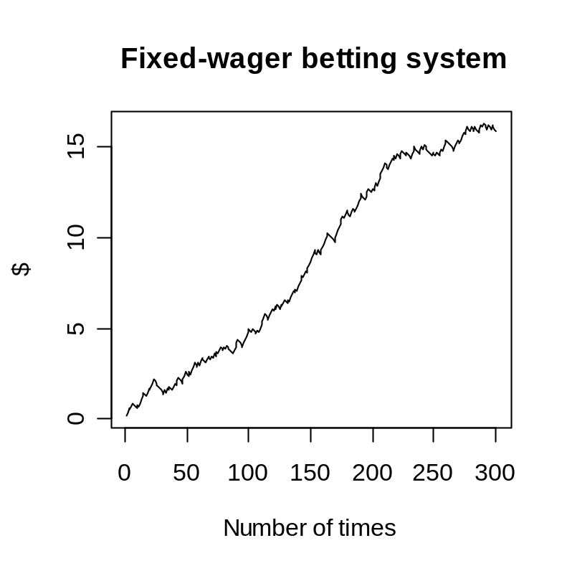
The line of the fixed-wager gambler’s wealth climbs slowly upward from 0.1 to 16.3.

II. Martingale betting system
The strategy had the gambler increases his bet, so that the first win would recover all previous losses plus win a profit equal to the original stake.
Suppose the bet amount starts at 1, that is:
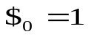
If the bettor wins, the next time the bet amount restarts from 1, otherwise the bet amount is increased as the bettor is losing, that is:
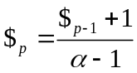
where 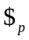= the bet amount after p constructive losses.
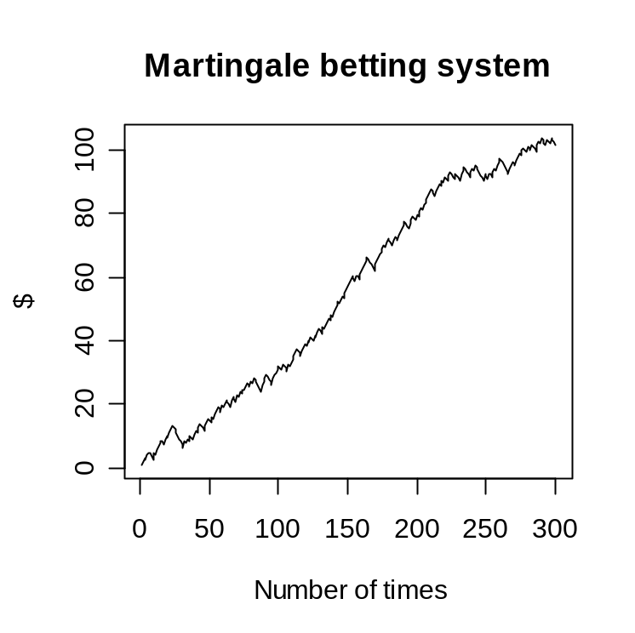
The line of the Martingale gambler’s wealth climbs upward gradually from 1 to 103.5547. The wicked-looking downward spikes in the martingale line (marked in red in the graph) tell a different story. The spikes are streaks of bad luck. The martingale bettor is required to increase his wager as long as he is losing. This can lead to rapidly escalating losses.

Unfortunately, none of these practitioners in fact possessed infinite wealth, and the exponential growth of the bets would eventually bankrupt those foolish enough to use the Martingale. Moreover, it has become more impossible to implement in modern casinos, due to the betting limit at the tables. Because the betting limits reduce the casino's short term variance, the martingale system itself does not pose a threat to the casino, and many will encourage its use, knowing that they have the house advantage no matter when or how much is wagered.

III. Comparison of three betting system
Results:
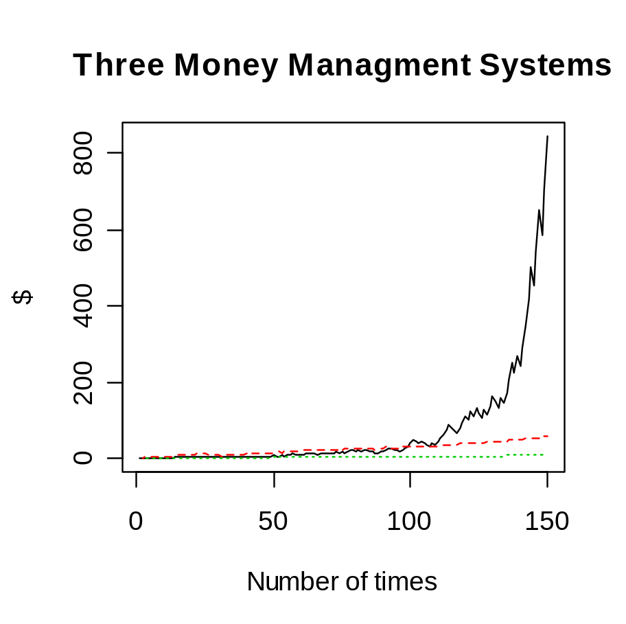
Kelly
Martingale
Fixed Wager
The general trends of the fixed-wager and martingale systems are straight lines, while the Kelly systems are an upward curve.

The wealth of the fixed-wager and martingale bettors tends to grow as an arithmetic series. The fixed-wager and martingale bettors are essentially earning a fixed hourly wage. They do not make bigger bets as their wealth grows. They are sitting on capital that could be put to use.

In comparison, in the left half of the chart, representing about 100 bets, the Kelly’s bettor’s line hugs that of the fixed wager and martingale. Much of time, martingale’s bettor is ahead. Then the Kelly strategy takes off, leaving the other two systems far behind. Notice also that the Kelly line is far jittery than the other systems. This shows that Kelly’s system fails in short term, but maximize the capital growth in long term.

  - Comparison in Logistic Regression Model
After considering the simple cases, we go back to our situation – horse racing betting. Moreover, our considered predictive model is Logistic Regression Model. Therefore, we should make sure that the properties of Kelly’s criterion are also valid in Logistic Regression Model. Similar as the previous section, a demonstration is performed to compare the Kelly’s betting system using true p and estimated p.

I. Demonstration
We simply the situation as horse racing with 2 horses only, called A and B. Moreover, we believe the p = P(A wins) is related to regressors. Therefore, we have the following settings to the demo dataset:
- 10 regressors, which are the only related variable to p.
- The odds of A and B for each horse racing are given.
- 6000 rows of data, which represent 6000 horse racings are happened.
  - 5000 rows of data are formed demo training dataset, which used for logistic model building.
  - 1000 rows of data are formed demo testing dataset, which used for model validation after building model.
Then we introduce the simulation by the following flow chart:
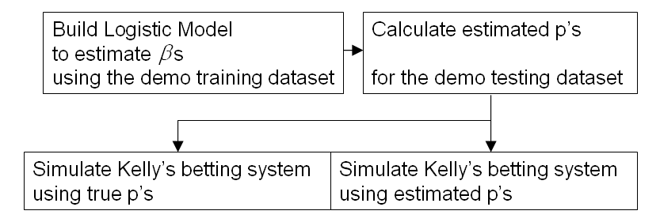
II. Result
With initial capitals $1, after 1000 horse racing in demo testing dataset, the final capitals and the time series of final capitals follows:
 | Using true p | Using estimated p
Final capital | 9.8357 | 3.5592
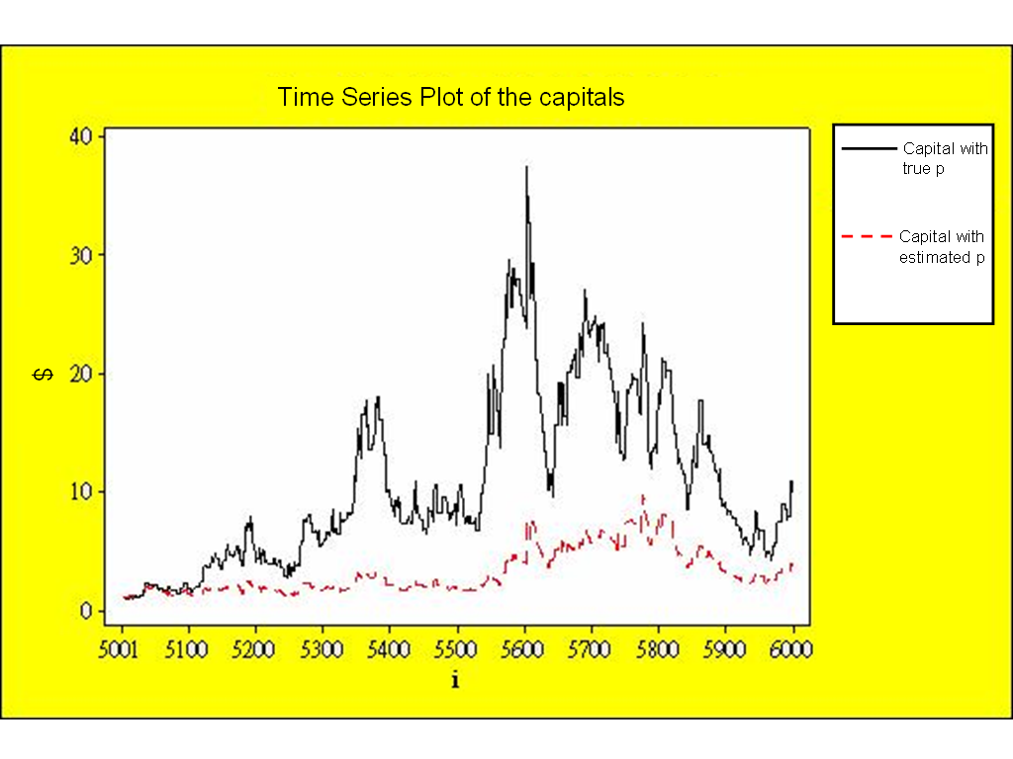
From the graph, there is about the same for both capitals at the beginning. This shows the power of Kelly’s criterion is low in short term. However in long run, the true p capital leads the other a lot. This shows the power is very strong in long term, and the power is less when the estimated p is different from the true p. In conclusion, the properties of Kelly’s criterion can be valid in Logistic Regression Model.
3. Predictive Model
3.1 Introduction to Multinomial Logistic Regression Model
When there is the case of dependent variables with more classes than two which cannot be ranked, the Multinomial Logistic Regression Model is built up to predict the categorical outcomes. In this case, models are constructed in order to predict the winning probability of each horse in the race. The predictive formula is as the following:
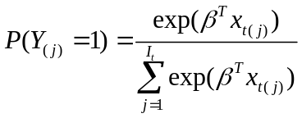
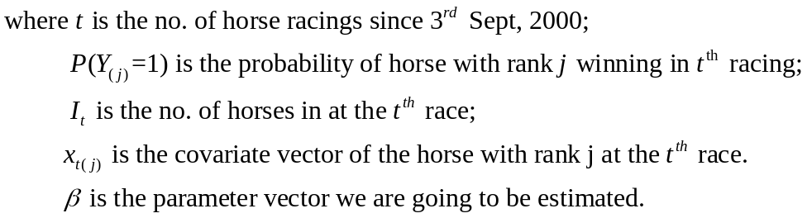
To find the winning probability of each horses that win the first place in each race we have to build up the likelihood of . Based on the likelihood, we can find the best estimates – Maximum Likelihood Estimate (MLE) of the .
  - Model Building
I. Likelihood Construction
We consider the information of first i horses to construct the likelihood, called 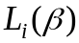. The general formula of is shown below:
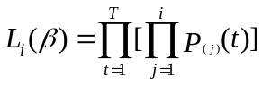
It is believed that different amount of data used in the likelihood will affect the result of , we have constructed 3 models to find the MLE of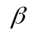to see the difference among them. The model and information are shown in the following table.
i | Considered Information
1 | Winner
2 | Winner, 1st runner up
3 | Winner, 1st and 2nd runner up
The general formula for the likelihood is as follows:
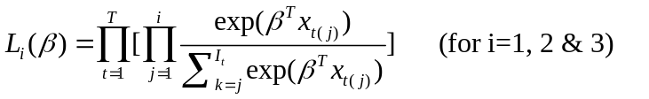
is the likelihood of betas in the Cox proportional hazard model which is a sub-class of survival model in Statistics, with strata confounding with respective to each race, is same as the likelihood used in multinomial logistic regression model. Therefore, we load Cox proportional hazard model building procedure to obtain the s in multinomial logistic regression model to get the estimated p.

II. Fitting Full Model
The aim of fitting the full model is to get preliminary image for the final model which can estimate p’s () accurately. Therefore, we run SAS program to build the full model with 60 variables.

However, there may be relationship between two or more important variables that are highly correlated so SAS cannot build models with these variables. To solve this problem, interaction terms will be included in the regression model to load SAS program.

It is suggested that NFIN is the time variable in the Cox proportional hazard model. However, some data are negative in the time variable. Note that for SAS software, it will delete all data with negative time automatically. Therefore we use a positive variable related to NFIN, the rank as the time variable in the Cox proportional hazard model.
The result is obtained and the output is shown at “Appendix Table 3”. The coefficients of determination, R², of 3 models are represented in the following table:
 | R²
Model 1 | 0.0957
Model 2 | 0.1093
Model 3 | 0.1184
R² are not high enough so the prediction is poor for each model. Now we move to Variable Selection and Model Diagnosis to improve our model predictive accuracy.

3.3 Methodology of Variable Selection
The reason why doing variable selection is to remove nuisance variables in the full model. As we need to check the model with diagnosis and do transformations to the variables, we should reduce the number of variables to reduce the modeling cost. In this section, we use Forward-Backward Stepwise Selection Method to select important variables and remove the nuisance variables.

I. Forward-Backward Stepwise Selection Method
We first study all regressors and compare the p-values of the model. Then we choose the one with maximum p-value and treat that specific regressor as one of the most important variables. We repeat this step with those regressors which are not yet chosen until the p-value of the model is greater than α to enter. This is Forward Selection Method.

After that, we want to eliminate non- significant factors in tentative model so we should have another process, Backward selection. We first study all i and compare the p-values of the model, deleting any that are not significant testing. Then we repeat this step until the p-value of the model is less than α to leave.

Now, we set α to enter to be 0.15 and α to leave to be 0.1 to run SAS program, posted at “Appendix SAS Programs 1”.

II. Rejection Criterion: Wald test
How do we calculate p-value to add or reject the regressors ? We conduct Wald Test for each step of forward-backward stepwise regression. We set the null hypothesis
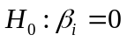
where β_{i} is going to be added or rejected
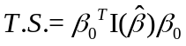
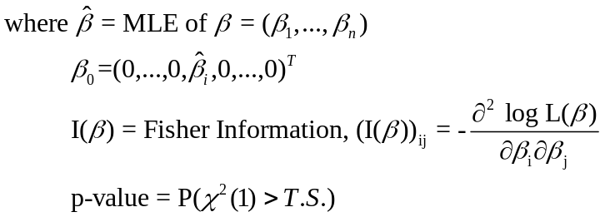
when p-value is small, then we reject H₀.

After performing forward-backward stepwise regression for 3 models, the reduced models are introduced. The regressors for each reduced model are listed at “Appendix Table 4”.
III. Full model - reduced model comparison: Likelihood Ratio Test
After variable reduction, we should conduct Likelihood Ratio Test to check whether the rejected variables are significant in the full model. We set the null hypothesis
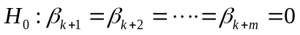
where k = the number of regressors in reduced model
m = the number of regressors rejected
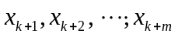= the regressors which are rejected from the full model
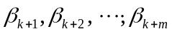= corresponding of
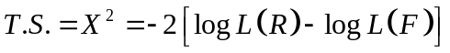
where L(R) is the likelihood of βs in the reduced model
L(F) is the likelihood of βs in the full model
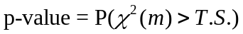
We reject H₀ when the p-value is small.

The result is obtained by the following table:
 | Test Statistics | Degree of freedom | P-value
Reduced Model 1 | 45.8676 | 44 | 0.3946
Reduced Model 2 | 28.4107 | 36 | 0.8122
Reduced Model 3 | 61.7066 | 39 | 0.0117
As all p-values > 0.01, we do not reject H₀ at 1% significant level for each model. Thus, we accept the reduced model for further model diagnostics.

3.4 Model Diagnostics
In order to obtain a better logistic regression model to estimate the probability for each horse in winning, we have to perform model diagnostics. The main procedure that we have to carry out is the residual analysis.

The aim of the residual analysis is to take any needed and possible transformations if we found any strange patterns displayed in the plots of residuals. There are actually two main components, one would be the addition of higher order terms of the single regressors and the second one is the addition of interaction terms of different variables into the model.

I. What is the Residual that we use?
We use the Logit Residual for our analysis of the models. The Logit Residual, being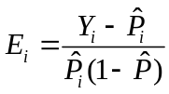, is one where is a dichotomous dependent variable, and will either take values of 0 or 1. And 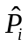 is the estimated probability of each horse in winning the match obtained from the regression functions.

II. What are we expect to observe from the plots of residuals?
In a rare case where only linear regressors were sufficient in accurately modeling the results of the response variable, we would need no any additions of higher order and interaction terms. But this would be real rare in normal daily life.

In our analysis, after plotting the residual plots against all the linear regressors in the three reduced models, we find that almost all plots show an independence of the error terms.
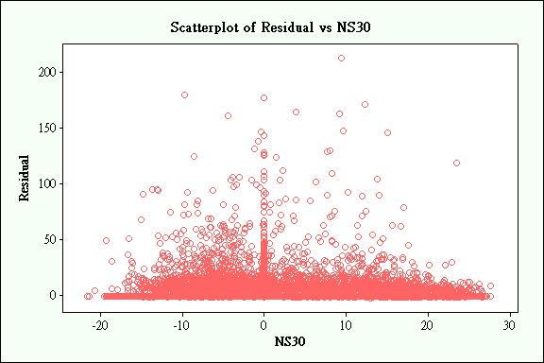
Except for the plots of residuals against three of the variables.

Reduced model 1 | Reduced model 2 | Reduced model 3
LogFinalOdds | FinalOdds | FinalOdds
PubPP | LogFinalOdds | LogFinalOdds
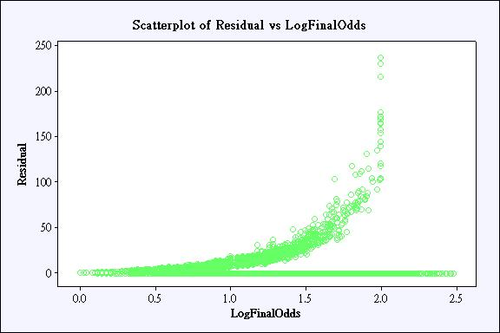
This actually indicates a poor goodness-of-fit of the regression functions in explaining the real data given. As a result, we need to improve our models.

III. How we improve our model from the analysis?
The first improvement method that we have to implement in order to improve our model would be to add the higher order terms of the above two variables.

The second improvement method that we have to implement to improve our model is the addition of interaction terms. We formulate the interaction terms according to the chi-squared value of each parameter obtain from the reduced models. We select the six most influential variables and make interaction terms between them. This would make each model with 15 more explanatory variables.

The table below lists the variables that we have made their interaction terms in each model.
Reduced model 1 | Reduced model 2 | Reduced model 3
LogFinalOdds | LogFinalOdds | LogFinalOdds
S14 | AveStdRank60 | FinalOdds
HVbyDrawC | HVbyDrawC | HVbyDrawC
HorseNo | FinalOdds | AveStdRank60
PubPP | HAgeNC | DaySince
NonGroupRacebyDrawC | S14 | S14

IV. What have we improved?
After implementing the needed interaction and higher order terms into the model building process, we then once again carry out the stepwise regression process to screen out the most important variables and then we can finally come up with the following better models.
Model 1
Number of variables before the improvement | Number of variables after the improvement | Hit Rate before the improvement | Hit Rate after the improvement
15 | 17 | 26.09% | 24.68%
Model 2
Number of variables before the improvement | Number of variables after the improvement | Hit Rate before the improvement | Hit Rate after the improvement
23 | 27 | 25.11% | 25.67%
Model 3
Number of variables before the improvement | Number of variables after the improvement | Hit Rate before the improvement | Hit Rate after the improvement
20 | 25 | 26.23% | 26.23%

4. Application
4.1 Simulation in betting and horse racing
After building model procedure, we have 3 tentative model for different likelihood. Our aim is having the largest capital growth so we need to choose a model having largest capital after simulations. Repeating section 2.4, we do simulations again for these 3 models, then we have the result in the following table:
 | Model 1 | Model 2 | Model 3
Final Capital | 0.346498 | 0.140962 | 0.022372
Return | -65.35% | -85.90% | -97.76%
Why we have negative returns? Because the model is not good enough in accuracy so estimates are far away to lead a bad ability using Kelly’s criterion. Moreover, odds are not favour for bettor declines the final capitals.
In Conclusion, due to the largest final capital, we choose model 1 to develop our earning strategy.

4.2 Suggested Capital Optimization Method
After choosing our optimal model, we try our best to change return: negative to positive so we modify our investment by update the formulae and strategy.
New Kelly’s formulae: 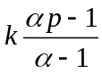
New strategy: Only bet the horse with the odds less than 10
After a series of simulation, the return is 137% which matches our aim, comparing with the original strategy. Moreover, we can change k such that we can magnify our return. The result is shown in the following table:
K | Final capital | Return | No. of betting
0.2 | 1.205098 | 20.51% | 24
1 | 2.371149 | 137.11% | 24
5 | 24.66461 | 2366.46% | 24
100 | 6.25 X 10⁸ | 6.25 X 10¹⁰% | 24
when k is set more, the return is more. The following graph shows the change in capital with time for k=0.2, 1, 5 to see the comparison with different k:
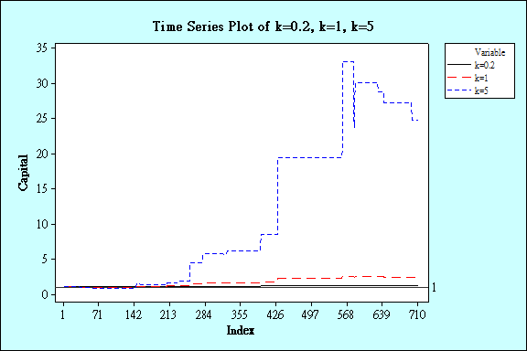
On the other hand, we consider the extreme case: k = 100. As k is very large, that means we borrow money to bet. For k = 100, we have extremely large capital in final. However, by the below graph, we need to take risk because we would lose a lot!
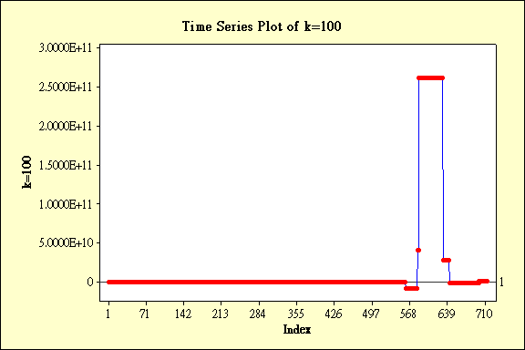
We see the capital is negative when index is around 568.
Back to the Kelly’s formula, k can be seen as a speculating factor to control the risk. Person can choose his/her suitable k to adjust risk in the investment.
5 Conclusion
The aim of this project is to maximize the profit as large as possible. By what we do is this project, we find that not only a good predictive model is needed, but also a good strategy. For example, we have the model 1 with interaction terms (The corresponding regressors and information are shown in “Appendix Table 6”), and the strategy shown in Section 4.2. As the strategy makes positive return, with the speculator k mentioned in the strategy, we can make portfolios of any return.

Due to the lack of predictive accuracy, there is less power of Kelly’s criterion. Then, in the model building section, it is hard to build a simple model having a positive return. Therefore we must choose a model which lose the least money. Moreover, designing good strategies which can make the return from negative to positive is necessary.

Besides these, we must make sure that assumptions of the Kelly’s criterion are valid and the data is available, reliable and completely found in the real world. Thus, although there exist an arbitrage system, it is difficult to earn money until we can confirm all the things are prefect.
6 Appendix
6.1 Reference
- Applied logistic regression; David W. Hosmer, Jr. ; Stanley Lemeshow; New York : Wiley, c1989
- Fortune's formula : the untold story of the scientific betting system that beat the casinos and Wall Street; William Poundstone; New York : Hill and Wang, 2005.
- Logistic regression : a self-learning text; David G. Kleinbaum, Mitchel Klein ; with contributions by Erica Rihl Pryor; New York : Springer, c2002
- Applied linear regression models; Kutner, Michael H.; Boston : McGraw-Hill/Irwin, c2004
- Applied regression analysis, linear models, and related models; author, John Fox.; Thousand Oaks, Calif. : Sage Publications, c1997
- Applied logistic regression analysis; Scott Menard; Thousand Oaks, Calif. : Sage Publications, c1995
- A new Interpretation of Information Rate; J.L. Kelly, JR.; 1956

6.2 Tables
Table 1: Explanation of all variables in the dataset
Variable | Explanation
Date | Date of the race
DateValue | Excel internal date count
Raceno | Race number of the day
HorseNo | Assigned horse number
NewH | Whether the horse is a first time to race in Hong Kong
Session | Yearly Session, from 2000 to 2007
Session2006 | Indicator for last session
NoRace | Race number within a Session
Going | Numerical value of the hardness of the surface
Ncourse | Numerical value for course “A” or “B” or “C”
HV | Indicator whether the race was held in Happy Valley
AWT | Indicator whether the race was held in all weather track
ST | Indicator whether the race was held in Shatin turf track
Dist | Distance of the race
DistT | log(Dist) – log(1000)
Drawing | Starting gate assignment of the horse
DaySinceNC | Days between last race and the current race
S14 | The number of swimming’s in last 14 days
HAgeNC | Age of horse, not centered
LHNR | The total number of races of the horse + 1
HWgtNC | Non centered horse body weight
HWgtChgNC | The change in body weight since last race
Brace2raceNC | Number of barrier trial since last race
ClaimNC | weight carried allowance for the apprentice jockey
RClass | Racing class offered by Jockey Club
NonGroupRace | Indicator of non group races
DrawC | Drawing centered within race
DaySince | Days between last race and the current race, centered
LastPubLogPP | Centered value of log Percentage of public betting in place Pool for the horse at its last race
Rating | Rating of the horse by Jockey Club
RatingChg | Rating change
WtCarried | Weight carried for the horse in this race, centered
LogHWgt12R | Log of horse body weight, truncated at 1200 pounds
LastLogOdds | The final Odds in the last race
HWinPer | Horse win percentage prior to the race
NHPP | Horse place percentage prior to the race
JWinPer | Jockey’s win percentage prior to the race
JPP | Jockey’s place percentage prior to the race
TwinPer | Trainer’s win percentage prior to the race
TPP | Trainer’s place percentage prior to the race
HAge | Age of the horse, centered
LifeHNoRace20 | LHNR truncated at 20
Brace2race | Number of barrier trial since last race, centered
NG14 | Number of gallops in last 14 days, centered
NT14 | Number of trotting in last 14 days, centered
NS14 | Number of awimmings in last 14 days, centered
AveStdRank60 | Recency weighted finishing ranks
AveSpeedRating | Average speed rating of the horse prior to the race
LastSpeedRating | Speed rating in its last outing, centered
WtCarriedChg | Weight carried change from its last race, centered
DistTChg | Change from last race in DistT
LWP60 | Recency weighted log of win percent in past battings
LogClaim jockey, centered | Log of the weight carried allowance for the apprentice
AveRating365ChgNC | Rating change in 365 days
AveRating365Chg | Rating change in 365 days, centered
NSTPer | ST race percentage
NAWTPer | All weather track race percentage
BR3012 | In indicator whether the horse won a recent barrier trial
FinalOdds | Final Win Odds for the horse
LogFinalOdds | Log of the final win odds
LogFOddsByNewH | LogFinalOdds times NewH, centered
Runners | Number of horsesin the race
Rank | finishing rank of the race
PubWinPer | Public win percent betting in this race
PubPP | Public Place percent betting
NFIN | Normalized finish position
Status3(4) | Indicator for the first 3 (4) horses in the race

Table 2: Regressors of the full model
Table 3: Full Model 1,2,3 output
Table 4: Regressors of the reduced models 1,2,3
Reduced model 1 | Reduced model 2 | Reduced model 3
DrawC | DrawC | DrawC
DaySince | DaySince | WtCarried
WtCarried | WtCarried | JPP
JPP | LogHWgt12R | NS14
Brace2race | JPP | AveSpeedRating
NS14 | Brace2race | WtCarriedChg
AveSpeedRating | NS14 | LWP60
LastSpeedRating | AveSpeedRating | FinalOdds
WtCarriedChg | LastSpeedRating | LogFinalOdds
DistTChg | WtCarriedChg | AWTbyDrawC
LWP60 | DistTChg | HVbyDrawC
LogClaim | LWP60
FinalOdds | LogClaim
LogFinalOdds | FinalOdds
AWTbyDrawC | LogFinalOdds
HVbyDrawC | AWTbyDrawC
 | HVbyDrawC

Table 5: Regressors of the reduced models 1,2,3 (with interactions)
6.4 SAS Programs
SAS Program 1: Full Cox Proportional Hazard Model Building (with Forward-Backward Stepwise)
proc import datafile="C:\Documents and Settings\User\Desktop\Data.xls"
out=datahorseracing replace;
run;

data training_data;
set datahorseracing;
if Session<=2005
then output;
run;

proc phreg data=training_data;
model Rank*Status1(0) = HorseNo NewH Drawing DaySinceNC S14
HAgeNC LHNR HWgtNC HWgtChgNC Brace2raceNC
ClaimNC DrawC DaySince LastPubLogPP Rating RatingChg
WtCarried LogHWgt12R LastLogOdds HWinPer NHPP
JWinPer JPP TWinPer TPP HAge LifeHNoRace20
Brace2race NG14 NT14 NS14 NG30 NT30 NS30
AveStdRank60 AveSpeedRating LastSpeedRating
WtCarriedChg DistTChg LWP60 LogClaim
AveRating365ChgNC AveRating365Chg NSTPer
NAWTPer BR3012 FinalOdds LogFinalOdds
LogFOddsByNewH Runners PubWinPer PubPP
DistbyDrawC GoingbyLogFinalOdds NcoursebyLogFinalOdds
DistTbyDrawC RClassbyDrawC NonGroupRacebyDrawC
AWTbyDrawC HVbyDrawC
/ selection=stepwise slentry=0.15
slstay=0.1 details;
strata Session NoRace;
run;

explanation of variables were attached in the “Appendix Table I”
The SAS program is at “Appendix SAS Program 1”
The table of all regressors and interaction terms in the full model is at “Appendix Table 2”.

