#### 

UNIVERSITY OF NAIROBI

RESTAURANT CHATBOT SYSTEM

PROJECT BY:

KIOKO KEVIN KYALO

P15/1643/2019

REGISTRATION NO: P15/1643/2019

SUPERVISOR: PROF. OPIYO

# OCTOBER 2021 – JANUARY 2022

# INTRODUCTION

## Problem Definition

Restaurant chatbot system is aimed at improving the sales of a restaurant by automating certain process that would require a restaurant worker to handle. The category of this project is speech and voice recognition systems and it falls under the domain of commerce. This chatbot is designed to allow a customer of a restaurant to book a table, order food or view the menu at any time they want which would not be possible if they had to call and wait for a restaurant worker to help them. The chatbot automates these processes and a customer can carry out those functionalities even if all restaurant workers are busy. This helps boost sales since a customer can always get service.

## Objectives

1. To gain an understanding of how chatbots work.
2. To create a training data object of the functionalities of the chatbot.
3. To train a chatbot on how to respond to scenarios related to its use case.
4. To create responses on input the chatbot is not trained for.
5. To create a graphical user interface where users will interact with the chatbot and input their data as well as receive output.
6. To test the chatbot in its given use cases and receive relevant output.

## Importance

The importance of the restaurant chatbot system is that:

1. It provides customer support in a human-like fashion as it responds to the user just how a restaurant worker would.
2. It allows a customer to book a reservation without having to contact the restaurant easing the process.
3. It displays the menu to users and suggests meals for them helping them in their decision making.
4. It allows a customer to leave feedback and categorizes it as positive or negative.
5. It also displays the ingredients of a recipe to the user so that they can make an informed decision.

In overall, the restaurant chatbot system is aimed at boosting sales by automating these processes while still offering the customer support in a way a normal person would.

# RELATED WORKS

Chatbots are simulations which can understand human language, process it and interact back with humans while performing specific tasks. Famous chatbots include Siri, Alexa and Google assistant which are voice-based chatbots and used as personal assistants. There are also text-based chatbots which are normally rule-based like this restaurant chatbot system.

Chatbots have many applications such as helpdesk assistant, operations assistant, pone assistant, home assistant (IOT) and email distributor. Chatbots help to automate processes and still give the impression it was done by a human thus boosting productivity of the restaurant.

# METHODOLOGY

The Rational Unified Process divides the software development cycle into four phases:

* Inception- this is where the project idea (Restaurant Chatbot System) is formed. A feasibility study is conducted and key use cases of the system are identified.
* Elaboration- the system’s architecture and resources it will use are checked. A project plan is made and components that will be used to build the system are chosen.
* Construction- the front- and back-end of the system are designed, coded, integrated and tested.
* Transition- the software is released to the clients for use. This is where students can give feedback on the actual system to refine any requirements or add any new features.

This methodology is use case driven. Use cases can be used as a requirement capturing method. A use case normally shows a functional requirement of the system. Using the RUP model, it focuses on identifying the business use cases of the Restaurant Chatbot System. For inception stage, requirements were gathered on what areas a chatbot could improve(automate) in a restaurant to boost sales. Then follows elaboration where the architecture of the restaurant chatbot is created and the tools to create it were identified. Construction phase is where the restaurant chatbot was implemented in code and integrated with its graphical user interface and tested with its functionalities to see whether it is working. The transition stage is where the restaurant chatbot would be put to use in an actual business but for this project is where it is presented as a finished product.

# SYSTEMS ANALYSIS

### Functional Requirements

1. A user should be able to reserve a table at the convenience of whichever location they are through the chatbot.
2. A user should be able to view the menu choices though the chatbot.
3. A user should be able to leave feedback on their experience with the restaurant.
4. A user should be able to view which meals are on offer.
5. A user should be able to get a meal suggestion from the chatbot.

### Non-functional Requirements

1. The system should limit reservations to the number of tables available.
2. The system should have an easy and simple interface for users to navigate easily.
3. The system should have a response for all user input even if not in training data.
4. The system should have an easy conversation flow for users.

# SYSTEM DESIGN

Chatbots implement natural language processing in order to function. The restaurant chatbot system is a contextual chatbot system(rule-based) that will learn its responses from a corpus (training data). It will use an interface for input and process it using the natural language processing model to return an output in the session created with the user.

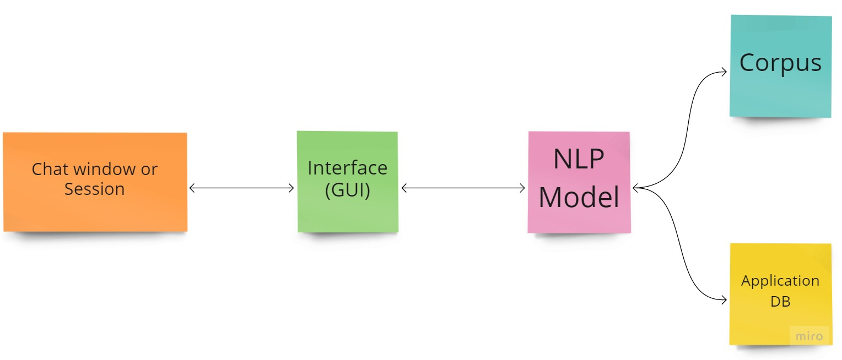

The chatbot system will comprise of the following models:

1. **Chat window or session**

A chatbot creates a session when the user is active. It continues to check if the user is still there to remain active. A session for this project will start when a user accesses the restaurant’s website.

1. **Interface (GUI)**

This is where the user can input text for the chatbot. It is also where the chatbot will output its response. The interface will be a chat box attached to the restaurant’s website.

1. **NLP model**

This is the neural network or programming for the chatbot to understand the question and provide a relevant response.

1. **Corpus**

Corpus is the training data needed for the chatbot to learn. This is use case specific. In this case, training data will be relevant to the functionalities identified in the restaurant scenario. The following are necessary preprocessing steps of the corpus before it reaches the NLP model:

1. Data preprocessing- This is text case handling where all data coming as input is converted to upper or lower case. This helps to avoid misrepresentation and misinterpretation of words if spelt with mixed cases.
2. Tokenization- This is the structured process of converting a sentence into individual collection of words for easier processing of input data.
3. Stemming- Process of finding similarities between words with same root words e.g., orders, ordering, ordered where the root word is order.
4. Generating bag of words- Process of converting words into numbers by generating vector embeddings from tokens generated.
5. One hot encoding- Process by which categorical variables are converted into a form that machine learning algorithms can use.
6. **Application DB**

This is where actions to be performed by the chatbot are processed. In this case, actions like fetching the menu form the database will fall here.

In summary, the system will have its corpus (training data), all input will be converted into a form for the NLP model to be able to get the intent of the user and using the intent the chatbot will give relevant output as it was trained.

# SYSTEM DEMONSTRATION

Prerequisites- the chatbot is a python program and requires the following libraries: numpy, nltk, punkt, torch, flask

