VoltRelay Energy — Final Data Analytics Report
Gradient Learnings Data Analytics Hackathon
Analysis period: January 2024 – June 2025 | 3,877,013 swap attempts | 6 cities | 152 stations

1. Executive Summary
VoltRelay is experiencing a reliability problem inside a rapidly growing network. Completed swaps increased from approximately 105k in January 2024 to 307k in June 2025, but the network-wide failure rate reached 9.91% in May 2025 and 8.55% in June 2025. The failure mix is dominated by unavailable charged batteries and queue abandonment. The evidence points to a concentrated operational problem: peak demand, low charged inventory, older Gen1 stations, specific cities, and weak battery cohorts. Retention is also associated with first-month failure exposure. Commercial pressure is more localized, with a large discount step-up at FP-03.
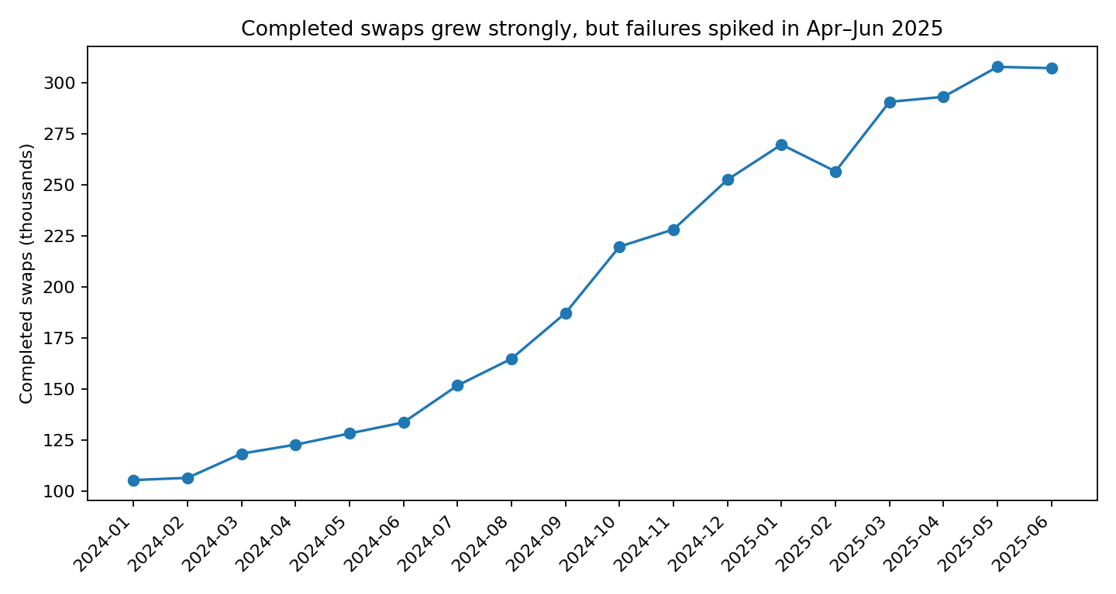
Figure 1. Completed swaps grew strongly while reliability became more volatile.

2. Business Problem and Analytical Questions
The project asks why service quality, rider retention and economics are under pressure despite network growth, and where VoltRelay should focus operational and commercial resources.
- How did swaps, revenue and failures change over time?
- Which failure modes, hours, cities and stations drive service problems?
- How do station generation, expansion wave and location relate to reliability?
- Which battery suppliers/lots are associated with lower health and more complaints?
- How do pricing and fleet-partner terms affect realized revenue and contribution?
- Which first-month rider experiences are associated with lower subsequent activity?

3. Data and Method
The analysis joins eight synthetic datasets: 3,877,013 swap events, 1,487,712 station-hour telemetry rows, 20,000 riders, 6,500 batteries, 44,000 support tickets, 152 stations, 3,282 city-day records and 12 fleet partners.
The swap file was analyzed from eight sequential CSV parts. The documented v3.2.0 timestamp bug was corrected by adding 5h30 to affected events from 10 March through 14 April 2025; 139,490 events were affected. Event IDs were unique. SOC >100 and implausible odometer values were flagged rather than silently deleted.

4. Key Findings

4.1 Growth vs reliability
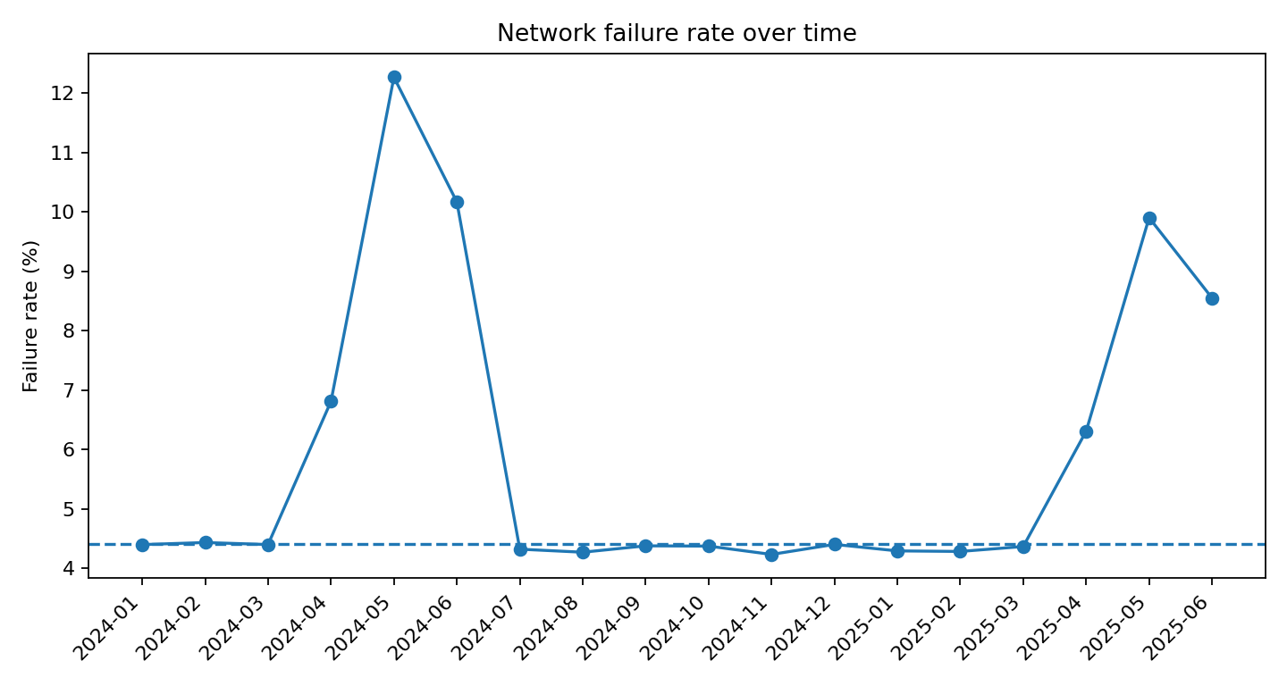
There were 3,645,809 completed swaps and 231,204 failed/abandoned/cancelled attempts. The overall failure rate is 5.96%. Failure spikes are operationally meaningful: 12.27% in May 2024, 6.31% in April 2025, 9.91% in May 2025 and 8.55% in June 2025.
Importantly, system errors are only about 5% of failures. The two largest categories are failed_no_charged_battery (58.1%) and abandoned_queue (29.6%).

4.2 Geographic and station concentration
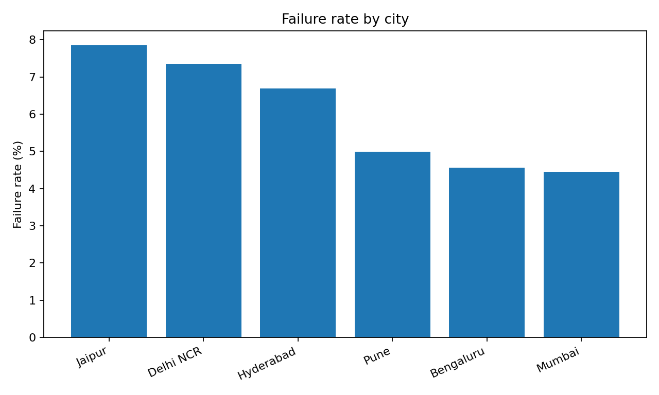
Jaipur has a 7.85% overall failure rate and Delhi NCR 7.35%, compared with 4.45% in Mumbai and 4.56% in Bengaluru. The top 20 stations account for about 30% of all failures. Several of the highest-failure stations are Gen1 sites in Delhi, Jaipur and Hyderabad, making targeted station intervention more efficient than a network-wide response.

4.3 Charger generation and expansion
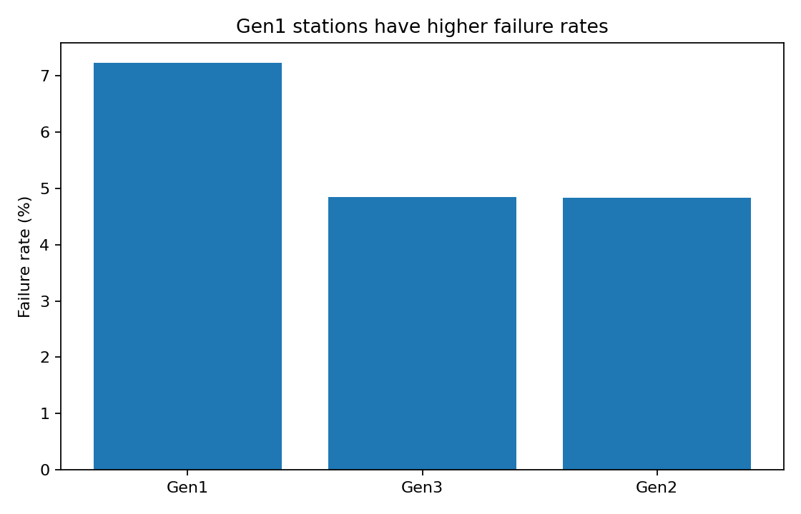
Observed failure rate is about 7.17% for Gen1 versus 4.87% for Gen2 and 4.88% for Gen3. This is an association, not proof that charger generation alone causes failures because station age, city and demand mix differ. Expansion waves have lower observed failure rates than the Launch cohort, but newer stations also have lower utilization, which reduces fixed-cost absorption under the contribution proxy.

4.4 Peak availability and battery inventory
Station-hour analysis shows the clearest operational mechanism: when charged inventory is very low, failure rates increase. For 2W events, station-hours with zero charged 2W packs have about 10.9% failure versus about 5.1% when more than five charged packs are available. For 3W, zero charged packs correspond to about 19.1% failure, versus roughly 10.0% when 3–5 charged packs are available.
The highest-risk hours are concentrated in the evening, especially around 19:00–22:00. This supports pre-positioning and peak-hour inventory management.

4.5 Battery health
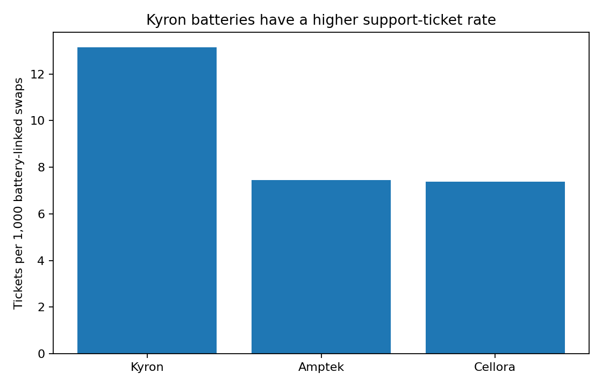
Kyron battery events have an average delivered SOH of about 88.5%, versus roughly 90.7% for Cellora and Amptek. Battery-linked support tickets are about 13.1 per 1,000 swaps for Kyron, compared with about 7.4 for the other two suppliers. Kyron lots KY-2407, KY-2408 and KY-2409 are especially weak in the event-level SOH data. These patterns justify a battery-quality review and cohort-level quarantine/rotation policy.

4.6 Rider retention
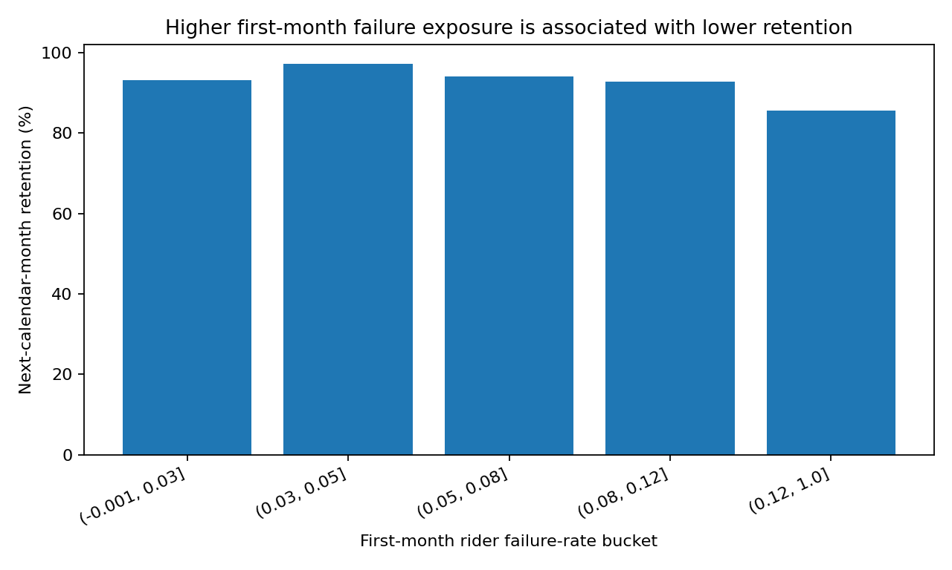
Using next-calendar-month activity among riders active in their signup month, retention is strongly associated with first-month failure exposure. Riders with first-month failure exposure above 12% have about 85.5% next-month retention, compared with about 93% at 3% or below. This is descriptive evidence; it does not establish causality. The practical implication is to protect new riders from repeated early failures.

4.7 Pricing and partner economics
The network-level operating contribution proxy does not show broad deterioration over the full period; it rises alongside price changes and scale. However, a localized commercial issue is clear at FP-03 (ZipDrop). Its effective discount moved from about 12.6% before the amendment period to 29.3% afterward, while realized revenue per completed swap fell from approximately ₹57.5 to ₹48.6. This indicates a contract-specific discount leak rather than a blanket pricing problem.

5. Recommendations

1. Stabilize high-risk peak stations
Create a station-hour health score using failure rate, queue abandonment, charged inventory, outage minutes and demand. Pre-position charged packs before the 19:00–22:00 peak and focus first on Jaipur, Delhi NCR and high-volume Gen1 stations.

2. Retrofit before blanket expansion
Prioritize high-volume Gen1 stations with persistent failure rates for charger/firmware/inventory upgrades. Use new expansion only where utilization forecasts can absorb fixed costs.

3. Launch battery quality controls
Review Kyron lots 2407–2409 and other low-SOH cohorts. Set operational thresholds for rotation, quarantine and retirement, and monitor low-range complaints by supplier/lot.

4. Protect new riders
Create a first-30-day service recovery trigger after repeated failed attempts, high queue exposure or no-battery incidents. Track next-month retention as the outcome.

5. Repair contract economics
Review FP-03's discount amendment and introduce volume tiers, minimum contribution thresholds and peak surcharges rather than unconditional discounting.

6. Use a weekly operating dashboard
Track completed swaps, failure rate, no-battery failures, queue abandonment, peak inventory, Gen1 station performance, battery SOH, new-rider retention and contribution proxy per completed swap.

6. Limitations
- The dataset is synthetic; findings should be treated as evidence within the hackathon scenario, not real-world causal estimates.
- Contribution margin is not a raw field. The report uses an operating contribution proxy based on realized revenue, energy cost and allocated station fixed costs.
- Support-ticket CSAT is missing-not-at-random and should not be treated as a representative satisfaction average.
- Battery supplier and charger-generation differences are observational associations and may be confounded by age, geography and utilization.
- Retention is defined explicitly in this report so that same-day repeat swaps are not mistaken for retention.

7. 3-Minute Demo Video Structure
Business problem → analytical approach → four key insights → recommendations. A complete word-for-word script is supplied in the accompanying TXT file.

