DOG BREED IDENTIFICATION USING DEEP LEARNING

Project Details
Name: SIRIGIREDDY KYATHI DURGA
Roll No: 224E1A4613
Team ID: LTVIP2026TMIDS45080
Domain: Artificial Intelligence and Machine Learning

Abstract
This project aims to identify different dog breeds using Deep Learning techniques. A Convolutional Neural Network (CNN) model is developed and trained on a dog breed dataset. The trained model predicts the breed of a given dog image and provides a confidence score. This project demonstrates the real-world application of Artificial Intelligence and Machine Learning in image classification.

Introduction
Image classification is one of the major applications of Artificial Intelligence. In this project, a Deep Learning model is trained to classify dog breeds. The system takes an input image and predicts the breed using a trained CNN model.

Technologies Used
• Python
• TensorFlow
• Keras
• NumPy
• Matplotlib
• Google Colab

Methodology
1. Dataset Collection
2. Data Preprocessing
3. Model Building using CNN
4. Model Training
5. Model Evaluation
6. Prediction on New Images

Final Google Colab Code
# Install Required Libraries
!pip install tensorflow matplotlib
import tensorflow as tf
import numpy as np
import matplotlib.pyplot as plt
from tensorflow.keras.preprocessing import image
from tensorflow.keras.models import load_model
from google.colab import files
# Upload Model File (.h5)
uploaded = files.upload()
# Load the trained model
model = load_model("dog_breed_model.h5")
# Upload Image for Prediction
uploaded = files.upload()
# Load and preprocess image
img_path = list(uploaded.keys())[0]
img = image.load_img(img_path, target_size=(224, 224))
img_array = image.img_to_array(img)
img_array = np.expand_dims(img_array, axis=0)
img_array = img_array / 255.0
# Prediction
prediction = model.predict(img_array)
confidence = np.max(prediction) * 100
predicted_class = np.argmax(prediction)
print("Predicted Class Index:", predicted_class)
print("Confidence:", confidence, "%")
# Display Image
plt.imshow(img)
plt.axis("off")
plt.show()

Project Output Screenshot
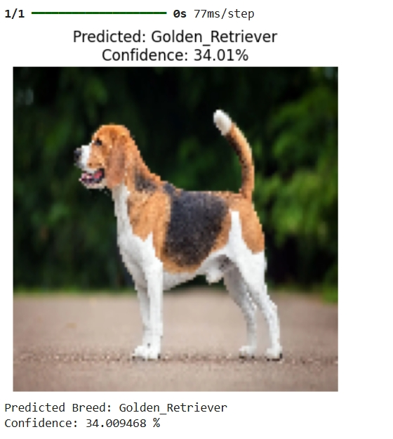

Conclusion
The Dog Breed Identification system successfully predicts dog breeds using Deep Learning. The model provides prediction results along with confidence scores. This project enhances understanding of CNN models and practical implementation of AI & ML.

