-UNIVERSITY OF COMPUTER STUDIES, YANGON
2023-2024 ACADEMIC YEAR



Project Report On
ONLINE BUS TICKET MANAGEMENT MODELING
Group (4)
DATA MODELING IN SE (IS-102) PROJECT
Guided by Dr. Hsu Myat Mo

Submitted By
YKPT-21349 Kyi Sin Linn
YKPT-21371 Linn Latt Hsu
YKPT-21879 Mya Thet Chel
YKPT-21978 Kyaw Pyae Sone
YKPT-22212 Paing Paing Ko

March, 2024 B.C.Sc.(SE/CSF)

Problem Statement 3
Introduction 4
Chapter-1 5
Software Requirement Specification 5
1.1. Introduction 5
1.2. Overall Description 7
1.3. External Interface Requirements 11
1.4. System Features 14
1.5. Other Nonfunctional Requirements 19
1.6. Conclusion 21
Chapter-2 22
Scenario-Based Modeling 22
2.1. Introduction 22
2.2. Browse Tickets 22
2.3. Choose Seat in Bus Ticket Management System 23
2.4. Book Ticket 24
2.5. Buy Ticket Online 25
2.6. Check customers’ information 27
2.7. Manage Ticket 28
2.8. Notify Ticket Confirmation 29
2.9. Manage Bus Routes 31
2.10. Manage Bus Schedules 32
Chapter-3 35
Class-Based Modeling 35
3.1. Introduction 35
3.2. Class Diagram of Online Bus Ticket Management Modeling 35
Chapter-4 36
Conceptual Data Modeling 36
4.1. Introduction 36
4.2. ER diagram of Online Bus Ticket Management System 36
Chapter-5 37
Process Modeling 37
5.1. Introduction 37
5.2. Context Diagram 37
5.3. Level 0 Diagram 38
5.4. Level 1 Diagram 39
Chapter-6 41
Behavior Modeling 41
6.1. Introduction 41
6.2. Behavioral Modeling of Online Bus Ticket Management System 42
Conclusion 50
Reference 51

Problem Statement
The Bus Ticket Management System aims to streamline and enhance the process of bus travel for both users and administrators. The system should enable users to easily search for bus schedules, routes, and ticket availability while allowing them to create secure accounts for personalized experiences. Users should have the flexibility to choose seats based on availability, applying filters as needed. The platform must facilitate online booking of bus tickets, incorporating secure payment options and collecting detailed information for each booked traveler. Successful bookings should trigger notifications to users.To enhance user flexibility, the system should allow ticket cancellations within a specified timeframe, offering a refund policy with a minimum cancellation notice of three days before the scheduled departure. Moreover, users should be able to book tickets online up to two hours before the departure time, providing last-minute travel options.
On the administrative side, the system should empower administrators to manage bus schedules by adding, updating, or deleting them as necessary. Admins must also be able to oversee seat allocation based on user requests and ensure efficient handling of online bookings and payments. Notification alerts should be in place to inform administrators about new bookings and schedule updates. Additionally, the system should support a refund process for canceled bookings, aligning with the user-centric approach. Overall, the Bus Ticket Management System seeks to create a user-friendly and efficient platform for booking and managing bus travel.

Introduction
This project book presents the modeling for Bus Ticket Management, undertaken at the request of Group 3. Throughout this project, we applied various modeling techniques, including scenario-based, behavioral, logical data, conceptual data, and class-oriented modeling, to deeply understand and build the system's structure and functions.

Chapter-1

Software Requirement Specification

1.1. Introduction

1.1.1. Purpose
The purpose of this system is to provide customers with a convenient and efficient way to book bus tickets online. It offers features such as 24/7 availability, a wide range of options, secure transactions, a time-saving booking process, and the ability to cancel or reschedule tickets. The goal is to simplify the ticket booking process, enhance the customer experience, and provide a seamless and hassle-free way to arrange bus travel.

1.1.2. Document Conventions
The document is made using Times New Roman where:
- Main sections are indicated with bold letters font 18.
- Subsections also bolded with font 16.
- Functional requirements are indicated in bold and italic letters.

1.1.3. Intended Audience and Reading Suggestions
The intended audience for Software Requirements Specification (SRS) documents of this system includes:
- Customers: Individuals who are looking to book bus tickets for their trip. This includes both local and international travelers who want to book their bus tickets online conveniently and securely.
- Bus Operators: Companies or individuals who own and operate bus services. They can utilize the online bus ticket booking system to list their buses, manage schedules, and effectively reach a wider audience.
- Development Team: This encompasses developers, designers, testers, and project managers involved in building the system. The SRS document provides a detailed blueprint of the system's functionality, interfaces, and constraints to guide the development process.
- Stakeholders: Stakeholders such as clients, investors, and end-users have a vested interest in understanding the requirements and scope of the project. The SRS document serves as a communication tool to align expectations and ensure everyone is on the same page regarding what the system will deliver.
- Quality Assurance Team: QA testers rely on the SRS document to create test cases and verify that the developed system meets the specified requirements. Clear and well-defined requirements help in conducting thorough testing and ensuring the system's quality.
- Maintenance and Support Team: After the system is deployed, maintenance and support personnel refer to the SRS document to understand the system's intended behavior and troubleshoot any issues that arise post-deployment.

1.1.4. Product Scope
The product scope of this system includes features such as user bus search and selection, seat selection, ticket booking and secure payment, ticket confirmation and notifications, ticket cancellation and rescheduling, user account management, customer support, and an admin dashboard for managing bus operators and system settings. These features aim to provide users with a convenient and efficient platform for searching, selecting, booking, and managing bus tickets online.

1.2. Overall Description

1.2.1 Product Perspective
This bus-ticket system is transformed from purchasing tickets in the real world into a computer-aided system. This system has users who will purchase tickets and admins who control tickets, trips and user payments. Using the system, customers or users can purchase tickets anywhere and at any time. The system makes users reduce work and time wasted and purchase by just one click. As an admin, he can control users’ information, trips, tickets and payments with ease.

1.2.2. Product Functions
For Users,
1. Users can choose destination and source.
2. Users can specify departure dates.
3. Users can choose seat numbers.
4. Users can choose VIP/Normal.
5. Users can purchase tickets online using digital wallets.
6. Users can book tickets and purchase with cash.
For Admins,
1. Admin can manage tickets, trip plans, bus info.
2. Admin can see users’ requests and confirm or cancel.

1.2.3. User Classes and Characteristics
For the system, two main classes exist:
- Customers: Customers are all people who will mainly use the system to purchase the bus tickets.
  - Customers should be familiar with internet applications.
  - Customers should initially install digital wallet apps (KBZ pay) for online payments.
  - Customers with less experiments with internet applications or web pages or without the possibility to use an online payment.
  - They want to choose a destination and source and specify a departure date.
  - They want to choose the types of tickets and the number of seats.
  - Some of them want to book tickets and purchase with cash.
  - He wants to see users’ requests and manipulate them..
  - Some users want to buy tickets online without wasting time.

- Admin: An Admin is the person who monitors this system and manages transactions and information.
  - Admin should have financial experiments.
  - Admin should realize how the system works.
  - He wants to manage bus information and trip plans.
  - He wants to create tickets.

1.2.4. Operating Environment
Bus Ticket System is a network-oriented application. It is set to operate on a high available since purchasing tickets is a vital thing in this system. Good quality of network is essential for this process. It can be used in both websites and web applications. For websites, it shall operate in all famous browsers, for a model we are taking Google Chrome, Mozilla Firefox, Microsoft Edge, Opera and Apple Safari. It will be compatible with
- For Google Chrome,
- Version 80 and above For Mozilla Firefox,
- Version 75 and above For Microsoft Edge,
- Version 80 and above For Apple Safari,
- Version 13 and above
- Supported OS: Windows, Mac, Android and IOS
- Client/server system
- Database: SQL database
- Platform: Java

1.2.5. User Documentation
To optimize the use of the Bus Ticket Management System, targeted user documentation will be provided for all key stakeholders. End-users will benefit from a User Manual that simplifies account setup and ticket booking. System administrators will have a guide for efficiently managing schedules, ticketing, configuration and security. These documents are designed to ensure smooth operation and a positive experience for every user interacting with the system.

1.2.6. Assumptions and Dependencies
Assumptions and dependencies play a crucial role in the development and operation of an online bus ticket booking system. Here are some common assumptions and dependencies:
Assumptions:
- The coding should be error free
- The system should be user-friendly so that it is easy to use for the users
- The information of all users and courses must be stored in a database that is accessible by the website
- The system should have more storage capacity and provide fast access to the database
- The system should provide a search facility and support quick transactions.
- The system should have necessary resources, such as servers, databases, and network infrastructure
- The system is running 24 hours a day
- The system should have more storage capacity and provide fast access to the database
- Users must provide accurate and truthful information when filling customer details for tickets.

Dependencies:
- System Updates: Regular updates and maintenance are performed for system health.
- Development Team: A skilled development team is available for system implementation.
- System Architecture: The system’s architecture aligns with the design specifications.
- Third-Party Services: Availability and proper functioning of third-party services are crucial.

1.2.7. Constraints
Constraints for Bus Ticket Management System:
- Technology Constraint: The system must operate within the limitations of available technologies, including hardware, software, and development frameworks. This may restrict the choice of programming languages, databases, and server architectures, impacting system performance, scalability, and feature implementation.
- Integration Constraint: The system must integrate seamlessly with various external systems and services, such as payment gateways, transportation networks, and passenger information systems.
- Security Constraint: The system must adhere to stringent security measures to protect sensitive passenger information, payment details, and transactional data from unauthorized access, data breaches, and cyberattacks.
- Compatibility Constraint: The system must ensure compatibility with a wide range of devices, browsers, and operating systems to accommodate diverse user preferences and technological environments.
- Scalability Constraint: The system must be capable of handling increasing loads of ticket bookings, especially during peak travel periods, without experiencing performance degradation or system failures.

1.3. External Interface Requirements

1.3.1. User Interfaces
Users are going to interact with the system through different interfaces.
User Dashboard:
- Search and Booking:
  - Search form with fields for origin, destination, date, and number of passengers.
  - List of available routes matching the search criteria.
  - Booking process with steps for selecting seats, adding passengers, and making payments.
  - Option to view booking history and upcoming trips.
- Booking Management:
  - View details of current and past bookings including seat numbers, fare, and payment status.
  - Ability to cancel or reschedule bookings if allowed by the system.
- Notifications:
  - Receive notifications for booking confirmations, reminders, changes to schedules, or any other relevant updates.
  - The option to manage notification preferences or opt-out of certain notifications.
- Customer Support:
  - Access to FAQs, help documentation, or customer support channels for assistance with bookings or inquiries.

Admin Dashboard:
- Dashboard Overview:
  - Summary of key metrics such as total bookings, etc.
  - Quick access to important tasks and alerts for pending actions.
- Routes and Schedules Management:
  - Interface to add, edit, or delete bus routes and schedules.
  - Assign buses and drivers to specific routes.
  - Manage recurring schedules and capacity for each departure.
- Booking Management:
  - List of all bookings with filters for date range, route, status, etc.
  - View and update booking details including passenger information, seat assignments, and payment status.
  - Option to generate reports on bookings, etc.
- Fleet Management:
  - Add, edit, or delete buses with details such as make/model, and seating capacity.
- User Management:
  - Add or remove staff members with different access levels (e.g., admin, agent).
  - View and manage user accounts, including resetting passwords or updating permissions.
- Settings:
  - Configuration options for system settings such as currency, time zone, etc.
- Help and Support:
  - Contact information for technical support or assistance with system configuration.
Common features:
- Payment Integration:
  - Secure payment processing for booking bus tickets online.
  - Support for various payment methods such as credit/debit cards, mobile wallets, and online banking.

- Notifications and Alerts:
  - SMS notifications for booking confirmations and reminders on trip status.
- Accessibility and Localization:
  - Ensure the system complies with accessibility standards for users with disabilities.
  - Support for multiple languages and currencies to accommodate international users.
These features collectively contribute to creating a robust and user- friendly bus ticket management system that meets the needs of passengers and administrators alike.

1.3.2. Hardware Interfaces
The system will be executed on many hardware devices. The following are the system's minimal hardware requirements:
- Proper running internet
- Clients’ devices, any internet access devices
- Browser that supports HTML, PHP and Java Script

1.3.3. Software Interface
- Databases: Oracle
- Operation systems: Any OS like Windows7, Linux, and Mac OS
- Programming Language: Java
- Front end: HTML, Java Script, PHP

1.3.4. Communication Interface
The main communication link is that the system will be using the internet.

1.4. System Features

1.4.1 Functional Requirements
For Administrator,
R.1: Bus Route Management
Input: Admin inputs details such as starting point, destination, intermediate stops, and schedule information.
Output: Ability to add, edit, and delete bus routes with specified details.
R.2: Bus Schedule Management
Input: Admin sets and updates bus schedules, including departure times, arrival times, and frequency. Special schedules for holidays or events can be configured.
Output: Management of bus schedules, allowing for easy updates and handling of special schedules.
R.3: Customer Detail Checking
Input: Admin checks customer details using information such as phone number, NRC number, and destination.
Output: Access to customer information for verification purposes.
R.4: Ticket Management
Input: Admin views and manages all ticket transactions, including sales, cancellations, and refunds. Ability to manually issue or cancel tickets.
Output: Comprehensive management of ticket transactions, ensuring accurate and timely processing.
For User,
R.1: Browse tickets
Description: Users can search for and view detailed information about bus routes, schedules and ticket availability.
R.1.1: Display ticket overview
Input: User enters origin, destination, date and passenger.
Output: Display available options (Day Bus, Afternoon Bus, and Night Bus), detailed route information, schedule, duration, and ticket prices.
R.1.2: Filter by Ticket Type (Normal and VIP)
Input: User selects ticket type filter (Normal, VIP)
Output: Filtered display showing only tickets of the selected type.
R.1.3: Filter by Time of Day (Morning, Afternoon, Night)
Input: User selects time of day filter (Morning, Afternoon, Night)
Output: Filtered display showing only tickets for buses departing in the selected time range.
R.2: Customer Details
Input: User continues to choose seat option.
Output: System prompts the user to enter their details to choose a seat.
Scenario 1:
Input: User chooses foreigner in customer type.
Output: The system asks for Name, Passport Number and Phone Number.
Scenario 2:
Input: Users choose local in customer type.
Output: The system asks for Name, NRC Number and Phone Number.
R.3: Display Available Seats
Input: Customer enters their details and then the system displays a visual representation of available seats based on the user's chosen route and date.
Output: A graphical representation of the bus seating arrangement with available and booked seats highlighted.
Information on seat availability, such as seat numbers and their current status (booked or available).
R.3.1: Seat Selection
Input: Selected Seat Numbers (based on the graphical representation)
Output: Confirmation of selected seats. Display of chosen seat numbers.
R.4: Confirmation and Ticket Details
Input: Customer entered required information.
Output: Confirmation message confirming the selected seats.
Display of ticket details, including:
- Customer Name
- Seat Numbers
Journey Details (Date, Time, Route) Ticket Price
R.5: Purchase Confirmation
Input: The customer confirms the details and agrees to proceed with the purchase.
Output: Display payment information, including total fare and available payment methods.
R.6: Book Ticket
Description: User filled in necessary information to buy a ticket and he chooses to book this ticket, so he has to go to bus ticket office by himself to get this ticket.
R.6.1: Choose to book the bus ticket
Input: User selects “booking ticket” option.
Output: A receipt / voucher will appear to allow the user to check the ticket information for the last time and choose to confirm or cancel.
R.6.2: Confirm Booking
Input: User chooses to confirm.
Output: A message box that notifies that the booking is confirmed.
Processing: The booking transaction will be stored in the database and a booking receipt (Name, Seat number, departure date and time, booking id (or) number) will be messaged to the user’s phone number, which is filled in earlier stage, via SMS.
R.6.3: Cancel Booking
Input: User chooses to cancel booking.
Output: User will be redirected to the customer’s detail page to modify the information.

R.7: Buy Ticket online
Description: After the user fills in the customer’s details, user chooses to directly buy the ticket online with third party apps (such as KBZ Pay, Wave Pay, Ayar Pay, UAB Pay and so on).
R.7.1: Choose to buy ticket online
Input: User chooses “Buy ticket online.”
Output: A radio box (online payment system) will appear, and it will allow the user to choose one of the online payments.
R.7.2: Choose one payment method
Input: Users choose one of the online payments.
Output: User will be redirected to the payment application and a receipt will appear to allow the user to choose to confirm to make this payment. (Users need to have a payment that will be used.)
Processing: If the user's account has a balance that is lower than the ticket’s price, there will appear a warning message about not enough balance and the user cannot make payment.
R.7.3: Confirm Payment
Input: Users choose to confirm payment
Output: A message box about successful payment will be appeared and a receipt will be saved as an image in the user's device.
Processing: This transaction will be stored in the database and can be checked in the app’s payment histories section and a message about successful payment will be messaged to their phone number via SMS.

1.5. Other Nonfunctional Requirements

1.5.1. Software Quality Requirement
The software quality requirements for the Bus Ticket Management System (BTMS) demand a robust and reliable platform that ensures seamless user experiences. The system should exhibit high usability, providing an intuitive interface for users to easily navigate through the ticket booking process. Compliance with standards, maintainability for easy updates, and fault tolerance contribute to an overall high- quality and resilient system.

1.5.2. Performance Requirement
The Bus Ticket Management System (BTMS)must exhibit high-performance characteristics to ensure an efficient and seamless ticket booking process. The system must be scalable to handle a predefined number of concurrent users during peak times and accommodate an increasing volume of ticket transactions. Integration with payment gateways and other systems, comprehensive reporting and analytics, mobile accessibility, and error handling mechanisms contribute to a well-rounded system. The Bus Ticket Management System should process user requests, like ticket bookings, within 2 seconds and scale to handle a 20% increase in traffic, maintaining 99.9% uptime. Additionally, it must ensure data privacy through encryption, data masking, and compliant data retention, coupled with robust access controls like multi-factor authentication and role-based access. Compliance with legal and data privacy regulations, an audit trail for user activities, and responsive support and maintenance further ensure the BTMS's performance aligns with operational requirements, providing a secure, reliable, and user-friendly ticket management experience.

1.5.3. Safety Requirement
A comprehensive backup and recovery plan must be established to safeguard against data loss or system failures. These safety measures collectively contribute to building user trust and confidence in the BTMS, ensuring a secure and reliable environment for handling bus ticket transactions.

1.5.4. Security Requirement
The security requirements for the Bus Ticket Management System (BTMS) are crucial for safeguarding sensitive data and ensuring the integrity of transactions. The system must employ robust encryption mechanisms to protect user information, especially during payment transactions. Secure user authentication protocols should be implemented to prevent unauthorized access to the system. The system should have intrusion detection and prevention measures to detect and respond to any suspicious activities.

1.5.5. Business Rules
The system should enable users to easily search for bus schedules, routes, and ticket availability. For each booked/bought ticket, the system shall collect detailed information for every traveler, including their full name and contact details. Users are allowed to cancel their booked tickets within a specified timeframe. The BTMS enforce a minimum cancellation notice of three days before the scheduled departure for eligibility for a refund. Users have the option to book tickets online up to two hours before the scheduled departure time.

1.6. Conclusion
In conclusion, the Bus Ticket Management System (BTMS) aims to revolutionize the process of booking bus tickets by providing a convenient, efficient, and secure online platform for both customers and bus operators. The system's purpose is to simplify the ticket booking process, enhance the customer experience, and streamline the management of bus services.
The product scope covers essential features such as bus search and selection, seat selection, secure payment, ticket confirmation, notifications, ticket cancellation, rescheduling, user account management, customer support, and an admin dashboard for efficient bus operator management. These features collectively contribute to providing users with a seamless and hassle-free way to arrange bus travel.
In summary, the Bus Ticket Management System aims to bring convenience, efficiency, and security to the bus ticket booking process. With a user-centric approach and comprehensive features, the system is poised to enhance the overall experience for customers and bus operators alike, contributing to a more seamless and modernized bus travel industry.

Chapter-2

Scenario-Based Modeling

2.1. Introduction
Scenario-based modeling of SRS involves creating narratives that describe how users will interact with the system under specific conditions. These scenarios capture the system's behavior from the user's perspective, detailing inputs, outputs, and expected system responses. We use scenario-based modeling because it helps uncover missing or ambiguous requirements in the SRS. By simulating real-world use cases, scenarios promote better understanding of user needs and identify potential issues before development begins.

2.2. Browse Tickets
Use case: Browse Tickets
Primary Actor: Customer
Secondary actor: Bus Ticket Management System
Goal in context: To search for and view detailed information about bus routes,
schedules and ticket availability.
Preconditions: No preconditions besides access to the system.
Trigger: The user enters origin, destination, date and passenger and clicks on the
“Search Now” button.
Scenario:
1. The user enters the system.
2. The user enters origin, destination, date and passenger and clicks the “Search
Now” button.
3. The system displays all available bus routes with detailed information.
4. The user selects a ticket type filter (Normal, VIP).
5. The system displays only tickets of the selected type. Each option shows detailed
information, including route information, schedule, duration and ticket price.
6. The user selects time of day (Morning, Afternoon, Night).
7. The system displays only tickets of the selected type. Each option shows detailed
information, including route information, schedule, duration, and ticket price.
Exceptions:
1. When a user selects a destination/date that is either fully booked or not available
for travel.
2. The system must display the following message to the user: "The selected
destination/date is currently not available. Please choose another destination/date
or try again later."
Priority: High
When available: First increment.
Frequency of use: Frequent
Channel to actor: Via browser and internet connection.

2.3. Choose Seat in Bus Ticket Management System
Use Case: Choose Seat in Bus Ticket Management System
Primary Actor: Customer
Goal in Context: The primary goal is for the customer to select a seat for their bus
journey, provide necessary information, and receive confirmation of the chosen seat.
Preconditions:
The customer is logged into the bus ticket management system.
Trigger: Customer initiates the process of choosing a seat for their journey.
Scenario:
1. Customer selects the "Choose Seat" option.
2. The system displays the available seats for selection.
3. Customer selects a seat number from the available options.
4. Customer enters required information, such as name, customer type, contact
details (phone number, passport number, NRC number), and any other necessary
details.
5. The system confirms the selected seat and displays a confirmation message.
Exception:
6. If the selected seat is not available, the system prompts the customer to choose
another seat.
7. If the customer enters invalid information, the system notifies the customer to
correct the information.
Priority: High
When Available: First increment
Frequency of Use: High, especially during peak travel times.
Channel to Actor: Through the bus ticket management system's user interface.
Open Issue: Ensuring real-time updates of seat availability to provide accurate
information to the customer.

2.4. Book Ticket
Use Case: Book Ticket
Primary Actor: customer
Secondary Actor: Bus Ticket Management System
Goal in Context: To book tickets and pay for the price with cash by going to ticket
station.
Preconditions: User filled in all necessary information to create a receipt.
Trigger: User choose an option labeled “book ticket.”

Scenario:
- User chooses a option labeled “book ticket”.
- System shows a receipt for the ticket booked.
- User checks the receipt.
- User confirms the receipt to book a ticket.
- User will be notified by the system about ticket information via SMS.
- User chooses to cancel the ticket booked.
- User will be redirected to the preconditions.
Exceptions:
1. The information on the receipt is wrong.
Priority: High
When Available: First Increment
Frequency of use: Frequent
Channel to Actor: Through the bus ticket management system's user interface.

2.5. Buy Ticket Online
Use Case: Buy Ticket Online
Primary Actor: Customers
Secondary Actor: Online Bus Ticket System
Goal in Context: To buy tickets online with digital wallets without wasting time.
Preconditions: User filled in all necessary information to create a receipt.
Trigger: User choose an option labeled “Buy Ticket Online”.

Scenario:
- User chooses an option labeled “Buy Ticket Online”.
- System shows online payment methods.
- User chooses one of the online payment methods.
- User checks the receipt for the ticket.
- User confirms payment.
- User will be redirected to the online payment application.
- The system will store the payment transaction in the datastore.
- User chooses to cancel the ticket without confirming.
- User will be redirected to the preconditions.
- User cancels ticket bought (2 hours before departure).
- User will be refunded all.
Exceptions:
1. The balance of the digital wallet is lower than the ticket’s price.
2. The information on receipt is wrong.
Priority: Highest, must be implemented first.
When available: First Increment
Frequency of use: whenever user wants to buy ticket online.
Channel to Actor: Through the bus ticket management system's user interface.
Open Issues:
1. Payment Integration methods can be different kind of methods.
Channel to Actor: Through the bus ticket management system's user interface.

2.6. Check customers’ information
Use Case: Check customers’ information
Primary Actors: Admin
Goal in Context: To allow administrators to check customers’ details for booked bus
tickets.
Precondition:
1. The admin must be logged into their admin account on the online booking
system.
2. The admin must have appropriate permissions to access and view customer
details.
Trigger: The admin has logged into their admin account and navigates the admin
dashboard or a specific section for customer detail checking.

Scenario:
1. The admin accesses the customer detail checking section.
2. The system provides options for the admin to search for customer bookings
based on different criteria such as booking reference number, customer name, or
booking date range.
3. The admin enters the necessary criteria to search for the customer booking they
want to check.
4. The system retrieves and displays a list of customer bookings matching the
search criteria.
5. The admin selects a specific booking from the list to view details.
6. The system retrieves and displays the details of the selected booking, including
Bus route and schedule, Departure and arrival times, Seat numbers, Passenger
names, Ticket price, Booking reference number.
Priority: Medium
When available: First Increment
Frequency of Use: Frequent
Channel to actor: Via browser and internet connection.

2.7. Manage Ticket
Use Case: Manage Ticket
Primary Actors: Admin
Goal in Context: Allow administrators to manage tickets effectively.
Precondition:
1. The admin must be logged into their admin account on the online booking
system.
2. The admin must have appropriate permission to access and manage tickets.
Trigger: The admin has logged into their admin account and navigates the admin
dashboard or a specific section for ticket management.
Scenario:
1. The admin accesses the ticket management section.
2. The system presents a list of available tickets with details such as ticket ID,
passenger name, destination, departure time, etc.
3. Admin reviews the list to get an overview of current ticket status.
4. The admin can search for a specific ticket using filters like booking reference
number, passenger name, destination, etc.
5. The system displays the relevant ticket details based on the search criteria.
The admin selects a ticket that needs to be canceled.
6. The system prompts for confirmation.
7. Admin confirms the cancellation request.
8. The system updates the ticket status to "Canceled" and notifies the passenger via
email or SMS.
9. The admin initiates the refund process,
10. The system handles the refund transaction accordingly.
Priority: High
When available: First Increment
Frequency of Use: Very Frequent
Channel to actor: Internet and Website

2.8. Notify Ticket Confirmation
Use case: Notify Ticket Confirmation
Primary Actor: System
Goal in context: To notify customers about ticket confirmation and other details.
Preconditions: The customer must have been given a phone number to receive
confirmation SMS.
Trigger: The customer’s confirmation of ticket purchase or book.
Scenario:
1. The customer purchased or booked a ticket.
2. Within a few minutes of completing the purchasing or booking, the customer
receives an SMS notification on the phone number provided.
3. The message includes
· Confirmation that the ticket has been successfully purchased or booked.
· The Purchase ID or Booking ID.
· Details of the trip (date, time, seat number, and boarding location).
· Instructions for required next steps for booked ticket(to arrive 2 hours early).

Exceptions:
1. The customer enters an invalid phone number during the process.
2. The SMS gateway experiences downtime or a failure, preventing SMS messages
from being sent.
Priority: High
When available: First increment.
Frequency of use: Frequent
Channel to actor: SMS Gateway

2.9. Manage Bus Routes
Use Case: Manage Bus Routes
Primary Actors: Admin
Goal in Context: Allow administrators to manage bus routes within the online
booking system.
Preconditions:
1. The administrator must be logged into their admin account on the online
booking system.
2. The administrator must have appropriate permission to manage bus routes.
Trigger: The administrator initiates the bus route management process.
Scenario:
1. The administrator selects the option to create a new bus route.
2. The system prompts the administrator to input details such as starting point,
destination, intermediate stops, and schedule information.
3. The administrator provides the required information.
4. The system validates the input.
5. If validation is successful, the new bus route is added to the system.
6. The system notifies the administrator of the successful creation of the bus route.
Exceptions:
Validation Failure:
If the input provided during route creation fails validation, the system notifies the
administrator of the specific validation error(s) and prompts for correction.
1. The administrator selects the option to update an existing bus route.
2. The system presents a list of available bus routes for selection.
3. The administrator chooses the route to be updated.
4. The system displays the current details of the selected route.
5. The administrator modifies the necessary information (e.g., schedule, stops).
6. The system validates the modifications.
7. If validation is successful, the bus route is updated.
8. The system notifies the administrator of the successful update.
Priority: Medium
When available: First Increment
Frequency of Use: Frequent
Channel to actor: Internet and Website

2.10. Manage Bus Schedules
Use Case: Manage Bus Schedules
Primary Actors: Admin
Goal in Context: Allow administrators to manage bus schedules within the online
booking system.
Preconditions:
1. The administrator must be logged into their admin account on the online
booking system.
2. The administrator must have appropriate permissions to manage bus schedules.
Trigger: The administrator initiates the bus schedule management process.
Scenario:
1. The administrator selects the option to create a new bus schedule.
2. The system prompts the administrator to input details such as departure times,
arrival times, frequency, and special schedules.
3. The administrator provides the required information.
4. The system validates the input.
5. If validation is successful, the new bus schedule is added to the system.
6. The system notifies the administrator of the successful creation of the bus
schedule.
Exceptions:
Validation Failure:
If the input provided during schedule creation fails validation, the system notifies the
administrator of the specific validation error(s) and prompts for correction.
1. The administrator selects the option to update an existing bus schedule.
2. The system presents a list of available bus schedules for selection.
3. The administrator chooses the schedule to be updated.
4. The system displays the current details of the selected schedule.
5. The administrator modifies the necessary information (e.g., departure times,
arrival times, frequency).
6. The system validates the modifications.
7. If validation is successful, the bus schedule is updated.
8. The system notifies the administrator of the successful update.
Priority: Medium
When available: First Increment
Frequency of Use: Frequent
Channel to actor: Internet and Website

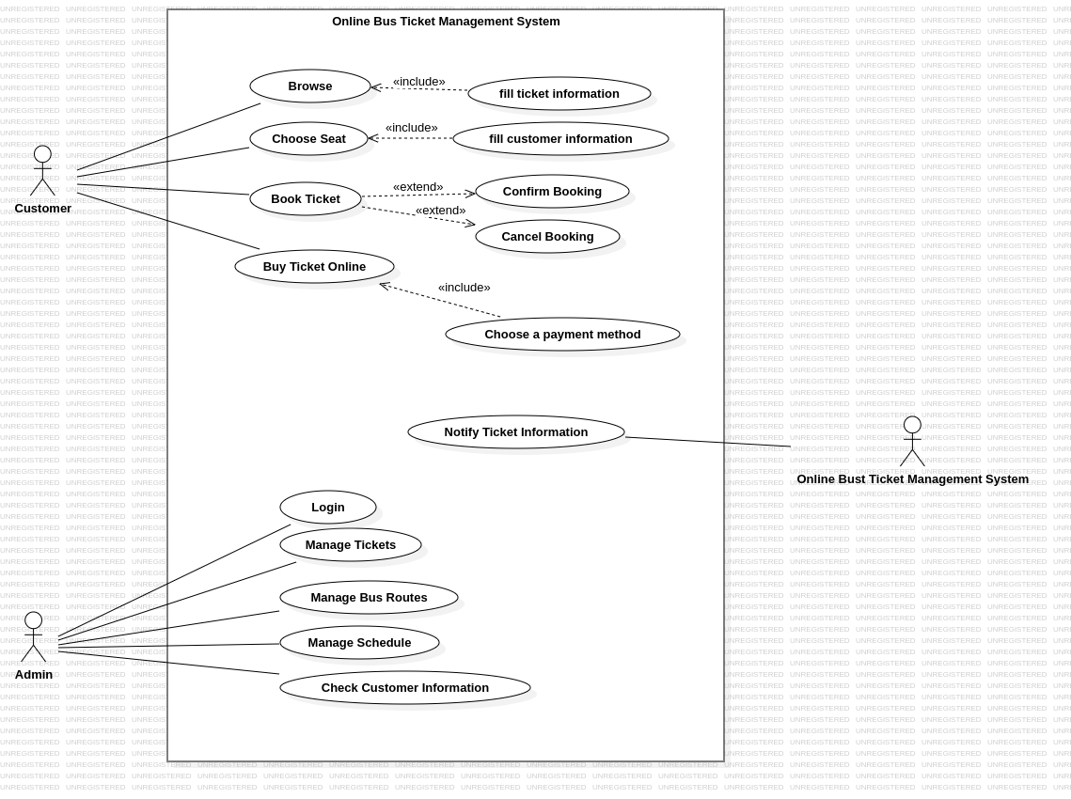
Fig.2.1. Use Case Diagram of Online Bus Ticket Management Modeling

Chapter-3

Class-Based Modeling

3.1. Introduction
An SRS (Software Requirements Specification) can be modeled using classes. This involves identifying the key entities (classes) and their attributes (data) within the system, along with the operations (methods) they can perform. This class-based model helps visualize the system's structure and how different parts interact. We use a class-based model because it promotes better understanding of the software's building blocks, simplifies communication between developers and stakeholders, and aids in early design decisions.

++3.2. Class Diagram of Online Bus Ticket Management Modeling

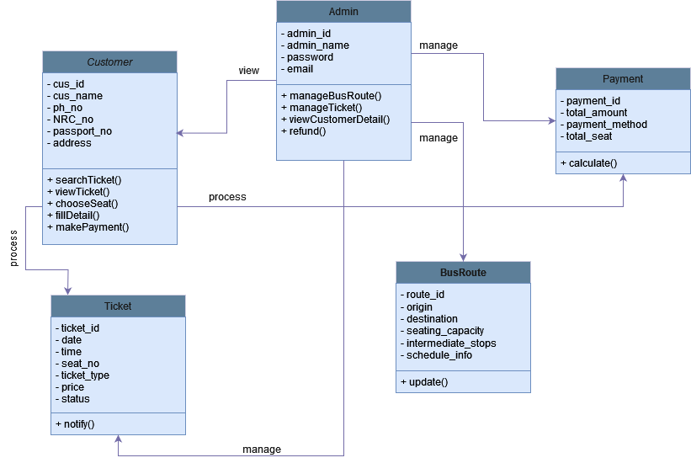
Fig.3.1. Class Diagram of Online Bus Ticket Management

Chapter-4

Conceptual Data Modeling

4.1. Introduction
A conceptual model of an SRS focuses on the high-level entities, attributes, and relationships within the software system, independent of specific technologies.It represents the core functionalities and data involved, using concepts like users, functionalities, data items, and their interactions.This high-level view helps stakeholders understand the overall system behavior and requirements before diving into technical details.By focusing on core concepts, a conceptual model promotes clear communication and ensures everyone aligns on the system's fundamental purpose.

4.2. ER diagram of Online Bus Ticket Management System
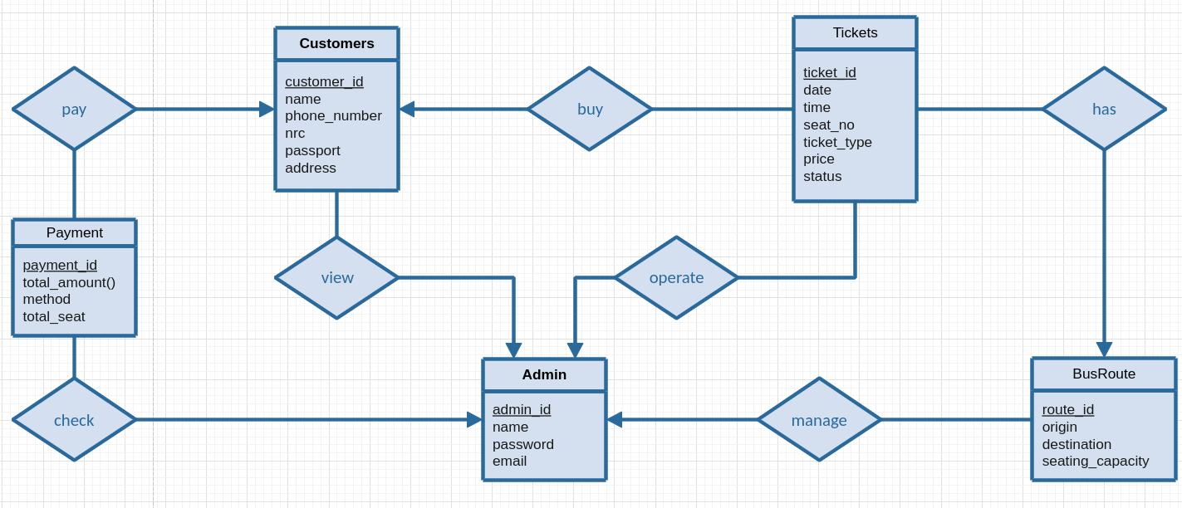
Fig.4.1. E-R Diagram of Online Bus Ticket Management

Chapter-5

Process Modeling

5.1. Introduction
This data flow diagram describes the way information flows through the process. It includes data inputs and outputs, data stores, and the various sub processes the data moves through.

5.2. Context Diagram
Context diagrams are the most basic data flow diagrams.A context diagram represents all the external components that may interact with the system, hence displays the entire software system as a unit.By reviewing a context is useful for describing the scope of the project correctly.

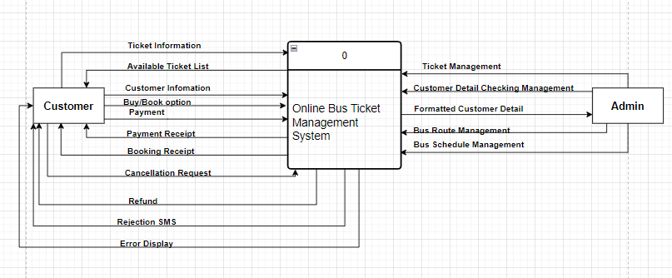
Fig.5.1 Context DFD of Bus Ticket Management

5.3. Level 0 Diagram
The Level 0 diagram is the detailed description of the context diagram.This diagram represents the primary individual processes in the system at the highest possible level of detail.

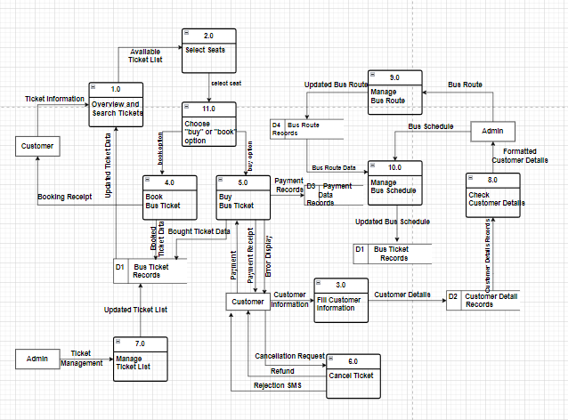

Fig.5.2 Level-0 DFD of Bus Ticket Management

5.4. Level 1 Diagram
A level 1 diagram provides greater detail, focusing on a system's main functions.In level 1 DFD, the single process node from the context diagram is broken down into sub-processes.

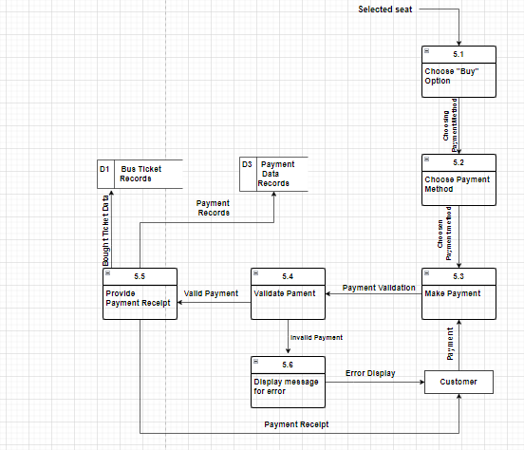
Fig.5.3 Level 1 DFD for Payment Process

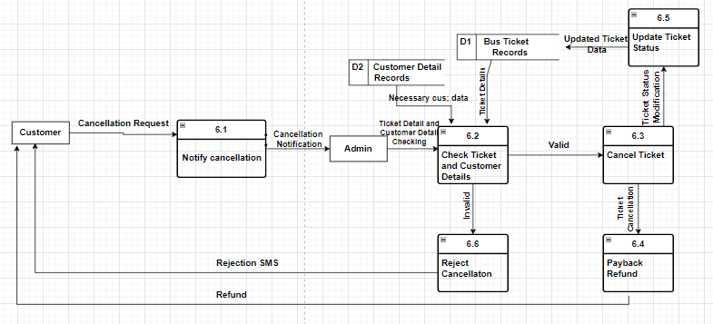
Fig.5.4 Level 1 DFD for Cancel Ticket Process

Chapter-6

Behavior Modeling

6.1. Introduction
Behavioral modeling of an SRS dives into how the system reacts to events. This can be through a state transition diagram where the system transitions between states (active, inactive, etc.) based on user actions or external triggers.
These diagrams depict the flow of the system's behavior, allowing for a clear understanding of how different scenarios play out.
Behavioral modeling helps identify potential issues and ensures the SRS captures the expected system responses.

6.2. Behavioral Modeling of Online Bus Ticket Management System

6.2.1. Browse Tickets

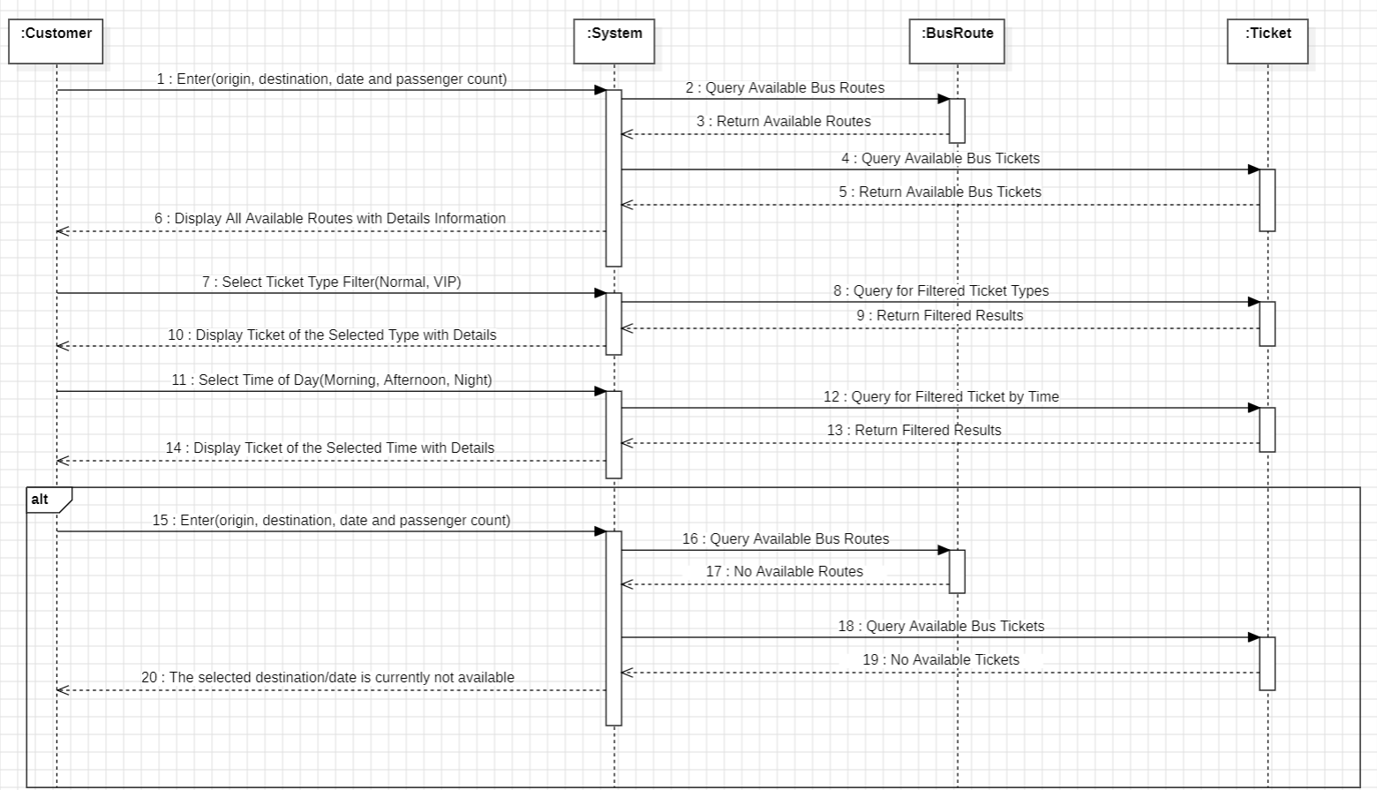
Fig.6.1 Sequence diagram of Overview the system

6.2.2. Choose Seat

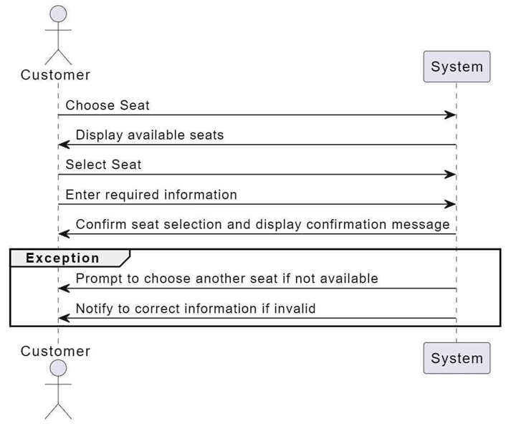
Fig.6.2 Sequence Diagram of Choose Seat

6.2.3. Book Ticket

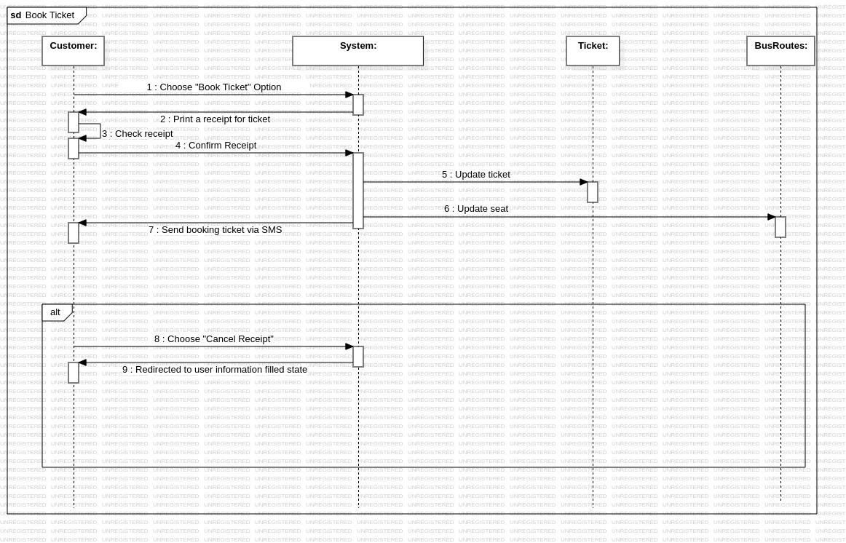
Fig.6.3. Sequence Diagram of Book Ticket

6.2.4. Buy Ticket Online

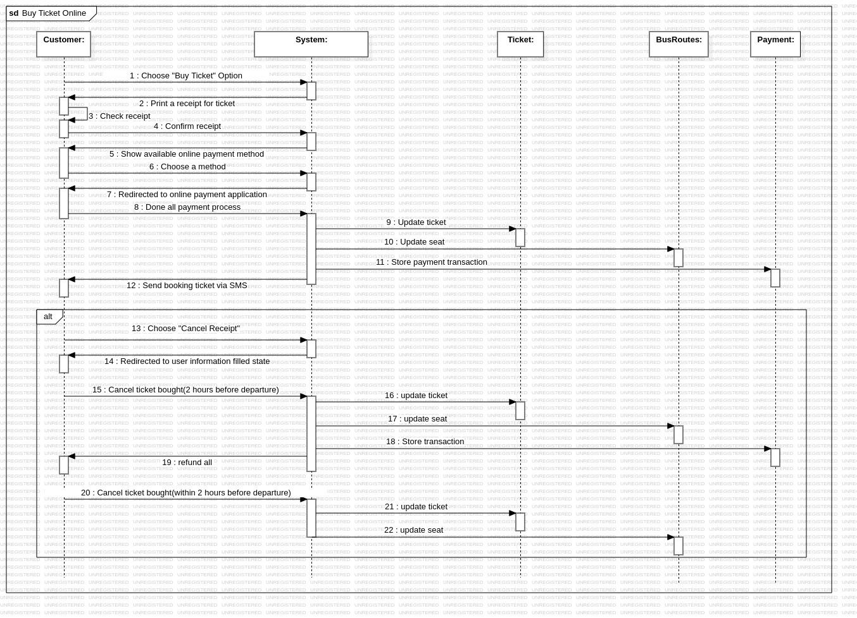
Fig.6.4. Sequence Diagram of Buy Ticket Online

6.2.5. Ticket Management

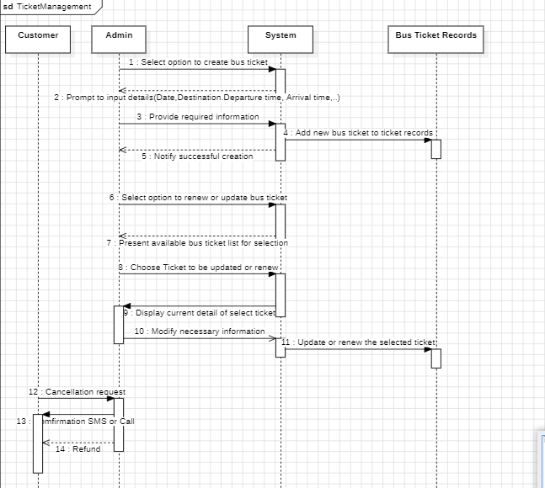
Fig.6.5. Sequence Diagram of Ticket Management

6.2.6. Customer Details Checking

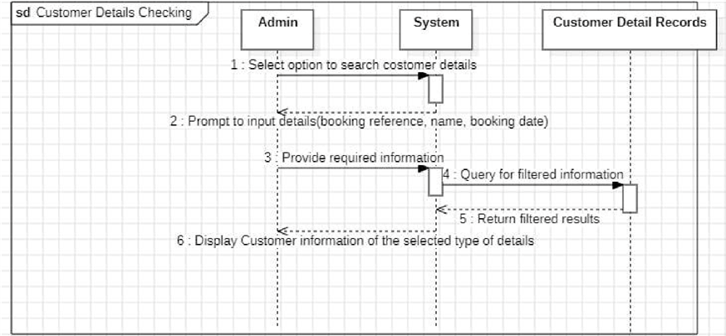
Fig.6.4. Sequence Diagram of Customer Detail Checking

6.2.7. Bus Route Management

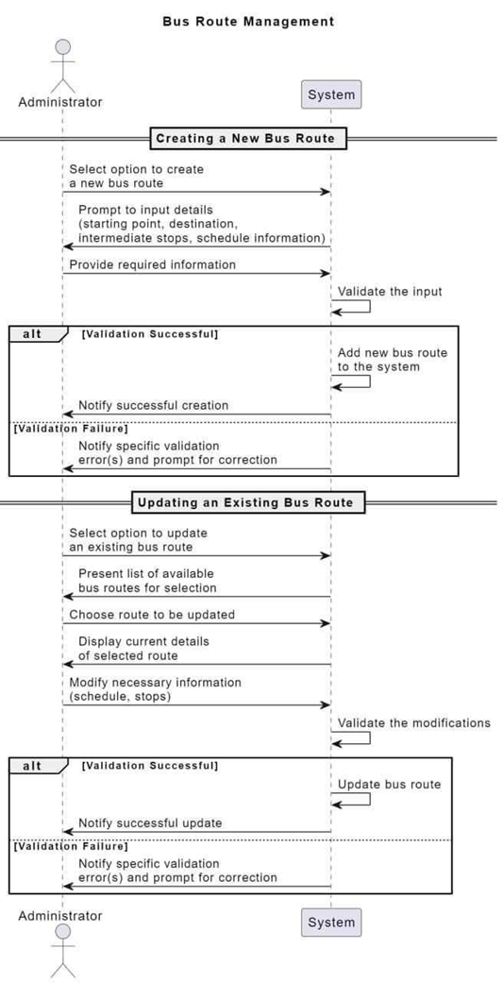
Fig.6.7 Sequence Diagram of Bus Route Management

6.2.8. Bus Schedule Management

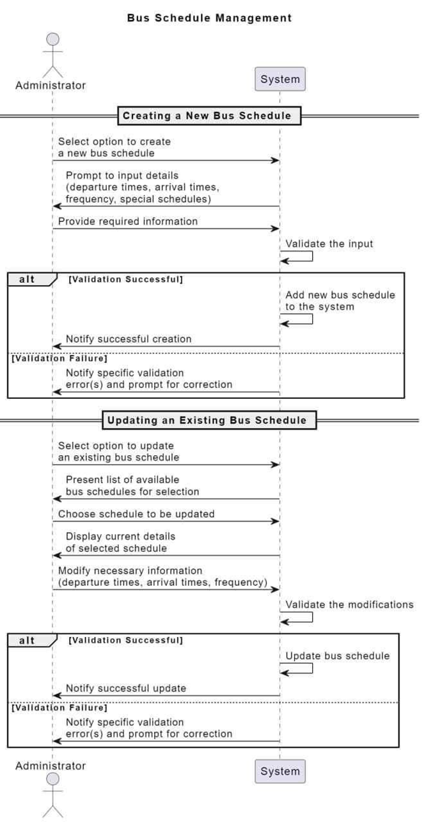
Fig.6.8. Sequence Diagram of Bus Schedule Management System

Conclusion
In conclusion, our next step is to focus on completing the design modeling, which will greatly enhance the functionality and user experience of our Bus Ticket Management System. This crucial future work promises to bring innovative solutions and improvements, ensuring our system meets the needs of our users.

Reference
- SRS-template-ieee.doc
- Software Engineering: A PRACTITIONER’S APPROACH, NINTH EDITION
- https://www.maiair.com/
- https://www.mmbusticket.com/
- https://www.airkbz.com/

