**Summary**

Our methodology earned a 3.85 percent rate of return over five days by using t-GARCH and QGARCH-t volatility models combined with optimization. The proportions and stock ticker symbols can be seen in the portfolio allocation below (Figure 1). This portfolio does 0.95 percent better than the Dow Jones Industrial Average over the same 5-day window, and 0.27 percent better than an even distribution of the five selected stocks. In this report, we will cover our methodology, provide more detailed results, and give a comparison of our portfolio to less analytical methods.

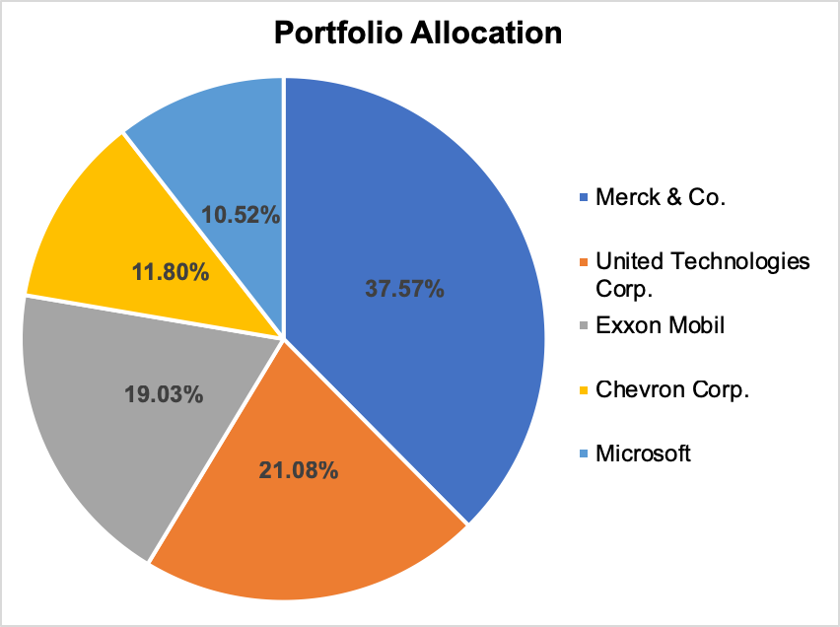

***Figure 1****: Portfolio Allocation*

**Methodology**

The overall process flow for the portfolio allocation is depicted in Figure 2. The methodology can be broken down into two parts: one trying to predict the volatility of stocks (indicated by the red color in Figure 2) and number two optimizing the stock strategy for portfolio allocation (indicated by the green color in Figure 2)

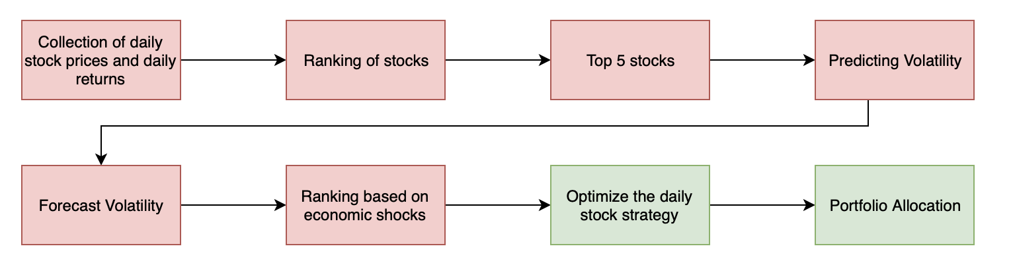

***Figure 2****: Flow Chart for portfolio allocation*

First, the daily stock prices and daily returns for the 30 stocks in the Dow Jones Industrial Average (DJIA) was collected for February 1, 2017 to February 8, 2019. The 30 stocks that were collected can be found in the Appendix. Then these 30 stock components of the DJIA was ranked for the most significant to be predicted with the volatility modeling. The top five stocks were found based on the Lagrange Multiplier Lag 1 test p-values. Then a series of models were created for the top 5 stocks with ARCH/GARCH modeling. The different models that were created were GARCH (1,1)- Normal, t-GARCH (1,1), QGARCH (1,1) - Normal, QGARCH (1,1) -t which helps in predicting the volatility. The best model for each stock was found based on the lowest AIC score. Finally, the volatility is forecasted for the top 5 stocks from February 11, 2019 to February 15, 2019. The stocks were ranked based on the most likely to be bothered by a shock to the market and ranked based on the longest effect a shock. These two rankings are compared and interpreted.

After modeling the volatility, we then move into the optimization part of the methodology (indicated by green color in Figure 1). Based on the forecasted median volatility of the five stocks and the historical median return, we optimized the daily stock strategy for the next five days. Risk is defined as the covariance of the weighted sum of stock returns. Forecasted median variance and historical covariance is used for the optimization. The proportion of the funds in a portfolio that is invested in each stock is found by minimizing risk with a daily expected return of at least 0.05%. Finally, the portfolio is allocated based on the results of the optimization.

**Results**

The five stocks with the most predictable volatility are shown in Table 1. Also shown in the table are the resulting p-value and LM test statistic from testing the lag 1 ARCH effects of stock returns.

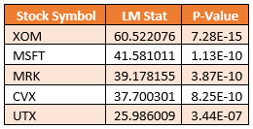

***Table 1:*** *Top 5 stocks with most predictable volatility*

The parameters of the best volatility model for each stock based on lowest AIC value is shown in Figure 3 on the next page.

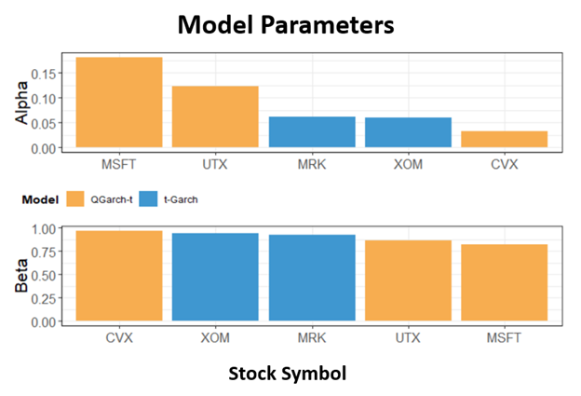

***Figure 3:*** *Best Volatility model for each stock*

In Figure 3 the stocks are ranked and ordered by most likely to be bothered by a shock in the market today in the Alpha plot and ordered by longest effect in price volatility from market events in the Beta plot. For example, Microsoft stock is the most sensitive to market events because it has the highest alpha but its effect from market events takes the shortest amount of time to dissipate because it has the lowest beta. The two rankings are inversely related. The stocks that are the most sensitive to market events have the shortest reaction to market events.

The allocation of stocks in an optimized portfolio that minimizes risk while having a return of at least 0.05 percent is shown on figure 1 in the summary. The expected return is 0.067 percent per day and the expected risk is 0.0095 (standard deviation)

The trade-offs between the optimal risk and return (efficient frontier) is illustrated in figure 4 below. It shows that as returns increase the minimal risk increases. A portfolio’s return that lies below the orange line would be suboptimal because it wouldn’t provide enough return for the level of risk.

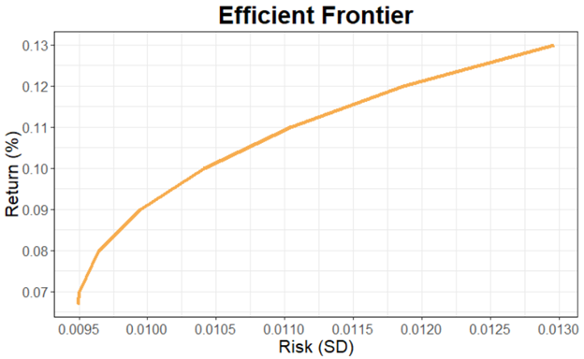

***Figure 4:*** *Efficient Frontier*

For illustrative purposes, figure 5 shows how the value of the optimized portfolio would grow over a five day period compared to a baseline portfolio that allocated an equal amount of funds in each stock. It’s assumed that the portfolio starts with $100k, stocks are purchased at the closing price on February 11, 2019 and purchase of partial shares is possible[1]. The optimized portfolio would have gained $3,850.10 (3.85 percent gain) over the five day period compared to just $3,579.00 (3.58 percent gain) for the baseline portfolio.

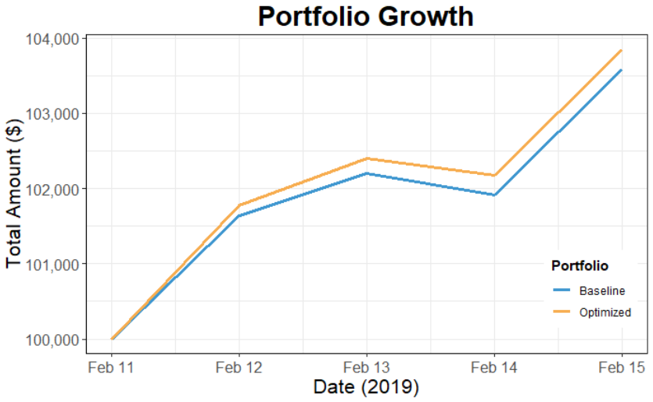

***Figure 5:*** *Portfolio Growth*

**Conclusion**

We created the ideal portfolio to minimize risk with an acceptable level of return. To do this we used GARCH volatility models to forecast risk. From there we used an optimization model to find the allocation of stocks that minimized risk and had an expected return of at least 0.05% per day. Our optimized portfolio suggests to place ~38 percent of personal funds into Merck & Co., 21 percent in United Technologies Corporation, 19 percent in Microsoft, ~12 percent in Chevron Corporation, and the remaining funds into Exxon Mobil. The suggested portfolio does 0.95 percent better than the DJIA over the same selected five-day window.

**DISCLAIMER**:   
Please remember that past performance may not be indicative of future results. Different

types of investments involve varying degrees of risk, and there can be no assurance that the future performance of any specific investment, investment strategy, or product made reference to directly or indirectly in this report, will be profitable, equal any corresponding indicated historical performance level(s), or be suitable for your portfolio. Due to various factors, including changing market conditions, the content may no longer be reflective of current opinions or positions. Moreover, you should not assume that any discussion or information contained in this report serves as the receipt of, or as a substitute for, personalized investment advice from Blue Team 7. To the extent that a reader has any questions regarding the applicability of any specific issue discussed above to his/her individual situation, he/she is encouraged to consult with a professional advisor of his/her choosing. A copy of our current written disclosure statement discussing our advisory services and fees is available for review upon request. We generally charge $250 an hour with a 3-hour minimum.[2]

1. The five day return from each portfolio would be about the same if the purchase of partial wasn’t possible.
2. Disclaimer verbiage from: https://www.etf.com/docs/ClearRock_Disclaimer.pdf