Chapter 1
INTRODUCTION
This is a template document for project report. This document is specific to one institution, but the vast majority of universities use very similar formats.
Your project report must be written in English. First, confirm that you have the correct template for your paper size. This template has been tailored for output on the A4 paper size. This section is a shorter version of the rest of the report. After abstract, introduction and conclusions are the two mainly read parts of a report. In this section you should answer the following questions:
- What exactly is the problem you are trying to solve? This is the problem statement.
- Why is the problem important to solve? This is the motivation. In some cases, it may be implicit in the background, or the problem statement itself.
- Why is the problem difficult to solve? This is the statement of challenges..
- How have you solved the problem? Here you state the essence of your approach. This is of course expanded upon later.
- What are the main results? You have to present the main summary of the results here, but it must be stated explicitly here.

  - Problem Definition
The formatting of the cover page and first few pages needs to be followed exactly. There is no space to use creativity in this case. The acknowledgements and abstract should not show up in table of contents.
If you are highly confident in your mastery of Microsoft Word, feel free to use your own ways of numbering and positioning manuscript elements. Otherwise, by reusing examples of figures, tables, equations, and headings.
  - Project Overview
The Table of Contents should be self-generated. The format of it can be changed through Insert-Index and Tables. The same is true for List of Figures. The List of Tables can be generated in the same command window as List of Figures.
Chapter 2
BACKGROUND

Existing System
It is convention to place captions below figures, yet above tables. In this template we have added a heading style just for lists, which includes a list of figures and tables. All figures should be numbered in order that they appear in the document. To add new figure to your document that utilizes this code, find a pre-existing figure and caption, highlight both the figure and the caption, copy both the highlighted figure and caption, and then paste the figure and caption to a location. Next, replace the caption text and figure image with your desired content.

Figure 2.1. Project Management Process Steps
  - Your System
Most universities have strict rules on the style of chapter titles and heading titles. The safest way is to follow this template and to consult with the appropriate parties who certify the formatting of a project report. Headings, or heads, are organizational devices that guide the reader through your report.
  - Feasibility Study
Most universities have strict rules on the style of chapter titles and heading titles. The safest way is to follow this template and to consult with the appropriate parties who certify the formatting of a project report. Headings, or heads, are organizational devices that guide the reader through your report.

Chapter 3
SYSTEM ANALYSIS AND DESIGN
  - Requirement Specification
These are tools that are necessary for the workability of the proposed system: these tools are divided into two specifically:
- Functional requirements
- Non-functional requirements

Functional Requirements
Functional requirements are product features that developers must implement to enable the users to achieve their goals. They define the basic system behavior under specific conditions.
Examples of functional requirements include user authentication, data management, workflow and business logic, reporting and analytics, and integration with external systems.

Non-Functional Requirements
Non-Functional Requirements define the qualities and constraints that the system should meet. They focus on aspects such as performance, reliability, security, usability, scalability, maintainability, and compatibility. Non-functional requirements ensure that the system operates effectively and efficiently. Examples of non-functional requirements include performance targets, system availability, data security measures, user interface usability, and system scalability.
  - Flowcharts and Diagrams
To show and display the details and functions of the system flow chart and the following diagrams are used.

Flowcharts for Admin and User
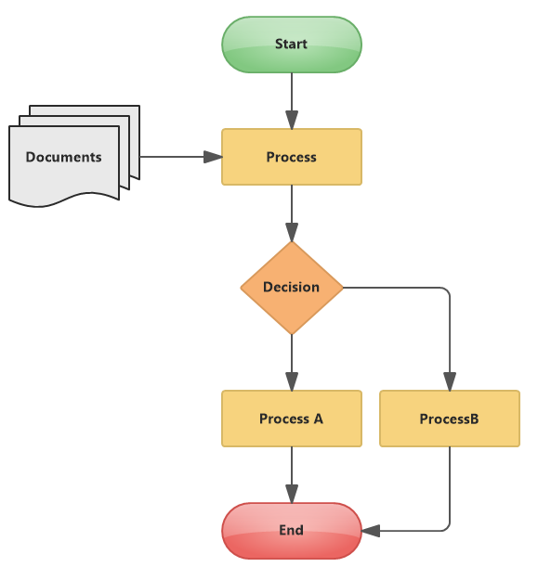
Figure 3.1. System Flow Diagram

Use Case Diagrams for Admin and User

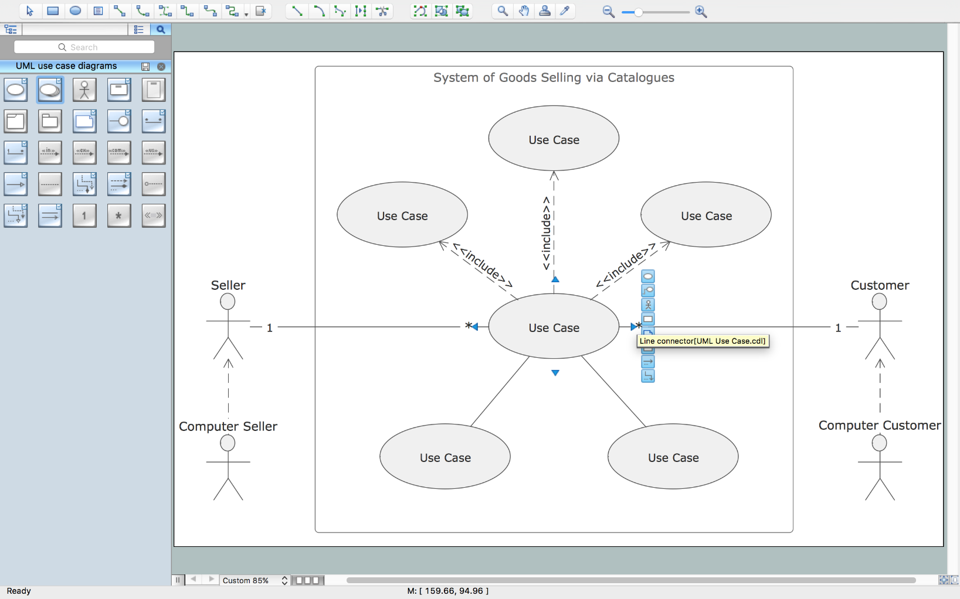
Figure 3.2. Use case Diagram

Sequence Diagrams for Admin and User
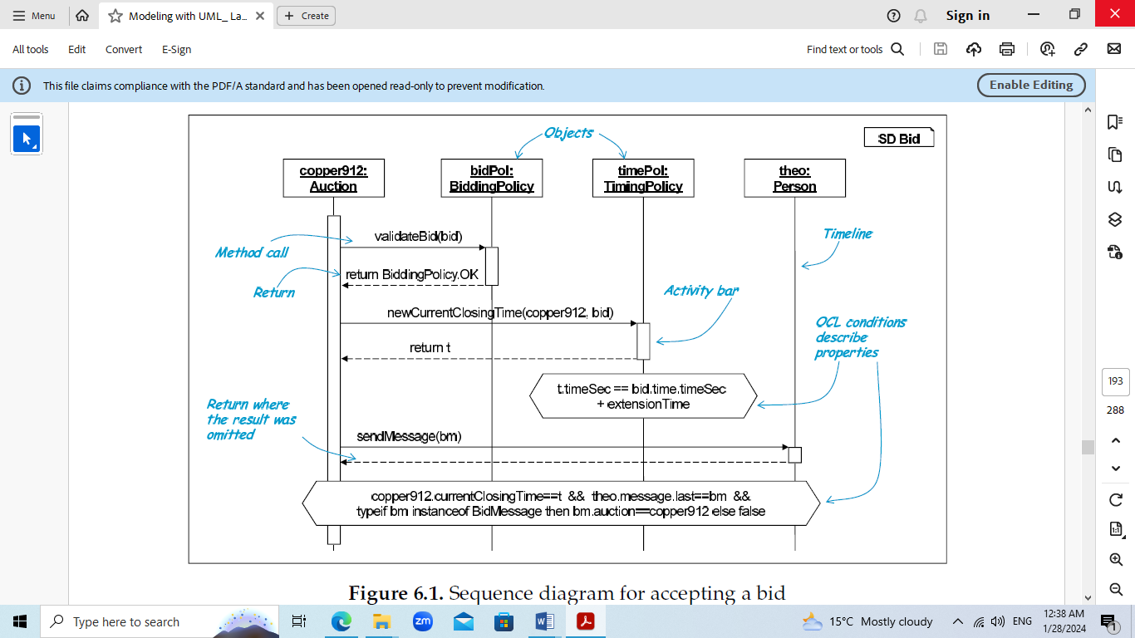
Figure 3.3. Sequence Diagram for explaining available concepts

Database Design for the system
An Entity Relationship Diagram (ER Diagram) is a pictorial representation of the relationship between entities to be stored in a database. It is a structural design of the database and acts as a framework created with specialized symbols for the purpose of defining the relationship between the database entities. It help to explain the logical structure of databases and are created based on three basic concepts: entities, attributes and relationships.
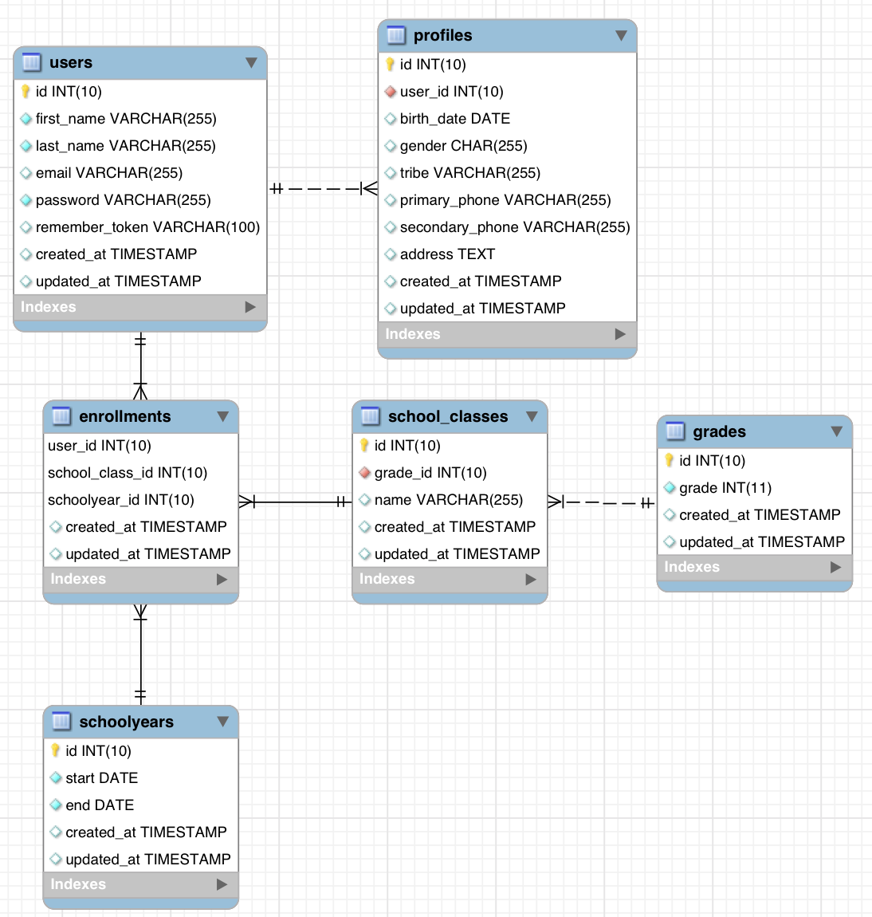
Figure 3.4. Sample Database Design (ER) Diagram

  - Testing Processes

3.3.1. Testing Rules
Table 3.1. Testing Results for Register
No. | Rule Description | Rule Type
1 | The length of the name at least 3 & at most 50. | Valid
2 | The name is null value or blank space (length=0). | Invalid
3 | The length of password is greater than or equal to 8. | Valid
4 | The password and confirm password are not the same. | Invalid
5 | The password is null value or a blank space(length=0). | Invalid
6 | The confirm password is null value or a blank space(length=0). | Invalid
7 | The type of the name is name is alphanumeric. | Valid
8 | The type of the name includes space. | Valid

3.3.2. Sample Static Testing
Table 3.2. Sample Static Testing
Static Testing | Input | Expected Result
 | Full Name : Ma Ma  Email : mama123@gmail.com  Password : Mama123@  Confirm Password : Mama123@ | User login process success.
 | Full Name : Thi Tar  Email : mama123@gmail.com  Password : Thitar456$  Confirm Password : Thitar456$ | User login process fails. Show the “Email already exist” because this email already exists in this system.
 | Full Name : Nilar  Email : nilar123@gmail.com  Password : Nilar123#  Confirm Password : Nilar123% | Registration is not successful. Show the “password not match” because password and confirm password are different.
 | Emial : admin123@gmail.com  Password : admin007 | Admin login process fails. Show the “Email or password invalid!”
 | Email : admin@gmail.com  Password : Admin123$ | Admin login process success.

3.3.3. Data Dictionary
The data elements using in the system are described in the following Table.
Table 3.3 Data Dictionary
Data Elements | Description | Composition or Data Type | Length | Values
Admin | The person, who control the system
User | The person, who using the system
User Name | The name of the user to enter the system | String (Alphanumeric Characters) | 50 | Special Characters are permitted
User Email | The email of the user to enter the system | String (Alphanumeric Characters) | 100
User Password | The password for the user to enter the system | String (Alphanumeric Characters) | 100
Admin Email | The email of the admin to enter the system | String (Alphanumeric Characters) | 100
Admin Password | The password for the admin to enter the system | String (Alphanumeric Characters) | 100

Chapter 4
IMPLEMENTATION OF THE SYSTEM
To show and display the information to the user, the user interface is used. The following are sample sections that used in this system.You can design and present your system implementation style as you like.
  - Subsection
Please use the following style for the sub-section heading titles.
    - Subsection Level 3
This section is just to show you how to make sub-sections. Technically, since no subsection should exist by itself, there should be a following section 4.2. However, as this section is an example, a subsequent section is unnecessary. This style is Heading 3, and it will automatically show up in the table of contents, like the other headings.

Terminology
A project report is a document offering a comprehensive overview of a project’s objectives, progress, team performance, and milestone accomplishments. It plays a critical role in the project planning and management process. It also gives an account of the challenges faced during a project’s execution. Use whichever term is preferred by your advisors.

References
The references list should conform to the report template’s reference section. All sources of information for your report should be cited in the writing. At the end of the report include a section called References and list each. The titles of books and articles are also to be included with the page numbers. This is intended to provide convenient means for the reader to locate the cited material.The reference list is organized numerically, not alphabetically.

Chapter 5
CONCLUSION
This template document will be updated as more and more students start to work on second year project. Although this template may also be helpful for writing a project report, it is important to identify the requirement difference and make appropriate changes.

REFERENCES
- www.google.com
- www.facebook.com
- www.missuniversemyanmar.com
- https://www.w3schools.in/laravel
- Ian Sommerville, “SOFTWARE ENGINEERING”, Ninth Edition

Appendix A.
An Example of an Appendix
Appendices should be used for supplemental information that does not form part of the main project report. Remember that figures and tables in appendices should not be listed in the List of Figures or List of Tables. In this section, you include additional information related to your project which the reader can refer to if needed, such as:
- data sheets of components you have used
- source code of programs you have written
- proofs of theorems, full-page graphs and plots
- hardware schematics

