Why larger images need more computation
  - Teaching notes on convolution weight sharing
A convolutional layer can process a larger image without learning more weights. The same filter is applied at more spatial positions, so computation grows while the parameter count stays fixed. Changing the number of filters is different: it changes both the learned weights and the computation.

One filter at many positions
A standard dense two dimensional convolution slides a learned kernel across an input. Each output filter spans every input channel and reuses its weights at each valid location. With biases enabled, each output filter has one learned bias shared across locations.
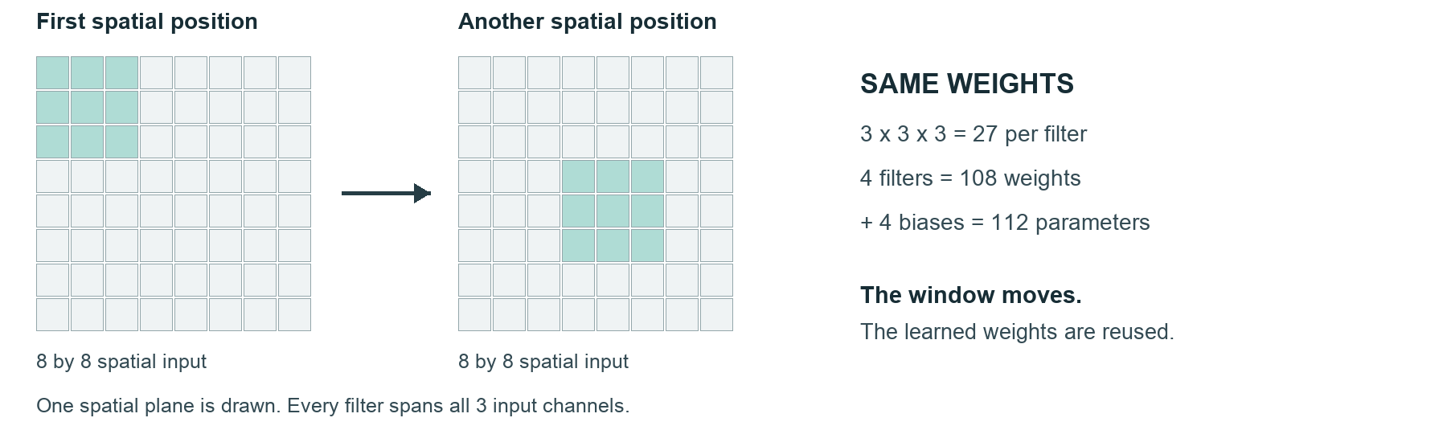

A small model with explicit assumptions
Use one square image, square kernels, no padding, dilation 1, and positive integer stride. N is the input side, K the kernel side, C the input channels, F the output filters, and S the stride. B is 1 with biases and 0 without. Always keep N at least K.
Quantity | Rule
Output side O | O = floor((N - K) / S) + 1
Learned parameters P | P = K × K × C × F + B × F
Direct multiplications M | M = O × O × K × K × C × F

floor rounds down to an integer. M counts scalar multiplications in a direct convolution. It excludes additions, bias additions, activations and backend optimizations; it is not a measure of elapsed time.

Predict what changes
Start with N = 8, K = 3, C = 3, F = 4, S = 1 and biases enabled. One output uses 3 × 3 × 3 = 27 multiplications. There are 6 × 6 locations for each of 4 filters, so M = 3,888. The learned parameters are 108 weights and 4 biases, giving P = 112.

Controlled comparisons
For each comparison, predict the result, change one quantity, and explain what changed and what stayed fixed. The first row is the starting case; each later row changes the quantity stated from the preceding row.
Case | Change | O | P | M
A | Start at N = 8 | 6 | 112 | 3,888
B | Increase N to 16 | 14 | 112 | 21,168
C | Increase S to 2 | 7 | 112 | 5,292
D | Restore S to 1 | 14 | 112 | 21,168
E | Increase F to 8 | 14 | 224 | 42,336
F | Turn biases off | 14 | 216 | 42,336

Why the results differ
A larger input creates more output locations. It does not create new copies of the learned filters, so P stays at 112 in A through D. Doubling N from 8 to 16 increases M by about 5.44 times here, not exactly four times, because valid convolution reduces the output side by K - 1 when S = 1.
Increasing stride skips spatial positions and reduces computation without changing the weights. Adding output filters introduces distinct learned kernels, so both P and M increase. Removing biases subtracts one parameter per filter while leaving this multiplication count unchanged.

The misconception to resolve
“A larger image needs a newly learned kernel at every position.” This confuses the number of times a filter is used with the number of unique weights it contains. The input changes, and the spatial location changes, but the same learned weights are reused.

Relationships to explore
With K, C, F, S and B fixed, P is independent of N. M follows the square of the output side O; at stride 2 it grows in steps because O is an integer. Useful exploration ranges are N from 8 to 24, K in 1, 3 or 5, and S in 1 or 2. A moving K by K window illustrates weight reuse; it represents one spatial plane, not all channels.
References: Dumoulin and Visin, A guide to convolution arithmetic for deep learning, arxiv.org/abs/1603.07285. NVIDIA, Convolutional Layers User’s Guide, docs.nvidia.com/deeplearning/performance/dl-performance-convolutional/.

