Lab 3.5.3: Troubleshooting VLAN Configurations

Topology Diagram
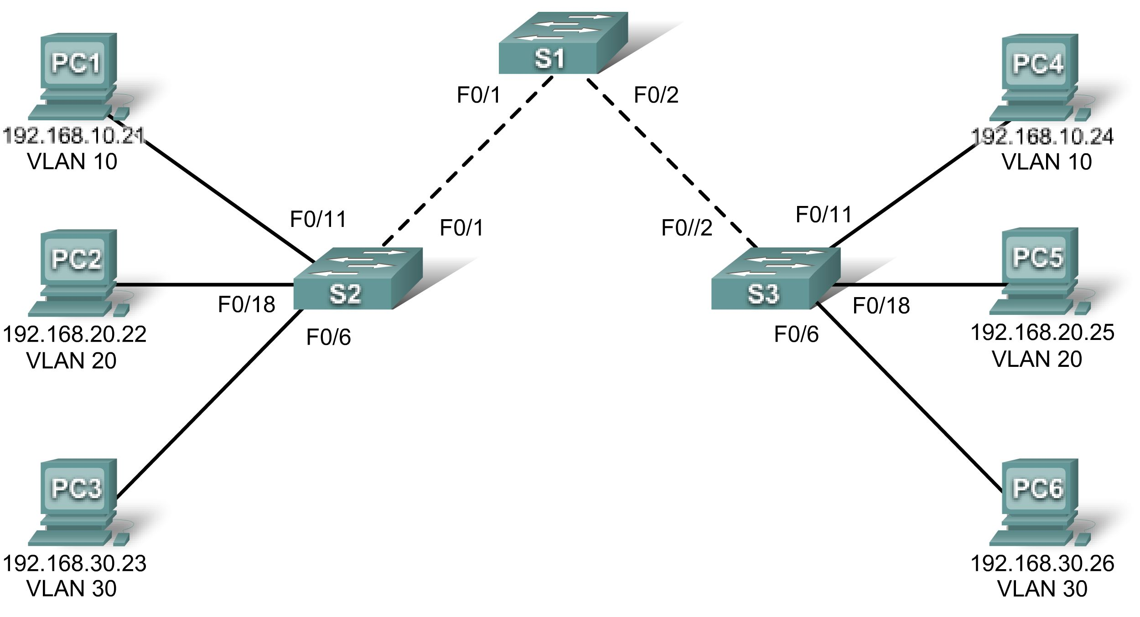

Addressing Table
Device  (Hostname) | Interface | IP Address | Subnet Mask | Default Gateway
S1 | VLAN 56 | 192.168.56.11 | 255.255.255.0 | N/A
S2 | VLAN 56 | 192.168.56.12 | 255.255.255.0 | N/A
S3 | VLAN 56 | 192.168.56.13 | 255.255.255.0 | N/A
PC1 | NIC | 192.168.10.21 | 255.255.255.0 | 192.168.10.1
PC2 | NIC | 192.168.20.22 | 255.255.255.0 | 192.168.20.1
PC3 | NIC | 192.168.30.23 | 255.255.255.0 | 192.168.30.1
PC4 | NIC | 192.168.10.24 | 255.255.255.0 | 192.168.10.1
PC5 | NIC | 192.168.20.25 | 255.255.255.0 | 192.168.20.1
PC6 | NIC | 192.168.30.26 | 255.255.255.0 | 192.168.30.1

Initial Port Assignments (Switches 2 and 3)
Ports | Assignment | Network
Fa0/1 – 0/5 | 802.1q Trunks (Native VLAN 56) | 192.168.56.0 /24
Fa0/6 – 0/10 | VLAN 30 – Guest (Default) | 192.168.30.0 /24
Fa0/11 – 0/17 | VLAN 10 – Faculty/Staff | 192.168.10.0 /24
Fa0/18 – 0/24 | VLAN 20 – Students | 192.168.20.0 /24

Learning Objective
Practice basic VLAN troubleshooting skills.

Scenario
In this lab, you will practice troubleshooting a misconfigured VLAN environment. Load or have your instructor load the configurations below into your lab gear. Your objective is to locate and correct any and all errors in the configurations and establish end-to-end connectivity. Your final configuration should match the topology diagram and addressing table. All passwords are set to cisco, except the enable secret password, which is set to class.
Task 1: Prepare the Network
Step 1: Cable a network that is similar to the one in the topology diagram.
Step 2: Clear any existing configurations on the switches, and initialize all ports in the shutdown state.
Step 3: Import the configurations below.
Switch 1
hostname S1
no ip domain-lookup
enable secret class
!
!
interface range FastEthernet0/1-5
switchport mode trunk
!
interface range FastEthernet0/6-24
shutdown
!
interface Vlan1
no ip address
no ip route-cache
!
interface Vlan56
ip address 192.168.56.11 255.255.255.0
no ip route-cache
!
line con 0
logging synchronous
line vty 0 4
no login
line vty 5 15
password cisco
login
!
end

Switch 2
hostname S2
no ip domain-lookup
enable secret class
!
vlan 10,20,30,56
!
interface range FastEthernet0/1-5
switchport trunk native vlan 56
switchport mode access
!
interface range FastEthernet0/6-10
switchport access vlan 30
switchport mode access
!
interface range FastEthernet0/11-17
switchport access vlan 10
switchport mode access
!
interface range FastEthernet0/18-24
switchport access vlan 20
switchport mode access
!
interface GigabitEthernet0/1
!
interface GigabitEthernet0/2
!
interface Vlan1
ip address 192.168.56.12 255.255.255.0
no ip route-cache
shutdown
!
line con 0
password cisco
login
line vty 0 4
password cisco
login
line vty 5 15
password cisco
login
!
end

Switch 3
hostname S3
no ip domain-lookup
enable secret class
!
vlan 10,20,30
!
interface range FastEthernet0/1-5
switchport trunk native vlan 56
switchport mode trunk
!
interface range FastEthernet0/6-10
switchport mode access
!
interface range FastEthernet0/11-17
switchport mode access
!
interface range FastEthernet0/18-24
switchport mode access
!
interface GigabitEthernet0/1
!
interface GigabitEthernet0/2
!
interface Vlan1
no ip address
no ip route-cache
shutdown
!
interface Vlan56
no ip route-cache
!
line con 0
password cisco
login
line vty 0 4
password cisco
login
line vty 5 15
password cisco
login
!
end
Task 2: Troubleshoot and Repair the VLAN Configuration
Task 3: Document the Switch Configurations
On each switch, capture the running configuration to a text file and save for future reference:
Task 4: Clean Up
Erase the configurations and reload the switches. Disconnect and store the cabling. For PC hosts that are normally connected to other networks (such as the school LAN or to the Internet), reconnect the appropriate cabling and restore the TCP/IP settings.

