Lab 6.3 – First Hop Redundancy Protocols – GLBP pre IPv4
Topo
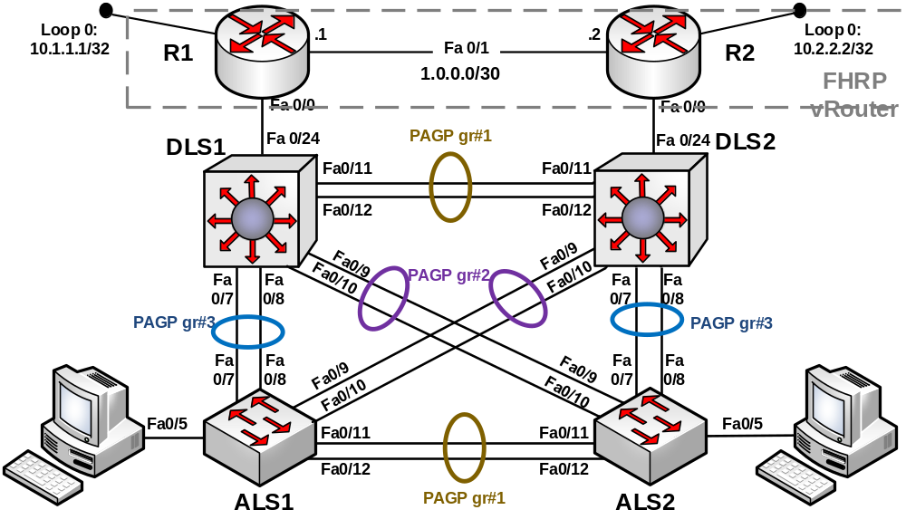
HSRP/VRRP Def. gw adresa
VLAN | Meno | Adresa
99 | Manazment | 192.168.99.1/24
100 | Users | 192.168.100.1/24
110 | Servers | 192.168.110.1/24
120 | Office | 192.168.120.1/24

Požadované kroky
Task | Konfigurácia |  | Verifikácia
Príprava prostredia
Cieľ. Potrebujeme dosiahnuť, aby routing pre všetky vlan robili smerovače, ktoré zgrupíme do GLBP skupiny.
- Využijeme ukončený lab 6.1, t.j.
  - Etherchannel ostáva
  - VTP doména ostáva
  - VLAN 99, 100, 110 a 120 ostávajú, PC na ALS zaraď do dvoch rôznych vlan
  - RSTP ostáva
  - Konfigurácia L3 adresovania:
    - Na všetkých prepínačoch len manažment vlan 99
    - Ostatné zrušiť – no int vlan 100
  - Vypni na distro prepínačoch smerovanie
    - Pre ipv4: No ip routing
    - Pre ipv6: No ipv6 unicast-routing
- Zmeny na DLS
Nastav na porte fa0/24 trunk smerom na smerovač | Int fa 0/24  Switchport trunk encapus dot1q  Switchport mode trunk |  | Sh int trunk
- Konfigurácia L3 adresovania a routing-u:
Konfiguruj smerovače ako router-on-stick tak, aby, každý smerovač mal 4 subrozhrania pre každú použitú vlan. R1 bude mať IP adresu .3/24 a router R2 .4/24 z daného VLAN rozsahu. | Príklad pre R1:  Int fa 0/0  No ip address  No shut  Int fa 0/0.99  Encapsualation dot1q 99  Ip add 192.168.99.3 255.255.255.0  Int fa 0/0.100  Encapsualation dot1q 100  Ip add 192.168.100.3 255.255.255.0  Int fa 0/0.110  Encapsualation dot1q 110  Ip add 192.168.110.3 255.255.255.0  Int fa 0/0.120  Encapsualation dot1q 120  Ip add 192.168.120.3 255.255.255.0 |  | Sh ip int brief
Over, čo vidia smerovače vo svojej smerovacej tabuľke. |  |  | Show ip route
- Konfigurácia smerovacieho protokolu
Konfiguruj/koriguj EIGRP smerovanie pre AS 1 na smerovačoch a vlož do smerovania všetky siete vrátane. | Router eigrp 1  No auto-summary  Network NET1 MASK  Network NET2 MASK  … |  | Show ip eigrp neighbor  Show ip route
Over smerovaciu tabuľku a koriguj chýbajúce záznamy
Over ping:  - Medzi PC v danej VLAN a jeho def. Gw.  - medzi DLS prepínačmi v rozdielnych VLAN, či smerovačmi,, je nejaký problém s konektivitou? |  |  | Ping
Konfigurácia GLBP
Konfiguruj GLBP takým spôsobom, aby:
- DLS1 bol AVG v GLBP grupe pre VLAN 99 a 100.
- DLS2 bol AVG v GLBPgrupe pre VLAN 110 a 120,
Príklad pre VLAN 99:  - Číslo glbp grupy 99, musí byť rovnaké u oboch prepínačoch  - Virtuálna IP adresa: 192.168.99.1/24  - Musí byť rovnaká u oboch prepínačov. | R1:  Int fa 0/0.99  glbp 99 ip 192.168.99.1  glbp 99 preempt  glbp 99 priority 150  exit | R2:  Int fa 0/0.99  glbp 99 ip 192.168.99.1  glbp 99 preempt  glbp 99 priority 100  exit | Show glbp brief  Show glbp
Podobne učiň pre vlan 100.
Príklad pre VLAN 120:  - Číslo glbp grupy 120, musí byť rovnaké u oboch prepínačoch  - Virtuálna IP adresa: 192.168.120.1/24  - Musí byť rovnaká u oboch prepínačov. | R1:  Int fa 0/0.120  glbp 120 ip 192.168.120.1  glbp 120 preempt  glbp 120 priority 100  exit | R2:  Int fa 0/0.120  glbp 120 ip 192.168.120.1  glbp 120 preempt  glbp 120 priority 150  exit | Show glbp brief  Show glbp
Podobne učiň pre vlan 110.
Overenie a pozorovanie
Prejdenie príkazu show glbp do detailu
Over ping-y medzi IP adresami v rozdielnych vlan, mali by byť úspešné (pozor na firewall vo win7/10).
Voer ARP na PC akú MAC používa
Pozorovanie zmien:
- Čo sa stane ak dáme na R1 subif fa0/0.99 shutdown? | Int fa 0/0.99  shutdown |  | Show glbp brief
- Čo sa stane ak dáme na R1 subif fa0/0.99 späť na UP? | Int fa 0/0.99  No shutdown |  | Show glbp brief
Konfigurácia GLBP interface tracking-u
Objekt na interface triacking
Pred konfiguráciou over konektivitu z DLS1 na R1 loop. Ak nie je, rieš!
Konfiguruj na R1 tracking loop-u a fa0/1 | track 1 interface loop0 line-protocol track 2 interface fa0/0 line-protocol
Konfiguruj GLBP tracking na R1 tak, že ak padne loop ponížim priority o 60,  Ak padne fast ponížim o 20 | Int fa 0/0.99  Standby 99 weighting track 1 decrement 60  Standby 99 weighting track 2 decrement 20
Konfiguruj váhovanie, kde ak padnem pod lower 85, vzdá sa R1 AVF.  Ak stúpnem nad 125, preberiem AVF späť | glbp 99 weighting 110 lower 85 upper 125
Pozoruj chovanie:  - Shutdown loop a fa 0/0 portu R1  - Oživenie portov R1 |  |  | Show glbp brief

R1# show glbp

GigabitEthernet0/1.10 - Group 10
State is Active,!!This refers to the role of the AVG. R1 is the Active AVG
1 state change, last state change 02:13:28
Virtual IP address is 10.1.10.254
This is the preemption configured for AVG operation. AVG preemption is disabled by default.
Hello time 3 sec, hold time 10 sec
Next hello sent in 1.792 secs
Redirect time 600 sec, forwarder timeout 14400 sec
Preemption enabled, min delay 0 sec
Active is local
Standby is 10.1.10.2, priority 100 (expires in 8.736 sec) R3 router is the standby AVG.
Priority 150 (configured) <-!This priority is to influence AVG selection.
Weighting 100 (default 100), thresholds: lower 1, upper 100 These are the default weighting thresholds used in the AVF operation of GLBP.
Load balancing: round-robin
Group members:
6c20.561f.5d19 (10.1.10.2)
fc99.47fd.b9b1 (10.1.10.1) local
There are 2 forwarders (1 active) R1 and R3 are both AVF’s.
Forwarder 1
State is Listen R3 is backup forwarder for the MAC ending in 01.
4 state changes, last state change 00:32:18
MAC address is 0007.b400.0a01 (learnt) This is the GLBP MAC; the last four hexadecimal digits correspond to the GLBP group and one of the four virtual MAC addresses used in GLBP operation.
Owner ID is 6c20.561f.5d19
Redirection enabled, 598.752 sec remaining (maximum 600 sec)
Time to live: 14398.752 sec (maximum 14400 sec)
Preemption enabled, min delay 30 sec
Active is 10.1.10.2 (primary), weighting 100 (expires in 10.432 sec)
Forwarder 2
State is Active
1 state change, last state change 00:37:11
R1 is also an AVF. Notice here the output shows that R1 is listening to the GLBP MAC address ending in 0a02. R1 is actively forwarding packets destined for this MAC address.
MAC address is 0007.b400.0a02 (default)
Owner ID is fc99.47fd.b9b1
Redirection enabled
Preemption enabled, min delay 30 sec
Active is local, weighting 100 --------
GigabitEthernet0/1.20 - Group 20

The show glbp brief command can also be used to view a brief synopsis of glbp operation.

R1# show glbp brief
Interface Grp Fwd Pri State Address Active router Standby router
Line 1 ->
Line 2 ->
Line 3 ->
Gi0/1.10 10 - 150 Active 10.1.10.254 local 10.1.10.2
Gi0/1.10 10 1 - Listen 0007.b400.0a01 10.1.10.2 -
Gi0/1.10 10 2 - Active 0007.b400.0a02 local -
Gi0/1.20 20 - 150 Active 10.1.20.254 local 10.1.20.2
Gi0/1.20 20 1 - Listen 0007.b400.1401 10.1.20.2 -
Gi0/1.20 20 2 - Active 0007.b400.1402 local -
Gi0/1.99 99 - 150 Active 10.1.99.254 local 10.1.99.2
Gi0/1.99 99 1 - Active 0007.b400.6301 local -
Gi0/1.99 99 2 - Listen 0007.b400.6302 10.1.99.2 -

The first line in the GLBP output shows the role of the AVG for group 10. The priority has been set to 150 for this group and the state shows R1 as the active AVG. The virtual IP address is 10.1.10.254. The standby AVG is 10.1.10.2 which is the R3 router.

