HyMeKo: One Hypergraph Substrate for Representing and Learning from Structured Systems
From declarative hypergraph structure to structural-prior learning.
PhD Seminar · Kato Laboratory · Csaba Hajdu · June 2026

Abstract
Structured systems — robot mechanisms, signed trust and affect networks, chemical processes, neural dataflow — are intrinsically n-ary, yet coercing their relations into pairwise graphs erases each relation's identity and inflates the representation to O(|E|·d²). HyMeKo addresses this with a single canonical-hypergraph substrate that serves both representation and learning, so that the structure a framework compiles is the same structure a model reasons over. A declarative language compiles to a content-hashed hypergraph intermediate representation (IR), from which one query-and-template engine emits URDF, SDF, MJCF, SysML v2 and PyTorch with cross-view consistency, while an O(|E|·d) star expansion streams zero-copy to the GPU. Learning is driven by enumerated signed cycles and walks through a SignedKAN, HSiKAN and Gömb family whose Kolmogorov–Arnold spline activations turn graph structure into an inductive prior, all under a leakage-audited strict protocol.

One substrate, two payoffs
A declarative .hymeko source compiles through a SIMD lexer and an LALRPOP parser to one canonical hypergraph IR with a Blake3 content-hash identity. From that single IR the framework both emits many target formats and feeds a structural-prior learning stack.
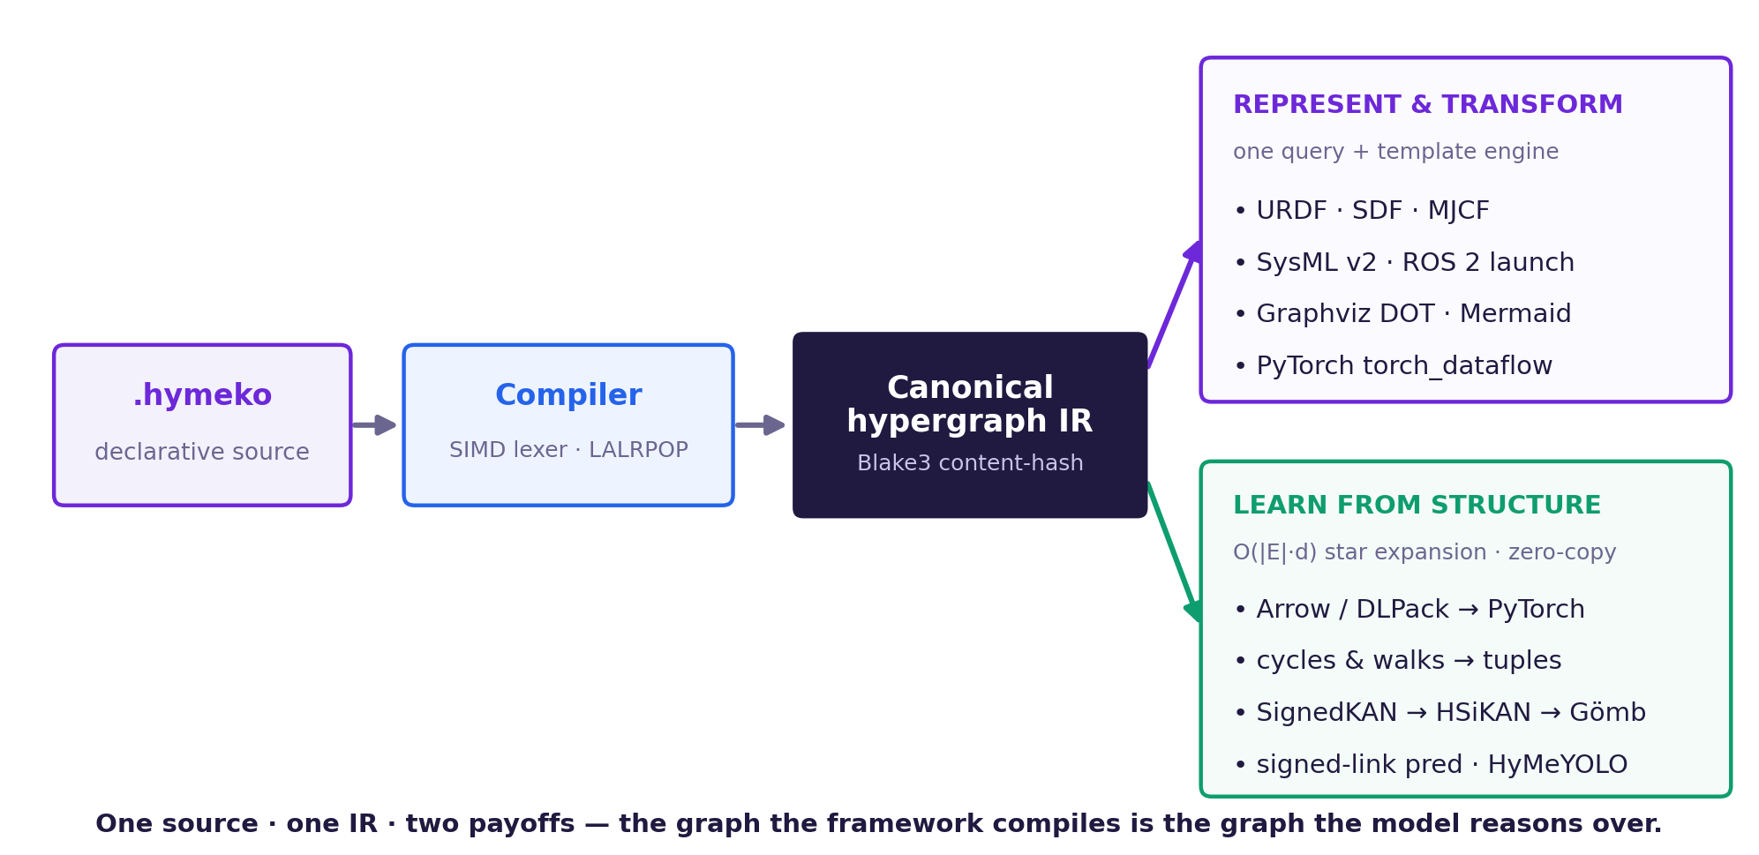
Figure 1 — The HyMeKo workflow: one source → one canonical IR → two payoffs (represent & transform; learn from structure).

Mathematical preliminaries
A compact reference for the objects used throughout the talk.
- Graph & signed graph. A graph G = (V, E) has vertices V and pairwise edges E ⊆ V×V; a signed graph adds σ: E → {+, −} (trust/distrust, like/dislike).
- Hypergraph (n-ary). A hypergraph H = (V, E) lets each hyperedge e ∈ E bind |e| = k vertices at once (a k-ary relation); k = 2 recovers an ordinary graph. d̄ denotes the mean arity.
- Incidence & star expansion. The Levi / Berge incidence is the signed vertex×hyperedge matrix B ∈ {−1, 0, +1} — equivalently the bipartite ‘star’ expansion with one hub per hyperedge; size O(|E|·d̄).
- Clique expansion. Replacing each hyperedge by a clique gives a vertex×vertex matrix of size O(|E|·d̄²) — the quadratic blow-up the star expansion avoids.
- Walks & cycles. A k-walk is an open length-k path; a k-cycle is closed (returns to its start). A cycle's sign is the product of its edge signs; structural balance (Cartwright–Harary) reads a missing edge's sign from the cycles through it.
- Kolmogorov–Arnold representation. Any continuous f(x₁,…,xₙ) = Σ_q Φ_q( Σ_p ψ_{q,p}(x_p) ); a KAN learns the univariate ψ as splines. HSiKAN places learnable Catmull–Rom splines on the signed cycle/walk tuples.
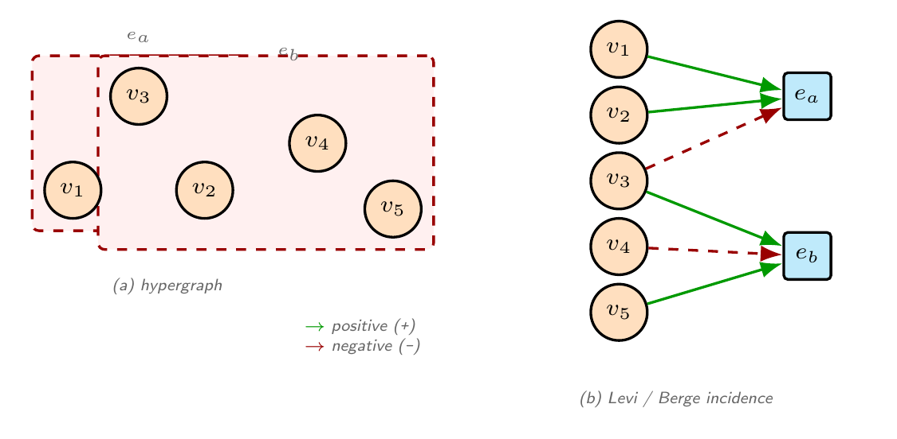
Figure 3 — A signed hypergraph (hyperedges e_a, e_b over v₁…v₅) and its Levi / Berge incidence — the star expansion (green +, red −).
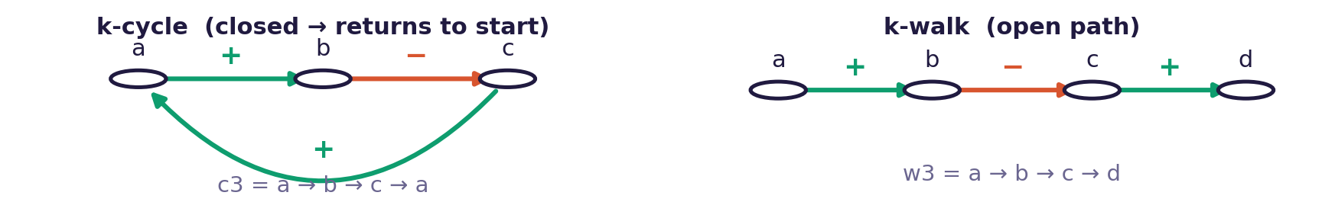
Figure 4 — A k-cycle (closed) and a k-walk (open); a cycle's sign is the product of its edge signs.
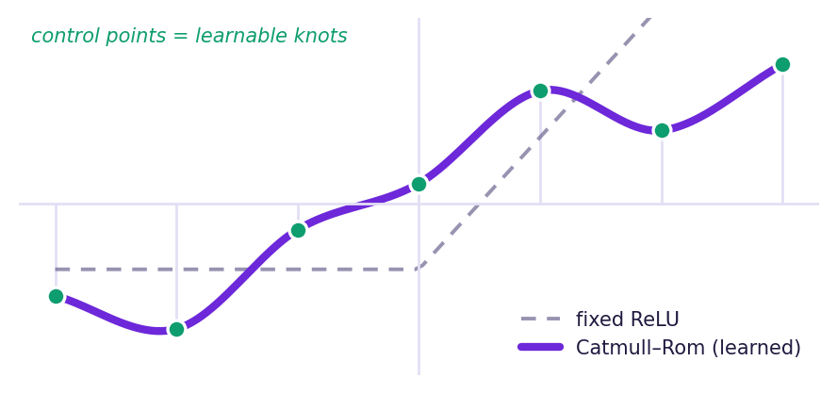
Figure 5 — A learnable Catmull–Rom spline activation (vs a fixed ReLU) — the KAN primitive.

How it works — the pipeline
- Author — write a declarative .hymeko source; geometry, colours and vocabulary are reused by reference, not duplicated.
- Compile — a SIMD lexer and an LALRPOP parser produce one canonical hypergraph IR with a Blake3 content-hash identity.
- Represent — one query-and-template engine emits URDF, SDF, MJCF, SysML v2, ROS 2 launch, DOT, Mermaid and a PyTorch module from that IR, cross-view consistent.
- Stream — the O(|E|·d) star expansion goes zero-copy to PyTorch (Iceoryx2 / Arrow / DLPack); a topology-hash gate (<100 µs) separates structure from weights.
- Enumerate — signed k-cycles and k-walks over the training edges become the structural tuples (c3 · c4 · c5 · w2 · w3).
- Learn — SignedKAN → HSiKAN → Gömb (Clifford-FIR → HSiKAN-CR → CPML) with learnable Catmull–Rom splines, a per-edge CR highway (edge_cr) and quaternion sign-attention.
- Audit — a leakage-audited strict protocol: the cycle pool never sees a test-edge sign; label-shuffle collapses to chance (0.540); 5-seed paired-Δ.
HyMeKo takes the hypergraph as a first-class object: a hyperedge binds several vertices at once, so n-ary relations keep their identity (no clique blow-up).
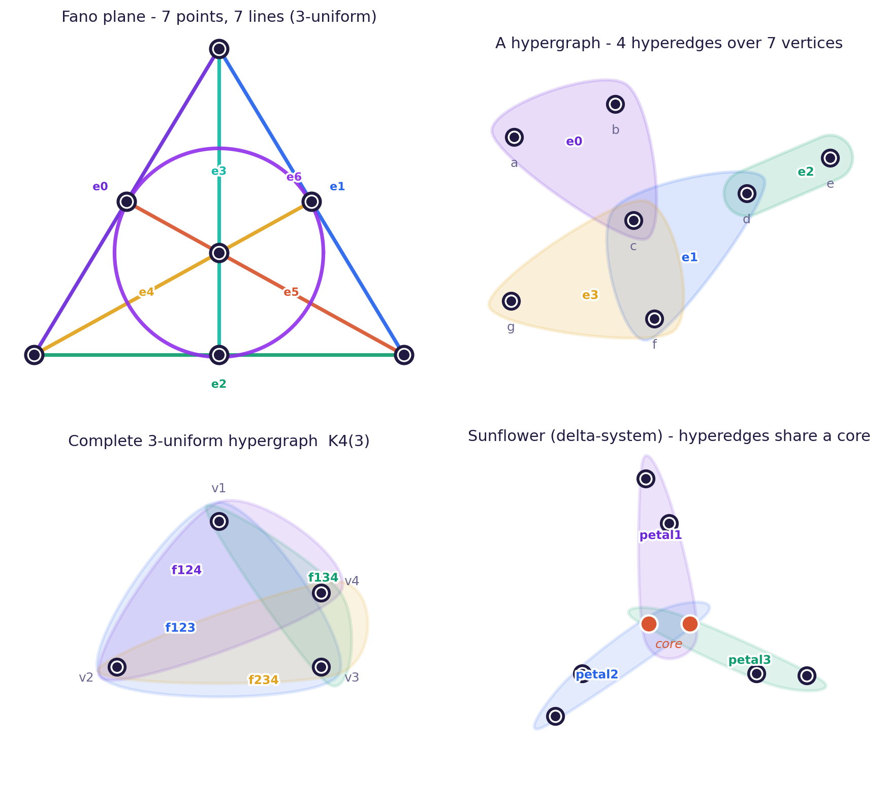
Figure 2 — Typical hypergraphs: vertices (•) and hyperedges as coloured sets (Fano plane, a generic hypergraph, K₄⁽³⁾, sunflower). Each is a .hymeko fixture; edge labels match the source.

Part I — The framework
- Declarative DSL with reuse by reference: a geometry (and colour) defined once, referenced by both visual and collision; the kinematics vocabulary imported once, not inlined.
- Canonical hypergraph IR with a Blake3 content-hash identity — isomorphic descriptions share one structural fingerprint.
- One query-and-template engine emits URDF, SDF, MJCF, SysML v2, ROS 2 launch, DOT, Mermaid and a PyTorch module — cross-view consistent, no recompile per target.
- Zero-copy bridge to PyTorch via Iceoryx2 / Arrow / DLPack, with a topology-hash gate (<100 µs) separating structure from weights.
Materialisation | Non-zeros | Extraction
Star — O(|E|·d) | 1,498 | 79.7 ms
Clique — O(|E|·d²) | 10,991 | 496 ms
Table 1 — Star vs clique materialisation on the same 50-node / 50-edge / 0.30-density hypergraph.
Kinematic structure | HyMeKo | URDF | MuJoCo
2-joint connection | 71 | 164 | 91
SCARA | 101 | 252 | 129
6-DoF arm (kinematics) | 2,779 | 5,088 | 1,733
Table 2 — Source size (characters), same robot. HyMeKo reuses geometry/colours by reference; URDF duplicates visual + collision. Full 6-DoF + control: one .hymeko file (6,134) vs a ROS/Gazebo bundle (~10 k across ~4 files).

Part II — Learning from structure
- Enumerated signed k-cycles and k-walks become inductive features (tuples). Examples — k-cycle (closed): c3 = a→⁺b→⁻c→⁺a, c4 = a→⁺b→⁻c→⁺d→⁻a; k-walk (open): w2 = a→⁺b→⁻c, w3 = a→⁺b→⁻c→⁺d.
- The SignedKAN → HSiKAN → Gömb family replaces fixed activations with learnable Kolmogorov–Arnold (Catmull–Rom) splines; HSiKAN adds an arity mixer, a per-edge Catmull–Rom highway (edge_cr) and quaternion sign-attention.
- Gömb is a strict three-shell cascade — Clifford-FIR (quaternion / multivector signed filter) → HSiKAN-CR → CPML (cycle-pool message layer) — with the cycle pool enumerated over training edges only.
- A vision variant adds Clifford-FIR / quaternion machinery with Forman–Ricci curvature and Hodge decomposition (∂²=0, 1-homology, discrete Ricci flow).
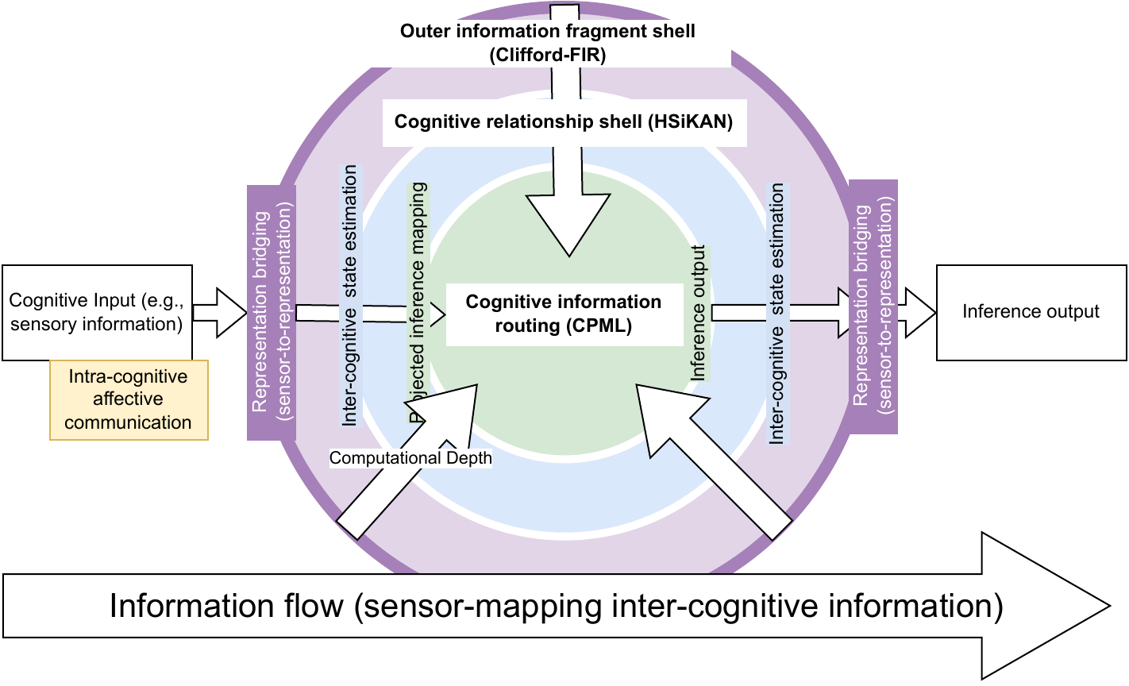
Figure 3 — The Gömb structural-prior cascade (Clifford-FIR → HSiKAN-CR → CPML).

Key results (honest framing)
- Competitive-to-leading at ≈¼ of the parameters, with the genuine lead on Epinions — not a flat SOTA claim. (Under the field's transductive convention, tuned configs reach 0.996 / 0.993 on Bitcoin.)
- Efficiency: ~30k parameters; the win is accuracy-per-parameter. Within-family forward gap (h4 vs h16, same device) ~3.5× on CPU, ≈1× on CUDA.
- Transfer: HyMeYOLO reaches mAP50 ≈ 0.90 (a statistical tie with a ReLU backbone) — an approach to hypergraph convolution, not a benchmark win. Kinematics recovered from topology alone to ≈5 cm.
- Methodology: label-shuffle leakage diagnostic (Gömb → 0.540 = chance); 5-seed paired-Δ; every number maps to an on-disk artifact.
Dataset | Gömb-strict (ours) | SGCN | SiGAT
Bitcoin-α | 0.897 | 0.929 | 0.903
Bitcoin-OTC | 0.915 | 0.942 | 0.932
Slashdot | 0.902 | 0.919 | —
Epinions | 0.943 (FT 0.953) | — | ≈0.95
Table 3 — Signed-graph link prediction, held-out test ROC-AUC (5-seed, Gömb-strict). Baselines are published numbers.

New result — Cayley-rotor embeddings (2026-06-16)
A flat-parameter, inductive, leakage-free embedding: each item embedding is a learned rotation (a Clifford rotor via the Cayley map) of one shared reference on a sphere — no per-node lookup table. It matches a growing-parameter baseline (DADSGNN) at ~9–16× fewer parameters, and label-shuffle collapses it to chance (~0.50).
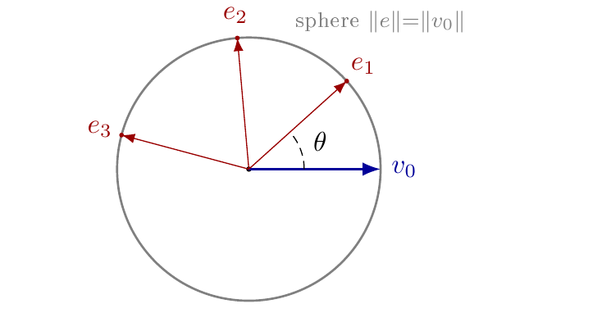
Figure 5 — The rotor embedding: each item is a rotation of one reference on a sphere; the angle is the similarity.
Dataset | Rotor AUROC | Rotor params | DADSGNN AUROC | DADSGNN params
Bitcoin-α | 0.867 ± 0.011 | 15.8k | 0.860 ± 0.011 | 142k
Bitcoin-OTC | 0.894 ± 0.006 | 15.8k | 0.880 ± 0.007 | 209k
wiki_elec | 0.885 ± 0.002 | 15.8k | 0.896 ± 0.007 | 249k
Table 4 — Signed-link test ROC-AUC, 5 seeds. Rotor is parameter-flat; the baseline grows. Source: reports/rotor_multiseed_20260616.jsonl.

Contributions
- A canonical hypergraph infrastructure — a DSL plus a content-hashed IR; one source, many targets.
- A structural-prior learning family — cycles and walks as inductive features (SignedKAN / HSiKAN / Gömb), strictly leakage-audited. The same IR is both the engineering transform and the learning substrate.
Co-authors: László Környei, Katalin Kovács, Ádám Csapó, and others.

Contact
Csaba Hajdu · Kato Laboratory. Code & docs: github.com/kyberszittya/hymeko_framework_rust

