SCUT토디주예제디버깅요약
먼저 감사하자. Scut 의 열정도움

1.mysql데이터베이스 설치
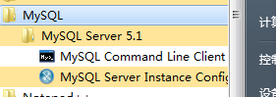
여기서 설치할 때 아이디와 비번을 잊지말도록 주의하자

2.Navicat 데이터베이스 비쥬얼라이징소프트웨어 설치
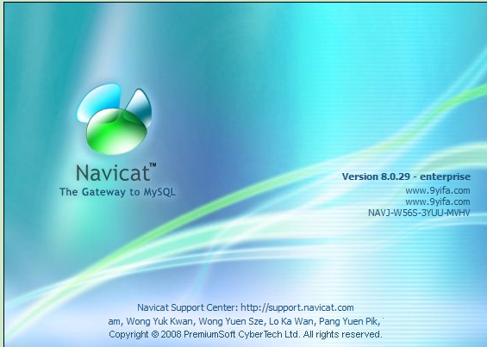
예제에서 사용함
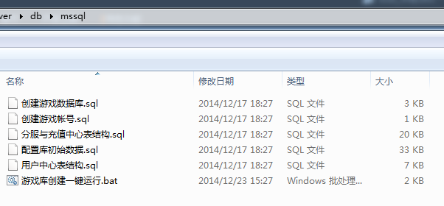
주로 마이크로소프트의 Sql 서버를 타겟으로 잡고있다.내가 그것을 사용하지 않은 주된이유는그것이 너무크고 어떻게 쓰는지 잘모르고 게임에서는 별의미가 없기 때문이다. 여기서 우리는 한 개의데이터베이스를 생성하고. SQL 문을 실행해야한다
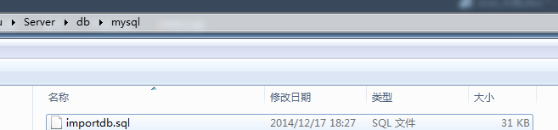
具体操作如下
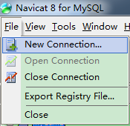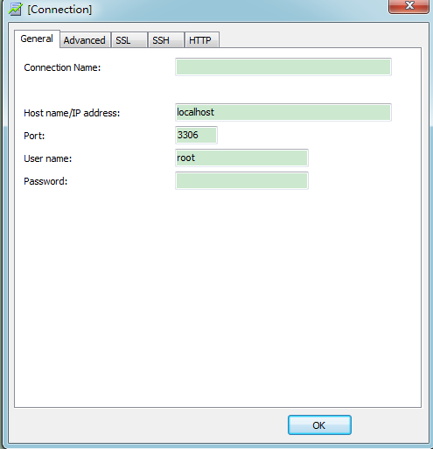
Psaaword：root, Connection Name: （니스스로 써봐）
생성후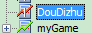
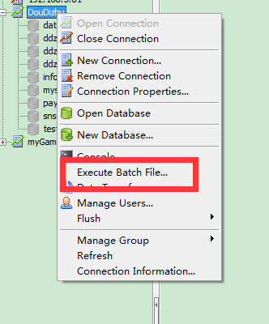
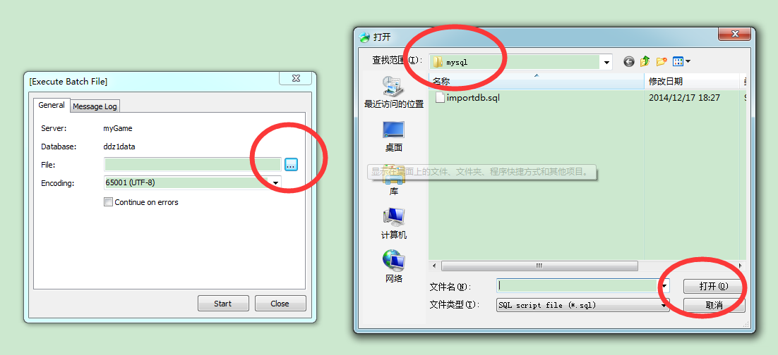

그리고 대략몇초후 우리의 mysql 이쪽부분은 준비가 완료된다.

3. 계속해서 우리는 Redis 를 설치해야한다
더이상설정할게없어보인다.이전에 설치할 때 아래 링크를 참고했다. http://www.zuidaima.com/share/1904177509714944.htm

4.配置SCUT Server Management Studio.
나스스로 여기서 죽어버림 정말로 어떻게 설정하는지 모르겠어 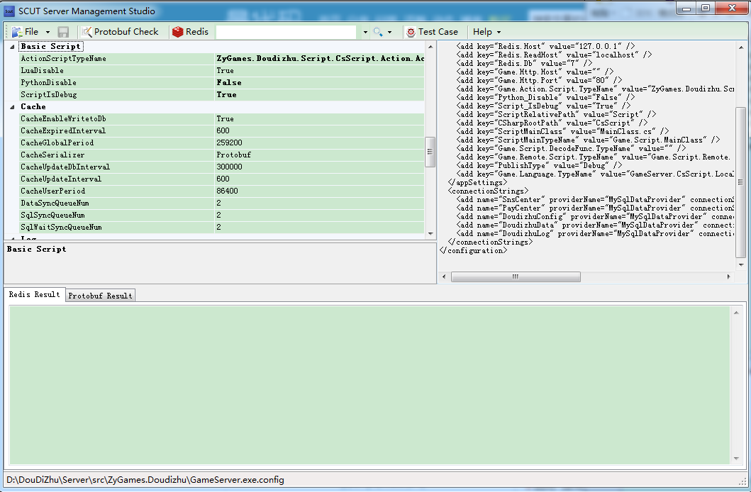
좌측비주얼라이징, 우측XML격식. 저장후생성된파라메터들은
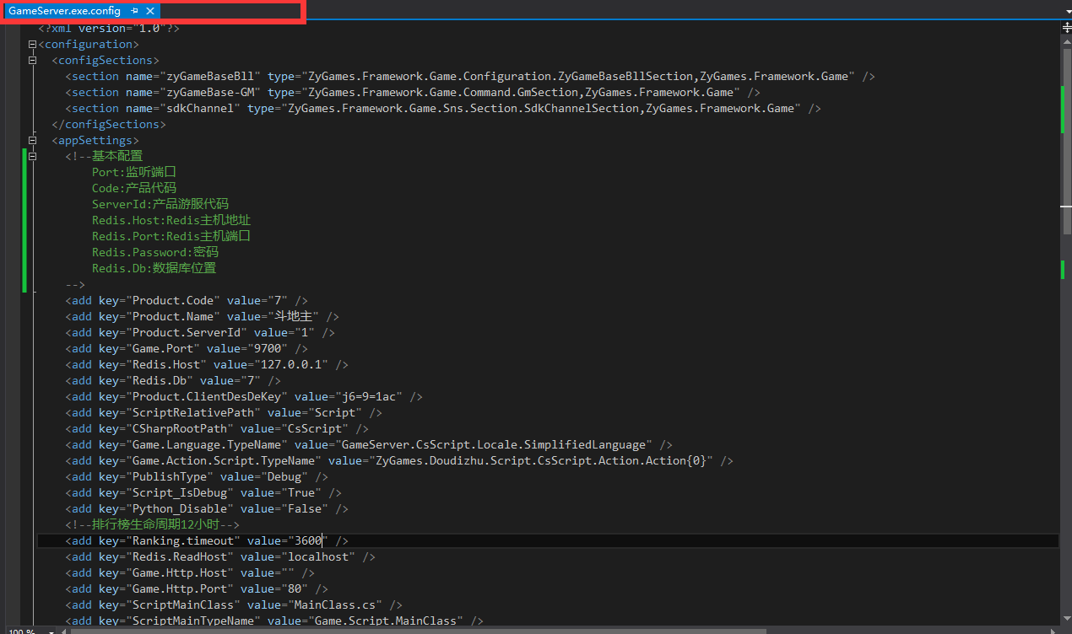이화일이다.
<?xml version="1.0"?>
<configuration>
<configSections>
<section name="zyGameBaseBll" type="ZyGames.Framework.Game.Configuration.ZyGameBaseBllSection,ZyGames.Framework.Game" />
<section name="zyGameBase-GM" type="ZyGames.Framework.Game.Command.GmSection,ZyGames.Framework.Game" />
<section name="sdkChannel" type="ZyGames.Framework.Game.Sns.Section.SdkChannelSection,ZyGames.Framework.Game" />
</configSections>
<appSettings>
<!--基本配置
Port:监听端口
Code:产品代码
ServerId:产品游服代码
Redis.Host:Redis主机地址
Redis.Port:Redis主机端口
Redis.Password:密码
Redis.Db:数据库位置
-->
<add key="Product.Code" value="7" />
<add key="Product.Name" value="斗地主" />
<add key="Product.ServerId" value="1" />
<add key="Game.Port" value="9700" />
<add key="Redis.Host" value="127.0.0.1" />
<add key="Redis.Db" value="7" />
<add key="Product.ClientDesDeKey" value="j6=9=1ac" />
<add key="ScriptRelativePath" value="Script" />
<add key="CSharpRootPath" value="CsScript" />
<add key="Game.Language.TypeName" value="GameServer.CsScript.Locale.SimplifiedLanguage" />
<add key="Game.Action.Script.TypeName" value="ZyGames.Doudizhu.Script.CsScript.Action.Action{0}" />
<add key="PublishType" value="Debug" />
<add key="Script_IsDebug" value="True" />
<add key="Python_Disable" value="False" />
<!--排行榜生命周期12小时-->
<add key="Ranking.timeout" value="3600" />
<add key="Redis.ReadHost" value="localhost" />
<add key="Game.Http.Host" value="" />
<add key="Game.Http.Port" value="80" />
<add key="ScriptMainClass" value="MainClass.cs" />
<add key="ScriptMainTypeName" value="Game.Script.MainClass" />
<add key="Game.Script.DecodeFunc.TypeName" value="" />
<add key="Game.Remote.Script.TypeName" value="Game.Script.Remote.{0}" />
</appSettings>
<connectionStrings>
<add name="SnsCenter" providerName="MySqlDataProvider" connectionString="Data Source=localhost;Database=snscenter;Uid=root;Pwd=root;" />
<add name="PayCenter" providerName="MySqlDataProvider" connectionString="Data Source=localhost;Database=PayDB;Uid=root;Pwd=root;" />
<add name="DoudizhuConfig" providerName="MySqlDataProvider" connectionString="Data Source=localhost;Database=DdzConfig;Uid=root;Pwd=root;" />
<add name="DoudizhuData" providerName="MySqlDataProvider" connectionString="Data Source=localhost;Database=Ddz1Data;Uid=root;Pwd=root;" />
<add name="DoudizhuLog" providerName="MySqlDataProvider" connectionString="Data Source=localhost;Database=Ddz1Log;Uid=root;Pwd=root;" />
</connectionStrings>
<!--业务层自定义配置-->
<zyGameBaseBll>
<login defaultType="ZyGames.Framework.Game.Sns.Login36you,ZyGames.Framework.Game">
<retailList>
<add id="0000" type="ZyGames.Framework.Game.Sns.Login36you,ZyGames.Framework.Game" args="Pid,Pwd,DeviceID" />
<add id="0001" type="ZyGames.Framework.Game.Sns.Login91sdk,ZyGames.Framework.Game" args="RetailID,RetailUser,Sid" />
<add id="2006" type="ZyGames.Framework.Game.Sns.Login91sdk,ZyGames.Framework.Game" args="RetailID,RetailUser,Sid" />
<add id="0036" type="ZyGames.Framework.Game.Sns.LoginUC,ZyGames.Framework.Game" args="RetailID,Sid,MobileType" />
<add id="0037" type="ZyGames.Framework.Game.Sns.LoginDanLe,ZyGames.Framework.Game" args="RetailID,RetailUser,Pwd,Pid" />
<add id="2014" type="ZyGames.Framework.Game.Sns.LoginDanLe,ZyGames.Framework.Game" args="RetailID,RetailUser,Pwd,Pid" />
<add id="2008" type="ZyGames.Framework.Game.Sns.Login360,ZyGames.Framework.Game" args="RetailID,Pid" />
<add id="0021" type="ZyGames.Framework.Game.Sns.Login360_V2,ZyGames.Framework.Game" args="RetailID,RetailUser,Pid,Code" />
</retailList>
</login>
</zyGameBaseBll>
<!--配置SDK-->
<sdkChannel>
<channel91 url="http://service.sj.91.com/usercenter/AP.aspx">
<channel name="0001" appId="101186" appKey="b456617302af2eed5ebf9590a74442fae2036a8b60eb190b" />
</channel91>
<channel360 url="https://openapi.360.cn/user/me.json" aceess_token_url="https://openapi.360.cn/oauth2/access_token" get_aceess_token_url="https://openapi.360.cn/oauth2/access_token">
<channel name="0021" appId="200708151" appKey="582e52129baec38109a9a150b17f8d7e" appSecret="06dd69d5bfec82de7fa9ca7fdbb66cd8" />
</channel360>
</sdkChannel>
<zyGameBase-GM>
<command>
<!--GM:cache-->
</command>
</zyGameBase-GM>
</configuration>

这个文件中需要注意的就是
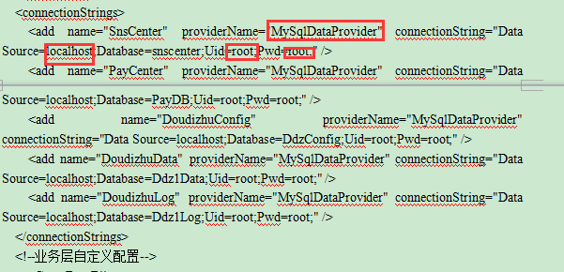
5개부분을 수정해야한다. 어딘지모르겠으면 직접 XML 을 수정하자
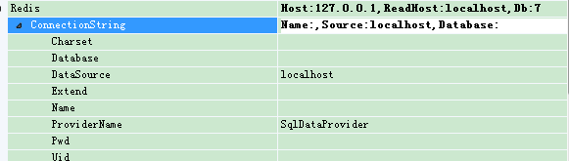
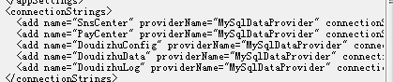
내가실행한 것은
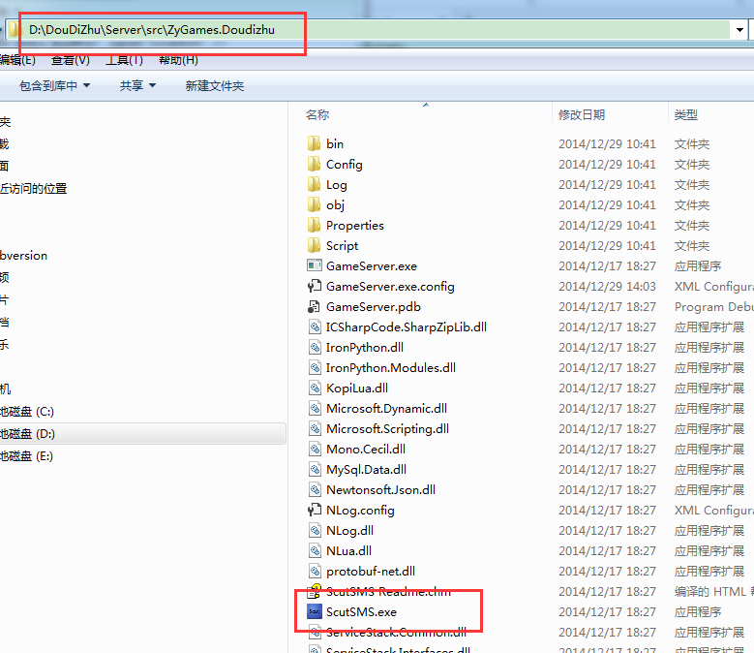这个目录下的工具所以调整之后 生成的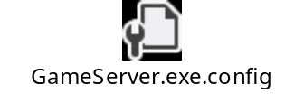文件会在该目录下，然后将这个修改后的文件copy到D:\DouDiZhu\Server\release 然后运行。
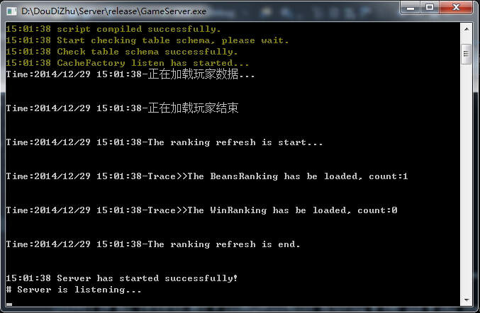
然后运行客户端
