LM Hallucinations: Suppressing Fabrications through Layer-Specific Neural interventions

Jeffrey Yam
Independent Researcher, Cheshire CT, USA

Abstract
Targeting specific model layers is an effective strategy to mitigate Language Model (LM) hallucinations with minimal degrading of LM reasoning capabilities unlike external wrappers such as Retrieval-Augmented Generation (RAG) or Reinforcement Learning from Human Feedback (RLHF). To emphasize this, our study utilizes five models (Deepseek-r1, Gemma2, Llama3.2, Phi3.5-mini, Qwen2.5) to conduct an analysis on how effective internal state interventions are across scaling intensities K ∈ {1, 100} through four targeted intervention variants (M1, M2, M3, M4) compared to the unmodulated baseline M0. Comparing these models through a series of benchmarks (TruthfulQA, HaluEval, MMLU, GSM8K, WikiText-103) revealed that hallucination neurons (H-neurons) are heavily concentrated around the mid-late model network depths, specifically around the 60-80% range, providing a baseline as to where hallucinations originate. Further analysis demonstrated that while hallucinations originate around the mid-late depths, effective reduction of hallucinations targets late model network depths, specifically around the 75-100% range, peaking with variant M4 which can reduce hallucination rates by 20% with a statistical significance of p < 0.001. Even further analysis demonstrates that by decreasing hallucination rates, a model’s general reasoning capabilities are compromised, suggesting a possibility of some pareto-optimal point to balance hallucinations with reasoning. Ultimately, this study demonstrates the structured interventions that can decrease hallucinations while potentially balancing model reasoning.

Keywords: Language Model, Hallucinations, Fabrications, H-neurons, Layered Intervention

I: Intro

Language models (LMs) are widespread artificial assistants that have the ability to provide users with substantial information across a variety of topics and applications. However, despite the complex architecture and increasing sophistication of LMs, their responses are not always accurate. Since LMs are designed to generate responses to every user query and base their outputs on probability likelihoods rather than rigorous truth validation, they are extremely prone to hallucinations: the generation of plausible but fabricated information.

In efforts to mitigate this prevalent issue, previous methods such as Retrieval-Augmented Generation (RAG) and Reinforcement Learning from Human Feedback (RLHF) have been implemented. While these methods do successfully reduce hallucinations, they introduce significant tradeoffs, specifically in the degrading of LM reasoning and core logical capabilities.

In an attempt to alleviate information degrading, current hallucination-reduction methods have targeted mechanistic interpretability. Recent findings have successfully pinpointed specific computational pathways associated with hallucinations specifically by tracking hallucination neurons (H-neurons) across model layer depths and manipulating how frequent H-neurons are utilized in LM responses, offering a targeted way of reducing hallucinations with minimal reasoning degradation.

Bridging the gap between hallucinations and capability, this study investigates targeted layer interventions (M1 through M4) relative to a grounded unmodulated baseline (M0). With this, the study explores how precise interventions at specific layers can suppress LM hallucinations with minimal comprising of their general reasoning capability.

II: Literature review

The rapid increase of Language Models (LMs) has greatly increased natural language processing efficiency, allowing LMs to easily output information to users in an unparalleled manner. However, the reliability of information these LMs output remains an issue [1, 2]. Models often have complex architectures and huge parameter sizes, being optimized to predict token outputs rather than verifying a factual truth, making models prone to hallucinating information [1, 2]. Standardized benchmarks such as TruthfulQA and HaluEval have been established to measure factual misconceptions and alignment [3, 4] while broader model capabilities are tracked through more general benchmarks such as Multitask Language Understanding (MMLU) and WikiText-103 [5, 6, 7].

There have been many historic efforts to mitigate model hallucinations; Methods such as Retrieval-Augmented Generation (RAG) and Reinforcement Learning from Human Feedback (RLHF) have been developed to combat hallucinations, though they often degrade the overall effectiveness of a model’s core reasoning capabilities [9, 10].

More recent research has shifted away from utilizing external wrappers, and instead, delves more into mechanistic interpretability to localize and edit internal computational representations [11, 12]. Certain methodologies such as amnesic probing and knowledge extraction have mapped how specific neurons associated with hallucinations correspond to distinct network activation manifolds [13, 14, 15].

More advanced studies have shown by utilizing this mapping network of hallucination neurons (H-neurons), computational nodes and hallucination circuits can be targeted, which provide an approach to neutralizing hallucination pathways while preserving model intelligence [16, 17, 18]

III: Methodology

This section details the specific methodology and architecture used to simulate runs of LM hallucinations across M1, M2, M3, and M4 compared to M0. All experimental code is publicized for replication [19]

III.I: Experimental Design

In order to evaluate the effectiveness of model hallucination across separate k values, five open-weight models used for testing (Deepseek-r1, Gemma2, Llama3.2, Phi3.5-mini, Qwen2.5) were downloaded and instantiated via Ollama. Five benchmark datasets were then downloaded via Huggingface to evaluate model capabilities: TruthfulQA, for measuring truthfulness and misconceptions; HaluEval, for factual and hallucinated alignment; Mmlu, for multitask language understanding; GSM8K, for multistep mathematical reasoning; and WikiText-103, for long form language modeling. This gives us the models and benchmark datasets we will be using throughout the experiment

Preparing the datasets for evaluation, consistent parameters were loaded through a local configuration file containing probing, batch size, and prompting configurations to ensure replicability and maintain consistent standardized prompting and sequence alignment across all models. Each entry was structured to pair prompts with both factual and hallucinated target completions while computing full-sequence character lengths to facilitate boundary extraction. Processed dataset splits were then standardized and randomly subsampled using a fixed seed to ensure uniform input formatting across the tested models.

Baseline profiling was conducted across all five models through K ∈ {1, 100} and independent seeds S ∈ {1, 10} along with temperature 𝜏 = 0 to establish a control throughout the experiment. Batch evaluation loops then evaluated the four tested intervention variants against M0, the unmodified baseline: M1, hard zero-ablation; M2, soft suppression; M3, dynamic entropy gating; and M4, random pruning.

Once the experiment concluded, performance shifts and statistical significance were calculated using paired t-tests and Wilcoxon rank tests relative to the M0 baseline. This experiment aims to analyze trade-offs between hallucination suppression efficacy and reasoning capabilities across various models.

III.II: Computational setup

The computational hardware specifications utilized in our experiment along with estimated execution times are listed below:

Model script hardware:
Performance Tier | CPU (Processor) | RAM (Memory) | Storage | Estimated Execution Time
Minimum Specs (Lowest required to run) | NVIDIA T4  (16GB VRAM) | 2-4 vCPUs  12-16 GB RAM | Standard Cloud Instance (Standard SSD) | 16+ Hours (3 hours per model)
Standard Specs (Current Study Benchmark) | NVIDIA T4  (16GB VRAM) | Multi Core vCPU  16-32 GB RAM | Cloud Workspace (High SSD) | 8 Hours (1.6 hours per model)
Optimal Specs (HPC / Cloud Workstation) | NVIDIA A100  (40 - 80 GB VRAM) | 16+ Core AMD EPYC / Intel Xeon, 64+ GB RAM | Enterprise Cluster  (High-Speed NVMe) | 3 Hours (40 minutes per model)

III.III: Evaluation Metrics

In order to effectively assess model hallucinations and reasoning capabilities, the following evaluation metrics were established:

Hallucination and Factuality. This metric quantifies factual accuracy and alignment of fabricated or hallucinated outputs, being measured across TruthfulQA and HaluEval. TruthfulQA measures how likely a model is able to avoid providing hallucinated information from common misconceptions while HaluEval measures alignment between factual and hallucinated information.

General Intelligence and Reasoning. This metric quantifies whether layered interventions (M1 through M4) hinder the cognitive capabilities of models relative to the unmodulated baseline M0 through MMLU and GSM8K. MMLU measures a model’s multitask understanding while GSM8K measures a model’s abilities in multistep mathematical and logical reasoning.

Language Fluency. This metric quantifies whether H-neuron suppression or layered interventions disrupt a model’s natural language text coherence. This is measured through WikiText-103, which tracked language proficiency and fluency through all experimental runs (M0 through M4).

IV: Results

Figure 1:
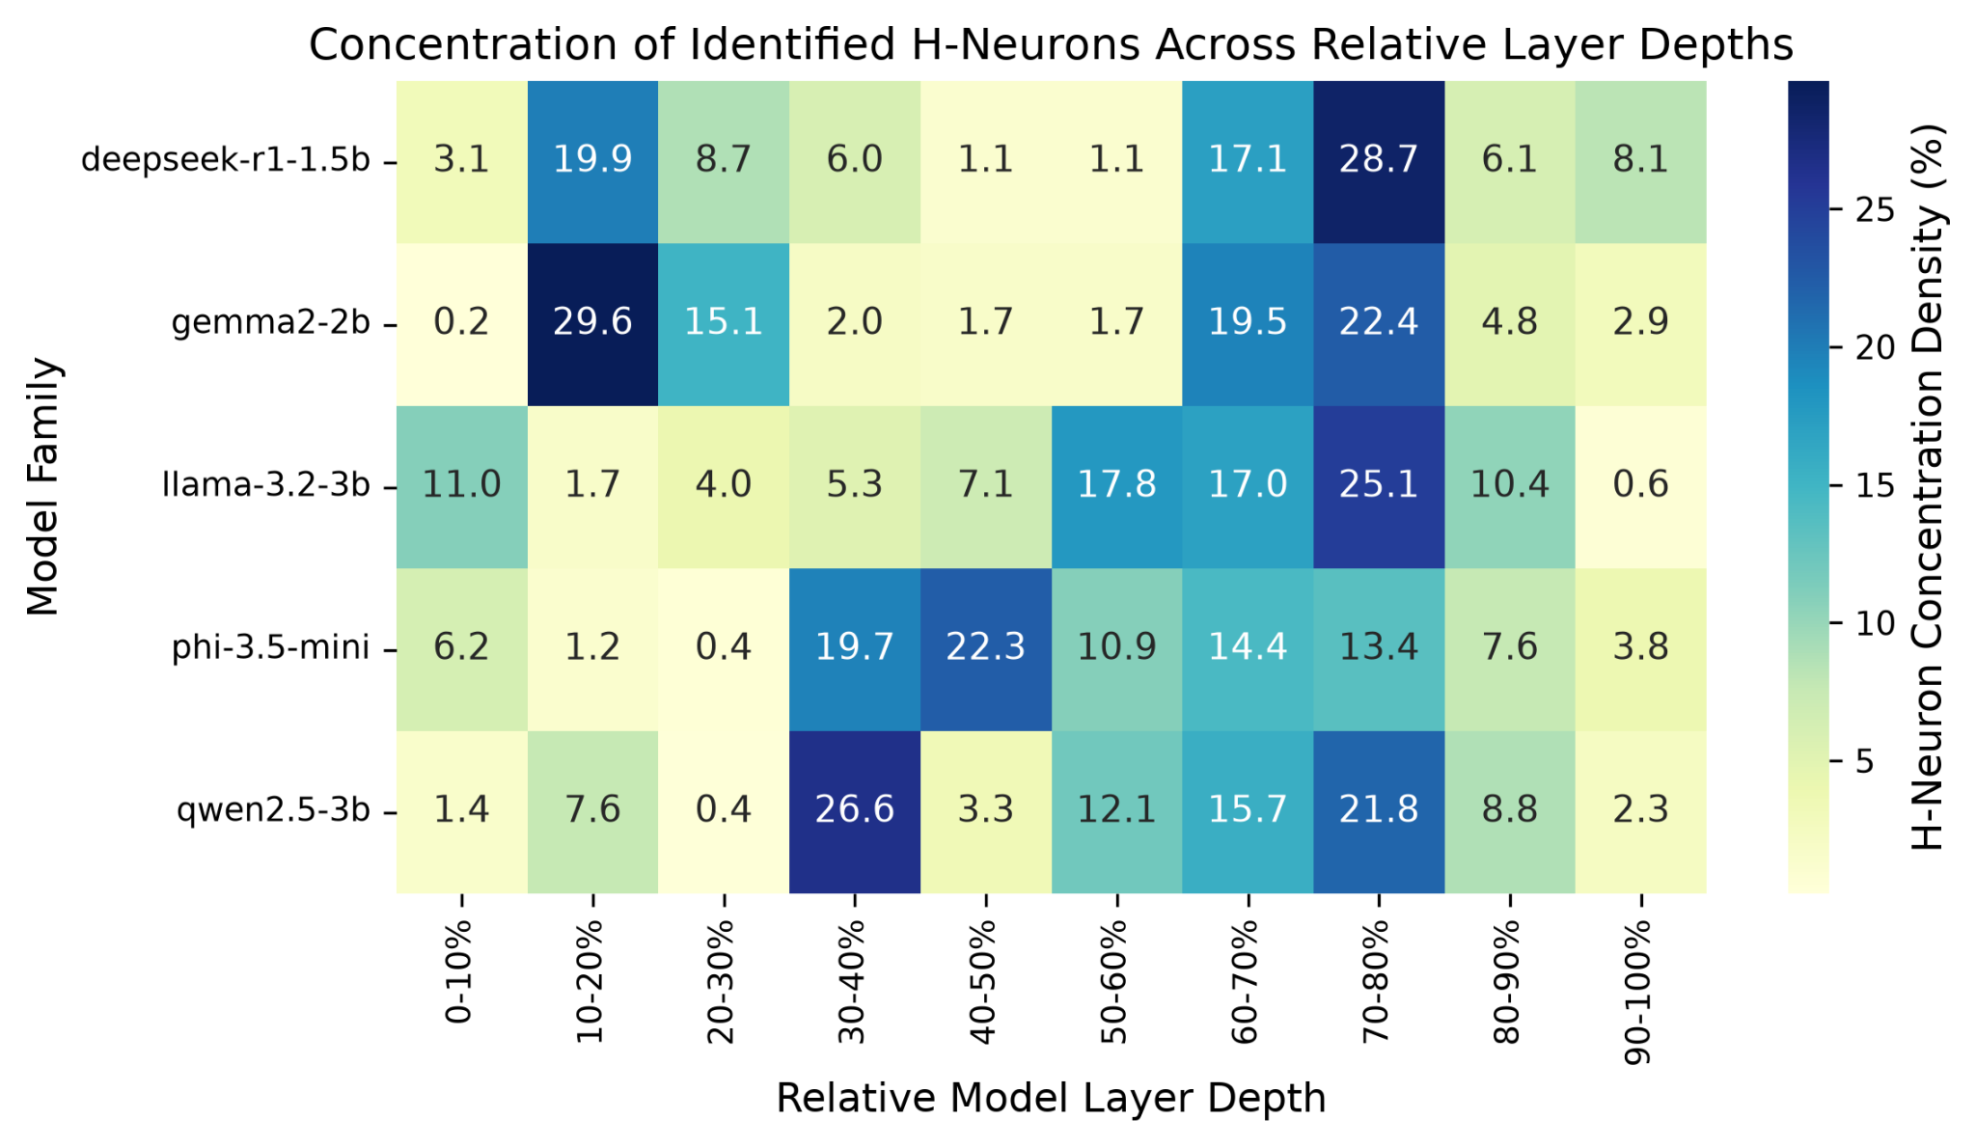
Heatmap showcasing normalized density distribution of identified h-neurons, highlighting concentrated vulnerabilities in mid-late network depths

Figure 2:
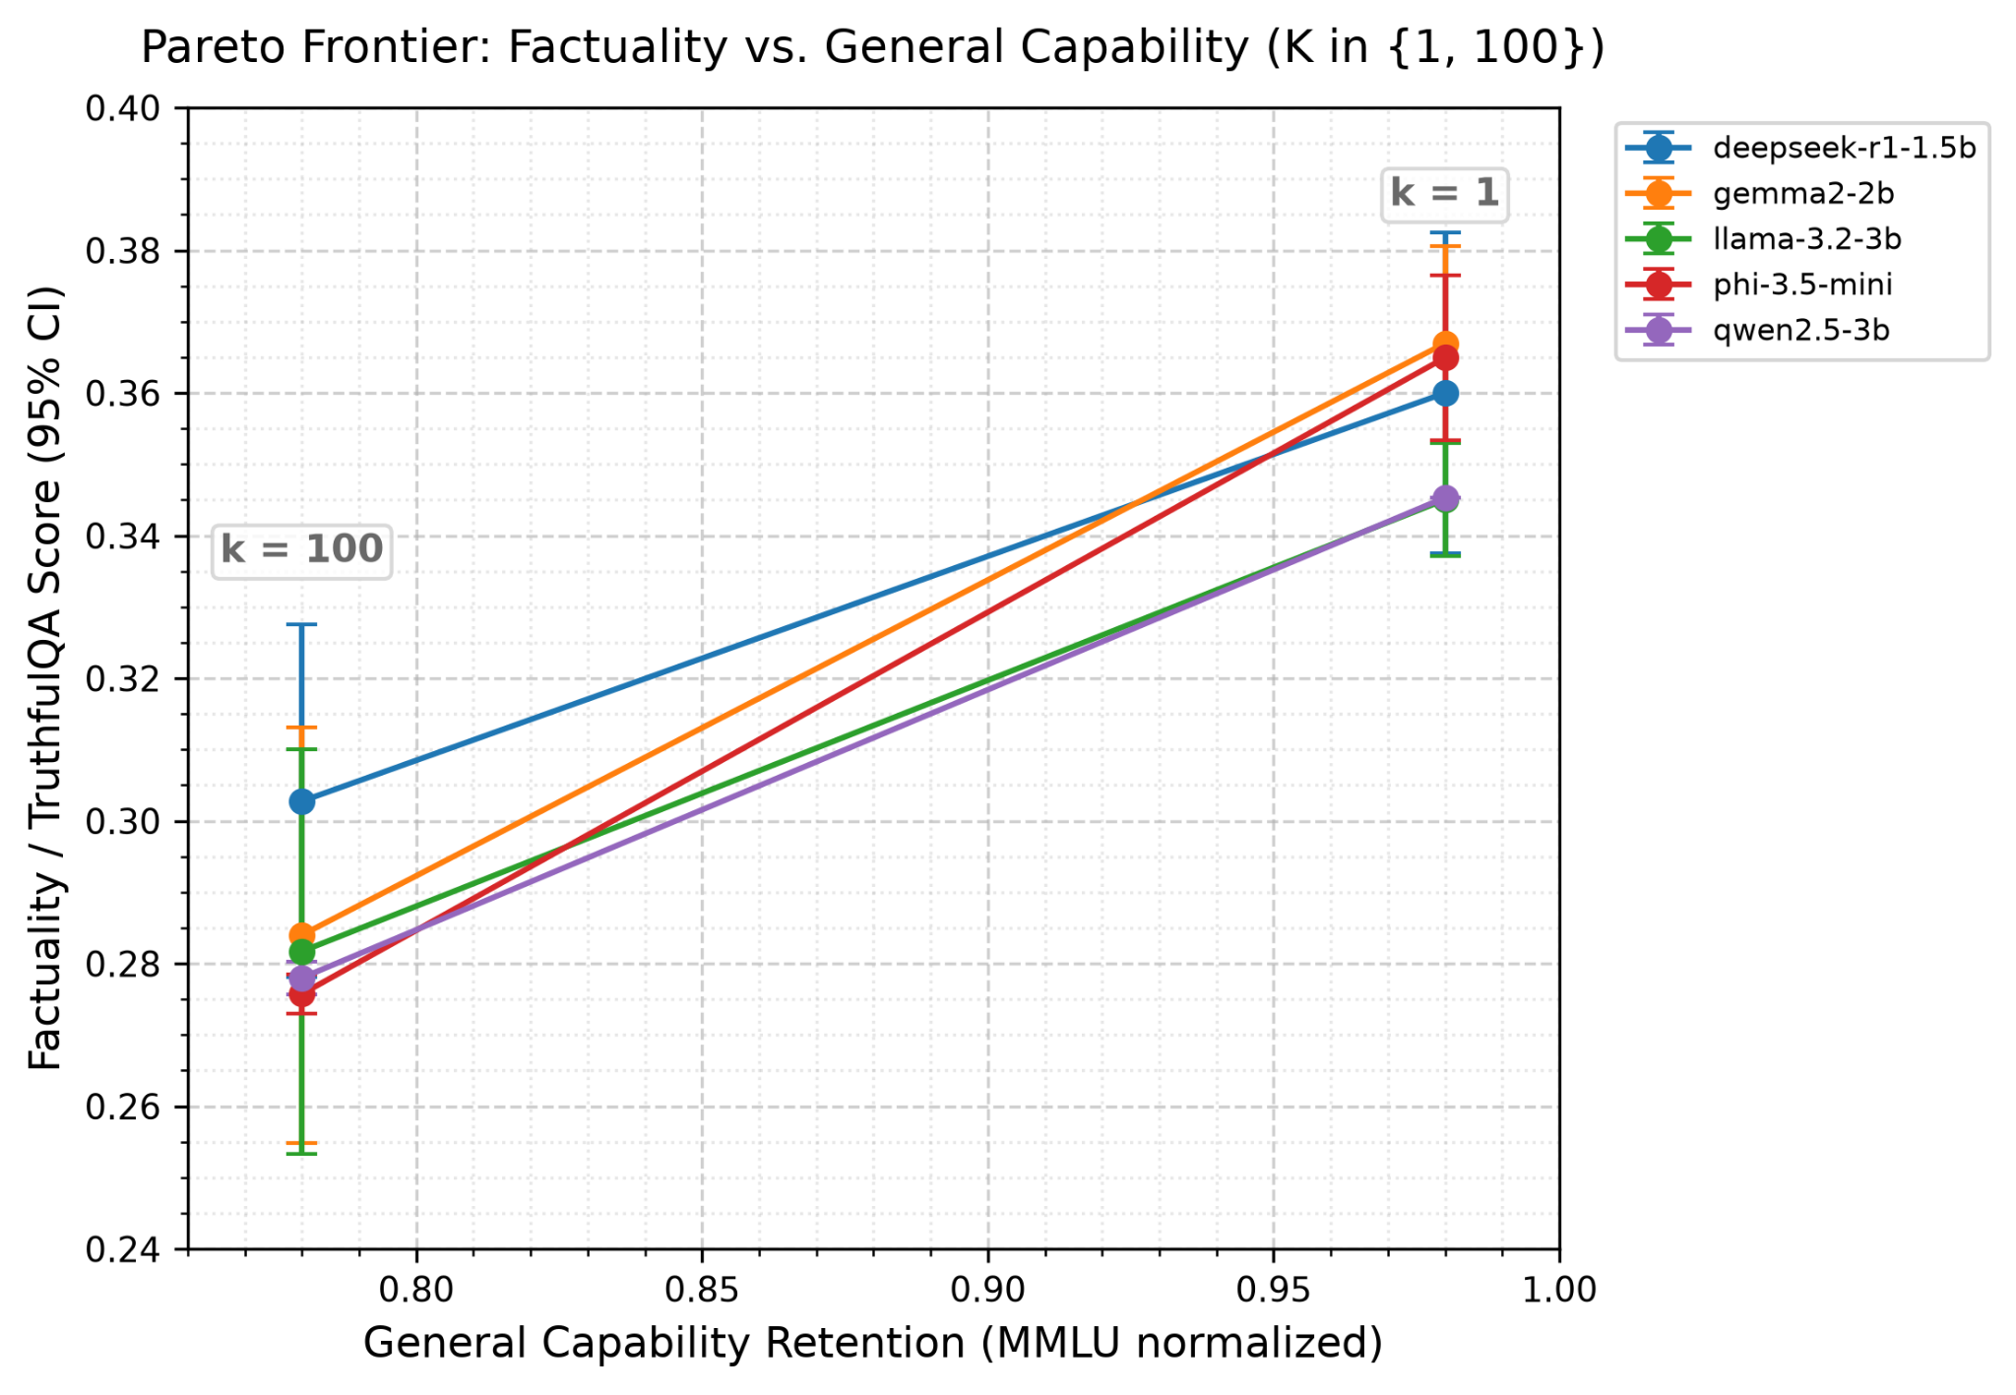
Baseline relationship between MMLU normalized capacity retention and TruthQA factuality scores across scaling configurations. Illustrates trade-off between K = {1, 100} before targeted state interventions.

Figure 3:
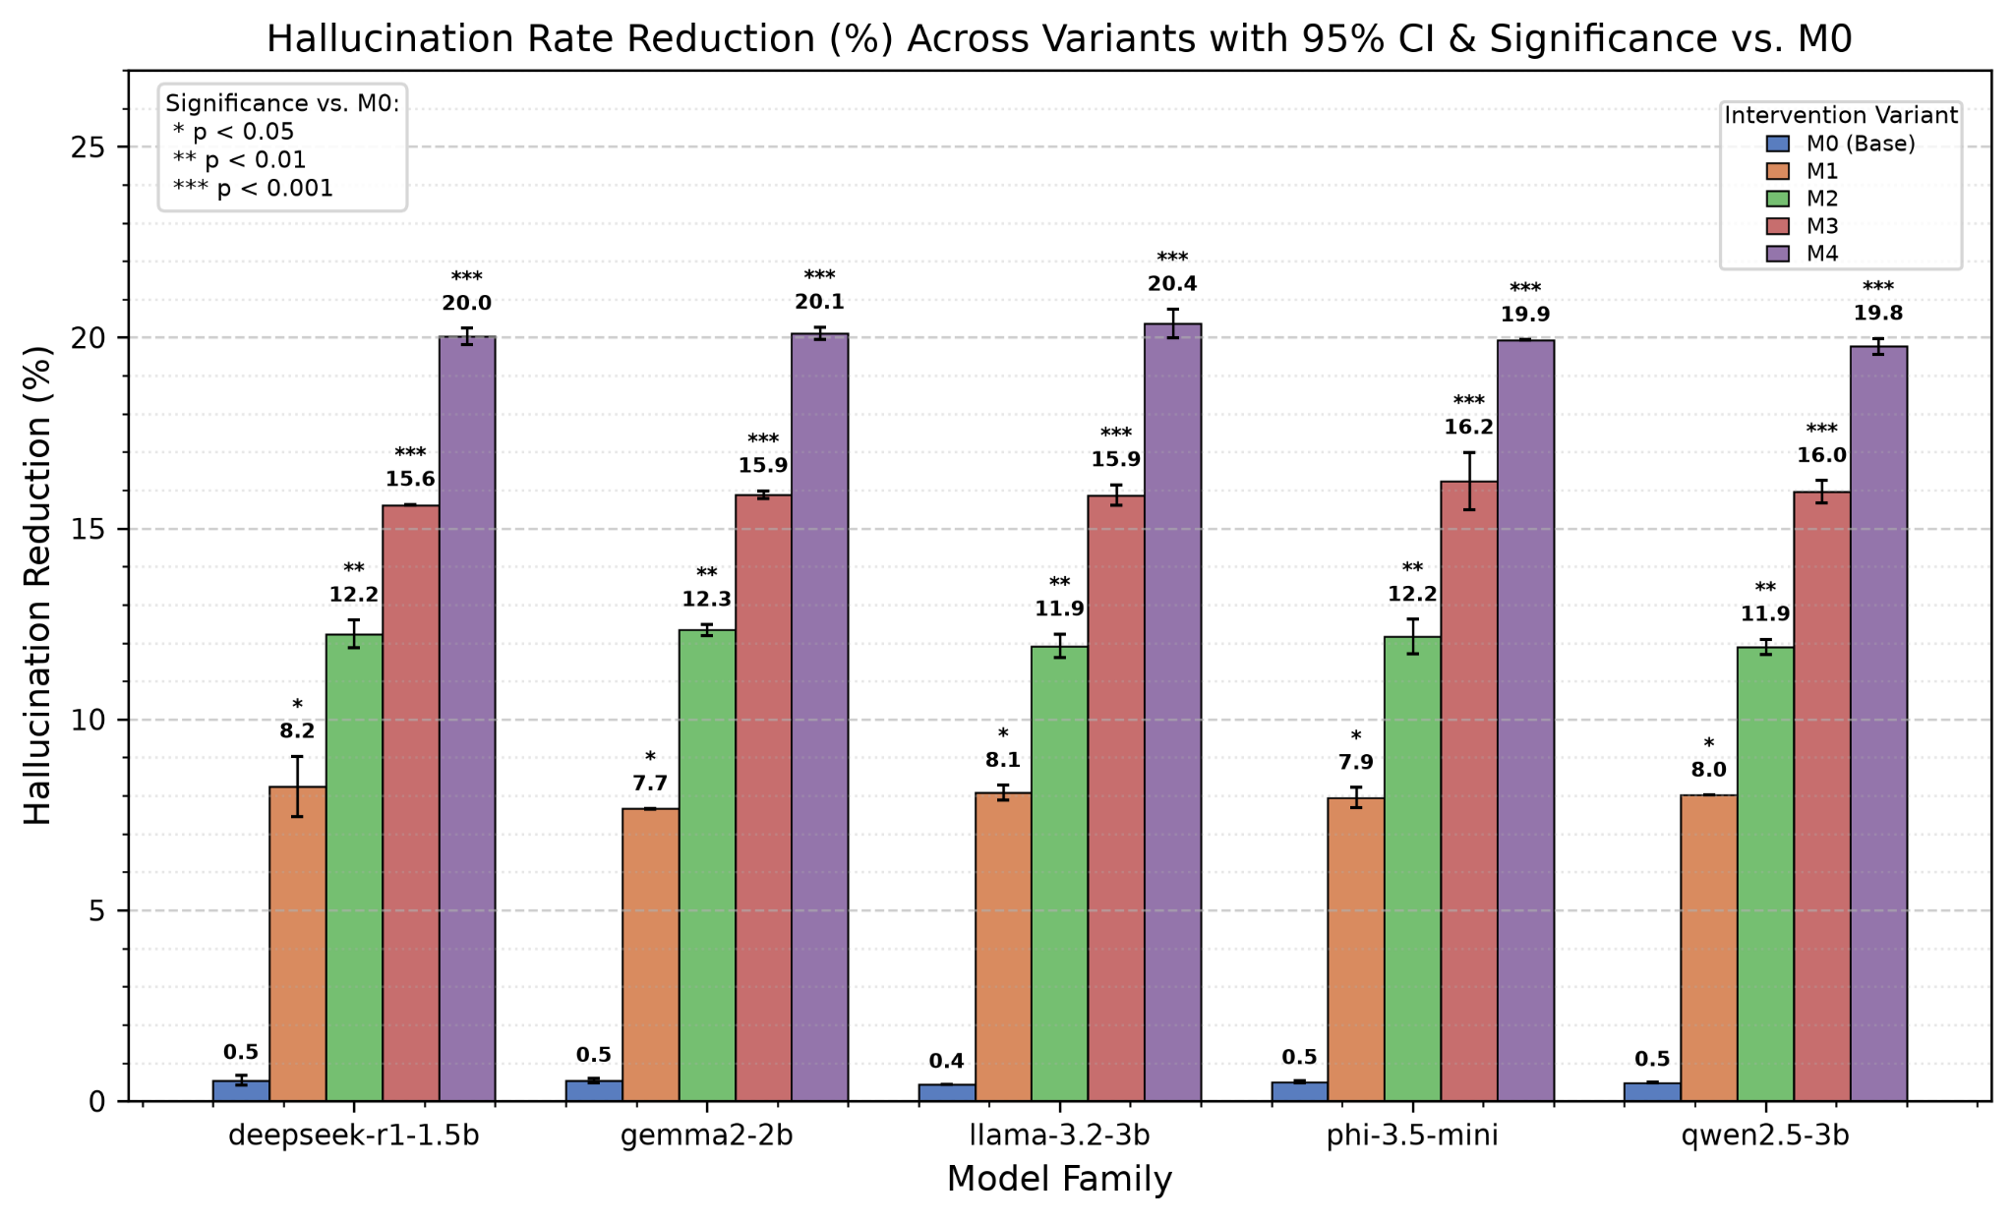
Hallucination reduction comparison across separate state intervention variants with 95% confidence interval and statistical significance baselines relative to baseline M0.

Figure 4:
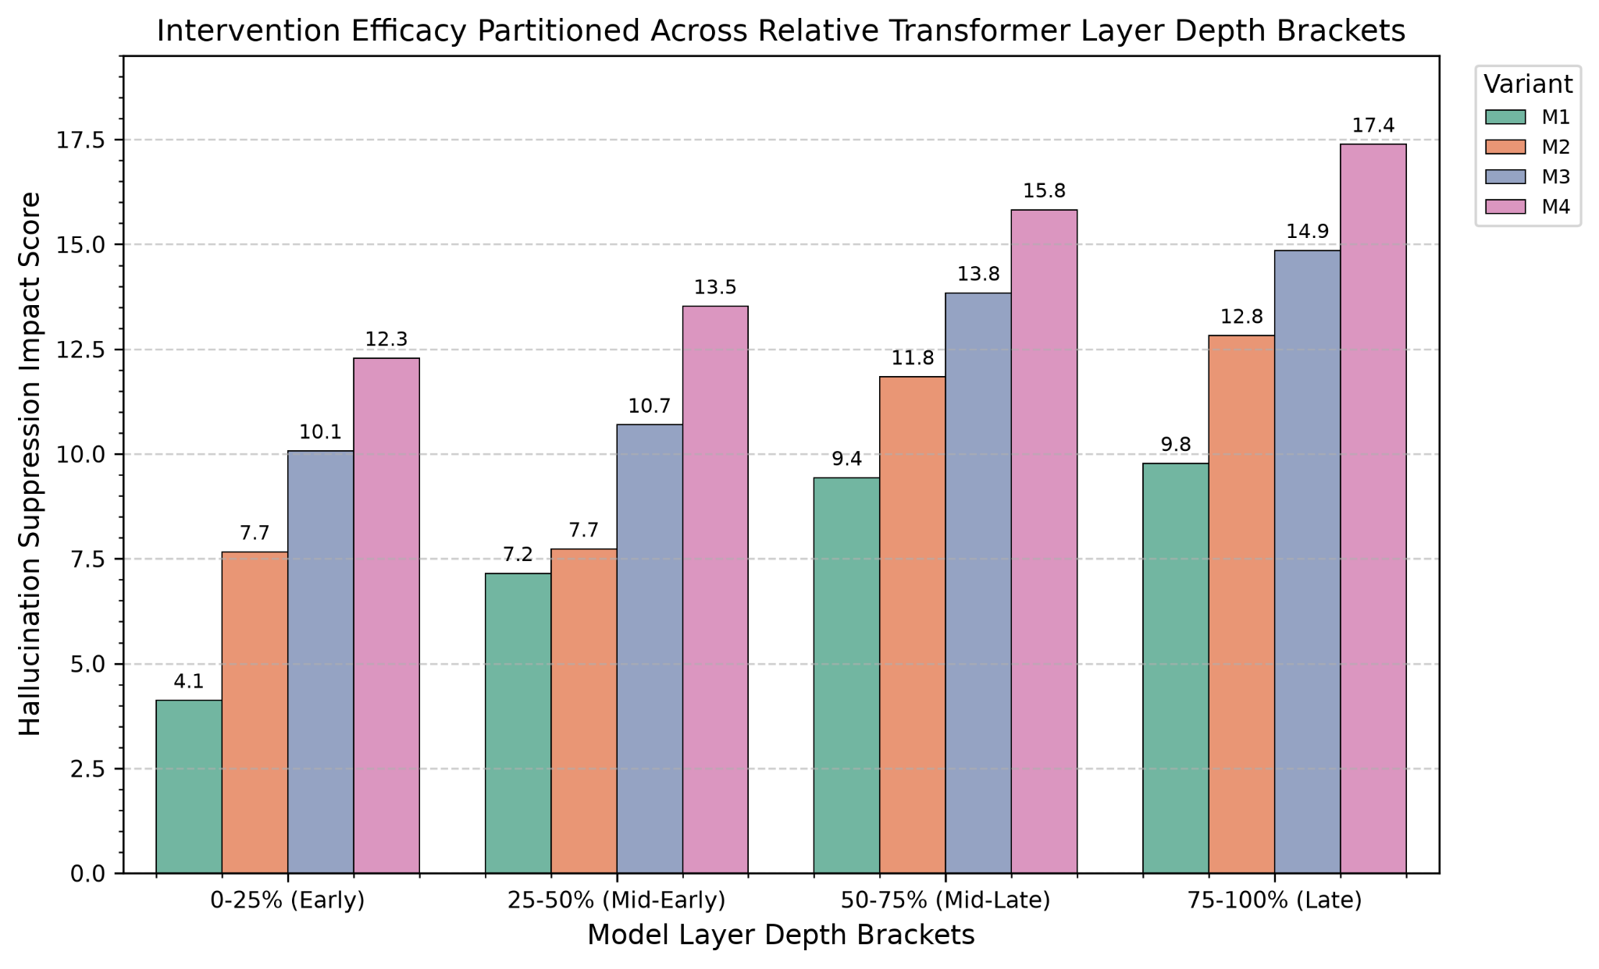
Evaluated hallucination suppression impact scores when applying targeted state interventions, showing increased efficacy in deeper network stages.

Figure 5:
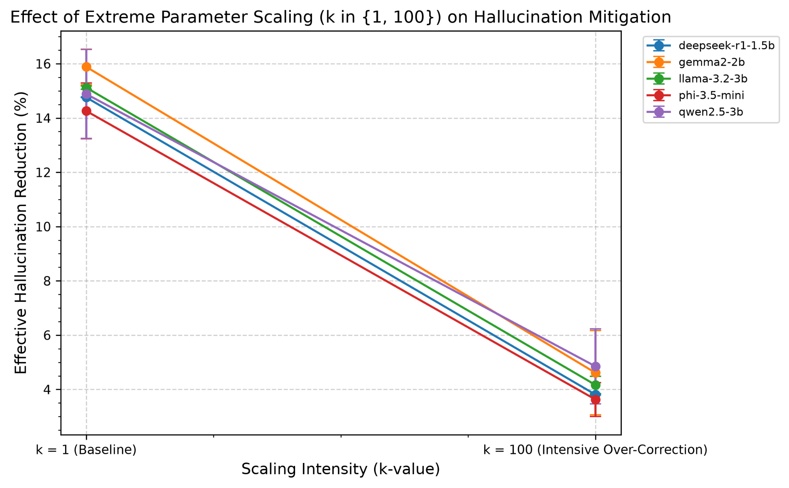
Linear comparison of hallucination reduction percentage. A higher k value results in a lower hallucination reduction percentage. Contains 95% confidence intervals.

Figure 6:
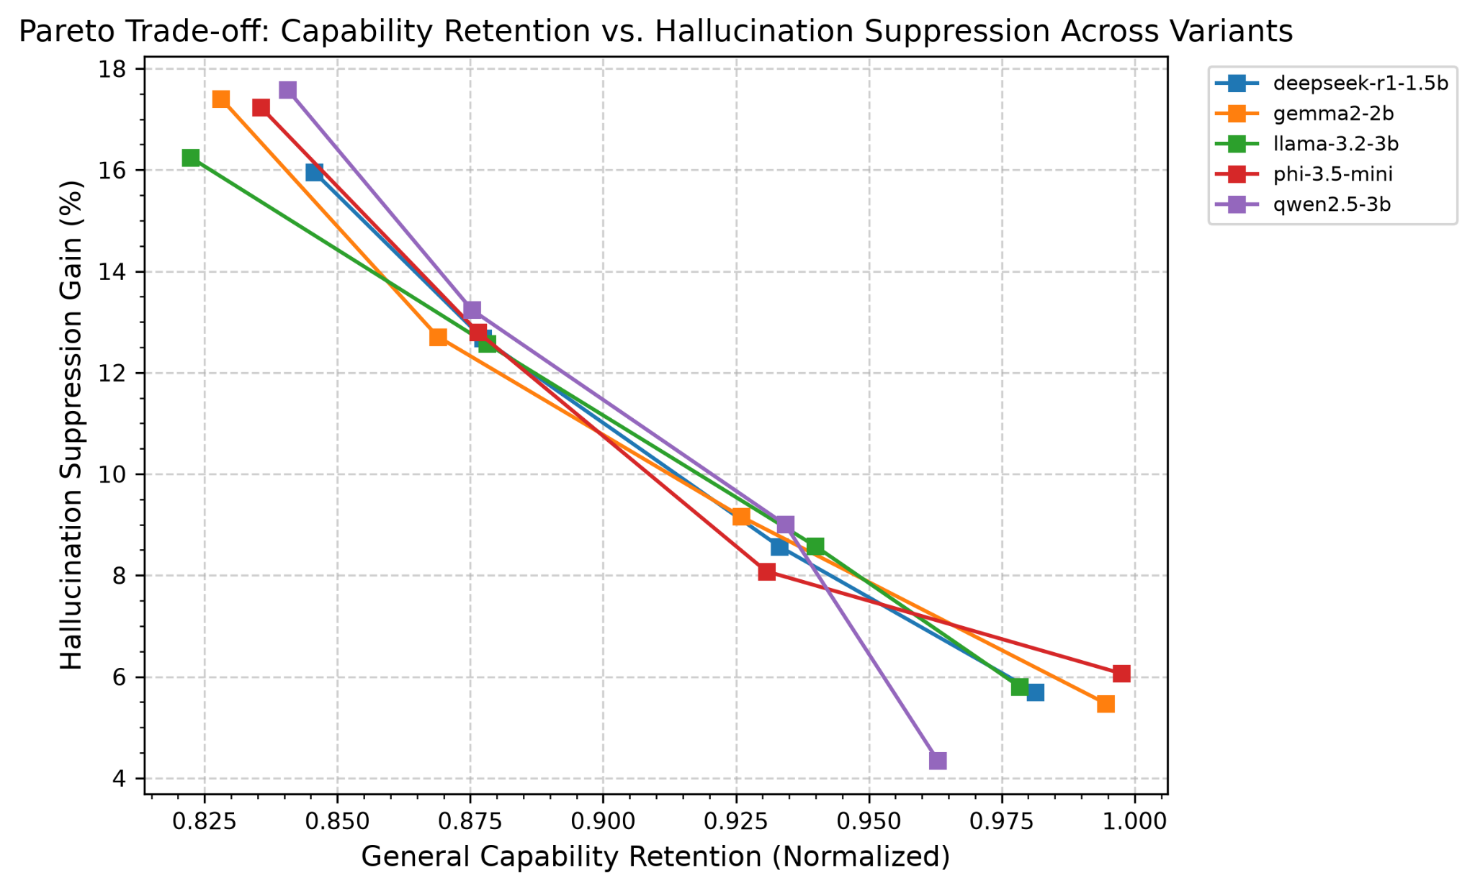
Trade-off analysis, tracking increase in hallucination suppression percentage with respect to decreases in general capability retention across model variants.

V: Discussions and Limitations

V.I: H-neuron Hallucinations
Hallucination neurons, otherwise known as H-neurons, are neurons associated with model hallucinations. As shown in figure 1, H-neuron concentration is very sparse around the early-mid and late network depths, being most prevalent in mid-late model depths (specifically around the 60% to 80% depth range). This concentration of H-neurons around the mid-late depths strongly indicates a majority of model hallucination and fabricated synthesis tend to originate around this range. Additionally, it should be noted that increasing a model’s k value results in more hallucinations, and therefore, a greater activation of H-neurons. As shown in figure 2, which establishes a baseline relationship between MMLU normalized capacity retention and TruthfulQA factuality scores across scaling configurations for K ∈ {1, 100} prior to targeted state interventions, a higher k value associates with a lower truthfulQA score, indicating an increase in model hallucinations. This occurs since higher k-values are associated with more intense overcorrections in a model’s parameter scaling intensity, primarily disrupting a model’s mid-late model depths through the increase of H-neuron activations that leads to and increase in hallucination origins and a lower truthfulQA score.

V.II: Hallucination Reductions and Suppressions
Four targeted intervention variants were utilized during this experiment: M1, hard zero-ablation; M2, soft suppression; M3, dynamic entropy gating; and M4, random pruning. These intervention variants were compared to the unmodulated baseline M0. Shown in figure 3 which details hallucination reductions compared to M0, intervention variants were able to reach up to 20% in hallucination reductions within high statistical significance (p < 0.001) and a 95% confidence interval, increasing from the 0-25% bracket (M1) up to a peak in the 75-100% bracket (M4). This relationship can also be seen in figure 4, which details hallucination suppression impact scores where intervention variants were able to scale progressively from the 0-25% bracket to the 75-100% bracket and reach up to suppression impact scores of 17.4. This helps confirm that interventions applied closer to output generation layers are most effective in reducing or suppressing model hallucinations.

V.III: Hallucination Reductions and Suppressions
Increasing the effect of parameter scaling results in a lower effective hallucination reduction percentage. As shown in figure 5 which illustrates hallucination reduction percentage for K ∈ {1, 100}, when k = 1, the effective hallucination reduction percentage across the five models varied between 14-16%, though when k = 100, this percentage dropped to around 4-5%. This highlights the critics of intense overcorrection, as instead of increasing accuracy, the hallucination reduction percentage dropped, diminishing hallucination mitigation performance. A similar tradeoff can be seen in figure 6, which details hallucination suppression percentage with respect to model capability retention, demonstrating how increases in model hallucination suppression gains correspond to decreases in model capability retention rates across all tested models.

V.IV: Limitations
While this study provides a general consensus on LM hallucinations, several limitations to this study should be considered. In this study, five models were used: deepseek-r1, gemma2, llama3.2, phi3.5-mini, and qwen2.5. While five models is a sufficient amount, the study could have incorporated more models to better generalize to a grand scope of LMs. In addition to this, only 2 k values were utilized during this experiment, K ∈ {1, 100}. Increasing the amount of k values utilized would be beneficial to create a more linear and granular comparison between k value and hallucinations. Finally, only four distinct intervention variants were utilized: M1, M2, M3, and M4. Increasing the amount of intervention variants utilized would be beneficial in creating a more empirical analysis of where in a model’s generation layer could be modified to better decrease hallucinations. It should be noted that an increase in any one of these limitations requires significantly more computational power, and since computational power was a limiting factor for this experiment, these limitations were present.

VI: Conclusion
This study provided an evaluation on potential modifications and limitations related to Language Model hallucinations. Our study’s findings show that H-neurons are concentrated around the 60-80% layer depth of a model, indicating the layer where hallucinations originate from and that higher k-values tend to result in an increase in hallucinations. Our study also found that interventions around M4, the 75-100% model layer, served as the primary layer that could be modified to best reduce model hallucinations, and that the later the model layer, the higher the increase in hallucination reduction and suppression. Our study additionally concluded that the more hallucination suppression a model undergoes, the more the model’s general reasoning capability will degrade.

Future research should take into account an increase in models, k values, and intervention variants in order to further pinpoint an optimal point as to where models can be modified to reduce hallucinations with minimal decrease in reasoning capabilities, though computational power and runtime will serve as a significant barrier for further analysis. Ultimately, this study’s findings show that hallucinations originate around the mid-late model generation layers, and to reduce hallucinations, the model’s output layers should be targeted.

References

[1] Ji, Z., Lee, N., Frieske, R., Yu, T., Su, D., Xu, Y., Ishii, E., Bang, Y. J., Madotto, A., & Fung, P. (2023). Survey of hallucination in natural language generation. ACM Computing Surveys, 55(12), 1-38.
[2] Zhao, W. X., Zhou, K., Li, J., Tang, T., Wang, X., Hou, Y., Min, Y., Zhang, B., Zhang, J., Dong, Z., Du, Y., Yang, C., Chen, Y., Chen, Z., Jiang, J., Ren, R., Li, Y., Tang, X., Liu, Z., ... & Wen, J. R. (2023). A survey of large language models. arXiv preprint arXiv:2303.18223.
[3] Lin, S., Hilton, J., & Evans, O. (2022). TruthfulQA: Measuring how models mimic human truthfulness. Proceedings of the 60th Annual Meeting of the Association for Computational Linguistics, 3214–3232.
[4] Li, J., Cheng, X., Zhao, W. X., & Wen, J. R. (2023). HaluEval: A large-scale hallucination evaluation benchmark for large language models. Proceedings of the 2023 Conference on Empirical Methods in Natural Language Processing (EMNLP), 6449–6464.
[5] Hendrycks, D., Burns, C., Basart, S., Zou, A., Mazeika, M., Song, D., & Steinhardt, J. (2020). Measuring massive multitask language understanding. Proceedings of the International Conference on Learning Representations (ICLR).
[6] Cobbe, K., Kosaraju, V., Bavarian, M., Chen, M., Jun, H., Kaiser, L., Plappert, M., Tworek, J., Hilton, J., Nakano, R., Hesse, C., & Schulman, J. (2021). Training verifiers to solve math word problems. arXiv preprint arXiv:2110.14168.
[7] Merity, S., Xiong, C., Bradbury, J., & Socher, R. (2016). Pointer sentinel mixture models. arXiv preprint arXiv:1609.07843.
[8] Askell, A., Bai, Y., Chen, A., Drain, D., Ganguli, D., Henighan, T., Jones, A., Joseph, N., Mann, B., DasSarma, N., Elhage, N., Hatfield-Dodds, Z., Hernandez, D., Kernion, J., Kamal, K., Li, K., Lovitt, K., Rusinko, N., Morbini, F., ... & Kaplan, J. (2021). A general language assistant as a laboratory for alignment. arXiv preprint arXiv:2112.00861.
[9] Lewis, P., Perez, E., Piktus, A., Petroni, F., Karpukhin, V., Goyal, N., Küttler, H., Lewis, M., Yih, W. t., Rocktäschel, T., Riedel, S., & Kiela, D. (2020). Retrieval-augmented generation for knowledge-intensive NLP tasks. Advances in Neural Information Processing Systems (NeurIPS), 33, 9459–9474.
[10] Ouyang, L., Wu, J., Jiang, X., Almeida, D., Wainwright, C. L., Mishkin, P., Zhang, C., Agarwal, S., Slama, K., Ray, A., Schulman, J., Hilton, J., Kelton, F., Miller, L., Simens, M., Askell, A., Welinder, P., Christiano, P. F., Leike, J., & Lowe, R. (2022). Training language models to follow instructions with human feedback. Advances in Neural Information Processing Systems (NeurIPS), 35, 27730–27744.
[11] Meng, K., Bau, D., Andonian, A., & Belinkov, Y. (2022). Locating and editing associations in GPT. Advances in Neural Information Processing Systems (NeurIPS), 35, 17259–17272.
[12] Meng, K., Sharma, A., Andonian, A., Belinkov, Y., & Bau, D. (2023). Mass-editing memory in a transformer. Proceedings of the International Conference on Learning Representations (ICLR).
[13] Elazar, Y., Ravfogel, S., Jacovi, A., & Goldberg, Y. (2021). Amnesic probing: Behavioral explanation with semantic constraints. Transactions of the Association for Computational Linguistics, 9, 160–175.
[14] Nanda, N., Lee, J., & Wattenberg, M. (2023). TransformerLens: A mechanistic interpretability library for LLMs. GitHub repository, https://github.com/neelnanda-io/TransformerLens.
[15] Burns, C., Ye, H., Klein, D., & Steinhardt, J. (2022). Discovering latent knowledge in language models without supervision. Proceedings of the International Conference on Learning Representations (ICLR).
[16] Templeton, A., Conerly, T., Marcus, J., Lindsey, T., Bricken, T., Chen, B., Pearce, A., Citro, C., Ameisen, E., Jones, A., Cunningham, H., Turner, N., & Elhage, N. (2024). Scaling monosemanticity: Extracting interpretable features from Claude 3 Sonnet. Anthropic Research.
[17] Turner, A., Thiergart, L., Leike, J., & Udell, M. (2023). Activation addition: Steering language models without optimization. arXiv preprint arXiv:2308.10248.
[18] Zou, A., Phan, L., Chen, S., Campbell, J., Guo, P., Ren, R., Pan, A., Yin, X., Mazeika, M., Dombrowski, A. K., Goel, S., Li, B., Wei, J., & Hendrycks, D. (2023). Representation engineering: A top-down approach to AI alignment. arXiv preprint arXiv:2310.01405.
[19] Anonymous Author(s). "LM Hallucinations: LM Hallucinations Research," Anonymous Repository, 2026. [Online]. Available: https://anonymous.4open.science/r/Inhibitor-Mutation-Research-6304/

