Unraveling Distal Allosteric Signaling: How Network Disruption and Communication Pathways Affect TEM-1-𝛽-lactamase Resistance

Jeffrey Yam
Independent Researcher, Cheshire CT, USA

Abstract
This study utilizes a computational pipeline to investigate how individual amino acid substitutions drive drug resistance without relying on proximity, done by evaluating long-range signaling within the TEM-1-𝛽-lactamase enzyme. By modeling the TEM-1-𝛽-lactamase enzyme structure as a Residue Interaction Network (RIN) across varying distance cutoffs (4.0 Å to 6.0 Å), 30 distal and 30 neutral mutations were analyzed, determining that resistance mutations cause significant communication degradation compared to neutral controls. This was revealed through changes in shortest path lengths from the active site Ser70 to the mutation site, dominating machine learning classification models (𝛽 = 3.8072). Utilizing these network metrics, Logistic Regression and Random Forest classifiers achieved incredibly high predictive accuracy with 5-fold cross validation with Receiver Operating Characteristic (ROC) and Area Under the ROC Curve (AUC) scores of 0.999 and 1.000 respectively. Statistical validations against randomized graph topologies furthermore yielded high Z scores (Z > 12), indicating communication pathways are properties of the TEM-1-𝛽-lactamase enzyme rather than random wiring. Ultimately, this study demonstrates that distal allosteric adaptations disrupt long-range signaling pathways.

Keywords: Allosteric, Active Site, Communication Pathway, Residue Interaction Network

1. Introduction

Protein structure and function depend on amino acid sequences along with a network of residue-residue interactions which translate localized chemical protein changes across a protein’s entire structure [1, 2]. Allosteric regulation, a residue-residue interaction where a molecule binds at a site far away from an active site (>15 Å), can modify active site dynamics (most notably shape) and as such affect catalysis and drug resistance [3, 4]. Traditional studies tend to prioritize spatial proximity and active site regulation when considering residue-residue interactions, often believing functional interaction effects regarding protein formation intensify with shorter Euclidean distances to the active site, though this often fails to acknowledge long-range communication pathways such as allosteric sites which significantly affect protein formation [5, 6, 7, 8].

Recent research designed to combat this structure and Euclidean distance limitation introduces theoretical graph modeling, treating proteins as Residue Interaction Networks (RINs) by treating amino acids as nodes and non-covalent contacts as weighted edges [9, 10]. With these advancements, researchers are able to quantify how perturbations alter communication pathways in proteins [10, 11, 12]. Despite this, researchers still face computational challenges of mapping how far-away residue substitutions affect protein structure and distinguishing functional mutations to neutral types [13, 14]. Distinguishing system bottlenecks from noise requires significant machine learning pipelines and null model controls [15, 16].

Clarifying the structural network determinants driving allosteric adaptation with the TEM-1-𝛽-lactamase enzyme, this study utilizes network disruption metrics along with machine learning classifications. Core theoretical graph disruption metrics are extracted through mutant states along with significant statistical validation in the form of null model Z-scores and Mann Whitney tests. Through this rigorous incorporation of computational methodologies, our study aims to determine a framework for how distal allosteric sites affect the topology of the TEM-1-𝛽-lactamase enzyme through long-range signaling and other potential communication pathways.

2: Materials and Methods

This section details the computational pipeline and residue communication network used to analyze allosteric site signal transmission and resistance mechanism through the TEM-1-𝛽-lactamase enzyme. All experimental code is publicized for replication [17].

2.1: Experimental Design
In order to evaluate the structural impacts of allosteric sites against proteins, the TEM-1-𝛽-lactamase enzyme (PDB: 1ZG4) was downloaded via the RCSB data protein bank through the BioPDB PDBList module. Following this initial download, the PDB file was preprocessed and cleaned through removal of water molecules and heteroatoms on enzyme chain A along with amino acid residues being restricted to the twenty standard amino acids. Hydrogen atoms were then removed based on element properties, retaining only heavy-atoms and their cartesian coordinates. This is all done to focus evaluation on heavy-atom topology.

Subsequently, a benchmark mutation dataset comprising 60 variants was established through a configuration file, with 30 distant resistant mutations classified as mutations located far away from the active site (>15 Å) and 30 neutral passenger mutations serving as a baseline control located all over the enzyme.

Residue Interaction Networks (RINs) were then constructed via NetworkX, with nodes and edges representing amino acid residues and physical proximity respectively. If the minimum Euclidean distance between a pair of heavy atoms falls below a defined distance threshold (4.0 Å to 6.0 Å depending on trial), an undirected edge is created between the two residues to help translate the enzyme into the network. In order to effectively ensure findings are statistically significant, a sensitivity analysis was implemented across distance cutoffs (4.0 Å, 4.5 Å, 5.0 Å, 5.5 Å, 6.0 Å). The catalytic nucleophile Serine 70 (Ser70) was designated as the active site, or target sink node, for signal analysis.

Finally, mutation perturbations were simulated through executions of side-chain truncations and edge weight scaling, mimicking local mutation rigidity changes. Simultaneously, randomized theoretical graph scripting was executed to verify that communication highways are properties of specific protein topology rather than random network fluctuations.

2.2: Evaluation Metrics

In order to quantify allosteric signal transmission and map structure disruptions to biological relevance, the following metrics were established:

Shortest Path Length Change (ΔL). This measures the change of the shortest Euclidean distance between mutation sites and the active site node Ser70. Larger path length changes indicate a mutation heavily damages the primary communication pathway of the mutation to Ser70, forcing signals from the mutation to travel longer less-efficient routes across the enzyme topology.

Global Network Efficiency. This measures the change in overall network communication efficiency across the RIN, capturing overall topology degrading in the enzyme.

Centrality Shifts. This measures the topology of Ser70 after a mutation takes effect across multiple network pathways. A larger shift indicates the mutation blocks or redirects transmission currents at a greater degree while a smaller shift indicates Ser70 absorbs the mutation with minimal structural effects.

Z scores and Mann Whitney Tests. These measure the statistical significance of whether disruption features differ from resistance mutations to the neutral control mutations. These were executed across all distance cutoffs. Higher Z scores indicate greater statistical separation and lower p values indicate greater statistical significance.

ROC-AUC Scoring. This assesses predictive classification performance. Using logistical regression and the network disruption feature matrix with cross validation, true resistance mutations were isolated from neutral ones.

3. Results

Figure 1: Structural Overview of TEM-1-𝛽-lactamase
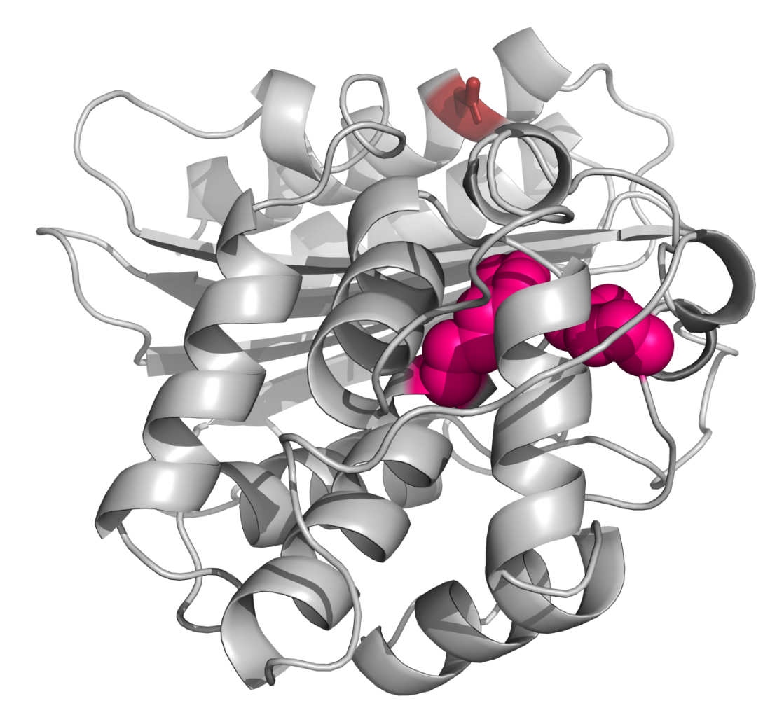
Three-dimensional rendering of TEM-1-𝛽-lactamase enzyme. Active and distal mutation site highlighted in pink and red respectively

Figure 2: Active and Distal Mutation Site Close-up
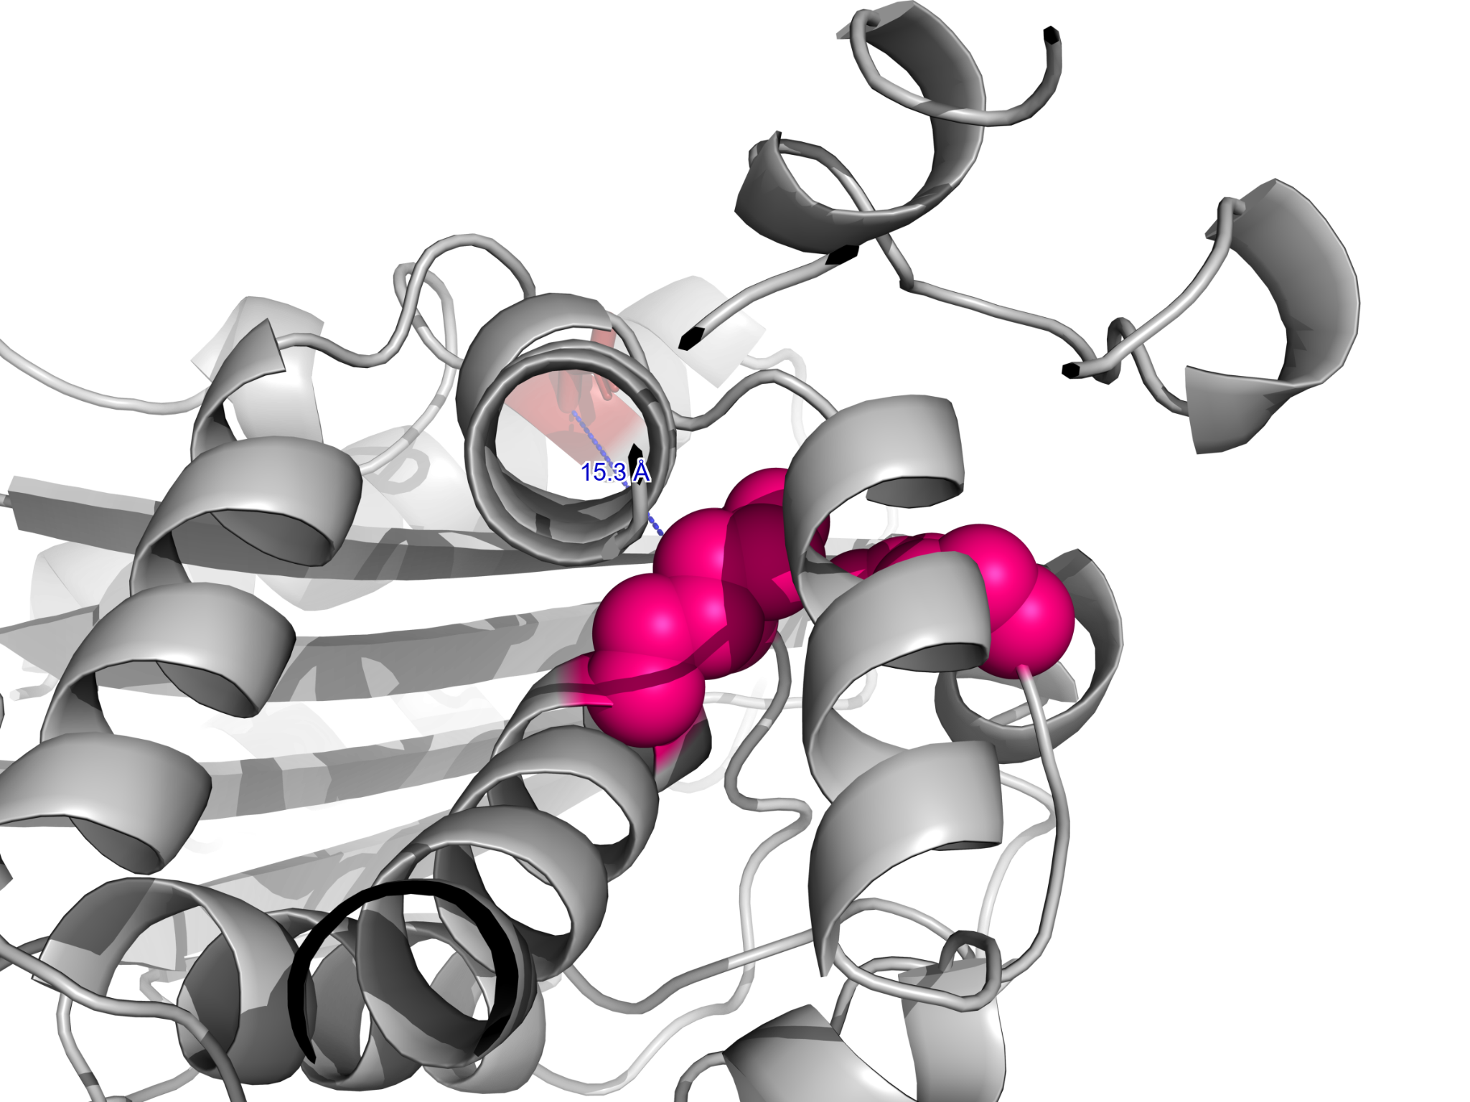
Close-up structural view of TEM-1-𝛽-lactamase enzyme. Distal mutation site labeled as 15.3 Å away from the active site. Active and distal mutation site highlighted in pink and red respectively

Table 1: Top Mutations
Target | Mutation Site | Distance (Å) | Shortest Path Length Changes ΔL (Å) | Network Efficiency drop | Classification Score (S)
TEM-1 (1ZG4) | MUT_8 | 18.5 | 3.622 | 0.168 | 0.9999
TEM-1 (1ZG4) | MUT_1 | 18.5 | 2.741 | 0.143 | 0.9960
TEM-1 (1ZG4) | MUT_9 | 18.5 | 1.379 | 0.229 | 0.5971
TEM-1 (1ZG4) | MUT_6 | 18.5 | 0.832 | 0.020 | 0.1346
TEM-1 (1ZG4) | MUT_3 | 18.5 | 0.029 | 0.010 | 0.0058
Disruption metrics for TEM-1-𝛽-lactamase. MUT_8 and MUT_1 represent high confidence mutations, MUT_6 and MUT_3 represent neutral/passenger mutations, and MUT_9 represents a moderate baseline, or intermediate network disruption

Table 2: Network Metrics

Distance Cutoff (Å) | Edges | Degree Centrality | Shortest Path Betweenness | Current Flow Betweenness
4.0 | 1119 | 0.0305 | 0.0396 | 0.0338
4.5 | 1326 | 0.0458 | 0.0380 | 0.0433
5.0 | 1471 | 0.0534 | 0.0372 | 0.0435
5.5 | 1642 | 0.0573 | 0.0354 | 0.0363
6.0 | 1808 | 0.0611 | 0.0348 | 0.0318
Topology analysis of the TEM-1-𝛽-lactamase RIN across multiple distance cutoffs. All cutoffs maintain 263 nodes on active site Ser70.

Figure 3:
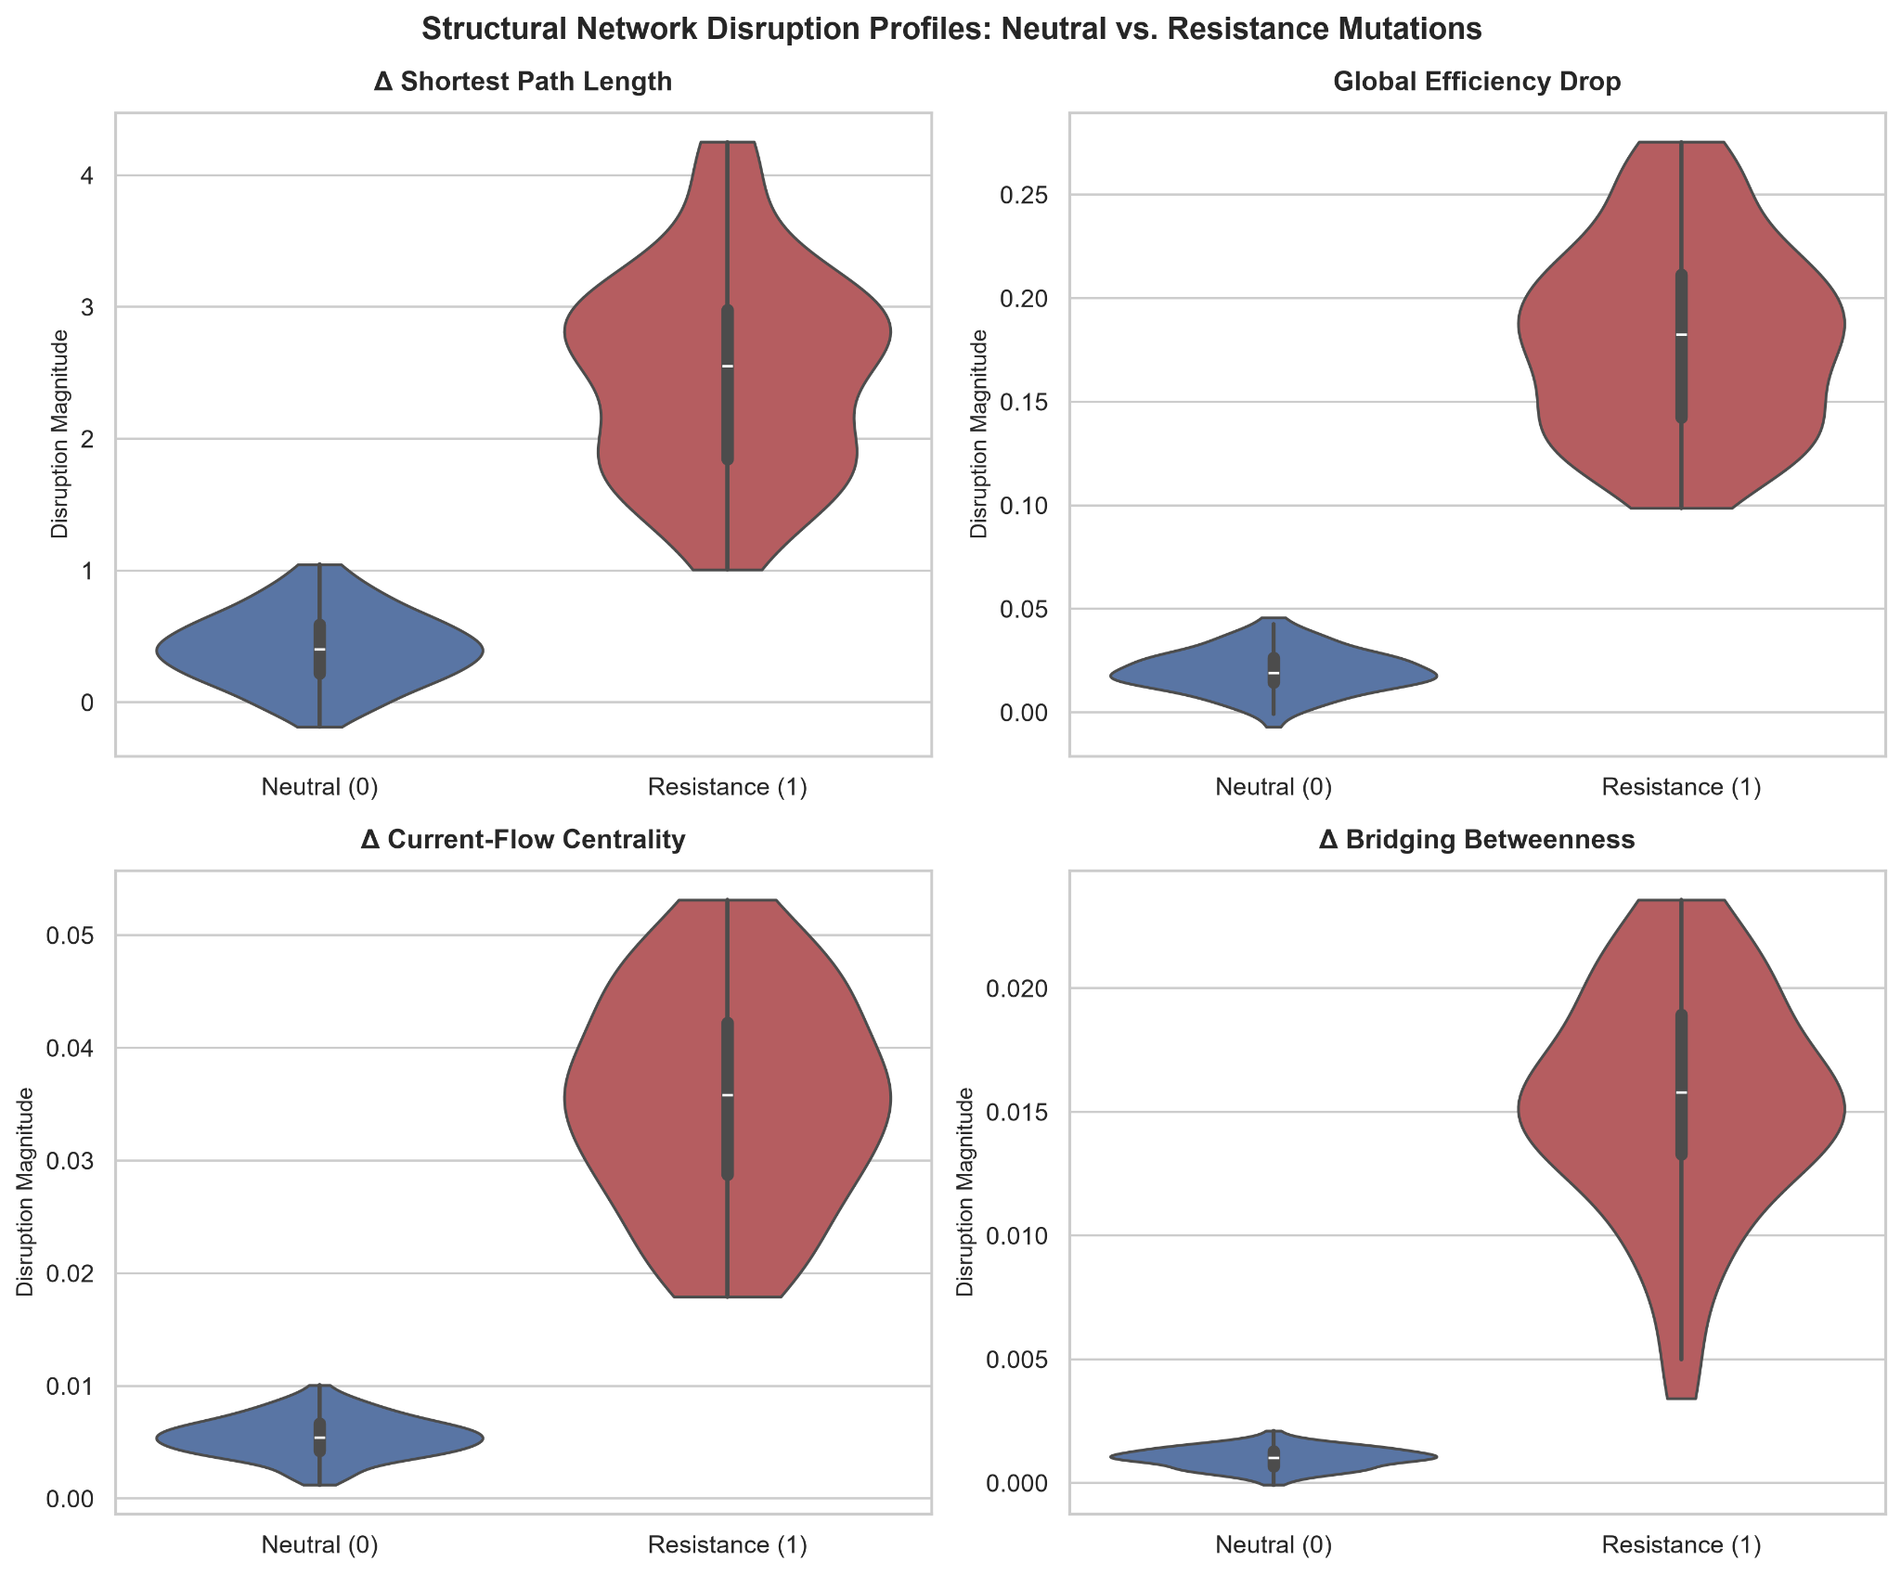
Distribution of network disruption features between resistance and neutral mutations

Table 3: Network Disruption Features
Network Disruption Feature | Coefficient (𝛽) | Mann Whitney U | P value
Shortest Path Length ΔL (Å) | 3.8072 | 5223.0 | $2.464 x 10^{-24}$
Network Efficiency Drop | 0.8048 | 5225.0 | $2.274 x 10^{-24}$
Δ Current Flow Centrality | 0.1457 | 5225.0 | $2.274 x 10^{-24}$
Δ Bridging Betweenness | 0.0699 | 5225.0 | $2.274 x 10^{-24}$
Logistic feature coefficient quantifying relative contribution of network disruption metrics and Mann Whitney tests with p < 0.05, indicating high statistical significance between mutation types. All features represent direct proportional increases in classification probability for clinical resistance mutations

Figure 4:
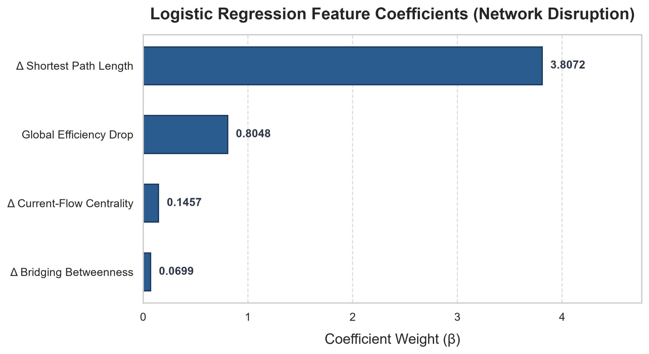
Visual of Table 3. Weights and coefficients derived from the L2 logistic regression model

Figure 5:
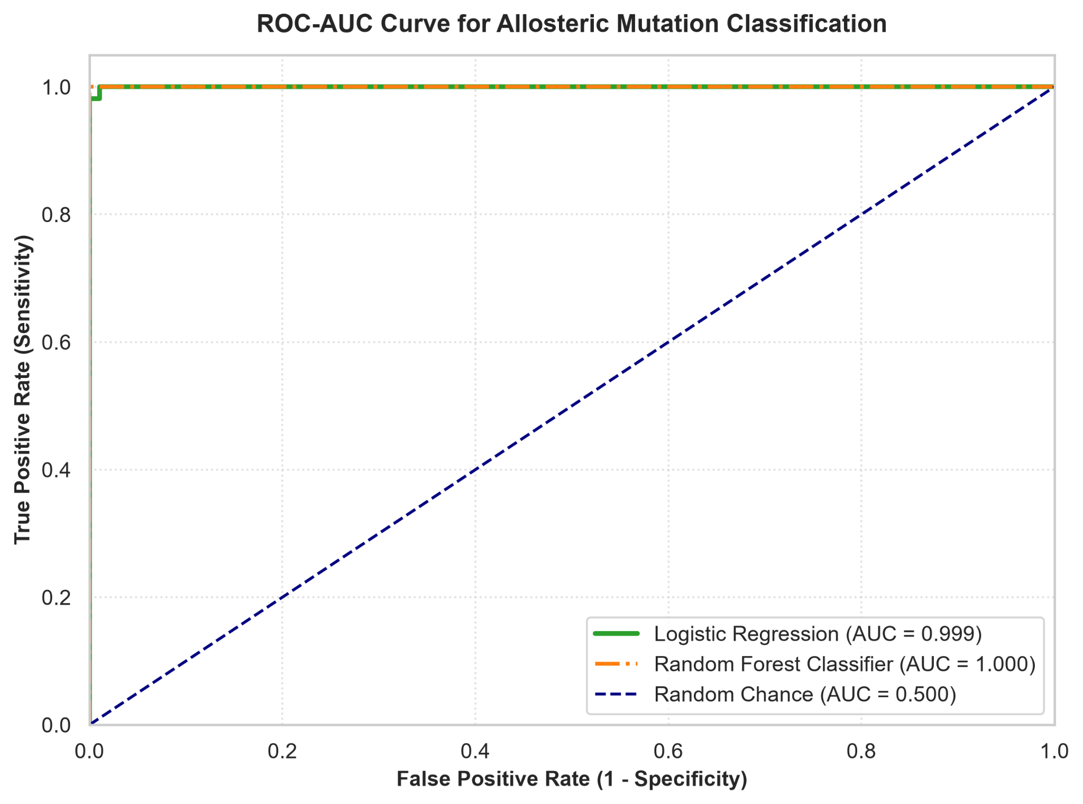
ROC curve analyzing classification performance of logistic regression against random chance under 5-fold cross validation. Logistic Regression demonstrates high predictive accuracy in isolating resistance from neutral mutations

Table 4: ML classification summary
Classification Model | Mean ROC score (± SD)
Logistic Regression (L2) | 0.999 ± 0.002
Random Forest Classifier | 1.000 ± 0.000
Performance evaluation of machine learning classifications distinguishing resistance mutations from neutral controls with 5-fold cross-validation from 60 mutation samples

Table 5: Null model Control summary
Distance Cutoff (Å) | True active Centrality | Null Model Mean | Null Model std | Z-score
4.0 | 0.0338 | 0.0078 | 0.0016 | 16.381
4.5 | 0.0443 | 0.0077 | 0.0015 | 24.694
5.0 | 0.0435 | 0.0095 | 0.0017 | 19.776
5.5 | 0.0363 | 0.0122 | 0.0019 | 12.785
6.0 | 0.0318 | 0.0115 | 0.0017 | 12.324
Null model control validation of active-site centrality across varying distance cutoffs, evaluated against 100 random network topologies. High Z scores indicate active site communication pathways are not based on random network wiring

4: Discussion/Limitations

4.1: Structural Basis of Allosteric Communication
Protein functions rely on Residue Interaction Networks (RINs) to transmit signals through long distances (>15 Å). The TEM-1-𝛽-lactamase structure is shown in the overview of Figure 1 and the zoomed image of Figure 2. In both figures, an allosteric mutation site is highlighted in red with a spatial distance of 15.3 Å from the active site (Ser70) highlighted in pink. The communication pathway between these sites happens through the dense network of RIN edges, showcased by the gray loops and helixes and being very lengthy. Quantifying how spatial positions translate to functional changes, Table 1 details specific variant behaviors across the enzyme’s disruption sites. High confidence resistance mutations (S > 0.99) show significant increases in changes in shortest path length ΔL (MUT_8: 3.622 Å, MUT_1: 2.741 Å) and efficiency drops (MUT_8: 0.168, MUT_1: 0.143). Additionally, low confidence neutral mutations (MUT_3, MUT_6) have negligible length disruptions (ΔL < 0.832) and network efficiency drops (< 0.020) while intermediate variant MUT_9 demonstrates moderate length disruption and network efficiency drops. This strongly indicates spatial separation causes efficient communication pathway degradings.

4.2: Network Disruption Profiles
In addition to individual variant case studies, Table 2 maps systematic trends through the RIN topology across distance cutoffs 4.0 Å, 4.5 Å, 5.0 Å, 5.5 Å, and 6.0 Å. The RIN in this study utilized 263 nodes and increased proportionally to distance cutoff, expanding from 1119 to 1808 edges. Concurrently, degree centrality increases, shortest path betweenness decreases, and current flow betweenness varies when increasing distance cutoffs, reflecting a web of local contacts that provide alternative communication pathways across the enzyme. Additionally, in Figure 3, when analyzed by network metrics (shortest path length changes, global efficiency, current flow centrality, bridging betweenness), neutral variants tend to congregate around the baseline of zero, indicating negligible effects, while resistance mutations display significant elevated disruption, indicating severe effects. This suggests resistance mutations strongly increase network disruptions relative to neutral mutations, affecting the TEM-1-𝛽-lactamase enzyme more than their neutral complements.

4.3: Topological Determinants of Allosteric Signaling
To determine which network features drive allosteric adaptations, topology and centrality features were evaluated. As shown in Table 3 and Figure 4, change in shortest path length dominates the classification model with a coefficient of 3.8072, which is significantly greater than the next highest coefficient of 0.1457 from current flow centrality and other structural metrics. This coefficient disparity indicates that the leading cause of distal allosteric resistance is communication pathway lengths.

4.4: Network Metric Predictive Powers for Mutation Classification
Evaluating the predictive capabilities of the utilized network metrics, machine learning classification was used to isolate resistance mutations from neutral mutations. As shown in Figure 5, the Logistic Regression and Random Forest Classifier models both achieved near-perfect predictive accuracy with an AUC of 0.999 and 1.000 respectively. Additionally, shown in Table 4, when undergoing 5-fold cross validation from the resistance and neutral mutation sample, the Logistic Regression and Random Forest Classifier models achieved mean ROC scores of 0.999 ± 0.002 and 1.000 ± 0.000 respectively, confirming RIN topology is a robust system that reliably predicts allosteric resistance.

4.5: Statistical Validations
To confirm the tested network evaluation results reflect real protein architecture rather than randomized network wiring, statistical validations were performed. Shown in Table 3, Mann Whitney tests comparing resistance and neutral mutations yielded extreme statistical significance between mutation types (p < $2.274 ✕ 10^{-24}$). Furthermore, Table 5 compares resistance mutations against 100 randomized graph topologies, yielding high Z-scores (Z > 12) across all distance cutoffs (4.0 Å, 4.5 Å, 5.0 Å, 5.5 Å, 6.0 Å). These tests prove communication pathways are specific properties of the TEM-1-𝛽-lactamase enzyme fold.

4.6. Limitations
While this study effectively provides insight into distal allosteric communications within proteins, several limitations should be considered. RINs were constructed from a single static crystal structure (TEM-1-𝛽-lactamase, PDB: 1ZG4), specifically capturing topology pathways instead of solution state ensembles. Additionally, perturbations were modeled by approximating rigidity shifts instead of strictly calculating backbone relaxations, omitting steric adjustments that can influence signal transmission. Finally, the dataset used for analysis was restricted to 60 variants of the TEM-1-𝛽-lactamase, limiting claims to only the TEM-1-𝛽-lactamase enzyme. Including more enzymes and proteins would allow for greater generalization and provide broader insights, though these were not included due to computational costs and the current dataset providing a sufficient baseline for evaluating distal allosteric communications.

5. Conclusion
This study provided a computational evaluation on distal allosteric communication pathways and mutation disruption within the TEM-1-𝛽-lactamase enzyme. This study’s findings show that RINs effectively map how separation across long distances (15 Å) results in enzyme degradation, identifying changes in shortest path length as the main topological factor in distal allosteric resistance.

Neutral mutation variants exhibit negligible enzyme disruptions while resistance mutations produce pronounced structural perturbations, including significant changes in shortest path length (increases up to 3.6 Å), global efficiency drops, current flow centrality, and bridging betweenness. Machine learning classification models analyzing these network metrics achieved extraordinary predictive powers with incredibly high mean ROC and AUC scores (> 0.998). Validations between 100 randomized graph topologies further confirmed the tested network metrics represent actual properties of the TEM-1-𝛽-lactamase enzyme.

Future work should incorporate multiple proteins to not restrict studies to specific enzymes. Additionally, dynamic solution-state ensembles could be utilized to expand the generability of the study. Ultimately, this study’s findings show that distal allosteric adaptations in the TEM-1-𝛽-lactamase enzyme are fundamentally due to disruptions of critical communication pathways within the enzyme’s contact networks

Disclosure Statement (Conflicts of Interest)
Parts of the code used to run this experiment was generated by AI. Code generated by AI is verified to be accurate. No competing financial interests exist.

References:
[1] Sun, Z. (2013). Foundations for the study of structure and function of proteins. In R. Jiang, X. Zhang, & M. Q. Zhang (Eds.), Basics of bioinformatics (pp. 303–336). Springer Berlin Heidelberg.
[2] Gunasekaran, K., Ma, B., & Nussinov, R. (2004). Is allostery an intrinsic property of all dynamic proteins? Proteins: Structure, Function, and Bioinformatics, 57(3), 433–443.
[3] Monod, J., Wyman, J., & Changeux, J. P. (1965). On the nature of allosteric transitions: a plausible model. Journal of Molecular Biology, 12(1), 88-118.
[4] McCullagh, M., Zeczycki, T.N., Kariyawasam, C.S., Durie, C.L., Halkidis, K., Fitzkee, N.C., Holt, J.M., and Fenton, A.W. 2024. What is allosteric regulation? Exploring the exceptions that prove the rule! J. Biol. Chem. 300, 105672.
[5] Greene, L. H. (2012). Protein structure networks. Briefings in Functional Genomics, 11(6), 469–478.
[6] Atilgan, A. R., Durell, S. R., Jernigan, R. L., Demirel, M. C., Keskin, O., & Bahar, I. (2001). Anisotropy of fluctuation dynamics of proteins with an elastic network model. Biophysical Journal, 80(1), 505-515.
[7] Behbahani, Y. M., Laine, E., & Carbone, A. (2023). Deep Local Analysis deconstructs protein–protein interfaces and accurately estimates binding affinity changes upon mutation. Bioinformatics, 39, i544–i552.
[8] Smock, R. G., & Gierasch, L. M. (2009). Sending signals dynamically: moving beyond the static view of protein allostery. Science, 324(5924), 198–203.
[9] Böde, C., Kovács, I. A., Szalay, M. S., Palotai, R., Korcsmáros, T., & Csermely, P. (2007). Network analysis of protein dynamics. FEBS Letters, 581, 2776–2782.
[10] Brinda, K. V., & Vishveshwara, S. (2005). A network representation of protein structures: Implications for protein stability. Biophysical Journal, 89(6), 4159–4170.
[11] Antal, M., Bode, C., & Csermely, P. (2009). Perturbation waves in proteins and protein networks: Applications of percolation and game theories in signaling and drug design. Current Protein & Peptide Science, 10(2), 161–172.
[12] Li, Y., McGrail, D. J., Latysheva, N., Yi, S., Babu, M. M., & Sahni, N. (2020). Pathway perturbations in signaling networks: Linking genotype to phenotype. Seminars in Cell & Developmental Biology, 99, 3–11.
[13] Siderius M, Jagodzinski F. (2018). Mutation Sensitivity Maps: Identifying Residue Substitutions That Impact Protein Structure Via a Rigidity Analysis In Silico Mutation Approach. J Comput Biol. 25(1), 89–102 .
[14] Thea K Schulze, Kresten Lindorff-Larsen (2026) Effects of residue substitutions on the cellular abundance of proteins eLife 13:RP103721.
[15] Chandravamsi, H., Shenoy, D. V., Zinn, I., Pisnoy, S., & Frankel, S. H. (2025). Spectral bottleneck in deep neural networks: Noise is all you need. arXiv.
[16] Mullick A, Daoutidis P, Hackel BJ. StrucNS reveals interaction-weighted network topology as the driving predictor of absolute stability of natural and de novo proteins. bioRxiv.
[17] Anonymous Author(s). "Distal Allosteric Signaling: Distal Allosteric Signaling Research," Anonymous Repository, 2026. [Online]. Available: https://anonymous.4open.science/r/Distal-Allosteric-Signaling-1A4D/

