1. download Rdxplorer file to this folder:

program_file_RDxplorer2\rlib\

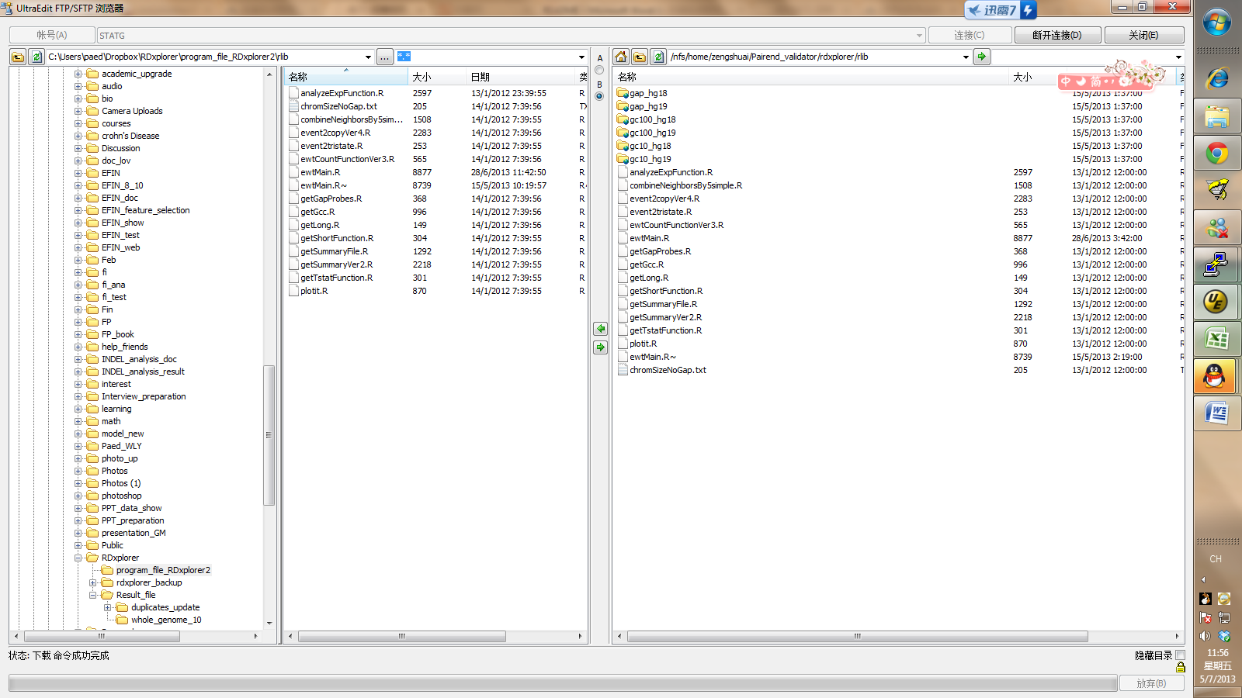

Command line example:

perl Rdxplorer2.pl In=/fisher/pcsham/WO216/LP6005162-DNA_B01/Assembly/genome/bam/LP6005162-DNA_B01.bam Out=/home/zengshuai/Pairend_validator/Data/LP6005162-DNA_B01.rdxp