**Topic: A.I and the future of work**

Project 1

By: Kason and Kofi

**BOWIE STATE UNIVERSITY**

Software and Operating Systems Security

CTEC 402

Spring 2024

Introduction

In today's fast-changing world, Artificial Intelligence (A.I) is becoming more common in how we live and work. It's promising to make things better and faster in many industries. But there are concerns to society about what it might mean for jobs and the economy. People wonder how A.I will affect the future of work, fearing that it might take away jobs and cause big changes. A.I is spreading into different areas like manufacturing and healthcare, and this could change how jobs work and who gets them. Understanding how A.I might change the future of work means looking at how technology has affected jobs before. Over time, new machines and inventions have changed the kinds of jobs available and the skills needed for them. But now, A.I is advancing quickly, with algorithms and machines doing tasks that used to need people.

Despite worries about A.I causing problems, it's important to see that it can also bring new ideas and help economies grow. By helping people work better and making tasks easier, A.I could open new chances for making money. But to make the most of these benefits, we need to plan carefully and make sure everyone can adapt to these changes. As we think about A.I and the future of work, it's important to think about both the good things it can bring and the challenges it might create. By working together and talking about these issues, we can use A.I to build a future where everyone has opportunities to succeed and thrive.

Problem Definition

The combination of artificial intelligence (A.I.) into many industries results in the rapid

transformation of the landscape of jobs and employment. The integration of A.I. technologies

with jobs provides the possibility to streamline certain processes, increase productivity, and

motivate innovation. However, with the increased usage of A.I. technology this raises concerns

about its impact on job displacement, skill requirements, and societal inequality. People are

starting to raise their concerns around the possible displacement of human employees by AI’s

leading to job losses. To add on to this, the rise of AI in jobs raises the questions of re-skilling

and up-skilling the needs of the workforce so that they can remain relevant in a more automated

world.

There is also the topic of ethical considerations when discussing the use of AI in a

decision-making processes, such as hiring potential employees, performance evaluation, and the

allocation of resources, which could contribute to biases and discrimination. There is also the

unequal distribution of AI across different sectors and demographics which may aggravate the

existing inequality in access to opportunities and wealth. The more AI continues to evolve, the

more businesses, policymakers, and society must grapple with these challenges to ensure that the

integration of AI into the work environment improves inclusive growth, fair outcomes, and

human flourishing. Addressing these potential challenges, will lead to society to embrace AI’s

while also lessening the adverse impacts on jobs and livelihoods.

Definition of Research Purpose

Artificial Intelligence (AI) has appeared as a transformative element in the workforce

environment, making great changes to industries and redefining the nature of work. The goal of

this research is to explain the impacts, challenges, and opportunities that are presented by AI

integration. Research endeavors seek to better understand the implications of AI adoption on the

employment dynamic. By inspecting the patterns of job displacement, transformation, and

creation, researchers are aiming to provide insight into the labor market. The research also delves

into the skills required for successful AI integration, informing educational and training future

employees to equip the work environment for the AI-driven economy.

This research will also delve into the ethical and societal ramifications of AI deployment are superior. The research will also examine issues such as algorithmic biases, privacy concerns, and socioeconomic disparities, with the aim of encouraging responsible AI development and deployment. Furthermore, the purpose of the research is to explore the full potential of AI to increase human capabilities and productivity. By examining the AI dominated innovations in workforce areas like automation, decision making, and personalized assistance, the aim is to unlock the full potential of AI. In a sense, research on AI in the workforce is driven by the ability to comprehend, alleviate, and capitalize on the impacts of AI on employment, society, and productivity.

Method Solution

Artificial intelligence and machine learning are the biggest and hottest A.I technologies known today, according to Caltech Center for Technology & Management Education (CTME). Artificial Intelligence means making computers smart, like humans. It helps them do tasks that need thinking, like understanding what we say, seeing and recognizing things, and even making decisions. AI aims to build computer systems that can understand the world around them and do things just like we do (CTME). On the other hand, Machine Learning is a way to teach computers to learn from examples. Instead of telling them exactly what to do, it is shown a lot of examples, and they learn patterns from those examples. Then, they use that knowledge to do similar tasks better in the future (CTME). According to Statista (Martin Armstrong), a study was conducted in 20 countries where the study showed that 52% of current job tasks will be performed by robots in 2025.

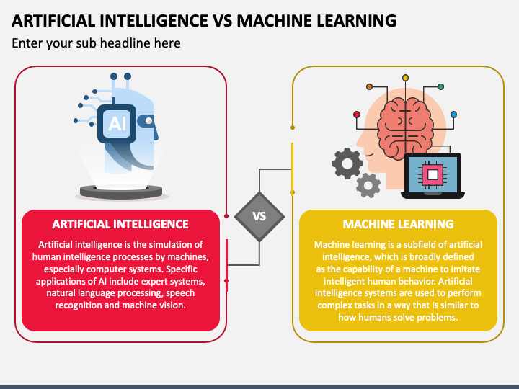

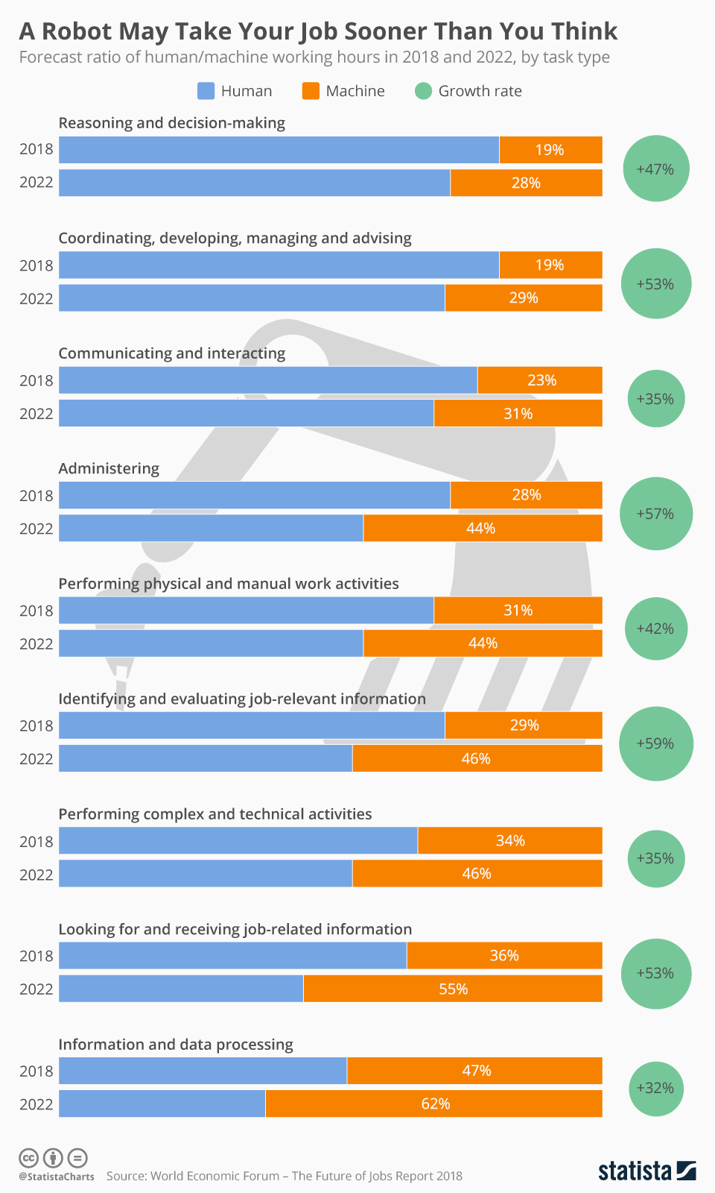

Case Study

With the competitive landscape of e-commerce, providing customers with good customer service

is important for success. The purpose of this case study examines how companies like Amazon

utilize artificial intelligence (AI) to transform its customer service operations, resulting in

improved efficiency and customer satisfaction. Facing certain challenges along with handling a

high volume of customer inquiries, Amazon uses AI to improve product listings, creating more

engaging advertisements, and see reviews on items. The implementation of AI in their product

listings helps sellers provide better information with less work. It reduces the need to enter

multiple pieces of specific product data, and instead just combines it all into one step. This helps

save time for the sellers and produces more thorough product listings.

The AI also helps advertisers make their ads more engaging for consumers by using the Amazon Ad Console, advertisers can select their product and click Generate, and within a matter of seconds, be delivered a series of lifestyle and brand themed images. Customers can also

determine what other customers are saying about a product by checking out the review of

highlights which AI provides by showing a short paragraph on the product detail page that

highlights the product features and customer sentiment. The product features and most frequently

mentioned customer sentiment about the product. As a result, of utilizing AI in its customer

service operations, Amazon experienced a notable increase in its customer satisfaction ratings.

Summary

In conclusion, Artificial Intelligence (A.I.) is changing the way we work. While A.I. can make things easier and better in jobs, some people worry it might also take away jobs and create problems. We need to think carefully about how to use A.I. so that everyone can benefit from it. A.I. is used in customer service at companies like Amazon, showing how it can make things faster and better for customers. Overall, we should use A.I. in a smart way to help everyone and avoid making things worse for some people.

References

Jaumotte, F. (2024) *Gen-AI: Artificial Intelligence and the Future of Work*, *International Monetary Fund*. Available at: https://www.imf.org/en/Publications/Staff-Discussion-Notes/Issues/2024/01/14/Gen-AI- (Accessed: 24 April 2024).

Terra, W. byJohn (2023) *Today’s top Ten AI technologies: Here’s Everything you should know*, *Caltech*. Available at: https://pg-p.ctme.caltech.edu/blog/ai-ml/what-are-todays-top-ten-ai-technologies (Accessed: 24 April 2024).

Armstrong, M. and Richter, F. (2018) *Infographic: A robot may take your job sooner than you think*, *Statista Daily Data*. Available at: https://www.statista.com/chart/15475/a-robot-may-take-your-job-sooner-than-you-think/ (Accessed: 24 April 2024).

*Artificial Intelligence vs machine learning* (no date) *Sketchbubble*. Available at: https://www.sketchbubble.com/en/presentation-artificial-intelligence-vs-machine-learning.html (Accessed: 24 April 2024).

Mondo Insights Recent employment news & industry insights from the Mondo digital content & research teams., Insights, M. and By (2023) *The Future of Work: How to offset AI Job Automation*, *Mondo Staffing Agency*. Available at: https://mondo.com/insights/how-to-offset-ai-job-automation/ (Accessed: 24 April 2024).

Amazon Staff. (2023). 8 ways Amazon is using generative AI to make life easier, from a

more conversational Alexa to a better reviews experience, Amazon, 1 pg.

https://www.aboutamazon.com/news/innovation-at-amazon/how-amazon-uses-

generative-ai

• Acemoglu, Daron &amp; Johnson, Simon. (2023). Choosing AI’s Impact on the Future of

Work, StanfordSOCIALINNOVATIONReview, 1pg. https://ssir.org/articles/entry/ai-

impact-on-jobs-and-work

• Rostron, Mark Talmage. (2024). How Will Artificial Intelligence Affect Jobs 2024-2030,

Nexford University, 1 pg. https://www.nexford.edu/insights/how-will-ai-affect-jobs

• Krasadakis, George. (2023). The Impact of AI on Society and Everyday Life. Mdeium,

1pg. https://medium.com/60-leaders/the-impact-of-ai-on-society-and-everyday-life-

711307e06b87#:~:text=AI%20is%20changing%20the%20way,help%20humans%20mak

e%20better%20decisions.

• Clark, Elijah. (2023). Unveiling The Dark Side Of Artificial Intelligence In The Job

Market, Forbes, 1pg. https://www.forbes.com/sites/elijahclark/2023/08/18/unveiling-the-

dark-side-of-artificial-intelligence-in-the-job-market/?sh=176610876652

• Georgieva, Kristalina. (2024). AI Will Transform the Global Economy. Let’s Make Sure

It Benefits Humanity, IMF Blog, 1pg.

https://www.imf.org/en/Blogs/Articles/2024/01/14/ai-will-transform-the-global-

economy-lets-make-sure-it-benefits-

humanity#:~:text=If%20AI%20significantly%20complements%20higher,these%20pheno

mena%20could%20exacerbate%20inequality.