Introduction

Examining the Impact of Board Gender Composition on Corporate ESG Scores:
In recent years, the composition of corporate boards has increasingly come under scrutiny, particularly concerning gender diversity. This focus is not only a matter of equity and representation but also stems from a growing body of research suggesting that diverse boards may lead to better overall corporate performance and decision-making. Among the various performance metrics, Environmental, Social, and Governance (ESG) scores have emerged as a crucial yardstick for assessing a company's commitment to sustainability and ethical practices. This study seeks to explore a question in this domain: "How does the gender composition of boards of directors influence a firm's Environmental, Social, and Governance (ESG) scores?"
The premise of this research hinges on the hypothesis that gender-diverse boards, characterized by a range of perspectives and experiences, could potentially lead to more comprehensive and ethical corporate strategies. This, in turn, could be reflected in higher ESG scores, indicating better performance in environmental stewardship, social responsibility, and corporate governance. The rationale behind this hypothesis is rooted in the understanding that diversity in boardrooms can enhance creative thinking and decision-making, leading to more robust and holistic approaches to managing a company's ESG-related challenges and opportunities.
This study's focus on ESG scores is particularly timely and relevant, given the increasing importance placed on these metrics by investors, regulators, and the public. In an era where sustainability and ethical conduct are becoming pivotal to a firm's reputation and financial success, understanding the drivers behind ESG scores is of great importance. By exploring the relationship between board gender diversity and ESG scores, this research aims to contribute to the ongoing discourse on the role of corporate governance in promoting sustainable and ethical business practices.
Furthermore, this research also aligns with the broader movement towards gender equality in corporate leadership roles. By examining the potential impact of gender diversity on a critical aspect of corporate performance, this study aims to provide empirical evidence that could inform policy discussions and corporate strategies aimed at promoting gender diversity in the upper echelons of corporate management.
In the following sections, the methodology of the study will be outlined, including a detailed description of the data and the econometric models employed. The results will be presented and discussed in the context of the hypothesis, followed by a conclusion that encapsulates the study's findings and their implications.

Methodology
  - Data Description
This study employs a dataset consisting of a selected group of S&P 500 companies, focusing on their board composition and various corporate performance metrics. The dataset includes a wide range of variables, encompassing elements of corporate governance, financial health, and ESG (Environmental, Social, and Governance) performance. Key variables in this dataset include the gender composition of corporate boards, comprehensive ESG scores, and other control variables pertinent to the study's focus.
  - Variables
- Dependent Variable:
  - esg_overall: The overall ESG score, aggregating environmental, social responsibility, and governance metrics.
- Independent Variables:
  - Primary:
    - gendiversity: Gender diversity on the board, quantified as the proportion of female directors.
  - Control Variables:
    - indus_femprop: The proportion of female workers in the industry.
    - firmsize: The size of the firm, measured as the natural logarithm of total assets.
    - firmleverage: The firm's leverage, calculated as the ratio of total debt to total assets.
    - boardindepend: The proportion of independent non-executive directors.
    - roa: Return on assets, indicating a company's profitability relative to its total assets.
    - agediversity: The standard deviation of board members’ ages, representing age diversity.
    - fem_ceo: Dummy variable for female CEO (1 = is female, 0 = else)
  - Econometric Models
The analysis will be conducted using two main econometric models:
  - Model 1 - Linear Regression Model:
- This model explores the direct relationship between board gender diversity and ESG scores, including control variables such as industry-specific gender proportion, firm size, firm leverage, board independence, return on assets, and age diversity.
- The linear regression formula for Model 1 is:

$$ESGoverall=β_{0}+β_{1}GenderDiversity+ Control Variables+ϵ_{i}$$

  - Model 2 - Joint Hypothesis Test (Restricted vs. Unrestricted Model):
- The restricted model excludes the interaction term and is the same as Model 1, with the addition of the fem_ceo variable.
- The unrestricted model includes the interaction term between gender diversity and the presence of a female CEO (gendiversity * fem_ceo) but is otherwise the same as the restricted model.
- The models are specified as follows:

  - Restricted Model:
$$ESGoverall=β_{0}+β_{1}GenderDiversity+β_{2}fem_{ceo}+OtherControl Variables+ϵ_{i}$$

  - Unrestricted Model:
$$ESGoverall=β_{0}+β_{1}GenderDiversity+β_{2}fem_{ceo}+β_{3}(gendiversity*fem_{ceo})+OtherControl Variables+ϵ_{i}$$
- The joint hypothesis test will be conducted to compare the restricted and unrestricted models, focusing on the significance of the interaction term.
  - Statistical Analysis
The analysis will begin with a descriptive statistical summary of the data. This will be followed by the estimation and comparison of the two regression models. For Model 2, a joint hypothesis test will be conducted to evaluate the significance of the interaction term between gender diversity and the presence of a female CEO.
Diagnostic tests for heteroskedasticity and multicollinearity will be performed to ensure the robustness of the models. The goodness-of-fit for the models will be assessed using R-squared and adjusted R-squared values.

Results and Discussion

Summary Statistics
The dataset comprises observations from a selected group of S&P 500 companies. Key variables include the overall ESG score, gender diversity on the board, and various control variables like firm size, leverage, and board independence. The summary statistics provide an overview of these variables (Table 1).
Table 1: Summary Statistics
## ==============================================
## Statistic N Mean St. Dev. Min Max
## ----------------------------------------------
## esg_overall 534 1.651 0.366 1.002 3.454
## agediversity 425 6.128 3.196 0.000 20.506
## indus_femprop 506 0.380 0.132 0.110 0.549
## firmleverage 504 0.279 0.284 0.000 3.892
## firmsize 492 8.880 1.243 4.973 12.540
## gendiversity 534 0.193 0.278 0.000 1.000
## roa 504 0.070 0.082 -0.390 0.485
## boardindepend 534 0.832 0.243 0.000 1.000
## fem_ceo 534 0.034 0.181 0 1
## ----------------------------------------------
Figure 1: Box plot and histogram of ESG overall
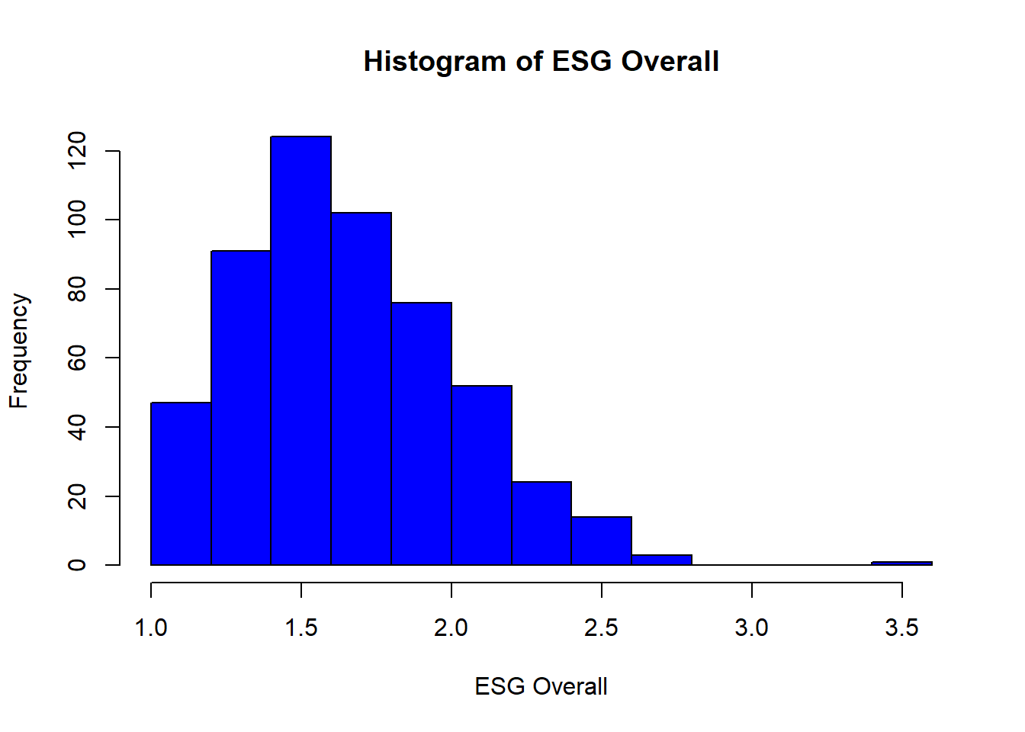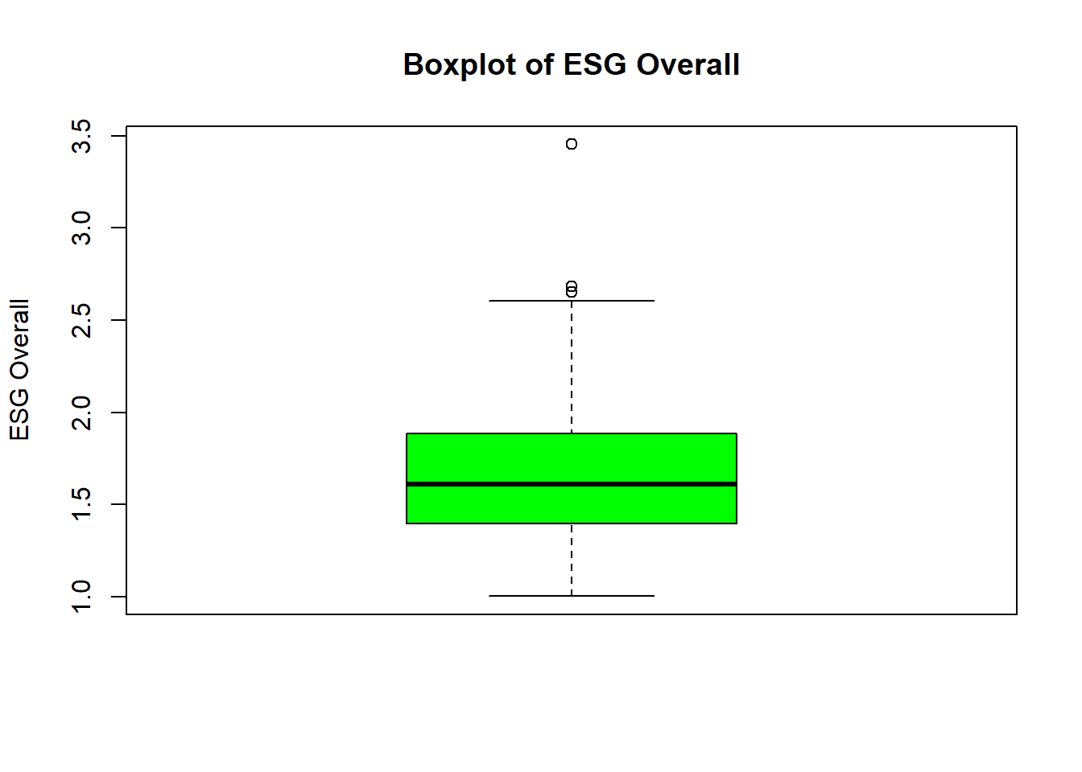

Regression Analysis
  - Model 1: Linear Regression
The initial linear regression model explored the relationship between gender diversity and ESG overall scores, controlling for firm size, firm leverage, ROA, board independence, age diversity, and industry female proportion. The results are as follows:
- Gender Diversity: The coefficient for gender diversity is 0.0549 (standard error: 0.0925), suggesting a modest positive relationship with ESG scores. However, the t-statistic (0.593) indicates that this relationship is not statistically significant at conventional levels, leading to a failure to reject the null hypothesis that gender diversity has no effect on ESG scores.
- Firm Size: Statistically significant at the 1% level (coefficient: 0.0964, standard error: 0.0143). This implies that larger firms tend to have higher ESG scores.
- Board Independence: Shows a potential impact on ESG scores with a t-value of 1.869, indicating significance at the 10% level but not at the 5% level.
Table 2: Regression Results for Model 1
## linear model
## ========================================================
## Dependent variable:
## -----------------------------
## --------------------------------------------------------
## Gender Diversity 0.0549
## (0.0925)
##
## Firm Size 0.0964***
## (0.0143)
##
## Firm Leverage -0.0392
## (0.0588)
##
## ROA 0.3284
## (0.2063)
##
## Board Independence 0.1631
## (0.0873)
##
## Age Diversity 0.0018
## (0.0055)
##
## Industry Female Proportion -0.1317
## (0.1328)
##
## Female CEO 0.6634***
## (0.1603)
##
## --------------------------------------------------------
## Observations 391
## R2 0.1359
## Adjusted R2 0.1201
## ========================================================
## Note: *p<0.05; **p<0.01; ***p<0.001

  - Robust Standard Errors
Upon recalculating the model using robust standard errors, the results remain largely consistent. Gender diversity still does not exhibit statistical significance, reinforcing the initial conclusion. The slight changes in standard errors do not materially affect the interpretation of the results.
Table 3: Regression Results with Robust Standard Errors
## =========================================
## Dependent variable:
## ---------------------------
##
## -----------------------------------------
## gendiversity 0.055
## (0.091)
##
## firmsize 0.096***
## (0.016)
##
## firmleverage -0.039
## (0.066)
##
## roa 0.328
## (0.210)
##
## boardindepend 0.163*
## (0.087)
##
## agediversity 0.002
## (0.005)
##
## indus_femprop -0.132
## (0.122)
##
## Constant 0.663***
## (0.170)
##
## =========================================
## =========================================
## Note: *p<0.1; **p<0.05; ***p<0.01
  - Diagnostic Tests and Goodness-of-Fit for Model 1
- Goodness-of-Fit: R-squared of 0.1359 and Adjusted R-squared of 0.1201 indicate that approximately 12.01% to 13.59% of the variance in ESG scores is explained by the model. This suggests a moderate level of fit, implying that while the model captures some variance, there are other factors influencing ESG scores that are not included in the model.
- Heteroskedasticity Test (Breusch-Pagan): P-value of 0.08814, suggesting no significant evidence of heteroskedasticity, indicating consistent error variances across the model. 1.
- Multicollinearity Test (VIF): VIF values for all variables were well below 10, indicating that multicollinearity is not a concern in this model. 2. Low VIF values suggest that each independent variable in the model provides unique and valuable information, allowing for more reliable and interpretable results.
  - Discussion
The findings suggest that while gender diversity on corporate boards is a positive factor, its impact on ESG scores within the scope of this dataset is not statistically significant. This could be due to several reasons:
- Potential for Non-Linear Relationships: The impact of gender diversity on ESG scores might be non-linear or influenced by other moderating factors not captured in the model.
- Industry-Specific Dynamics: The effect of gender diversity might vary across different industries, a factor that could be explored in further studies.
- Board Dynamics and Governance Quality: The quality of governance and dynamics within the board might play a more significant role, as indicated by the borderline significance of board independence.

Conclusion
The analysis suggests that while gender diversity is a desirable attribute of corporate boards, its direct impact on ESG scores is not statistically significant in this dataset. This finding contributes to the nuanced understanding of the relationship between board composition and corporate social responsibility, underlining the complexity of governance issues in modern corporations.

Results and Discussion for Model 2

Model 2: Joint Hypothesis Test (Restricted vs. Unrestricted Model)
  - Restricted Model Analysis
The restricted model includes gender diversity and control variables without the interaction term (Gender Diversity * Female CEO). The results indicate the following:
- Gender Diversity: The coefficient is slightly higher than in Model 1 at 0.067955 with a standard error of 0.095421. However, the t-value (0.712) still suggests no statistical significance, affirming the findings of Model 1.
- Firm Size remains significantly positive, implying larger firms have higher ESG scores.
- Board Independence is borderline significant, indicating its potential influence on ESG scores.
- Goodness-of-Fit: The restricted model, which does not include the interaction term, has an R-squared value of 0.1366 and an Adjusted R-squared value of 0.1185. These values suggest that about 11.85% to 13.66% of the variance in the ESG scores is explained by the model. This level of explanatory power is moderate, implying that while the model captures some variance, other factors not included in the model may also play a significant role in determining ESG scores.
- Heteroskedasticity Test (Breusch-Pagan): The p-value of 0.1424 indicates that there is no significant evidence of heteroskedasticity in the restricted model. This means that the variance of the residuals is approximately constant across different levels of the independent variables, which is a desirable property in regression analysis. 3.
- Multicollinearity Test (VIF): VIF values are all below 10 for the restricted model, indicating that multicollinearity is not a major concern for these variables. This suggests that the independent variables in the restricted model provide unique information and are not overly redundant with each other. 4.
  - Unrestricted Model Analysis
The unrestricted model includes the interaction term between gender diversity and the presence of a female CEO.
- Gender Diversity: The coefficient is 0.093781 with a standard error of 0.096078, indicating a non-significant direct effect on ESG scores again.
- Interaction Term (Gender Diversity * Female CEO): The coefficient is -1.316985 with a standard error of 0.696667, showing a negative direction and is marginally significant (p-value = 0.0595). This suggests that the presence of a female CEO might alter the relationship between board gender diversity and ESG scores.
- Goodness-of-Fit: The unrestricted model, which includes the interaction term, shows a slight improvement with an R-squared of 0.1446 and an Adjusted R-squared of 0.1244. This increase, although small, might suggest that the interaction term adds some explanatory power to the model.
- Heteroskedasticity Test (Breusch-Pagan): Similar to the restricted model, the unrestricted model's p-value of 0.1794 suggests that there is no significant heteroskedasticity. This consistency across models is encouraging and supports the validity of the regression analysis. 5.
- Multicollinearity Test (VIF): While most VIF values in the unrestricted model remain below 10, the interaction term I(gendiversity * fem_ceo) has a notably high VIF, exceeding 11. This indicates potential multicollinearity issues with this term. High VIF values for interaction terms are not uncommon, as they are often correlated with their constituent terms. However, this finding should prompt caution in interpreting the interaction term's effect, as multicollinearity can inflate standard errors and make estimates less reliable. 6.
Table 4: Comparison of Regression Results
## Comparison of Regression Models
## ============================================================
## Dependent variable:
## ------------------------------
## (1) (2)
## ------------------------------------------------------------
## Gender Diversity 0.0680 0.0938
## (0.0954) (0.0961)
##
## Firm Size 0.0974*** 0.0959***
## (0.0144) (0.0144)
##
## Firm Leverage -0.0413 -0.0524
## (0.0590) (0.0591)
##
## ROA 0.3311 0.3409
## (0.2066) (0.2059)
##
## Board Independence 0.1661 0.1732*
## (0.0875) (0.0873)
##
## Age Diversity 0.0021 0.0018
## (0.0055) (0.0055)
##
## Industry Female Proportion -0.1240 -0.1366
## (0.1336) (0.1333)
##
## Female CEO -0.0556 0.4918
## (0.0977) (0.3055)
##
## Gender Diversity * Female CEO -1.3170
## (0.6967)
##
## Constant 0.6477*** 0.6599***
## (0.1627) (0.1623)
##
## ------------------------------------------------------------
## Observations 391 391
## R2 0.1366 0.1446
## Adjusted R2 0.1185 0.1244
## ============================================================
## Note: *p<0.05; **p<0.01; ***p<0.001

  - Joint Hypothesis Test
The F-test comparing the restricted and unrestricted models yields an F-value of 3.5746 with a p-value of 0.05946, suggesting that the unrestricted model with the interaction term fits the data marginally better than the restricted model. However, this difference is only significant at the 10% level. This marginal improvement should be interpreted with caution due to the potential multicollinearity issues indicated by the high VIF of the interaction term.
Table 5: F-test Results for Model Comparison
## ==========================================
## Statistic N Mean St. Dev. Min Max
## ------------------------------------------
## Res.Df 2 381.500 0.707 381 382
## RSS 2 43.925 0.290 43.720 44.130
## Df 1 1.000 1 1
## Sum of Sq 1 0.410 0.410 0.410
## F 1 3.574 3.574 3.574
## Pr(> F) 1 0.059 0.059 0.059
## ------------------------------------------
  - Discussion

The analysis from Model 2 underscores the complexity in evaluating the impact of gender diversity on ESG scores, particularly when considering the role of a female CEO. The high VIF for the interaction term in the unrestricted model suggests that while there might be a nuanced relationship between these variables, the accuracy of this estimate could be compromised by multicollinearity. This complexity, combined with the moderate explanatory power of both models, indicates that additional factors not captured in the model might also be influential in determining ESG scores.

Conclusion
The results from Model 2 reinforce the notion that the relationship between gender diversity on corporate boards and ESG performance is complex. The potential moderating effect of a female CEO on this relationship, as suggested by the interaction term, introduces an additional layer of complexity. However, the high VIF associated with this term calls for a cautious interpretation of its impact. These findings contribute to a deeper understanding of corporate governance dynamics and highlight the need for further research to unravel the tricky interactions between board composition, leadership, and corporate sustainability practices.

Econometrics Final Project R Code

Kye Jones

2023-12-07
library(readxl)
Company_Data <- read_excel("ECON 424 Paper Data.xlsx")
View(Company_Data)
summary(Company_Data)
## company_name esg_overall agediversity indus_femprop
## Length:534 Min. :1.002 Min. : 0.000 Min. :0.1100
## Class :character 1st Qu.:1.395 1st Qu.: 3.948 1st Qu.:0.2920
## Mode :character Median :1.608 Median : 5.814 Median :0.2920
## Mean :1.651 Mean : 6.128 Mean :0.3803
## 3rd Qu.:1.884 3rd Qu.: 8.155 3rd Qu.:0.5210
## Max. :3.454 Max. :20.506 Max. :0.5490
## NA's :109 NA's :28
## firmleverage firmsize gendiversity roa
## Min. :0.00000 Min. : 4.973 Min. :0.0000 Min. :-0.39048
## 1st Qu.:0.09184 1st Qu.: 8.011 1st Qu.:0.0000 1st Qu.: 0.02225
## Median :0.25034 Median : 8.830 Median :0.0000 Median : 0.05792
## Mean :0.27862 Mean : 8.880 Mean :0.1928 Mean : 0.07012
## 3rd Qu.:0.39088 3rd Qu.: 9.668 3rd Qu.:0.3333 3rd Qu.: 0.10732
## Max. :3.89205 Max. :12.540 Max. :1.0000 Max. : 0.48518
## NA's :30 NA's :42 NA's :30
## boardindepend fem_ceo
## Min. :0.0000 Min. :0.00000
## 1st Qu.:0.7500 1st Qu.:0.00000
## Median :1.0000 Median :0.00000
## Mean :0.8324 Mean :0.03371
## 3rd Qu.:1.0000 3rd Qu.:0.00000
## Max. :1.0000 Max. :1.00000
##
stargazer(as.data.frame (Company_Data), type = "text", out = "summarystats.text")
##
## ==============================================
## Statistic N Mean St. Dev. Min Max
## ----------------------------------------------
## esg_overall 534 1.651 0.366 1.002 3.454
## agediversity 425 6.128 3.196 0.000 20.506
## indus_femprop 506 0.380 0.132 0.110 0.549
## firmleverage 504 0.279 0.284 0.000 3.892
## firmsize 492 8.880 1.243 4.973 12.540
## gendiversity 534 0.193 0.278 0.000 1.000
## roa 504 0.070 0.082 -0.390 0.485
## boardindepend 534 0.832 0.243 0.000 1.000
## fem_ceo 534 0.034 0.181 0 1
## ----------------------------------------------
##Model 1
Linear_model <- lm(esg_overall ~ gendiversity + firmsize + firmleverage + roa + boardindepend + agediversity +indus_femprop, data=Company_Data)
summary(Linear_model)
##
## Call:
## lm(formula = esg_overall ~ gendiversity + firmsize + firmleverage +
## roa + boardindepend + agediversity + indus_femprop, data = Company_Data)
##
## Residuals:
## Min 1Q Median 3Q Max
## -0.89361 -0.23989 -0.00998 0.22736 1.94507
##
## Coefficients:
## Estimate Std. Error t value Pr(>|t|)
## (Intercept) 0.663358 0.160260 4.139 4.29e-05 ***
## gendiversity 0.054907 0.092546 0.593 0.5533
## firmsize 0.096354 0.014256 6.759 5.20e-11 ***
## firmleverage -0.039164 0.058825 -0.666 0.5060
## roa 0.328368 0.206326 1.592 0.1123
## boardindepend 0.163095 0.087253 1.869 0.0624 .
## agediversity 0.001848 0.005527 0.334 0.7383
## indus_femprop -0.131670 0.132765 -0.992 0.3219
## ---
## Signif. codes: 0 '***' 0.001 '**' 0.01 '*' 0.05 '.' 0.1 ' ' 1
##
## Residual standard error: 0.3396 on 383 degrees of freedom
## (143 observations deleted due to missingness)
## Multiple R-squared: 0.1359, Adjusted R-squared: 0.1201
## F-statistic: 8.603 on 7 and 383 DF, p-value: 8.266e-10
stargazer(Linear_model, type = "text",
title = "linear model",
align = TRUE,
header = FALSE,
digits = 4,
dep.var.labels.include = FALSE,
covariate.labels = c("Gender Diversity", "Firm Size", "Firm Leverage", "ROA", "Board Independence", "Age Diversity", "Industry Female Proportion", "Female CEO", "Gender Diversity * Female CEO"),
omit.stat = c("LL", "ser", "f"),
star.cutoffs = c(0.05, 0.01, 0.001))
##
## linear model
## ========================================================
## Dependent variable:
## -----------------------------
## --------------------------------------------------------
## Gender Diversity 0.0549
## (0.0925)
##
## Firm Size 0.0964***
## (0.0143)
##
## Firm Leverage -0.0392
## (0.0588)
##
## ROA 0.3284
## (0.2063)
##
## Board Independence 0.1631
## (0.0873)
##
## Age Diversity 0.0018
## (0.0055)
##
## Industry Female Proportion -0.1317
## (0.1328)
##
## Female CEO 0.6634***
## (0.1603)
##
## --------------------------------------------------------
## Observations 391
## R2 0.1359
## Adjusted R2 0.1201
## ========================================================
## Note: *p<0.05; **p<0.01; ***p<0.001
1. bptest_result <- bptest(Linear_model)
print(bptest_result)
##
## studentized Breusch-Pagan test
##
## data: Linear_model
## BP = 12.4, df = 7, p-value = 0.08814
robust_se_linear_model <- coeftest(Linear_model, vcov = vcovHC(Linear_model, type = "HC3"))
tidy(robust_se_linear_model)
## # A tibble: 8 × 5
## term estimate std.error statistic p.value
## <chr> <dbl> <dbl> <dbl> <dbl>
## 1 (Intercept) 0.663 0.170 3.89 0.000116
## 2 gendiversity 0.0549 0.0910 0.603 0.547
## 3 firmsize 0.0964 0.0158 6.09 0.00000000278
## 4 firmleverage -0.0392 0.0658 -0.595 0.552
## 5 roa 0.328 0.210 1.56 0.119
## 6 boardindepend 0.163 0.0870 1.87 0.0616
## 7 agediversity 0.00185 0.00530 0.348 0.728
## 8 indus_femprop -0.132 0.122 -1.08 0.283
stargazer(robust_se_linear_model, type = "text")
##
## =========================================
## Dependent variable:
## ---------------------------
##
## -----------------------------------------
## gendiversity 0.055
## (0.091)
##
## firmsize 0.096***
## (0.016)
##
## firmleverage -0.039
## (0.066)
##
## roa 0.328
## (0.210)
##
## boardindepend 0.163*
## (0.087)
##
## agediversity 0.002
## (0.005)
##
## indus_femprop -0.132
## (0.122)
##
## Constant 0.663***
## (0.170)
##
## =========================================
## =========================================
## Note: *p<0.1; **p<0.05; ***p<0.01
hist(Company_Data$esg_overall, main = "Histogram of ESG Overall", xlab = "ESG Overall", col = "blue")

boxplot(Company_Data$esg_overall, main = "Boxplot of ESG Overall", ylab = "ESG Overall", col = "green")

IQR_value_esg <- IQR(Company_Data$esg_overall)

lower_bound_esg <- quantile(Company_Data$esg_overall, 0.25) - 1.5 * IQR_value_esg
upper_bound_esg <- quantile(Company_Data$esg_overall, 0.75) + 1.5 * IQR_value_esg

outliers_esg <- which(Company_Data$esg_overall < lower_bound_esg | Company_Data$esg_overall > upper_bound_esg)

Company_Data$esg_overall[outliers_esg]
## [1] 3.454 2.651 2.685
Company_Data_Cleaned <- Company_Data[-outliers_esg, ]
Linear_model_clean <- lm(esg_overall ~ gendiversity + firmsize + firmleverage + roa + boardindepend + agediversity +indus_femprop, data=Company_Data_Cleaned)
summary(Linear_model_clean)
##
## Call:
## lm(formula = esg_overall ~ gendiversity + firmsize + firmleverage +
## roa + boardindepend + agediversity + indus_femprop, data = Company_Data_Cleaned)
##
## Residuals:
## Min 1Q Median 3Q Max
## -0.8769 -0.2298 -0.0073 0.2280 0.9870
##
## Coefficients:
## Estimate Std. Error t value Pr(>|t|)
## (Intercept) 0.656394 0.152658 4.300 2.18e-05 ***
## gendiversity 0.071158 0.087696 0.811 0.4176
## firmsize 0.093853 0.013591 6.906 2.11e-11 ***
## firmleverage -0.028107 0.055548 -0.506 0.6132
## roa 0.359884 0.194806 1.847 0.0655 .
## boardindepend 0.160121 0.082453 1.942 0.0529 .
## agediversity 0.003871 0.005226 0.741 0.4593
## indus_femprop -0.127452 0.125744 -1.014 0.3114
## ---
## Signif. codes: 0 '***' 0.001 '**' 0.01 '*' 0.05 '.' 0.1 ' ' 1
##
## Residual standard error: 0.3205 on 380 degrees of freedom
## (143 observations deleted due to missingness)
## Multiple R-squared: 0.1444, Adjusted R-squared: 0.1286
## F-statistic: 9.159 on 7 and 380 DF, p-value: 1.788e-10
stargazer(Linear_model_clean, type = "text")
##
## ===============================================
## Dependent variable:
## ---------------------------
## esg_overall
## -----------------------------------------------
## gendiversity 0.071
## (0.088)
##
## firmsize 0.094***
## (0.014)
##
## firmleverage -0.028
## (0.056)
##
## roa 0.360*
## (0.195)
##
## boardindepend 0.160*
## (0.082)
##
## agediversity 0.004
## (0.005)
##
## indus_femprop -0.127
## (0.126)
##
## Constant 0.656***
## (0.153)
##
## -----------------------------------------------
## Observations 388
## R2 0.144
## Adjusted R2 0.129
## Residual Std. Error 0.320 (df = 380)
## F Statistic 9.159*** (df = 7; 380)
## ===============================================
## Note: *p<0.1; **p<0.05; ***p<0.01
hist(Company_Data_Cleaned$esg_overall, main = "Histogram of ESG Overall", xlab = "ESG Overall", col = "blue")
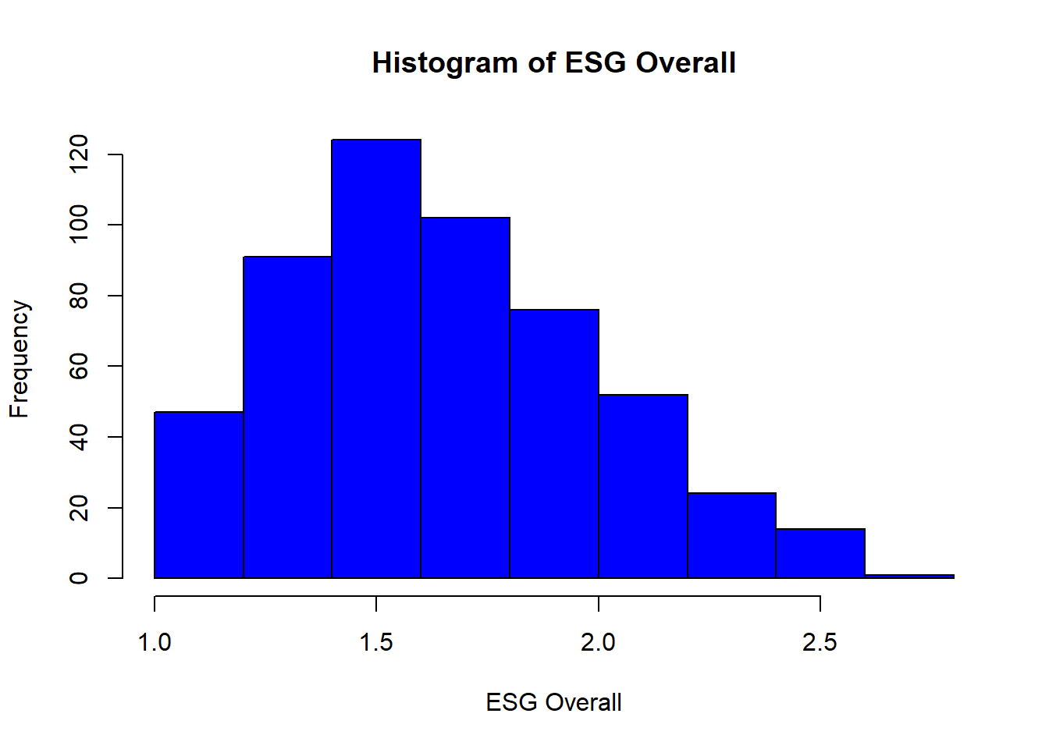
boxplot(Company_Data_Cleaned$esg_overall, main = "Boxplot of ESG Overall", ylab = "ESG Overall", col = "green")
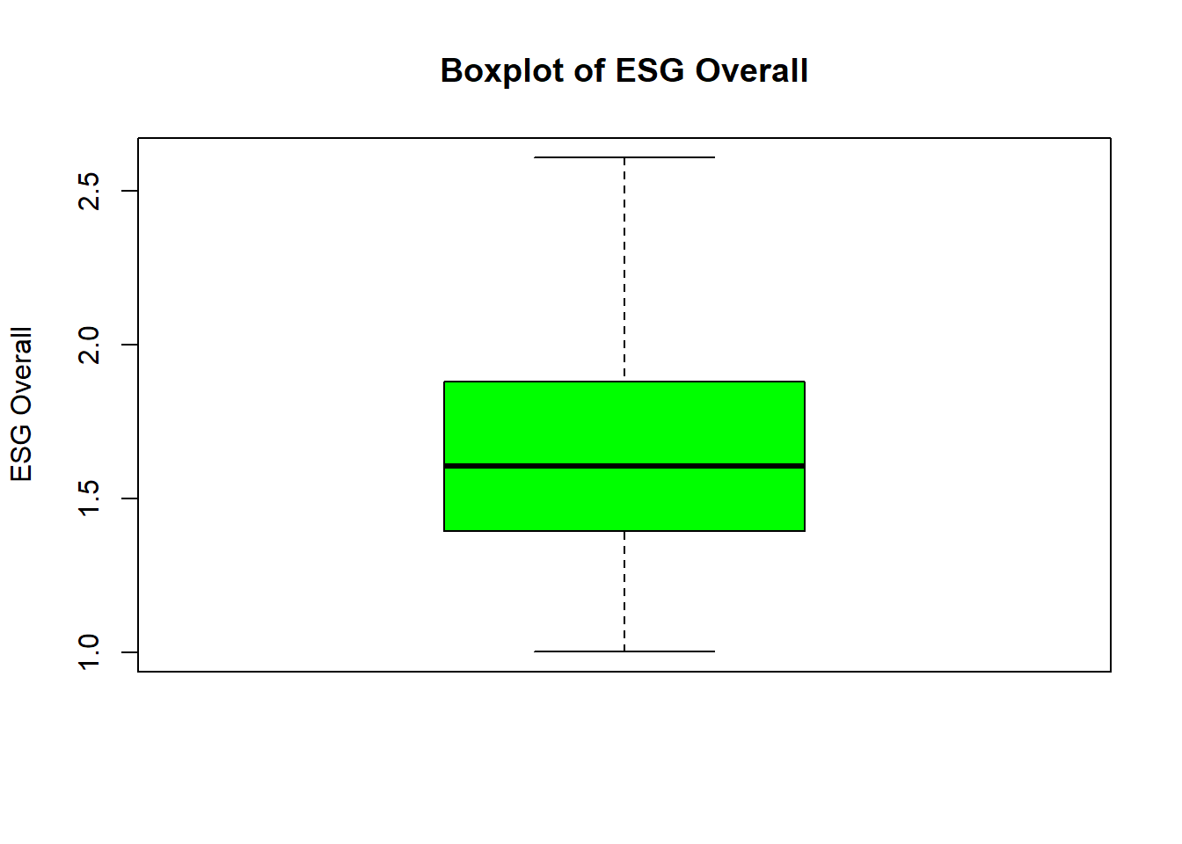
## Test stat Pr(>|Test stat|)
## gendiversity -0.5079 0.611818
## firmsize -0.5975 0.550504
## firmleverage -2.0520 0.040860 *
## roa -0.2449 0.806636
## boardindepend -0.5659 0.571768
## agediversity -0.8024 0.422813
## indus_femprop -3.1465 0.001783 **
## Tukey test 0.0760 0.939393
## ---
## Signif. codes: 0 '***' 0.001 '**' 0.01 '*' 0.05 '.' 0.1 ' ' 1
2. vif_results <- vif(Linear_model)
print(vif_results)
## gendiversity firmsize firmleverage roa boardindepend
## 1.083468 1.052436 1.047713 1.023796 1.069030
## agediversity indus_femprop
## 1.048939 1.025288
stargazer(vif_results, type = "text")
##
## =================================================================================
## gendiversity firmsize firmleverage roa boardindepend agediversity indus_femprop
## ---------------------------------------------------------------------------------
## 1.083 1.052 1.048 1.024 1.069 1.049 1.025
## ---------------------------------------------------------------------------------
##Model 2
restricted_model <- lm(esg_overall ~ gendiversity + firmsize + firmleverage + roa + boardindepend + agediversity + indus_femprop + fem_ceo , data=Company_Data)
summary(restricted_model)
##
## Call:
## lm(formula = esg_overall ~ gendiversity + firmsize + firmleverage +
## roa + boardindepend + agediversity + indus_femprop + fem_ceo,
## data = Company_Data)
##
## Residuals:
## Min 1Q Median 3Q Max
## -0.90100 -0.23895 -0.00665 0.22534 1.94740
##
## Coefficients:
## Estimate Std. Error t value Pr(>|t|)
## (Intercept) 0.647704 0.162742 3.980 8.25e-05 ***
## gendiversity 0.067955 0.095421 0.712 0.4768
## firmsize 0.097388 0.014384 6.771 4.85e-11 ***
## firmleverage -0.041302 0.058997 -0.700 0.4843
## roa 0.331119 0.206565 1.603 0.1098
## boardindepend 0.166075 0.087487 1.898 0.0584 .
## agediversity 0.002099 0.005549 0.378 0.7054
## indus_femprop -0.124024 0.133559 -0.929 0.3537
## fem_ceo -0.055599 0.097664 -0.569 0.5695
## ---
## Signif. codes: 0 '***' 0.001 '**' 0.01 '*' 0.05 '.' 0.1 ' ' 1
##
## Residual standard error: 0.3399 on 382 degrees of freedom
## (143 observations deleted due to missingness)
## Multiple R-squared: 0.1366, Adjusted R-squared: 0.1185
## F-statistic: 7.555 on 8 and 382 DF, p-value: 2.21e-09
4. vif_results_res <- vif(restricted_model)
print(vif_results_res)
## gendiversity firmsize firmleverage roa boardindepend
## 1.149811 1.069481 1.051976 1.024356 1.072871
## agediversity indus_femprop fem_ceo
## 1.055601 1.035764 1.114508
stargazer(vif_results_res, type = "text")
##
## =========================================================================================
## gendiversity firmsize firmleverage roa boardindepend agediversity indus_femprop fem_ceo
## -----------------------------------------------------------------------------------------
## 1.150 1.069 1.052 1.024 1.073 1.056 1.036 1.115
## -----------------------------------------------------------------------------------------
3. bptest_result_res <- bptest(restricted_model)
print(bptest_result_res)
##
## studentized Breusch-Pagan test
##
## data: restricted_model
## BP = 12.202, df = 8, p-value = 0.1424
Low p-value (e.g., < 0.05): Indicates evidence of heteroskedasticity, meaning the variance of the residuals is not constant across levels of the independent variables. High p-value: Suggests that there is no evidence of heteroskedasticity, and the assumption of homoscedasticity is not violated.
robust_se_restricted_model <- coeftest(restricted_model, vcov = vcovHC(restricted_model, type = "HC3"))
tidy(robust_se_restricted_model)
## # A tibble: 9 × 5
## term estimate std.error statistic p.value
## <chr> <dbl> <dbl> <dbl> <dbl>
## 1 (Intercept) 0.648 0.174 3.71 0.000236
## 2 gendiversity 0.0680 0.0937 0.725 0.469
## 3 firmsize 0.0974 0.0161 6.06 0.00000000330
## 4 firmleverage -0.0413 0.0658 -0.628 0.530
## 5 roa 0.331 0.210 1.58 0.116
## 6 boardindepend 0.166 0.0877 1.89 0.0590
## 7 agediversity 0.00210 0.00536 0.391 0.696
## 8 indus_femprop -0.124 0.124 -1.00 0.317
## 9 fem_ceo -0.0556 0.107 -0.519 0.604
unrestricted_model <- lm(esg_overall ~ gendiversity + firmsize + firmleverage + roa + boardindepend + agediversity + indus_femprop + fem_ceo + I(gendiversity*fem_ceo) , data=Company_Data)
summary(unrestricted_model)
##
## Call:
## lm(formula = esg_overall ~ gendiversity + firmsize + firmleverage +
## roa + boardindepend + agediversity + indus_femprop + fem_ceo +
## I(gendiversity * fem_ceo), data = Company_Data)
##
## Residuals:
## Min 1Q Median 3Q Max
## -0.90361 -0.23361 -0.00291 0.21673 1.94585
##
## Coefficients:
## Estimate Std. Error t value Pr(>|t|)
## (Intercept) 0.659860 0.162324 4.065 5.83e-05 ***
## gendiversity 0.093781 0.096078 0.976 0.3296
## firmsize 0.095941 0.014356 6.683 8.34e-11 ***
## firmleverage -0.052432 0.059093 -0.887 0.3755
## roa 0.340936 0.205938 1.656 0.0986 .
## boardindepend 0.173243 0.087276 1.985 0.0479 *
## agediversity 0.001796 0.005533 0.325 0.7457
## indus_femprop -0.136581 0.133277 -1.025 0.3061
## fem_ceo 0.491819 0.305498 1.610 0.1082
## I(gendiversity * fem_ceo) -1.316985 0.696667 -1.890 0.0595 .
## ---
## Signif. codes: 0 '***' 0.001 '**' 0.01 '*' 0.05 '.' 0.1 ' ' 1
##
## Residual standard error: 0.3388 on 381 degrees of freedom
## (143 observations deleted due to missingness)
## Multiple R-squared: 0.1446, Adjusted R-squared: 0.1244
## F-statistic: 7.158 on 9 and 381 DF, p-value: 1.307e-09
5. bptest_result_unres <- bptest(unrestricted_model)

print(bptest_result_unres)
##
## studentized Breusch-Pagan test
##
## data: unrestricted_model
## BP = 12.644, df = 9, p-value = 0.1794
6. vif_results_un <- vif(unrestricted_model)
print(vif_results_un)
## gendiversity firmsize firmleverage
## 1.173538 1.072532 1.062523
## roa boardindepend agediversity
## 1.025008 1.074900 1.056488
## indus_femprop fem_ceo I(gendiversity * fem_ceo)
## 1.038344 10.978690 11.101974
stargazer(vif_results_un, type = "text")
##
## ===================================================================================================================
## gendiversity firmsize firmleverage roa boardindepend agediversity indus_femprop fem_ceo I(gendiversity * fem_ceo)
## -------------------------------------------------------------------------------------------------------------------
## 1.174 1.073 1.063 1.025 1.075 1.056 1.038 10.979 11.102
## -------------------------------------------------------------------------------------------------------------------
f_test <- anova(restricted_model, unrestricted_model)
print(f_test)
## Analysis of Variance Table
##
## Model 1: esg_overall ~ gendiversity + firmsize + firmleverage + roa +
## boardindepend + agediversity + indus_femprop + fem_ceo
## Model 2: esg_overall ~ gendiversity + firmsize + firmleverage + roa +
## boardindepend + agediversity + indus_femprop + fem_ceo +
## I(gendiversity * fem_ceo)
## Res.Df RSS Df Sum of Sq F Pr(>F)
## 1 382 44.13
## 2 381 43.72 1 0.41008 3.5736 0.05946 .
## ---
## Signif. codes: 0 '***' 0.001 '**' 0.01 '*' 0.05 '.' 0.1 ' ' 1
stargazer(f_test, type = "text")
##
## ==========================================
## Statistic N Mean St. Dev. Min Max
## ------------------------------------------
## Res.Df 2 381.500 0.707 381 382
## RSS 2 43.925 0.290 43.720 44.130
## Df 1 1.000 1 1
## Sum of Sq 1 0.410 0.410 0.410
## F 1 3.574 3.574 3.574
## Pr(> F) 1 0.059 0.059 0.059
## ------------------------------------------
stargazer(restricted_model, unrestricted_model, type = "text",
title = "Comparison of Regression Models",
align = TRUE,
header = FALSE,
digits = 4,
dep.var.labels.include = FALSE,
covariate.labels = c("Gender Diversity", "Firm Size", "Firm Leverage", "ROA", "Board Independence", "Age Diversity", "Industry Female Proportion", "Female CEO", "Gender Diversity * Female CEO"),
omit.stat = c("LL", "ser", "f"),
star.cutoffs = c(0.05, 0.01, 0.001))
##
## Comparison of Regression Models
## ============================================================
## Dependent variable:
## ------------------------------
## (1) (2)
## ------------------------------------------------------------
## Gender Diversity 0.0680 0.0938
## (0.0954) (0.0961)
##
## Firm Size 0.0974*** 0.0959***
## (0.0144) (0.0144)
##
## Firm Leverage -0.0413 -0.0524
## (0.0590) (0.0591)
##
## ROA 0.3311 0.3409
## (0.2066) (0.2059)
##
## Board Independence 0.1661 0.1732*
## (0.0875) (0.0873)
##
## Age Diversity 0.0021 0.0018
## (0.0055) (0.0055)
##
## Industry Female Proportion -0.1240 -0.1366
## (0.1336) (0.1333)
##
## Female CEO -0.0556 0.4918
## (0.0977) (0.3055)
##
## Gender Diversity * Female CEO -1.3170
## (0.6967)
##
## Constant 0.6477*** 0.6599***
## (0.1627) (0.1623)
##
## ------------------------------------------------------------
## Observations 391 391
## R2 0.1366 0.1446
## Adjusted R2 0.1185 0.1244
## ============================================================
## Note: *p<0.05; **p<0.01; ***p<0.001

