Final Project – Dashboard Presentation Script

Title: Global Superstore: Sales & Profit Insights for Strategic Growth
Student: Kye Jones
Course: IT688 – Reporting Data and Analytics
Date: Aug 1
Introduction
This dashboard was built using the Global Superstore dataset to uncover actionable insights across sales, profit, customer segments, and logistics performance. The goal was to deliver a visual narrative that helps decision-makers identify strategic areas for revenue growth and operational efficiency. Each visualization is designed using best practices in dashboard design: clear titles, labeled axes, consistent colors, clean layout, and visual hierarchy to guide the viewer.
Visual 1: Regional Sales Breakdown by Customer Segment
This bar chart presents sales performance by region, further segmented by customer type: Consumer, Corporate, and Home Office.
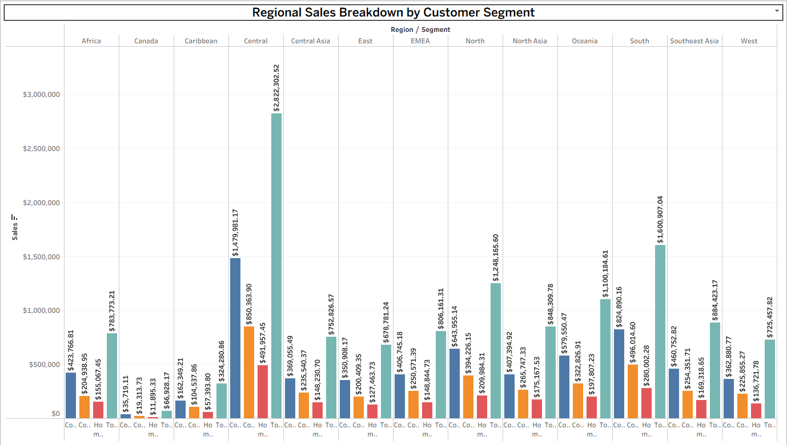
Key insights:
- The Central region dominates in overall sales, particularly in the Consumer segment, with over $2.8M in revenue.
- Regions like North and South also show strong diversified performance across segments.
- This visual helps identify where to focus customer acquisition strategies by segment and geography.
Visual 2: Top 10 Most Profitable Sub-Categories
This horizontal bar chart ranks the top sub-categories by total profit.
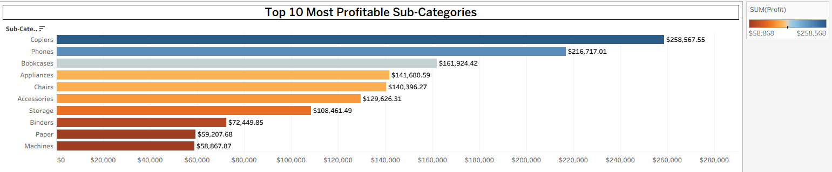
Key insights:
- Copiers and Phones are the most profitable categories, generating $258K and $216K respectively.
- Other top performers include Bookcases, Appliances, and Chairs.
- Investing in or expanding the marketing efforts for these high-profit products can yield the greatest margin returns.
Visual 3: Monthly Sales Trend by Segment
This line chart tracks monthly sales over four years, separated by Consumer, Corporate, and Home Office segments. Each line includes a trend line to forecast growth.
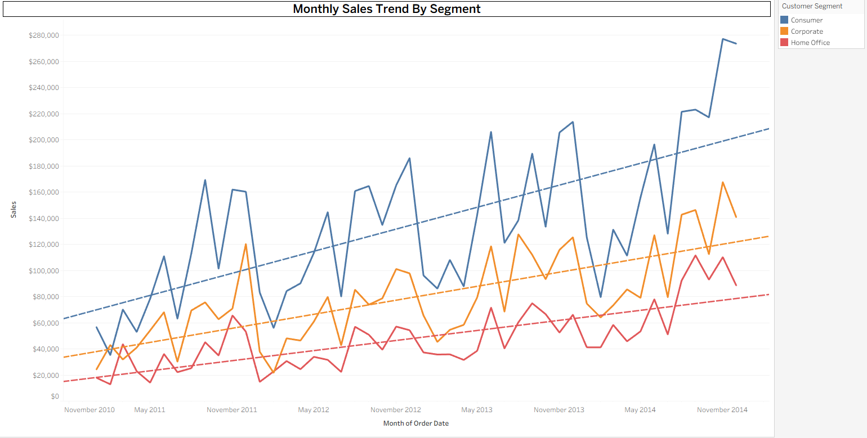
Key insights:
- The Consumer segment shows the most significant upward trend in monthly sales.
- Despite seasonal dips, growth is consistent across all segments.
- This visual emphasizes market stability and helps forecast future revenue projections.
Visual 4: Days to Ship vs. Profit
This line graph shows how shipping time (in days) correlates with profitability by segment.
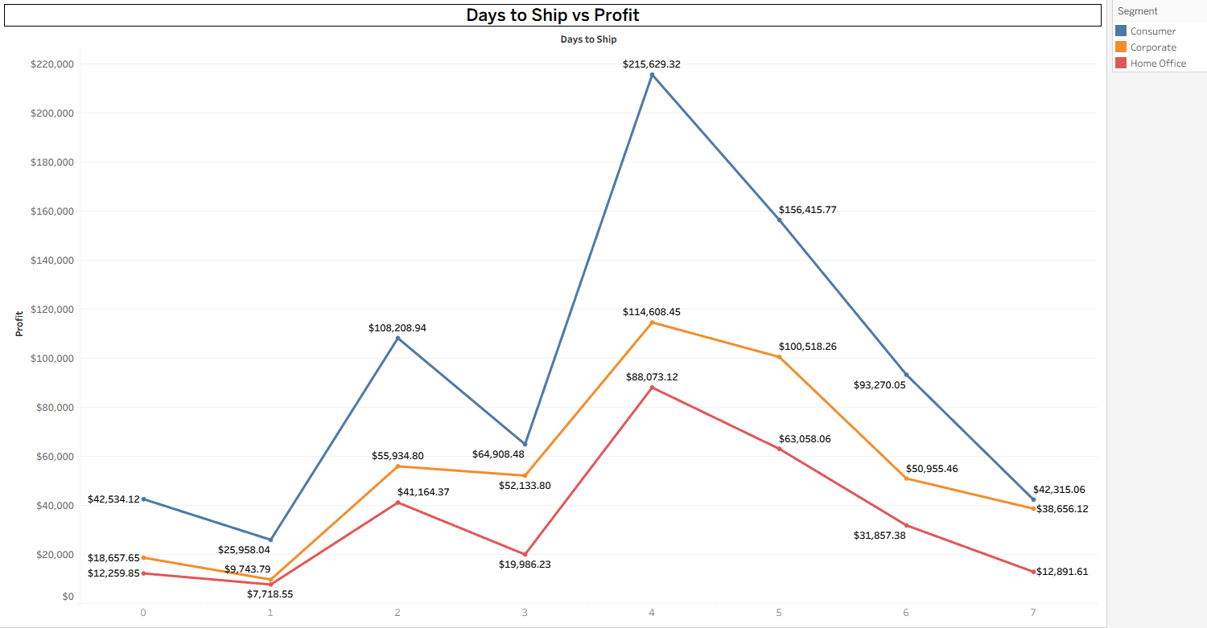
Key insights:
- Orders that take 4–5 days to ship generate the highest profits, especially in the Consumer segment.
- Longer or shorter shipping durations correlate with lower margins.
- This suggests that optimizing logistics around the 4–5 day window may strike the best balance between speed and cost.
Visual 5: Profit by Ship Mode
This chart analyzes profit based on shipping method—First Class, Same Day, Second Class, and Standard Class—broken down by Product Category.
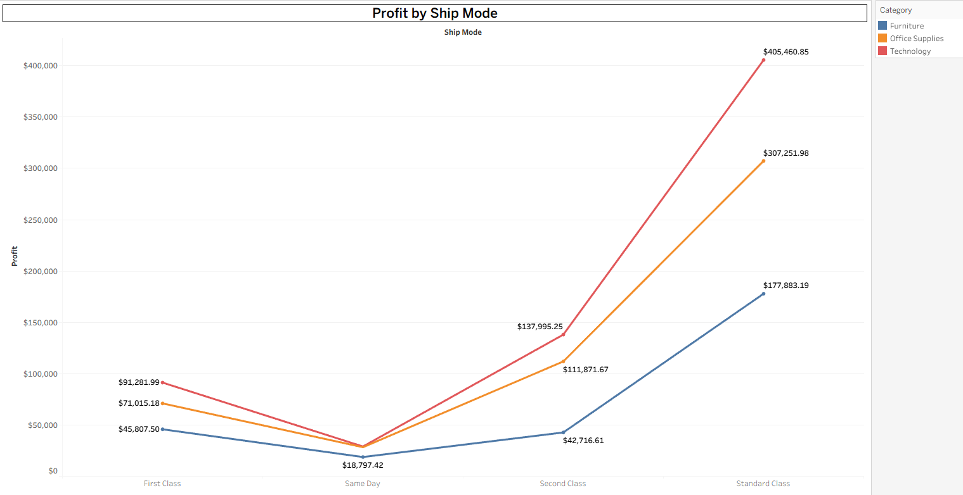
Key insights:
- Standard Class yields the highest profit, especially for Technology products, which bring in over $400K.
- Same Day shipping, while faster, yields significantly lower profits across the board.
- This indicates that Standard Class is likely the most efficient shipping method relative to cost and profit.
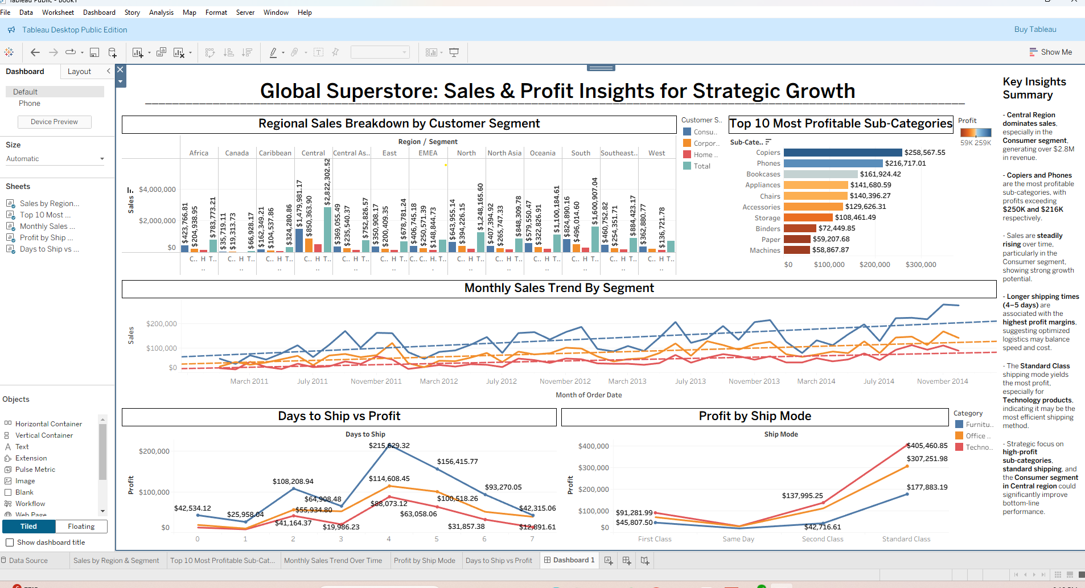
Dashboard Design Highlights

- Three-tiered layout: Top-level views (region and category), mid-level trends (time), and bottom-level operational performance (shipping).
- Color-coded legends and consistent formatting allow for intuitive comparisons.
- Key Insights Summary sidebar provides executive-friendly takeaways for immediate action.
Conclusion
The Global Superstore dashboard reveals actionable insights that can guide strategic business decisions across sales, operations, and logistics. The strongest profits stem from specific sub-categories like Copiers and Phones, particularly within the Consumer segment and the Central region. Sales trends show steady growth over time, reinforcing the opportunity for continued investment in high-performing segments.
Shipping analysis highlights an important operational trade-off: while longer shipping times (4–5 days) tend to be more profitable, this may reflect optimized cost structures rather than customer preferences. It’s possible that extended fulfillment windows allow for consolidated shipments, reduced express costs, or better inventory management. Similarly, the high profitability of the Standard Class shipping method suggests this balance between cost and delivery speed is a key contributor to margin control.
These patterns, however, could also be influenced by external factors not captured in the dataset — such as regional customer density, local promotions, or supply chain constraints. For example, the Central region’s dominant sales figures may reflect not only customer demand, but also warehousing proximity, fulfillment center availability, or targeted marketing campaigns.
As the designer of this dashboard, my goal was to transform static data into a dynamic, story-driven visual tool — one that not only informs but also persuades. By using best practices in layout, color, and hierarchy, I’ve organized these visuals to create a logical narrative flow that guides decision-makers from insight to action.
Looking ahead, next steps could include conducting deeper customer segmentation, analyzing return or warranty data to assess net profit, or evaluating promotion timing to capitalize on seasonal trends. With a clear understanding of where performance is strong and where optimizations are possible, leadership can be empowered to act confidently on the story this data tells.

