Automated Alignment Analysis of Overhead Crane Rails

Executive Summary
Problem. Misalignment of overhead crane rails leads to uneven wheel loading, premature wear, and avoidable downtime. Tolerances are tight typically 3/16–1/4" so small deviations matter. Traditional total station surveys collect sparse points every 3–5 ft and can drift by ~1/8 in per 500 ft, which is not ideal for long runs.
Goal. From 3D point clouds, isolate three specific faces on each rail (1) head‑top, (2) head‑side, (3) web‑side then prepare them for alignment checks (elevation, straightness, span) against CMAA guidelines.
Approach. Scanning was performed with a Leica BLK360 mounted on the bridge crane, moving 12–20 ft between scans with 6–7 positions per side; the south rail (Rail A) and north rail (Rail B) were cropped to equal axial length. After cleaning and geometric normalization (relative top/side corrections), local 3D features were engineered (PCA eigen‑features, curvature, roughness, DIP, PCV). A Random Forest (trained on an ideal synthetic rail) provided a supervised pre‑classification, and unsupervised clustering (DBSCAN, Ward, Spectral, GMM‑3, KMeans‑3) separated the final three faces.
Findings.
- Data quality: Rail B had lower point density and missing sections along the rail, complicating classification. Synthetic axial duplicates (6” shift) filled some gaps (+50% points).
- Modeling: Across datasets, KMeans‑3 often had the top silhouette but on the most critical subset (Rail A, RF‑filtered), DBSCAN scored highest (0.68). Visual boundary quality favored GMM‑3, which was selected for the final component isolation.
- Deliverable: Clean, combined A+B rail components (265,124 rows × 13 columns) and exported for final rail alignment analysis.
Impact. The pipeline produces repeatable and automation‑ready rail faces to evaluate alignment with less human error and higher spatial resolution than the traditional prism surveys.

1) Problem Statement
Industrial overhead cranes require closely controlled rail elevation, straightness, and span to meet CMAA tolerances (commonly 3/16–1/4 in). Discrete total‑station shots every 3–5 ft and cumulative ~1/8 in per 500 ft drift create uncertainty for long runs. We seek a high‑density, automated method using 3D scanning and machine learning to reliably extract the critical faces of each rail for alignment checks.
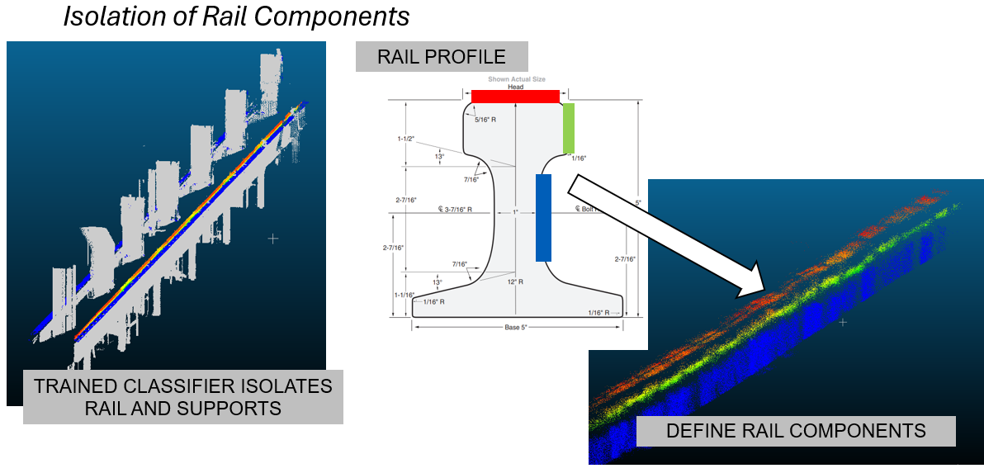

2) Data & Methods

2.1 Acquisition & Pre‑processing
- Scanner & coverage. Leica BLK360, mounted on the bridge, scanning in 12–20 ft increments from 6–7 positions per side. The south rail (A) was longer; we cropped A to match Rail B’s axial range
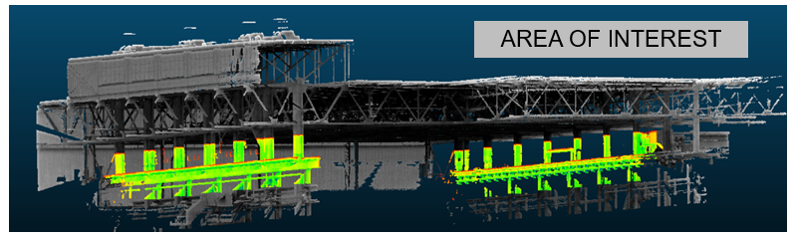
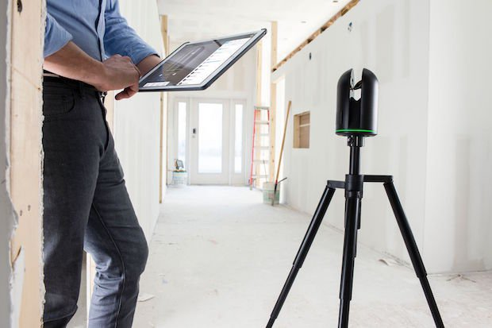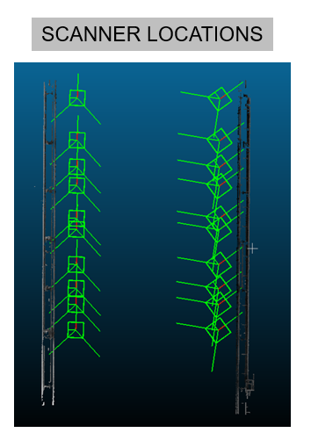
- Coordinate normalization. Converted meters→feet→inches; reset vertical/axial origins; created lateral_inch, axial_inch, vertical_inch, and rounded variants.
- Rail labeling & equalization. Defined Rail A as lateral < 0 and Rail B as lateral ≥ 0, then truncated A to B’s axial bounds to equalize rail length in the analyses.
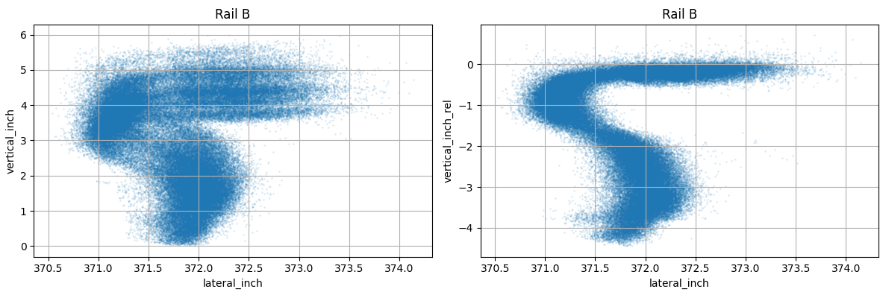

(Normalization comparison to flatten top of rail, highlights ‘stripping’ prior synthetic shifted dups)
- Relative corrections.
  - Top flattening via rolling 99th‑percentile of vertical_inch in a narrow lateral crown band → relative_vertical_inch.
  - Side straightening via rolling 99th‑percentile of lateral_inch in a narrow vertical band → relative_lateral_inch.
- Gap filling. To reduce “striping” (missing scans), we added synthetic axial duplicates (+6 in) and flagged them; this increased point count by 50% to help the classifiers (removed later for final alignment).
- Processed dataset. Exported data/df_processed.csv as the clean, normalized base for feature engineering.

2.2 Feature Engineering
- Local PCA features (λ1–λ3 eigenvalues; eigenvectors e1–e3) and derived descriptors (omnivariance, eigenentropy, anisotropy, planarity, linearity, surface variation, sphericity, pca1, pca2, verticality, first‑order moment O). Normals (Nx, Ny, Nz) oriented to +Z.
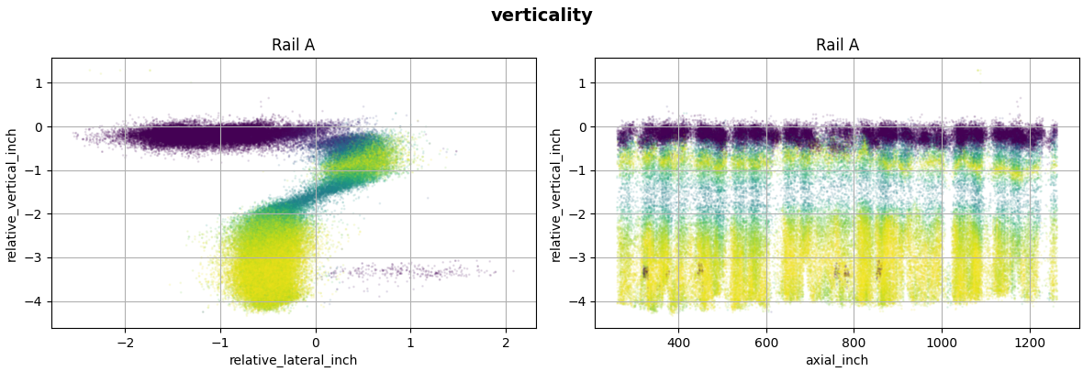
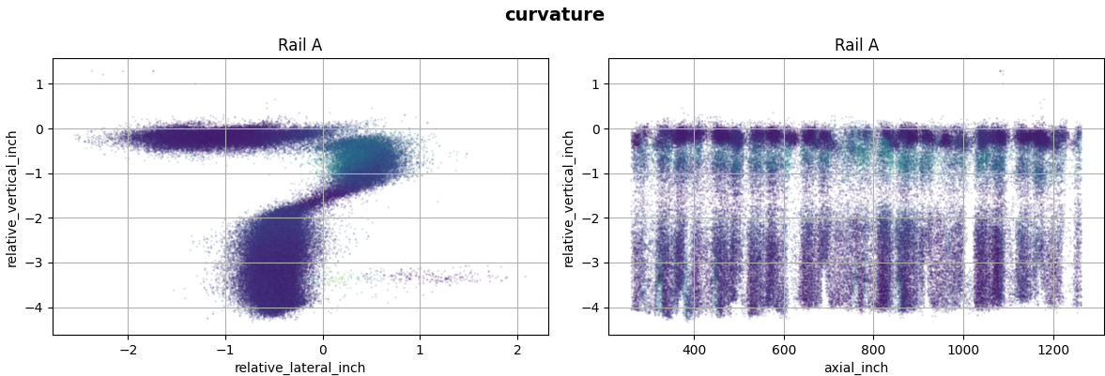
(Geometric feature examples)
- Surface stats & orientation: curvature (λ3/(λ1+λ2+λ3)), roughness (mean, RMS, std) via point‑to‑plane residuals, DIP (0° horizontal–90° vertical), DIPDIR (azimuth).
- PCV / “sky visibility.” Computed in CloudCompare for speed (GPU) and ingested as PCV; CPU reference implementation included for reproducibility.
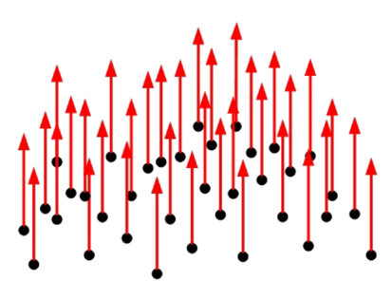
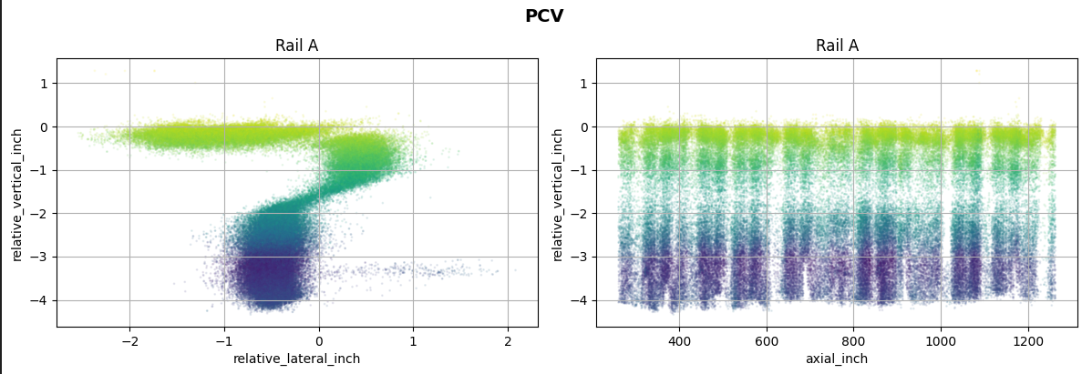
- Featured dataset. Exported data/df_featured.csv, 53 columns, ready for modeling.

2.3 Modeling Pipeline
- Supervised pre‑step. A Random Forest trained on an ideal synthetic rail provided RF_Prediction to roughly separate rail points; probabilities recorded where available.
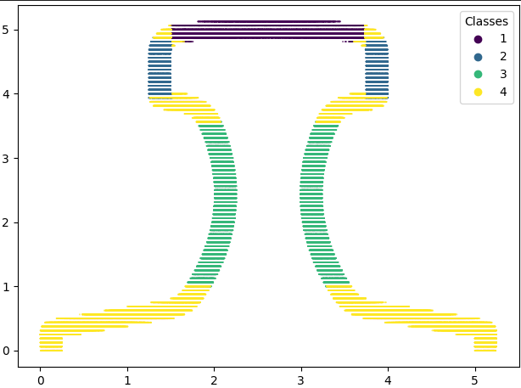
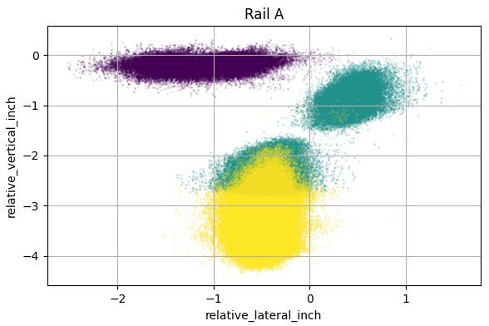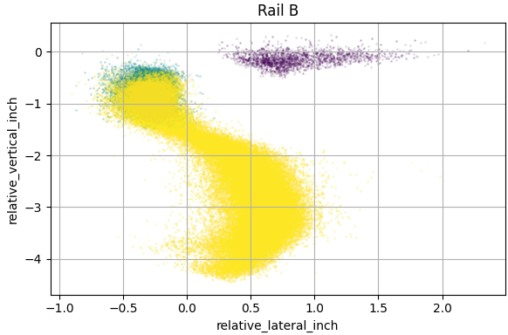
- Denoising. Applied IsolationForest(contamination=0.02) to each subset to remove outliers for fair comparison across clustering methods (kept ~98%).
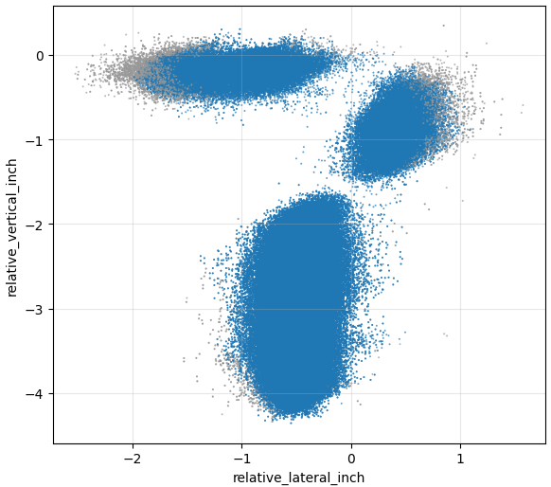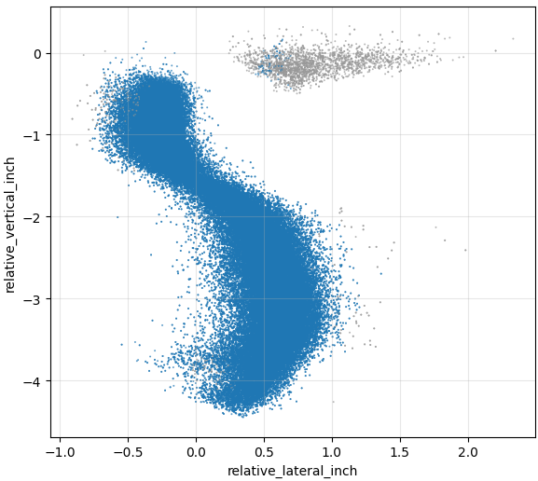
- Unsupervised benchmarking (feature set for clustering = ['lateral_inch', 'vertical_inch']):
  - DBSCAN: min_samples=20, dataset‑specific eps via k‑distance quantile (Aall~0.028, Ball~0.050, ARF~0.035, BRF~0.068); clusters ≤200 relabeled as noise.
  - Ward (Agglomerative): n_clusters=3, connectivity graph with n_neighbors=20.
  - Spectral (2‑stage): MiniBatchKMeans(microk=1000) → SpectralClustering(nclusters=3, nearest‑neighbors affinity, assignlabels='kmeans', ninit=10, random_state=42).
  - GMM‑3: n_components=3, random_state=42.
  - KMeans‑3: n_clusters=3, n_init=10, random_state=42.
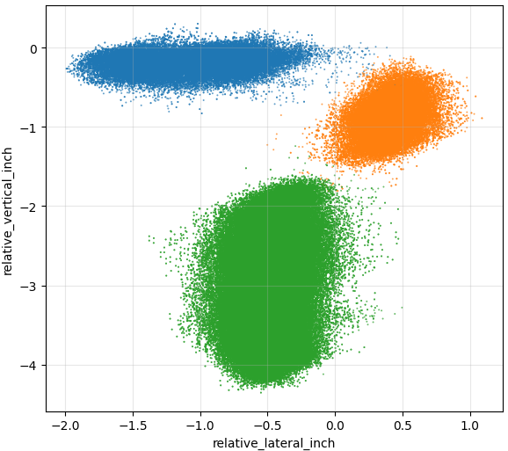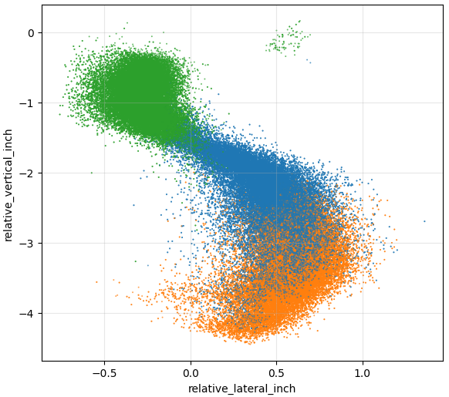
- Metrics. Silhouette computed per dataset/method; DBSCAN silhouettes exclude noise (or reported NaN when not applicable).

3) Results & Findings

3.1 Data quality observations
- Rail B exhibited lower point density and missing strips, degrading separability of vertical faces and increasing misclassifications; Rail A was denser.
- Synthetic axial duplicates (+6 in) effectively filled striping and improved neighborhood feature stability (+50% rows during modeling; removed prior to alignment export).

3.2 Clustering performance (silhouette)
Across four evaluation datasets (dfa_all_points, dfb_all_points, dfa_rf_filtered, dfb_rf_filtered), the top silhouettes were:
- dfaallpoints: KMeans‑3 = 0.652738.
- dfarffiltered (Rail A, RF‑filtered): DBSCAN = 0.675451 (best on the priority subset).
- dfballpoints: KMeans‑3 = 0.556085.
- dfbrffiltered: KMeans‑3 = 0.459269; DBSCAN = 0.335005 with notable noise.
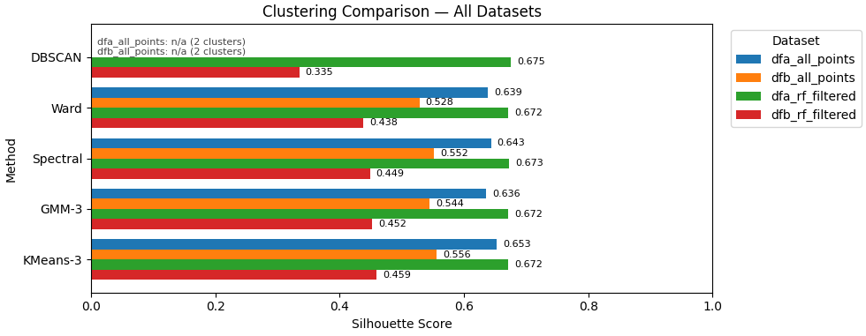
Why GMM‑3 in the end? While KMeans‑3/DBSCAN posted strong silhouettes, visual inspection showed GMM‑3 produced cleaner, more stable boundaries between head‑side and web‑side practical for downstream alignment measurements. Thus, we selected GMM‑3 for the final component isolation.
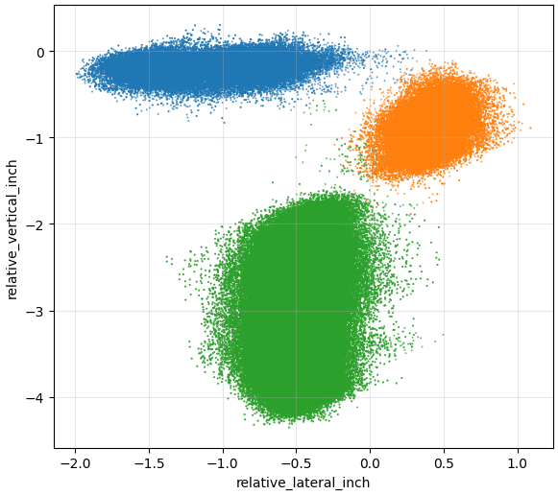
(Best method plot - GMM)

3.3 Final label mapping & export
GMM‑3 cluster IDs were mapped to faces as follows and exported the isolated components:
- is_web_a := (CL_GMM3 == 0) & (is_rail_a == 1)
- is_web_b := (CL_GMM3 in {0,2}) & (is_rail_b == 1)
- is_head_top_a := (CL_GMM3 == 1) & (is_rail_a == 1)
- is_head_side_a := (CL_GMM3 == 2) & (is_rail_a == 1)
- is_head_side_b := (CL_GMM3 == 1) & (is_rail_b == 1)
- (head_top_b not populated in this run)
Prepared dataset for alignment: data/df_isolated_components.csv with 265,124 rows × 13 columns, recombined A+B, non‑synthetic. This is the recommended input for the alignment evaluation stage (elevation, straightness, span).

4) Limitations
- Sensor/coverage constraints. Lower density and occlusions (notably on Rail B) led to classification uncertainty in vertical faces; better coverage would reduce reliance on synthetic augmentation.
- Supervised dependency. The Random Forest was trained on an ideal synthetic profile; domain gaps between ideal and as‑built geometry can bias pre‑labels.
- Not included in this report: Full numerical CMAA compliance calculations (elevation/straightness/span) will run on the exported faces in a subsequent step.

5) Ideas for Further Research
1) Acquisition strategy study. Quantify silhouette/accuracy vs. station spacing and standoff distance to find the minimal scan plan that eliminates striping without changing hardware.
2) Robust face fitting. Per‑cluster RANSAC/total‑least‑squares planes and breakline detection along the head/web transitions to derive alignment statistics with uncertainty bounds.
3) Model selection automation. Compare Calinski–Harabasz and Davies–Bouldin alongside silhouette to auto‑select clustering per shift/day; log MLOps metrics for drift monitoring.

6) Up to Three Concrete Client Recommendations
1) Operationalize the GMM‑based isolation pipeline.
Use the provided steps (i) RF pre‑filter on df_featured.csv, (ii) IsolationForest denoising, (iii) GMM‑3 on ['lateral_inch','vertical_inch'], and (iv) the final label mapping above to regenerate df_isolated_components.csv after each scan. This creates consistent inputs for your alignment checks and trend monitoring.
2) Tighten the scan plan to reduce striping before considering new hardware.
Keep the BLK360 but reduce station spacing (e.g., closer than 12–20 ft in occluded spans) and ensure line‑of‑sight to the head/web faces on Rail B, where density was low. This directly improves classification stability and may eliminate the need for synthetic augmentation.
3) Automate CMAA checks on the exported faces.
On df_isolated_components.csv, compute elevation, straightness, and span vs. tolerances (3/16–1/4 in), summarize by 5–10 ft stations, and flag exceedances with location/extent for targeted maintenance. Schedule recurring scans to track correction effectiveness over time.

7) Appendix: Key Technical Details
- Relative corrections: rolling q99 of top/side bands to produce relative_vertical_inch and relative_lateral_inch.
- Feature set (53 columns): PCA eigen‑features, normals, curvature, roughness stats, DIP/DIPDIR, PCV.
- Denoising: IsolationForest contamination=0.02; kept ≈98%.
- DBSCAN eps (approx.): Aall ~0.028, Ball ~0.050, ARF ~0.035, BRF ~0.068 (with min_samples=20, clusters ≤200 → noise).
- Silhouettes (best): Aall KMeans‑3=0.652738, ARF DBSCAN=0.675451, Ball KMeans‑3=0.556085, BRF KMeans‑3=0.459269.
- Final export: data/df_isolated_components.csv, 265,124 × 13.

Developed a high-resolution rail alignment analysis system using 3D scanning and machine learning. Engineered geometric features from PCA eigenvectors and applied RF, GMM, and DBSCAN clustering to isolate overhead crane rail faces. Replacing sparse manual surveys and enabling proactive maintenance to prevent wheel wear and avoid costly unplanned outages.

