Garage Management System – Service Scheduling Module
University DBMS Project Report
Prepared by: KYEYUNE IDRISA 2025/BCS/110/PS
GROUP:20
Course: Database Management Systems
Date: May 2026
EXECUTIVE SUMMARY
The Garage Management System – Service Scheduling Module is a comprehensive relational database solution designed to modernize and optimize the appointment booking, resource allocation, and service tracking processes in an automotive repair garage. Built using MySQL, the system replaces inefficient manual scheduling methods (such as paper diaries or basic spreadsheets) with a robust, scalable, and user-friendly database application.
The primary purpose of this database system is to efficiently manage customer vehicle service bookings, assign mechanics, track service progress, handle rescheduling and cancellations, maintain complete service history, and generate management reports. Key features include real-time appointment scheduling, mechanic workload balancing, estimated duration and cost calculation, payment tracking, and historical data analysis.
Service scheduling is critical in garage operations because it directly impacts customer satisfaction, mechanic productivity, resource utilization (bays, tools, parts), and overall revenue. Poor scheduling leads to overbooking, long waiting times, idle mechanics, and lost customers. This system addresses these pain points by providing visibility into availability, automated conflict detection, and data-driven decision support.
Main features:
Client and car registration
Online/real-time appointment booking with availability checking
Technician assignment and workload management
Service status tracking
Service history
Cost estimation and payment recording
Comprehensive reporting and analytics
Expected benefits include reduced booking errors, improved mechanic utilization (target >85%), shorter customer wait times, higher customer retention through better service history access, and increased daily service capacity. The system is expected to deliver tangible ROI through operational efficiency and enhanced customer experience.
BUSINESS CASE
Introduction
Automotive garages handle a high volume of daily service requests ranging from routine maintenance (oil changes, tire rotations) to complex repairs (engine diagnostics, brake overhauls). Traditional manual scheduling relies on physical appointment books or shared Excel sheets, which frequently result in double-bookings, lost records, difficulty in tracking mechanic availability, and challenges in generating accurate reports.
These challenges lead to operational bottlenecks, customer dissatisfaction, revenue leakage from unrecorded services, and inefficient use of skilled labor. The proposed Service Scheduling Module provides a centralized, digital solution tailored to the unique needs of a mid-sized garage operating 6 days a week with 8–12 mechanics.
Application Domain
The system supports core garage operations by enabling:
Customers to book services for their vehicles
Reception staff to manage appointments and customer data
Mechanics to view assigned jobs and update progress
Managers to monitor performance, workload, and revenue
Types of users:
Reception/Admin staff
Mechanics/Technicians
Garage Manager/Owner
Customers (via self-service portal in future versions)
Real-world usage scenario: A customer calls or visits the garage complaining of unusual engine noise. The receptionist searches the customer’s vehicle history, checks available mechanics with relevant expertise, books a suitable slot, estimates cost and duration, and assigns the job. The mechanic updates status in real-time, parts used are recorded, and upon completion, payment is processed and history updated. The manager reviews daily reports to optimize staffing.
System Requirements
Functional Requirements:
Register and manage customers and vehicles
Define service types with standard duration and cost
Check real-time availability and book appointments
Assign mechanics to appointments
Track service status and update progress
Handle rescheduling and cancellations with audit trail
Record payments and generate invoices
Maintain complete service history per vehicle
Generate various analytical reports
Non-functional Requirements:
System must support at least 50 concurrent appointments per day
Response time
Data integrity and referential integrity enforced
User-friendly interface with role-based access
Backup and recovery capability (daily)
Scalability for future modules (inventory, billing)
Security compliance (password hashing, audit logs)
Benefits Analysis
Tangible Benefits:
Reduction in administrative time by approximately 40%
Increase in daily serviced vehicles through better scheduling
Accurate cost tracking and reduced billing errors
Data for performance-based mechanic incentives
Intangible Benefits:
Improved customer satisfaction and loyalty
Professional image of the garage
Better decision-making through historical insights
Reduced stress for staff
Operational efficiency improves through automated conflict detection and optimized bay/mechanic allocation. Customer satisfaction rises due to reliable booking, timely updates, and personalized service based on history.
Cost Analysis
Estimated Implementation Costs (UGX):
Hardware (server, computers, network): 12,000,000
MySQL licensing (open source – free) + development tools: 2,500,000
Staff training (20 staff × 3 days): 4,000,000
Initial data migration and customization: 5,000,000
Annual maintenance and support: 3,500,000
Total first-year cost: 27,000,000 UGX. Expected payback period: 14–18 months through efficiency gains.
User Issues
The system assumes basic computer literacy. Reception staff and managers require intermediate skills; mechanics need simple interface training. Adoption challenges include resistance to change from long-serving staff and initial data entry effort. Comprehensive training programs, user manuals are recommended. The interface is designed with intuitive forms and minimal clicks for common tasks.
Risk Assessment
Technical risks: Database downtime, poor query performance solved by proper indexing and normalization.
Organizational risks: Low user adoption (mitigated by training).
Security risks: Unauthorized access to customer data (addressed via roles and encryption).
Data loss risks: Hardware failure (mitigated by regular backups and replication).
Limitations of the System
Current version does not include real-time parts inventory integration, online payment gateway, SMS/Email notifications, or mobile app. It assumes stable internet/power supply. Complex multi-vehicle fleet management for corporate clients is simplified.
LOGICAL DESIGN
Identification of Entities
The main entities identified through requirements analysis are:
Client: Individuals or companies owning vehicles.
Car: Specific cars/motorcycles/trucks serviced.
Technician: Garage technicians with skills.
Service: Standardized services offered.
Booking: Booking/scheduling instance.
RepairHistory: Completed service details (history).
Payment: Financial transactions linked to services.
Entities and Attributes
Customer
CustomerID (PK, INT AUTO_INCREMENT)
FirstName, LastName, Phone, Email, Address, RegistrationDate
Car
CarID (PK)
CustomerID (FK)
Make, Model, Year, LicensePlate, VIN, Mileage
Technician
TechnicianID (PK)
FirstName, LastName, Specialization, Phone, HireDate, AvailabilityStatus
Service
ServiceID (PK)
ServiceName, Description, StandardDuration (minutes), BaseCost
Booking
BookingID (PK)
CarID (FK), TechnicianID (FK), ServiceID (FK)
AppointmentDate, StartTime, EndTime, Status, Notes
RepairHistoryID (PK)
BookingID (FK), CarID (FK)
ActualDuration, ActualCost, CompletionDate, Remarks
Transaction
TransactionID (PK)
BookingID (FK) or HistoryID
Amount, TransactionDate, TransactionMethod, Status
Entity Relationships
Customer to Car: Binary 1:M (one customer can own multiple vehicles)
Car to Booking: Binary 1:M
Technician to Booking ; Binary 1:M
Service to Booking : Binary 1:M
Booking to RepairHistory: Binary 1:1 (or 1:0..1)
Booking/RepairHistoryto Payment: Binary 1:0..1 or 1:1
No significant unary or ternary relationships in the core model (a junction table could be added later for multiple services per Booking).
Multiplicities/Cardinalities
One-to-Many: Customer-Car, Car-Booking, etc.
Many-to-Many: Potentially between Booking and Service if supporting multiple services .
ERD theoretical representation.
Customer (1) (M) Car (1) (M)Bookings (M) (1) Technician
| |
| |
Service RepairHistory (1) (1) Payment
Detailed ERD:
[Customer] (1:M owns)[Car] (1:M books) [Bookings](1:M assigned_to) [Technician]
|
(references)-- [Service]
|
(results_in) [RepairHistory] (links_to) [Transaction]
Normalization
Unnormalized Form (UNF): Single large table with repeating groups for services, vehicles, etc.
1NF: Atomic values, no repeating groups. Separate tables created.
2NF: Full functional dependency. Removed partial dependencies (e.g., ServiceType details not repeated in appointments).
3NF: No transitive dependencies. Customer details not stored in Vehicle; Mechanic details independent, etc.
All tables in the final design are in 3NF.
Database Schema
Tables use appropriate MySQL data types, constraints , and indexes on frequently searched columns .
User Interface Design
Appointment Booking Form: Fields for customer search, vehicle selection, service type dropdown, date/time picker with availability validation.
Manager Dashboard: Calendar view, today’s appointments, mechanic utilization charts.
Mechanic Interface: List of assigned jobs with status update buttons.
Service Tracking: Search by plate or customer, view history timeline.
The database was created in MySQL 8.0+. Tables, indexes, and constraints were defined via SQL scripts. Stored procedures.
Screenshots
THE CLIENT TABLE CONTENTS
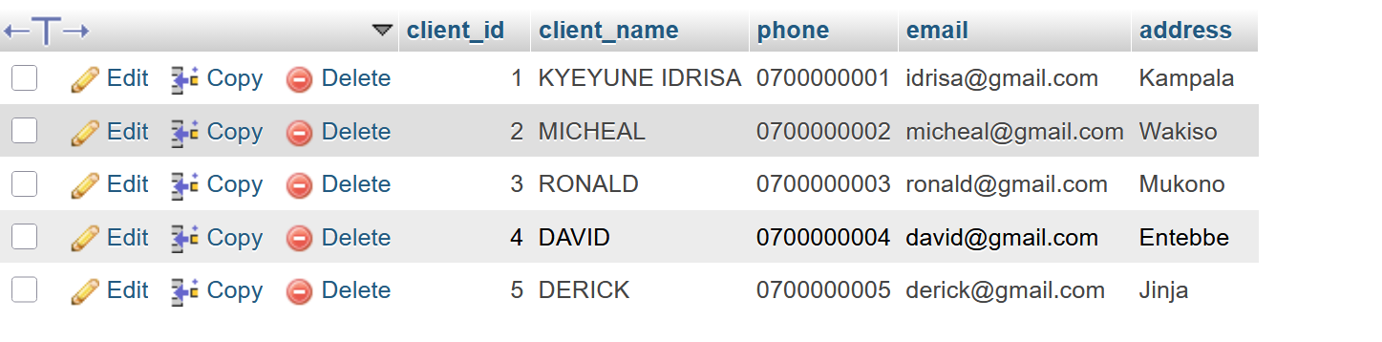
SAMPLE QUERY
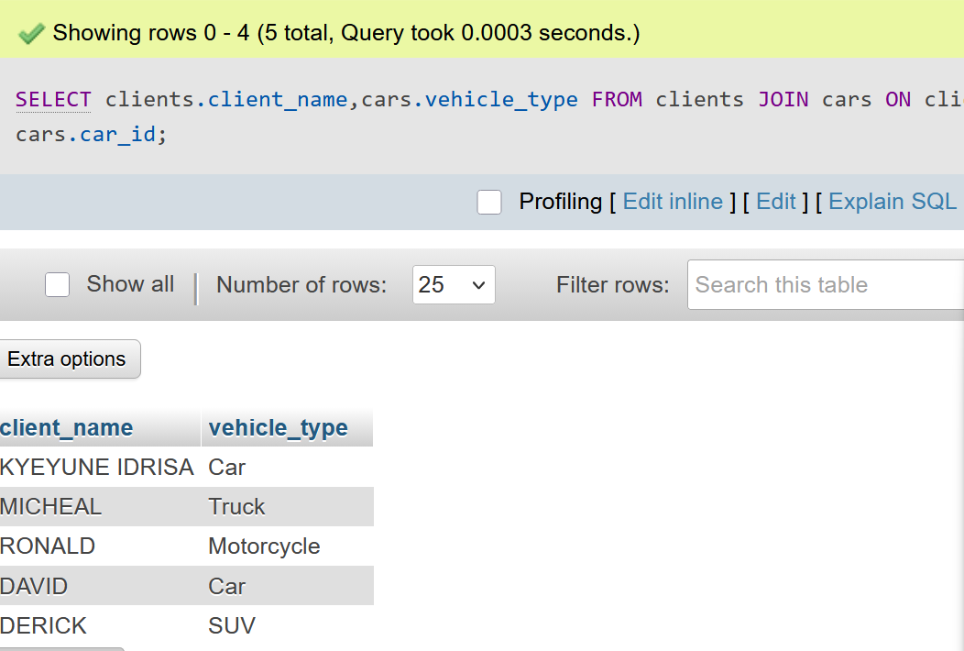
ENTITY RELATIONSHIP DIAGRAM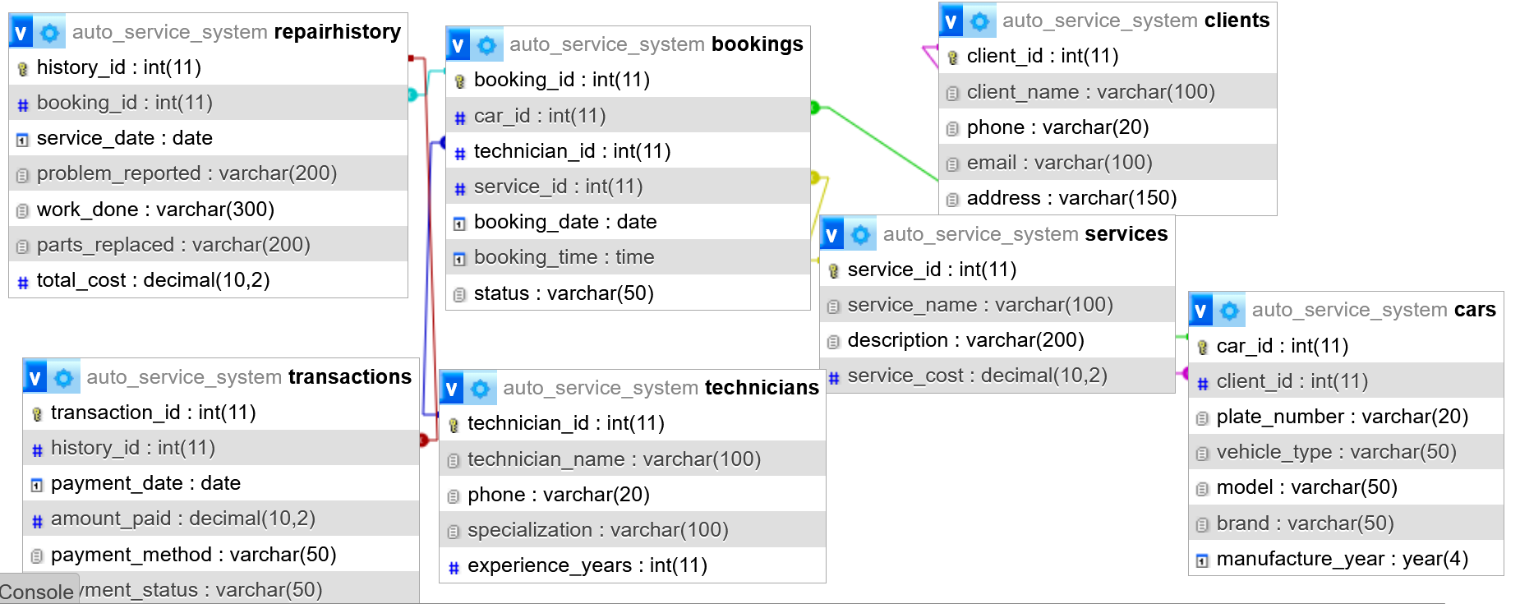
Sample Queries and Outputs
Query 1: List all appointments for today with customer and vehicle details
SELECT a.BookingID, CONCAT(c.FirstName, ' ', c.LastName) AS Customer,
v.Model, a.StartTime, a.Status
FROM RepairHistory a
JOIN car v ON a.carID = v.carID
JOIN Customer c ON v.CustomerID = c.CustomerID
WHERE DATE(a.AppointmentDate) = CURRENT_DATE
ORDER BY a.StartTime;
REPORTS GENERATED BY THE SYSTEM
Daily Appointment Report: Summary of bookings, completed, pending.
Mechanic Workload Report: Hours worked, jobs completed, utilization %.
Customer Service History Report: Full timeline per vehicle.
Revenue Report: By service type, period, with aggregates.
SQL views and queries provided for each.
SECURITY AND DATA INTEGRITY
Role-based access .
Password hashing for any login system.
Regular backups .
Referential integrity via FK constraints with RESTRICT/SET NULL as appropriate.
Input validation and triggers for data consistency
FUTURE IMPROVEMENTS
Integration with SMS gateway for reminders.
Web-based customer portal for online booking.
Mobile app for mechanics.
AI/ML for predictive scheduling and demand forecasting.
Full inventory management linkage for parts.
Cloud deployment (AWS RDS or similar) for scalability.
CONCLUSION
The Service Scheduling Module successfully demonstrates the application of DBMS principles to solve real-world business problems in the automotive service industry. By implementing a normalized, secure, and efficient MySQL database, the system provides a solid foundation for improved operational performance, customer service, and data-driven management. This project highlights the transformative power of well-designed databases in small-to-medium enterprises.

