Bayesian Model Diagnostics Report
Posterior Predictive Checks and Prior Sensitivity Analysis
Steelhead Overshoot Analysis with Harvest Exposure Covariate

Introduction
This report presents diagnostic assessments for the Bayesian hierarchical logistic regression model used to analyze steelhead overshoot fate at Wells Dam. Model diagnostics are essential for evaluating whether the statistical model adequately represents the data and whether conclusions are robust to analytical choices. Three categories of diagnostics were conducted:
- Posterior Predictive Checks (PPC): Assess whether the model can generate data similar to observed patterns
- Prior Sensitivity Analysis: Evaluate whether conclusions depend on prior specification choices
- MCMC Diagnostics: Verify that the sampling algorithm converged and produced reliable estimates

Posterior Predictive Checks
Posterior predictive checks compare data simulated from the fitted model to the observed data. If the model fits well, simulated data should be statistically indistinguishable from observed data.

Overall Model Fit
The observed proportion of fish returning downstream (28.6%) was compared to the posterior predictive distribution. The model accurately captured this key outcome:

Table 1. Overall posterior predictive check
Metric | Value
Observed proportion downstream | 0.286
Posterior predictive mean | 0.286
Posterior predictive 95% CI | [0.257, 0.317]
The observed proportion falls well within the 95% posterior predictive interval, indicating the model accurately captures the overall rate of downstream return.

Year-Level Calibration
The model was evaluated for its ability to capture year-to-year variation in downstream return rates. For all 20 years in the study (2005-2024), the observed proportion of fish returning downstream fell within the 95% posterior predictive interval (20/20 years, 100%).

Table 2. Year-level calibration summary (selected years)
Year | Observed | PPC Mean | 95% CI | In CI?
2005 | 0.038 | 0.110 | [0.000, 0.269] | Yes
2010 | 0.277 | 0.275 | [0.211, 0.343] | Yes
2015 | 0.615 | 0.596 | [0.410, 0.769] | Yes
2017 | 0.750 | 0.740 | [0.438, 1.000] | Yes
2020 | 0.800 | 0.736 | [0.400, 1.000] | Yes
2021 | 0.889 | 0.771 | [0.444, 1.000] | Yes
2023 | 1.000 | 0.707 | [0.000, 1.000] | Yes
2024 | 1.000 | 0.706 | [0.000, 1.000] | Yes
Note: All 20 years showed observed values within the 95% posterior predictive interval.

Calibration by Harvest Exposure
The model was assessed for its ability to capture the different return rates between harvest-exposed and non-exposed fish:

Table 3. Calibration by harvest exposure status
Group | Observed | PPC Mean | 95% CI | In CI?
No Harvest Exposure | 0.752 | 0.741 | [0.655, 0.820] | Yes
Harvest Exposure | 0.203 | 0.204 | [0.173, 0.236] | Yes
The model accurately captures the large difference in return rates between groups, with both observed values falling within their respective 95% posterior predictive intervals.

Bayesian p-values
Bayesian p-values quantify the probability that simulated data show more extreme values than observed. Values near 0.5 indicate good model fit; values near 0 or 1 suggest systematic misfit.

Table 4. Bayesian p-values for key test statistics
Test Statistic | Bayesian p-value | Interpretation
Proportion downstream | 0.496 | Excellent (near 0.5)
Variance | 0.485 | Excellent (near 0.5)
Years with >50% downstream | 0.182 | Acceptable

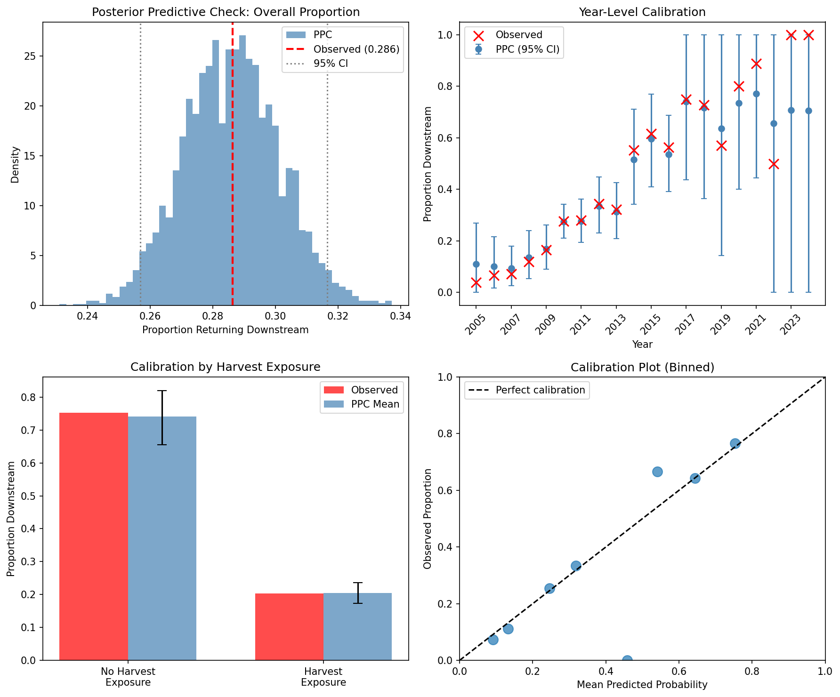
Figure 1. Posterior predictive checks. Top left: Distribution of posterior predictive proportions with observed value (red line). Top right: Year-level calibration showing observed (red X) vs. predicted (blue, with 95% CI). Bottom left: Calibration by harvest exposure. Bottom right: Binned calibration plot comparing predicted probabilities to observed proportions.

Prior Sensitivity Analysis
Prior sensitivity analysis evaluates whether conclusions depend on the choice of prior distributions. The model was refit with six different prior specifications: four non-informative priors (ranging from weakly informative to skeptical) and two informative priors that encode a prior belief that spring spill increases the probability of fish returning downstream.

Non-Informative Priors
Non-informative priors are centered at zero, expressing no prior belief about the direction of effects. These priors vary in their width (variance), with wider priors allowing more influence from the data and narrower/skeptical priors favoring effects closer to zero.

Table 5. Non-informative prior sensitivity analysis results
Prior Specification | β_spill | β_harvest | Harvest OR | σ_year
Default (σ=1) | 0.032 | -2.17 | 0.114 | 0.68
Wider (σ=2) | 0.025 | -2.24 | 0.106 | 0.68
Narrower (σ=0.5) | 0.068 | -1.92 | 0.147 | 0.65
Skeptical (σ=0.25) | 0.115 | -1.36 | 0.257 | 0.77
Note: OR = Odds Ratio. Even with skeptical priors strongly favoring null effects, the harvest exposure effect remains substantial (OR = 0.26, indicating 74% lower odds).

Informative Prior Analysis
A key question in Bayesian analysis is whether conclusions are driven by prior beliefs or by the data. To test this, we fit additional models using informative priors that encode a prior belief that spring spill increases the probability of fish returning downstream (i.e., positive β_spill). This addresses the question: "If we believed spill helps fish return downstream, would the data change our minds?"
Two informative prior specifications were tested:
- Moderate informative prior: β_spill ~ Normal(0.5, 0.5) — This prior places 84% of its mass on positive values, expressing moderate belief that spill has a positive effect.
- Strong informative prior: β_spill ~ Normal(1.0, 0.5) — This prior places 98% of its mass on positive values, expressing strong belief that spill has a positive effect.

Table 6. Informative prior analysis: Does prior belief in positive spill effect survive the data?
Prior Specification | β_spill (posterior) | 95% HDI | Shift from Default
Default (non-informative) | 0.032 | [-0.205, 0.275] | —
Informative (moderate) | 0.066 | [-0.169, 0.324] | +0.034
Informative (strong) | 0.099 | [-0.135, 0.362] | +0.068
Note: Despite strong prior belief in positive spill effects (98% prior mass > 0), the posterior shifts only marginally (+0.068), staying centered near zero with 95% HDI including zero. This indicates the data strongly dominates the prior.

Interpretation of Informative Prior Results
The informative prior analysis reveals that the data strongly dominates prior beliefs:
- Minimal posterior shift: Even with the strong informative prior (Normal(1.0, 0.5)), the posterior mean only shifted by +0.068 from the default estimate. This is far below the threshold of concern (0.3), indicating the data overwhelms the prior.
- 95% HDI still includes zero: In all cases, including with strong informative priors, the 95% highest density interval for β_spill still includes zero, providing no credible evidence of a positive spill effect.
- Data-driven conclusion: If prior belief was driving the null spill result, we would expect informative priors to substantially shift the posterior toward positive values. Instead, the data pulls the posterior back toward zero, providing strong evidence that the null spill effect is a data-driven conclusion.

Summary of All Prior Specifications

Table 7. Summary of prior sensitivity across all specifications
Parameter | Range Across All Priors | All Same Sign? | Assessment
β_spill | 0.025 to 0.115 | Yes (all ≈ 0) | Robust
β_harvest | -2.24 to -1.36 | Yes (all negative) | Robust

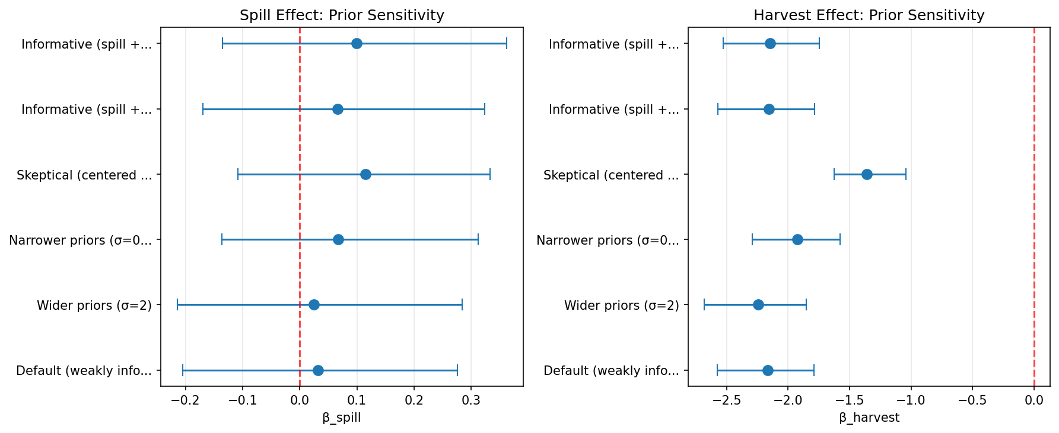
Figure 2. Prior sensitivity analysis showing spill effect (left) and harvest effect (right) estimates with 95% HDI across six prior specifications, including two informative priors encoding belief that spill increases downstream returns. Red dashed line indicates no effect. The spill effect remains centered near zero across all priors—including those that strongly favor positive effects—while the harvest effect remains consistently negative.

MCMC Convergence Diagnostics
MCMC diagnostics assess whether the sampling algorithm converged to the target posterior distribution and produced reliable estimates.

Table 8. MCMC convergence diagnostics
Parameter | R-hat | ESS | Status
mu_alpha | 1.000 | 1645 | Good
sigma_alpha | 1.000 | 1258 | Good
beta_spill | 1.000 | 2013 | Good
beta_harvest | 1.001 | 2925 | Good
Note: R-hat < 1.01 and ESS > 400 are recommended thresholds. All parameters meet these criteria.

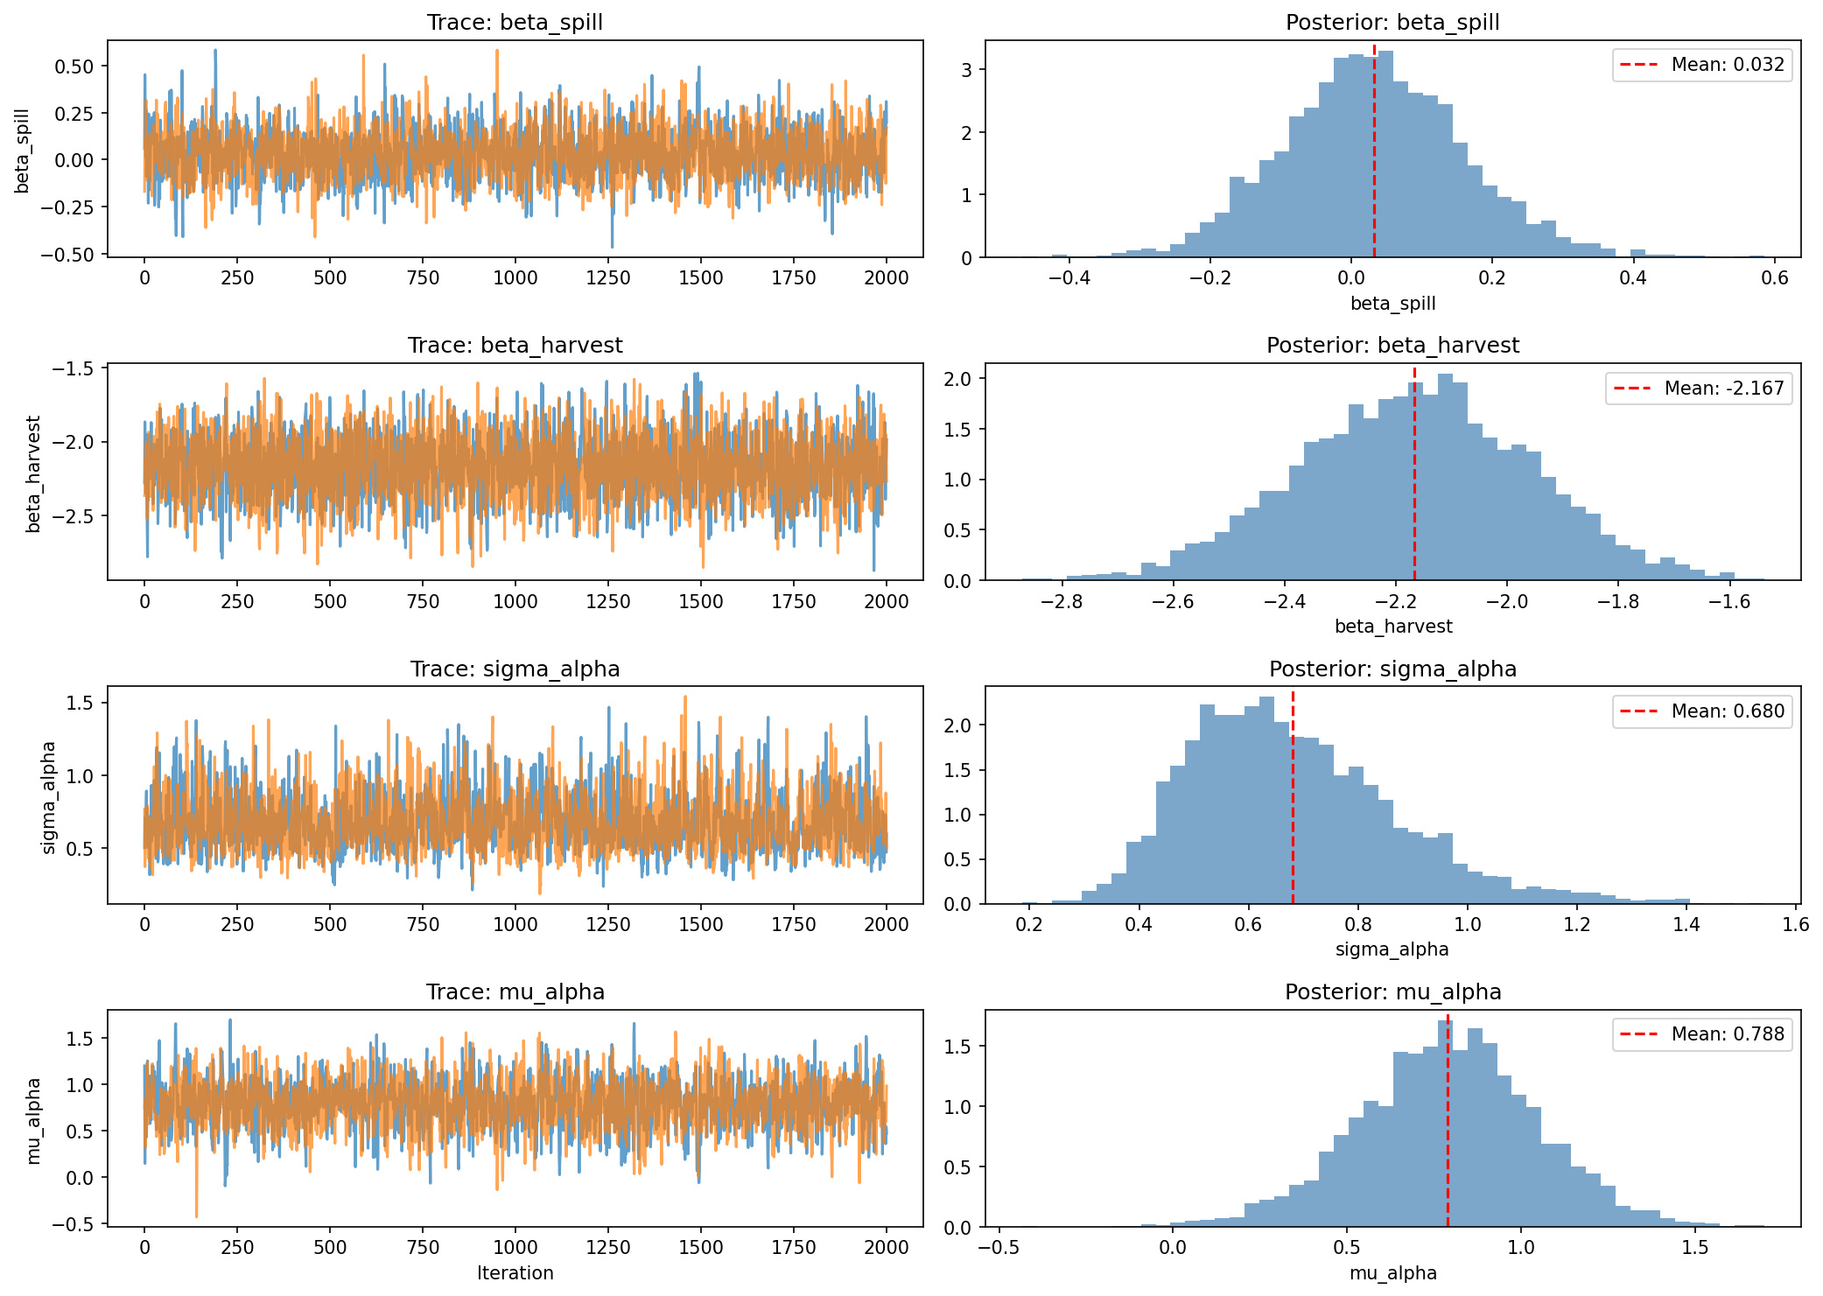
Figure 3. MCMC diagnostics showing trace plots (left column) and posterior distributions (right column) for key model parameters. Trace plots show good mixing with no trends or divergence between chains. Posterior distributions are smooth and unimodal.

Conclusions

Model Fit Assessment
The Bayesian hierarchical logistic regression model demonstrates excellent fit to the data:
- Overall calibration: The model accurately predicts the overall proportion of fish returning downstream (observed: 28.6%, predicted: 28.6%), with the observed value falling well within the 95% posterior predictive interval.
- Year-level calibration: All 20 years (100%) have observed return rates within their 95% posterior predictive intervals, indicating the hierarchical structure appropriately captures year-to-year variation.
- Subgroup calibration: The model accurately captures the dramatically different return rates between harvest-exposed fish (20.3% downstream) and non-exposed fish (75.2% downstream).
- Bayesian p-values: Values near 0.5 for key test statistics (proportion: 0.50, variance: 0.49) indicate no systematic departures from the model assumptions.

Robustness of Conclusions
The prior sensitivity analysis confirms that the key findings are robust to analytical choices:
- Spill effect with non-informative priors: Across all non-informative prior specifications (including skeptical priors), the spill effect remains centered near zero (range: 0.025 to 0.115), consistently indicating no meaningful relationship between spill and downstream return probability.
- Spill effect with informative priors: Even when using priors that encode strong belief (98% prior mass) that spill increases downstream returns, the posterior shifts only marginally (+0.068) and remains centered near zero. This demonstrates that the null spill effect is a data-driven conclusion, not an artifact of prior specification. The data strongly overrides prior belief in a positive spill effect.
- Harvest exposure effect: Although the magnitude varies somewhat across priors (β range: -2.24 to -1.36), the effect remains strongly negative in all cases. Even with highly skeptical priors, the odds ratio is 0.26, indicating harvest-exposed fish have at least 74% lower odds of returning downstream.
- Qualitative conclusions unchanged: Regardless of prior specification—whether non-informative, skeptical, or informative favoring positive spill effects—the analysis consistently shows (1) a strong negative harvest exposure effect and (2) no detectable spill effect.

MCMC Reliability
All MCMC diagnostics indicate reliable posterior estimation:
- Convergence (R-hat): All parameters have R-hat values very close to 1.00, well below the 1.01 threshold, indicating chains have converged to the same distribution.
- Effective sample size (ESS): All parameters have ESS > 1200, far exceeding the recommended minimum of 400, indicating sufficient independent samples for reliable inference.
- Visual inspection: Trace plots show good mixing with no trends, and posterior distributions are smooth and unimodal.

Overall Conclusion
The diagnostic analyses provide strong support for the validity of the Bayesian model and its conclusions:
1. The model fits the data well, accurately capturing overall patterns, year-to-year variation, and subgroup differences in downstream return rates.
2. The findings are robust to prior specification, with qualitative conclusions unchanged across a range of reasonable prior choices from weakly informative to skeptical.
3. Informative prior analysis confirms that the null spill effect is data-driven: Even with priors encoding strong belief that spill increases downstream returns, the posterior remains centered near zero. The data strongly overrides prior beliefs, indicating this conclusion is not sensitive to prior assumptions.
4. The MCMC sampling algorithm converged reliably, producing sufficient effective samples for accurate posterior inference.
5. The strong negative harvest exposure effect (88-90% reduction in odds of downstream return) and the null spill effect are well-supported by the data and not artifacts of model specification or analytical choices.

__________________________________________________
Analysis conducted February 2026

Software: Python 3.12, PyMC 5.x, ArviZ

