Kazakh-British Technical University
Data collection and preparation

SIS Project 1
Football Players, Clubs and Performance

Full Name: Yerlan Kamila
ID: 23B031287

15.10.2026
Almaty

Football Clubs and Player Performance: Bundesliga 2024/2025

1. Introduction
The purpose of this project was to collect, clean, combine, and analyze real football data from two different sources. The project focuses on the performance of Bundesliga clubs and the goals scored by selected players during the 2024/2025 season.

2. Data Sources
Two sources were used:
- API-Football: provided the Bundesliga standings, including club names, positions, points, wins, draws, losses, goals scored, and goals conceded.
- Wikipedia: the 2024–25 Bundesliga page was scraped using Python libraries to collect a table of top goal scorers, including player names, clubs, and goals.
The API dataset contained 18 clubs and 10 selected columns. The scraped top-scorers dataset contained 12 player records.

3. Data Collection and Preparation
The data was collected using requests and processed with pandas and BeautifulSoup. The HTML table was located with BeautifulSoup and converted into a DataFrame using pandas.read_html().
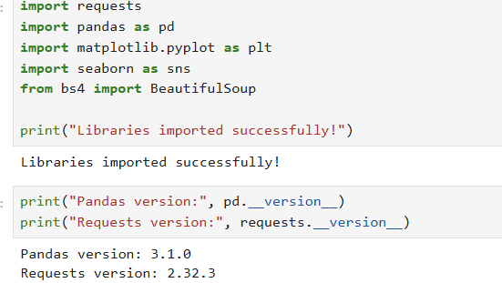
Data preparation included checking data types, missing values, and duplicate records. Numeric columns were converted to numeric types, player reference marks were removed, and duplicate records were checked.
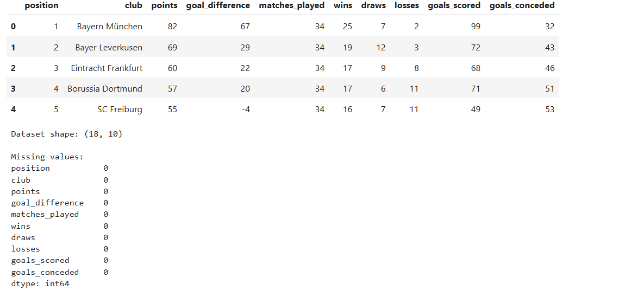
The datasets were combined using club names as the matching key. Some club names differed between sources, so a mapping dictionary was used to standardize them. A left merge preserved all 18 clubs from the API dataset.
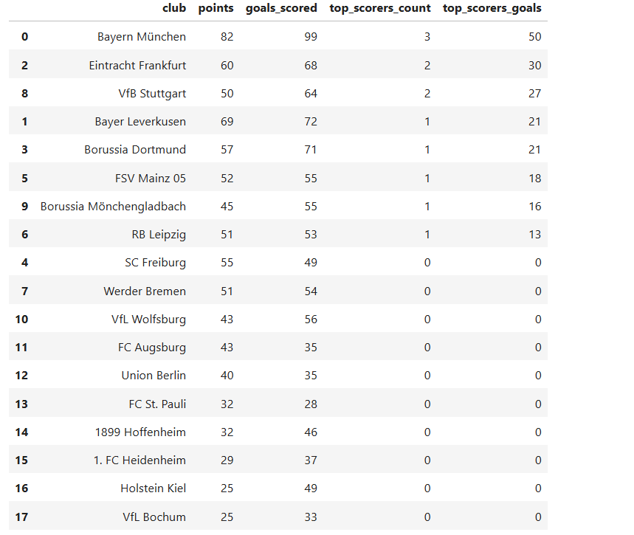
Two additional variables were created: the number of listed top scorers per club and the total goals scored by those players.

4. Exploratory Data Analysis
Descriptive statistics, club rankings, and correlation analysis were used to explore the data. Three main visualizations were created: a bar chart comparing club points, a scatter plot comparing goals scored and conceded, and a correlation heatmap.
Bayern München finished first with 82 points and scored 99 goals, the highest total among the clubs in the dataset. Bayer Leverkusen finished second with 69 points, while Eintracht Frankfurt finished third with 60 points.
VfL Bochum and Holstein Kiel had the lowest points totals, with 25 points each. Bayern München also had the best goal difference, at +67.
The merged dataset showed that the selected top-scorer records covered only some of the 18 clubs. For example, the listed top scorers associated with Bayern München scored 50 goals in total, while the listed scorer associated with FSV Mainz 05 scored 18 goals.

5. Conclusion
This project demonstrated how data from an API and a static web page can be collected, cleaned, and combined for football performance analysis. The analysis showed differences in club performance and provided additional information about selected top scorers.
The results should be interpreted with one important limitation: the Wikipedia dataset contained only selected top scorers, not every player. Therefore, a club with no matching player in the extracted table does not necessarily have zero goals from its players. The analysis identifies patterns in the collected data but does not prove that individual scoring alone caused a club's final position.
Overall, the project provided practical experience in data collection, web scraping, data cleaning, merging, exploratory data analysis, and visualization using Python.

