score

rhadoop

2019년 3월 12일

## R Markdown

This is an R Markdown document. Markdown is a simple formatting syntax for authoring HTML, PDF, and MS Word documents. For more details on using R Markdown see <http://rmarkdown.rstudio.com>.

When you click the **Knit** button a document will be generated that includes both content as well as the output of any embedded R code chunks within the document. You can embed an R code chunk like this:

library(readxl)  
getwd()

## [1] "/project/03_src/R"

#read.csv("../Data/csv_exam.csv") -> df_csv  
read_excel("Data/excel_exam.xlsx")-> df_excel  
str(df_excel)

## Classes 'tbl_df', 'tbl' and 'data.frame': 20 obs. of 5 variables:  
## $ id : num 1 2 3 4 5 6 7 8 9 10 ...  
## $ class : num 1 1 1 1 2 2 2 2 3 3 ...  
## $ math : num 50 60 45 30 25 50 80 90 20 50 ...  
## $ english: num 98 97 86 98 80 89 90 78 98 98 ...  
## $ science: num 50 60 78 58 65 98 45 25 15 45 ...

### 1.학급별 점수

df_excel[df_excel$class==1,]

## # A tibble: 4 x 5  
## id class math english science  
## <dbl> <dbl> <dbl> <dbl> <dbl>  
## 1 1. 1. 50. 98. 50.  
## 2 2. 1. 60. 97. 60.  
## 3 3. 1. 45. 86. 78.  
## 4 4. 1. 30. 98. 58.

df_excel[df_excel$class==2,]

## # A tibble: 4 x 5  
## id class math english science  
## <dbl> <dbl> <dbl> <dbl> <dbl>  
## 1 5. 2. 25. 80. 65.  
## 2 6. 2. 50. 89. 98.  
## 3 7. 2. 80. 90. 45.  
## 4 8. 2. 90. 78. 25.

df_excel[df_excel$class==3,]

## # A tibble: 4 x 5  
## id class math english science  
## <dbl> <dbl> <dbl> <dbl> <dbl>  
## 1 9. 3. 20. 98. 15.  
## 2 10. 3. 50. 98. 45.  
## 3 11. 3. 65. 65. 65.  
## 4 12. 3. 45. 85. 32.

df_excel[df_excel$class==4,]

## # A tibble: 4 x 5  
## id class math english science  
## <dbl> <dbl> <dbl> <dbl> <dbl>  
## 1 13. 4. 46. 98. 65.  
## 2 14. 4. 48. 87. 12.  
## 3 15. 4. 75. 56. 78.  
## 4 16. 4. 58. 98. 65.

df_excel[df_excel$class==5,]

## # A tibble: 4 x 5  
## id class math english science  
## <dbl> <dbl> <dbl> <dbl> <dbl>  
## 1 17. 5. 65. 68. 98.  
## 2 18. 5. 80. 78. 90.  
## 3 19. 5. 89. 68. 87.  
## 4 20. 5. 78. 83. 58.

## Including Plots

You can also embed plots, for example:

library(ggplot2)  
qplot(class, math, data=df_excel,geom='auto', color=class)

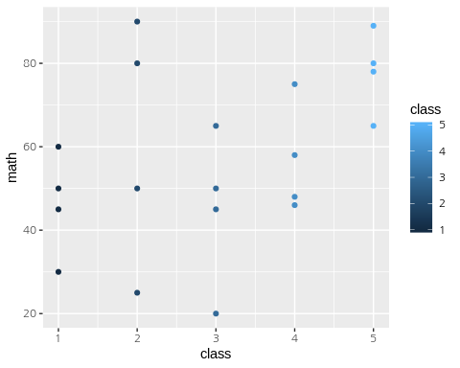

Note that the echo = FALSE parameter was added to the code chunk to prevent printing of the R code that generated the plot.