mpg

rhadoop

2019년 3월 12일

## R Markdown

This is an R Markdown document. Markdown is a simple formatting syntax for authoring HTML, PDF, and MS Word documents. For more details on using R Markdown see <http://rmarkdown.rstudio.com>.

When you click the **Knit** button a document will be generated that includes both content as well as the output of any embedded R code chunks within the document. You can embed an R code chunk like this:

library(ggplot2)  
str((mpg))

## Classes 'tbl_df', 'tbl' and 'data.frame': 234 obs. of 11 variables:  
## $ manufacturer: chr "audi" "audi" "audi" "audi" ...  
## $ model : chr "a4" "a4" "a4" "a4" ...  
## $ displ : num 1.8 1.8 2 2 2.8 2.8 3.1 1.8 1.8 2 ...  
## $ year : int 1999 1999 2008 2008 1999 1999 2008 1999 1999 2008 ...  
## $ cyl : int 4 4 4 4 6 6 6 4 4 4 ...  
## $ trans : chr "auto(l5)" "manual(m5)" "manual(m6)" "auto(av)" ...  
## $ drv : chr "f" "f" "f" "f" ...  
## $ cty : int 18 21 20 21 16 18 18 18 16 20 ...  
## $ hwy : int 29 29 31 30 26 26 27 26 25 28 ...  
## $ fl : chr "p" "p" "p" "p" ...  
## $ class : chr "compact" "compact" "compact" "compact" ...

## Including Plots

You can also embed plots, for example:

qplot(drv,cty,data=mpg,geom="boxplot",color=drv)

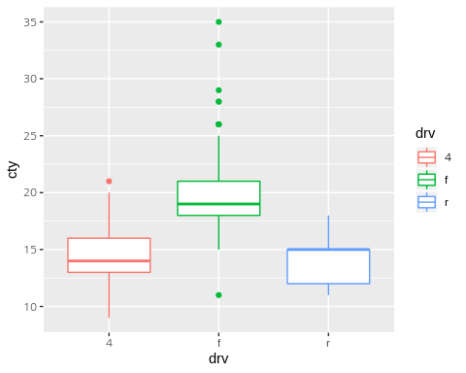

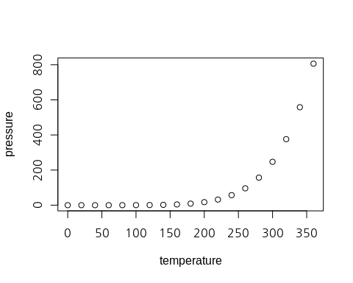

Note that the echo = FALSE parameter was added to the code chunk to prevent printing of the R code that generated the plot.