Performance gain with variable chunk size in GFS-like file systems
Zhifeng Yang, Qichen Tu, Kai Fan, Lei Zhu, Rishan Chen, Bo Peng†
Networks Lab, Peking University, Beijing 100871, China

Abstract
A concept of functional dependency in XML documents based on constraint-tree is proposed. The definition proposed in this paper captures the tree-structured characteristics of XML documents in structure and considers a more general situation of XML functional dependencies based on sub-trees with some constraint conditions in XML documents, which overcomes the shortcomings of related definitions of XML functional dependencies. The relationship between XML functional dependencies and XML keys are also discussed.
We have designed and implemented Tianwang File System(TFS), which is a distributed file system much like Google file system(GFS). The system has its origins in our Tianwang search engine and web mining research work. Our system has the same assumptions and the same architectures with GFS. But the key design choice that the chunk size is variable lets our system to adopt simpler system interactions which significantly improves the performance of the record append operation.
In this paper, we discuss many aspects of our design which are different from GFS, and verify their pros and cons by performance experiments. The experiment results shows that the utilization ratio of our record append operation excels GFS by 25%. And the throughput of record append of TFS is also several times better.
Keywords: Fault tolerance, scalability, data storage, clustered storage

Introduction

1.1 Background
With the rapid growth of Web, search engine companies have achieved tremendous successes. We have come into a new era in which who owns the most data and the most powerful data process ability will be the leader of technological innovation. The huge Web is a treasure trove of this new era. As a result, Web information retrieval and Web data mining become more and more popular, and people urgently need a computing environment for Web scale data processing.
TFS(Tianwang ﬁle system) is a scalable, distributed ﬁle system, which meets the need for data storage and management services in large scale data processing. The system has its origins in our Tianwang search engine [7] and web mining research work. There are always lots of diﬃculties which face researchers who engage in processing large scale data, especially Web scale data. For example, the hardware is unreliable and there are disc and machine failures all the time. Every programmer of distributed applications should consider where to locate data and how to access them. Many of them are just duplicates work already done by someone else. It is worse that the task of implementing an eﬃcient distributed application presents many diﬃculties even to a senior programmer without much experience in the parallel programming, and their applications are usually ineﬃcient. Moreover, with the growth of the data, we add more and more machines. But these data and resources are not easily shared, and the utilization ratio of these hardware resources is low. All these problems call for a reliable, scalable infrastructure for large scale data computing. And our Tianwang ﬁle system is a basic component of such an infrastructure.

1.2 Related Works
The most remarkable and pathbreaking related work is Google ﬁle system [6]. Google has built a reliable, scalable and high performance distributed ﬁle system on inexpensive commodity hardware. Their subsequent publications ([1], [2]) make more and more people begin to realize the importance of building such an infrastructure for distributed data-intensive applications. Google’s work shows us the rudiments of a super computing platform of the new era.
Another work in progress is a project called Hadoop [3]. It was a module in Lucene/Nutch java project to provide the similar function of Google ﬁle system and mapreduce. As a active open source project, it helps us to think more deeply of the work from the technical view. Hadoop does not support concurrent atomic record append, which is a very important operation. Files are created and written by one writer and can not be modiﬁed any more. KFS [5] is another recent project implemented in C++ programming language. It has more features than Hadoop supports. An interesting feature is that it can be integrated with Hadoop using Hadoop’s ﬁle system interfaces. Microsoft’s Dryad system [4] is indicative of their eﬀort towards the same direction, though public paper is not yet available.
Our long-term goal is to build an infrastructure for processing large scale data, TFS is our ﬁrst step to the goal.

System Overview

2.1. Architecture
We have followed the same architecture with Google ﬁle system. A TFS cluster consists of a single master and multiple chunkservers and is accessed by multiple clients.
Files are divided into variable-size chunks. Each chunk is identiﬁed by an immutable and globally unique 64 bit chunk handle assigned by the master at the time of chunk creation. Chunkservers store chunks on local disks as Linux ﬁles and read or write chunk data speciﬁed by a chunk handle and byte range. For reliability, each chunk is replicated on multiple chunkservers. By default, we store three replicas, though users can designate diﬀerent replication levels for diﬀerent ﬁles.
The master maintains all ﬁle system metadata. This includes the namespace, access control information, the mapping from ﬁles to chunks, and the current locations of chunks. It also controls system-wide activities such as garbage collection of orphaned chunks, and chunk migration between chunkservers. Each chunkserver periodically communicates with the master in HeartBeat messages to report its state and get back instructions.
TFS client code linked into each application implements the ﬁle system API and communicates with the master and chunkservers to read or write data on behalf of the application. Clients interact with the master for metadata operations, but all data-bearing communication goes directly to the chunkservers.
The system is designed to minimize the master’s involvement in ﬁle accessing operations. We do not provide the POSIX API. Besides providing the ordinary read and write operations, like GFS, we have also provided an atomic record append operation so that multiple clients can append concurrently to a ﬁle without extra synchronization between them. And we realize that the record append operation is the key operation we should optimize so our system interactions is diﬀerent from GFS and we expect better performance of record append than GFS.

2.2 Chunk Size
In Google ﬁle system, a ﬁle is divided into ﬁxed-size chunks(64 MB). In GFS’ design, when a client use record append operation to append data, the system checks to see if appending the record to the current last chunk would cause the chunk to exceed the maximum size. If so, it pads all the replica of the chunk to the maximum size, and replies to the client indicating that the operation should be retried on the next chunk. (Record append is restricted to be at most one-fourth of the maximum chunk size to keep worstcase fragmentation at an acceptable level.) On the occurrence of write failure, this at-least-once semantic can lead to duplicated records and incomplete records.
In TFS, the chunks of a ﬁle have variable sizes. With our diﬀerent system interactions which will be addressed in details in the following subsections, this design choice makes our record append operation nobler and more eﬃcient. Padding data, record fragments, record duplications do not exist in our system. Of course, this improvement brings some problems and concerns. For instance, every data structure of chunk need a chunk size attribute, which increases the memory overhead. Despite this drawback, we expect that read and record append operations that are key operations in our system can beneﬁt from this design choice.

2.3 Read Operation
During a read operation, the client exchanges messages with the master and gets the current locations of chunks it wants to read from. Then it communicates with the chunkservers and gets the data. This process is different due to the different chunk size strategy.
In Google ﬁle system, using the ﬁxed chunks size, the client translates the ﬁle name and byte oﬀset speciﬁed by the application into a chunk index within the ﬁle. Then, it sends the master a request containing the ﬁle name and chunk index. The master replies with the corresponding chunk handle and locations of the replicas. The client caches this information using the ﬁle name and chunk index as the key.
The client then sends a request to one of the replicas, most likely the closest one. The request speciﬁes the chunk handle and a byte range within that chunk. Further reads of the same chunk require no more client-master interaction until the cached information expires or the ﬁle is reopened.
In our system, because the chunk size is variable, the client can not translate the byte oﬀset into a chunk index directly. It has to know all the chunks’ sizes of the ﬁle before deciding which chunk should be read. Our strategy is simple, when a client opens a ﬁle using read mode, it also gets all the chunks’ information, including chunk handle, chunk size and locations, from the master. When the client needs to read some data, it can use these informations to get the proper chunk. Although this strategy is determined by the fact of variable chunk size, its advantage is that the client need only to communicate with the master once for reading the whole ﬁle, which is much eﬃcient than GFS’ original design.
The disadvantage, though, is that when a client has opened a ﬁle for reading, later appended data by the other clients is invisible to this client. But we think this is acceptable, considering the most ﬁles in our applications are created and appended once, and read by data processing applications many times without modiﬁcations. If in any situation this problem becomes critical, it can be easily overcome by set a expired time for the chunks’ information and refresh it when invalid. So the novelty of ﬁle’s metadata is under control.

2.4 Record Append Operation
High performance of the record append operation is the most important factor that affects our design decisions. Because a write or an append operation is performed at all the chunk’s replicas, the system must maintain the consistency among replicas.
In Google ﬁle system, they use leases to maintain a consistent mutation order across replicas. The master grants a chunk lease to one of the replicas, which we call the primary. The primary picks a serial order for all mutations to the chunk. All replicas follow this order when applying mutations. Thus, the global mutation order is deﬁned ﬁrst by the lease grant order chosen by the master, and within a lease by the serial numbers assigned by the primary.
When a client use record append operation to append data, the system checks to see if appending the record to the current last chunk would cause the chunk to exceed the maximum size. If so, it pads all the replica of the chunk to the maximum size, and replies to the client indicating that the operation should be retried on the next chunk. If a record append fails at any replica, the client retries the operation. As a result, replicas of the same chunk may contain diﬀerent data possibly including duplicates of the same record in whole or in part. GFS does not guarantee that all replicas are bytewise identical. It only guarantees that the data is written at least once as an atomic unit.
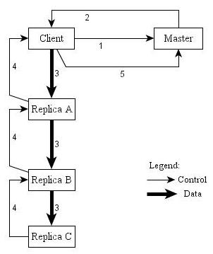
Figure 1: Append Control and Data Flow
In our system, we do not use the complex lease mechanism. Append operation is based on chunk level. In Figure 1, we illustrate this process by following the control ﬂow of an append through these numbered steps.
- The client asks the master to allocate a new chunk to append data to.
- The master allocates a new chunk handle and choose several chunkserver as chunk replicas according to the workloads of all the chunkservers at that moment. It records this new chunk in its data structures and returns the chunk handle and locations to the client.
- The client sends the append command and the appended data to the nearest chunkserver, then the ﬁrst chunkserver send the data and command to the next chunkserver. . . The data is sent by pipeline.
- The message about whether a chunkserver’s replica is successfully written is sent back to the client by pipeline.
- If at least one of the chunkservers is successfully written, the client send message of success and the successfully written replicas to the master, then the master modiﬁes its metadata. If none of the replicas is written successfully, the client can retry the operation for several times before eventually it tells the master to abandon the allocated chunk and throws the exception to the application. The orphan chunks will be deleted by the system’s garbage collection mechanism.
In our system, every appending chunk has only one writing client, but we allow multiple chunks of a ﬁle to be appended simultaneously. The client itself in fact plays the role of the primary. This is our diﬀerent mechanism to support concurrent record appends. But it is false that every record append operation of applications will generate a new chunk. In fact the client library bundles up multiple appended data and generate a chunk in batch. Because there is cached appending data, the client’s exception will lead to lost of some data. We supply a ﬂush API to allow the applications who can not tolerate such situation to make sure the critical data has been written to the chunkservers.
In GFS, the aggregate record append performance is limited by the network bandwidth of the chunkserver that store the last chunk of the ﬁle, independent of the number of clients. But in our system, the more chunkservers and concurrent clients, the higher the aggregate performance, the only limit is aggregate bandwidth between clients and chunkservers.

2.5 Write Operation
In Google ﬁle system, write operation use the same lease mechanism as record append operation. So concurrent write to the same region is allowed, but the result is undeﬁned. The region is most likely made up of fragments from different write operation. However, as long as the write operation is successful, the lease mechanism can guarantee the replicas of the same chunk are consistent.
We consider that it is not necessary to adopt the complex mechanism in order to allow concurrent write operation. First, although the results of the concurrent writes operations are consistent, it is useless. Secondly, for the existence of record append operation, write operation is mainly used to overwrite the existing chunks. In practice, overwrite operation is rare, and concurrent overwrite operation is even more rare. For the sake of the rarely used write operation, they lose the opportunity to improve the performance of record append operation because both of these operations use the same lease mechanism. The loss outweighs the gain.
In our system, we treat write and record append distinctly. They are implemented using diﬀerent system interactions so we can adopt more eﬃcient way to implement the record append operation. We simply do not allow concurrent write operations. When a client opens a ﬁle as write mode, the whole ﬁle is locked exclusively.

2.6 Implications for Applications
The GFS record append operation can generate paddings, duplicated records, incomplete records and inconsistent replicas. So the GFS applications have to accommodate these with a few other techniques: relying on appends rather than overwrites, checkpointing, and writing self-validating, self-identifying records.
Our append operation with append-exactly-once semantics is noble, and we only require the applications to rely on appends rather than overwrites. Practically all our applications mutate ﬁles by appending rather than overwriting. In one typical use, many writers concurrently append to a ﬁle for merged results or as a producer-consumer queue. Then many other readers concurrently read the diﬀerent region of the ﬁle, process the data and concurrently append the result to another ﬁle.
Like GFS, TFS’ record append cannot guarantee the sequence of the operations. That means, if an application sequentially append two record into a ﬁle, it should not expect they are stored in the ﬁle beside each other. However, it is true the ﬁrst appended record will have smaller oﬀset than the second one.

Experiments
We measured performance on a TFS cluster consisting of one master, nine chunkservers, and ten clients. Note that this conﬁguration was set up for ease of testing. Typical clusters may have hundreds of chunkservers and hundreds of clients.
The master and chunkserver machines are Dell 2850 conﬁgured with two 2.80GHz Intel Xeon processors, 2GB of memory, six 7200 rpm Ultra SCSI drives conﬁgured as one software RAID-0 volume. All the client machines are the same as above except the memory is 4GB. And all these machines have a 1 Gbps full-duplex Ethernet connection to a Dell 2748 1 Gbps switch.

3.1 Master Operation
This experiment is set up to test the performance of the master operations, and whether the single master architecture will be the bottleneck of the whole system.
Ten clients simultaneously send RPC request to the master. Each operation is repeated for 10000 times. The evaluation measure we use is operations per second(Ops/s). For each operation we calculate its Ops/s.
Table 1 shows the master’s Ops/s of chunk operations. The getChunksInfo is the key operation that aﬀects the whole system performance. We set up diﬀerent numbers of chunks to represent diﬀerent typical ﬁle size in real system to test it. The results show the master can easily handle thousands of getChunksInfo requests every second. And the Ops/s of some of the simple operations is extremely high, e.g. abandonAddChunk.
In the real running system, these operations are interleaving. We designed a simulation workload of a real system, following the ratio of diﬀerent type of operations indicated in Google’s experiments(in [6] section 6.3.4). Ten clients concurrently execute the sequence with 42000 operations. The test shows that on average every client consumed about 122 seconds to ﬁnish the operations. That is, the workload of the master is 3443 operations per second. In Google’s paper, they mention that the rate of operations send to their master is around 200 to 500 operations per second. Our master can easily keep up with this rate. And there is no bottleneck even for the workload of 3000 Ops/s.

3.2 Read Buﬀer Size
In our read operation, the client uses a buffer to receive the data from chunkservers. The buffer size determines the size of data transferred to the client in each communication. In this experiment, we test how different buffer size will affect the performance of read.
Chunk Operation | Ops/s
addChunk | 2933
completeWrittenChunk | 7663
abandonAddChunk | 11403
getChunksInfo(0 chunk) | 8782
getChunksInfo(20 chunks) | 2578
getChunksInfo(50 chunks) | 1225
getChunksInfo(100 chunks) | 683
getChunksInfo(150 chunks) | 453
getChunksInfo(200 chunks) | 350

Table 1: Master Chunk Operations
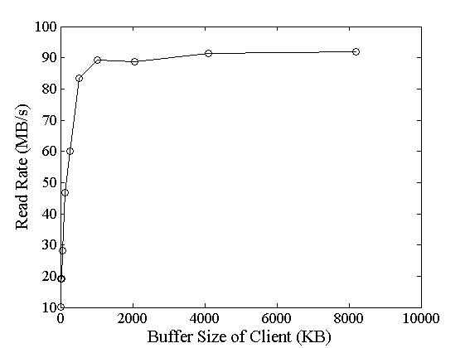
Figure 2: Read Buffer Size
Using diﬀerent read buﬀer size, one client reads a 1GB region from a ﬁle. Figure 2 shows diﬀerent buﬀer size and its read rate. The read rate reaches its maximum when the size is around 1024KB, and becomes ﬂat. So we choose 1024KB as the default value of the read buﬀer size.

3.3 Reads and Record Appends
Because all our clients and servers machines are connected to one switch, to get the theoretical network limits, we run all the clients as different threads on one client machine. So the limit of network throughput of all these clients is bound to 125MBps.
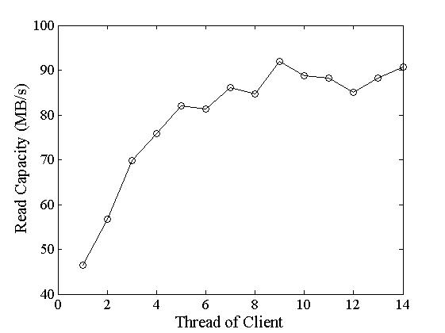
Figure 3: Aggregate Read Rate
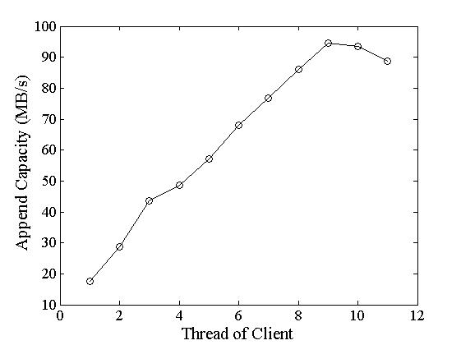
Figure 4: Aggregate Record Append Rate
N clients read simultaneously from the ﬁle system. Each client reads a randomly selected 4 MB region from an 18 GB ﬁle. This is repeated 256 times so that each client ends up reading 1 GB of data. Figure 3 shows the aggregate read rate for N clients. Note that the limit peaks at an aggregate of 125 MB/s when the client’s 1 Gbps network interface gets saturated. The aggregate read rate reaches 90 MB/s, about 72% of the 125 MB/s network limit. The eﬃciency of single client drops sometimes most likely because as the number of readers increases, so does the probability that multiple readers simultaneously read from the same chunkserver. Figure 4 shows the record append performance. N clients append simultaneously to a single ﬁle. Performance is limited by the aggregate bandwidth of links between the chunkservers and clients. That is 125 MBps in our network topology. The aggregate append rate reaches 95 MB/s, about 75% of the 125 MB/s network limit. In another experiment , we run multiple clients on diﬀerent machines. The result shows that aggregate append rate can easily exceed 380MB/s, which is a demonstration of our expectation that out record append performance will not drop due to the network limit of one chunkserver like in GFS.
In contrast to our performance, the read and record append operations in Google ﬁle system can reach 75% and 50% of the theoretical limit, separately. So our record append performs much better. During the entire test, the rate of CPU of that client machine maintained less than 5%, so there is no contest of CPU which may lead to the deviation of the results.

Conclusions
The Tianwang ﬁle system demonstrates our effort to build an infrastructure to support large scale data processing. Although our system has the same assumptions and the same architectures with Google ﬁle system, the key design choice that the chunk size is variable, which is different from GFS, lets our system to adopt different system interactions for record append operation. And the experiment results show that our design signiﬁcantly improves the record append performance by 25%. We believe the design may apply to other similar data processing infrastructure.
We observed that using the same system interaction for both write and record append is a shortcoming in GFS and restricts the possibility of digging for more better append performance, which led to our diﬀerent points in the design space. Our chunk size of ﬁle is variable and record append operation is based on chunk level. Because of this, the aggregate record append performance is no longer limited by the network bandwidth of the chunkservers that store the last chunk of the ﬁle.
Our system is going to be used by our research group to manage the largest Chinese Web archive system [8]. And we are working on a distributed computing environment to support data processing ﬁles upon our ﬁle system.

Acknowledgement
This work is supported by National Grand Fundamental Research 863 program of China under Grant No. 2006AA01Z196, National Natural Science Foundation of China under Grant No. 60672171 and MOST Grant 2006BAH02A10. And we wish to thank Conglei Yao for his valuable comments and suggestions to the paper. The authors are also grateful for the anonymous reviewers who made constructive comments.

References
- Dean, J., and Ghemawat, S. Mapreduce: Simpliﬁed data processing on large clusters. In OSDI (2004).
- Fay Chang, J. D., and Ghemawat, S. Bigtable: A distributed storage system for structured data. In OSDI (06), pp. 205–218.
- Hadoop. The hadoop project. http://lucene.apache.org/hadoop/, 2006.
- Isard, M., Budiu, M., Yu, Y., Birrell, A., and Fetterly, D. Dryad: distributed data-parallel programs from sequential building blocks. In EuroSys ’07: Proceedings of the ACM SIGOPS/EuroSys European Conference on Computer Systems 2007 (New York, NY, USA, 2007), ACM, pp. 59–72.
- KFS. Kosmos distributed ﬁle system. http://kosmosfs.sourceforge.net/, 2007.
- Sanjay Ghemawat, H. G., and Leung, S.-T. The google ﬁle system. In SOSP03 (2003). SOSP03, October 1922, 2003, Bolton Landing, New York, USA.h.
- University, P. Tianwang search engine. http://e.pku.edu.cn.
- University, P. Web infomall. http://www.infomall.cn/.

† Email addresses: {yzf, tqc, fankai, zhulei, crs, pb}@net.pku.edu.cn

