EE4204 Assignment Lab Report
I implemented a TCP-based client-server socket program. This program sends a large txt file from the client to the server in small data units. Implementation of the stop and wait ARQ was done by using ACKs and NACKs, while ignoring timeouts.
This one done using the following assumptions
- This experiment was done on a single local machine, using the 127.0.0.1 address as a loopback. We assume that the timings will mimic that of a server and client on separate machines.
- Assumption that rand() actually generates random numbers (while in reality it is pseudo-random)
How was random numbers generated?
- Usage of rand() function, generating between a range of 0 to 99. Using ERRORPROB in the header file, the error probability can be easily changed.
- If it falls below the specified ERRORPROB range, packet loss is simulated, and NACK is sent from server to client.
How was ARQ stop and wait implemented?
- I chose to ignore timeouts, and solely relied on negative acknowledgements (NACK) to determine that a packet has been lost.
- When there is no packet loss, client will receive the data unit (size is specified by DATALEN in header file), append the data to the txt file and then send an acknowledgement (ACK) back to the client.
- When client sends out data unit, it stops to wait for an acknowledgement, and not sending another data unit. Only will react to the servers ACK or NACK.
- When ACK is received, data unit is assumed to be successfully received by the server, and client proceeds to send the next data unit chunk.
- If NACK is received, data unit is assumed to be unsuccessfully received, hence the client will retransmit the same data unit length again.
- This happens in a loop until it reaches the end of the txt file.

- Transfer time vs error probability (2 graphs; size = 500 and size = 1000 bytes)
Data Unit Size (bytes) | Error Probability | Transfer Time (ms)
500 | 0 | 5.783
500 | 0.1 | 6.481
500 | 0.15 | 7.216
500 | 0.2 | 8.681
500 | 0.25 | 9.574
500 | 0.3 | 11.497

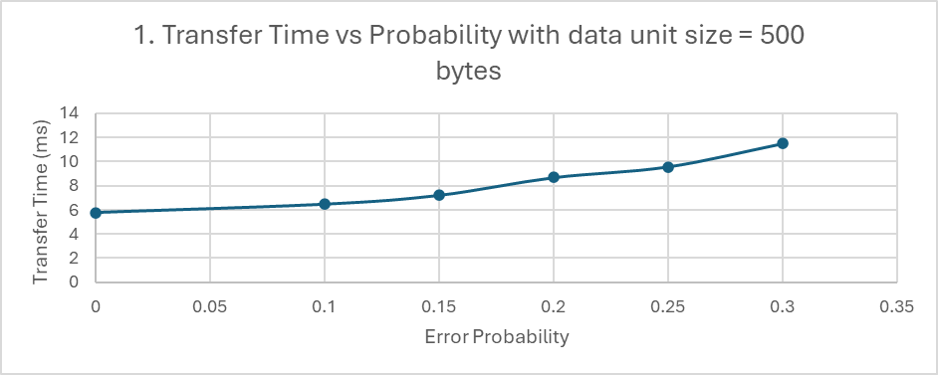

Data Unit Size (bytes) | Error Probability | Transfer Time (ms)
1000 | 0 | 2.282
1000 | 0.1 | 2.99
1000 | 0.15 | 3.622
1000 | 0.2 | 4.079
1000 | 0.25 | 4.858
1000 | 0.3 | 6.468

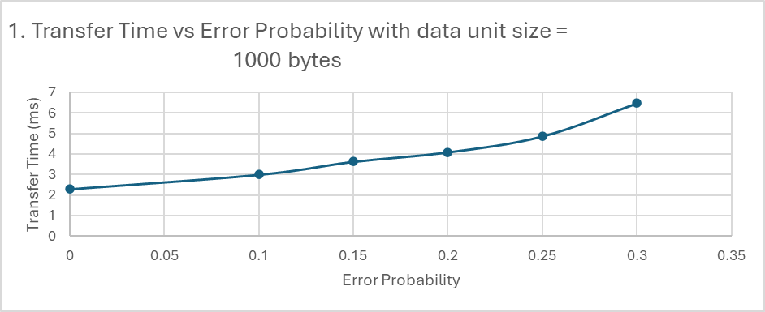

- Throughput vs error probability (2 graphs; size = 500 and size = 1000 bytes)
Data Unit Size (bytes) | Error Probability | Throughput (Kbytes/s)
500 | 0 | 11124.27
500 | 0.1 | 8920.33
500 | 0.15 | 7734.18
500 | 0.2 | 7097.93
500 | 0.25 | 6333.33
500 | 0.3 | 4957.95

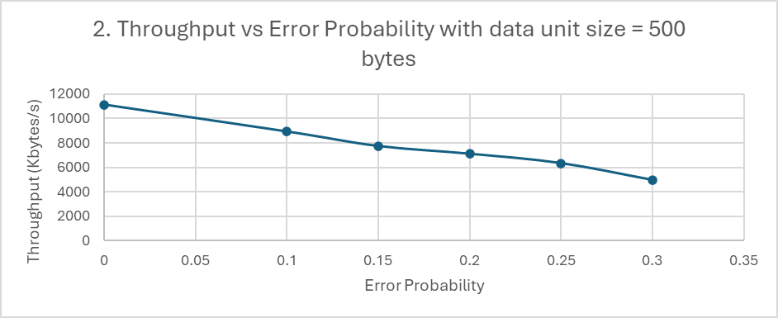

Data Unit Size (bytes) | Error Probability | Throughput (Kbytes/s)
1000 | 0 | 19733.66
1000 | 0.1 | 19195.18
1000 | 0.15 | 16431.16
1000 | 0.2 | 14152.18
1000 | 0.25 | 13243.18
1000 | 0.3 | 9589.89

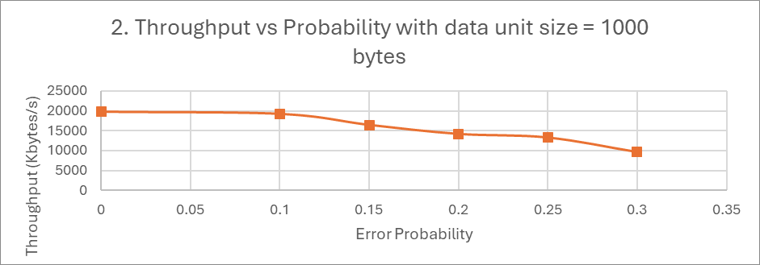

- Transfer time vs data unit size (2 graphs; error probability = 0, error probability = 0.1)
Error Probability | Data Unit Size (bytes) | Transfer Time (ms)
0 | 200 | 13.116
0 | 400 | 6.417
0 | 600 | 4.91
0 | 800 | 3.684
0 | 1000 | 2.847
0 | 1200 | 2.33

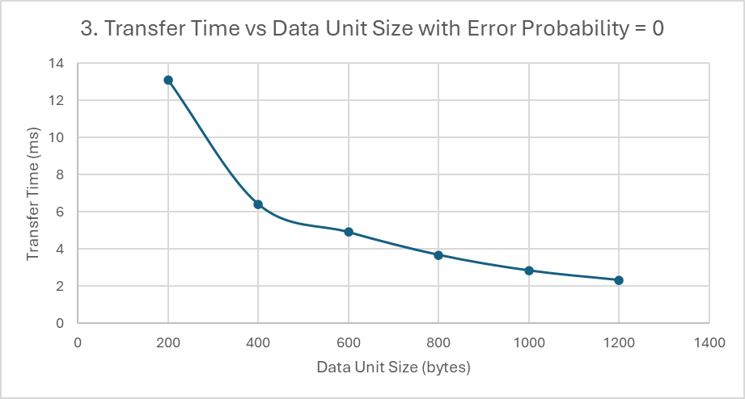
Error Probability | Data Unit Size (bytes) | Transfer Time (ms)
0.1 | 200 | 15.549
0.1 | 400 | 8.432
0.1 | 600 | 5.731
0.1 | 800 | 3.939
0.1 | 1000 | 3.21
0.1 | 1200 | 2.639

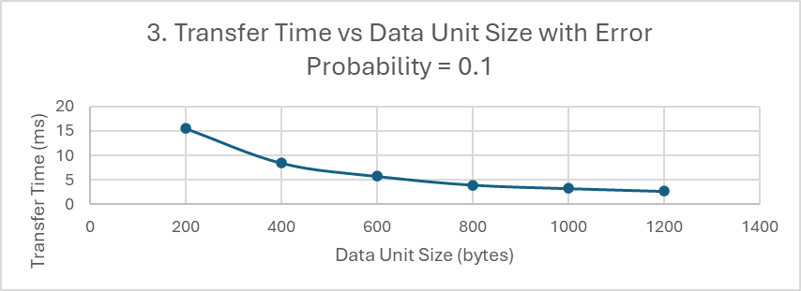

- Throughput vs data unit size (2 graphs; error probability = 0, error probability = 0.1)
Error Probability | Data Unit Size (bytes) | Throughput (Kbytes/s)
0.1 | 200 | 3845.45
0.1 | 400 | 7091.2
0.1 | 600 | 10433.25
0.1 | 800 | 15179.74
0.1 | 1000 | 18627.1
0.1 | 1200 | 22657.44
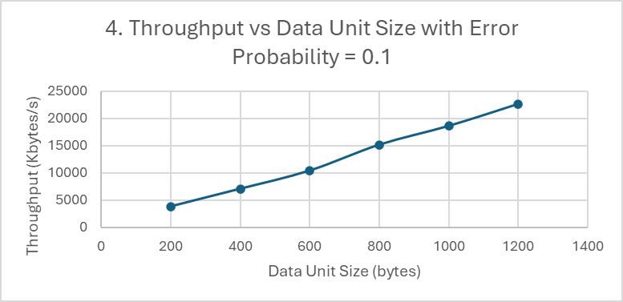

Error Probability | Data Unit Size (bytes) | Throughput (Kbytes/s)
0 | 200 | 4558.78
0 | 400 | 9317.91
0 | 600 | 12177.8
0 | 800 | 16230.45
0 | 1000 | 21002.11
0 | 1200 | 25662.23

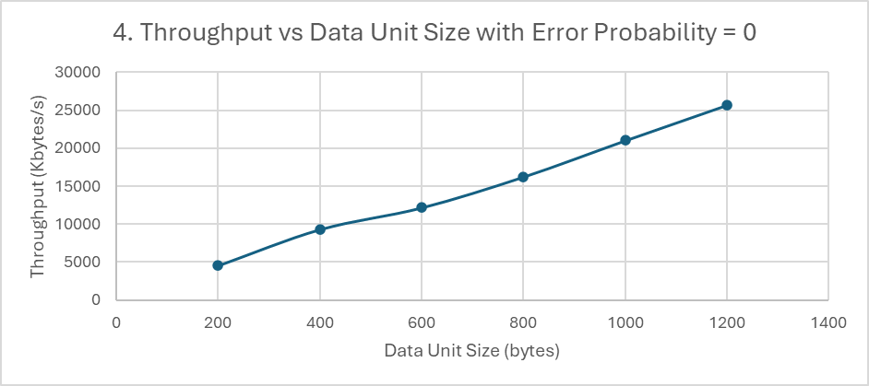

Findings:
- Transfer times increases as error probability increases.
- Throughput decreases as error probability increases.
- Transfer time decreases as data unit size increases.
- Transfer time increases as data unit size increases.

