UNIVERSITI TUNKU ABDUL RAHMAN

ACADEMIC YEAR 2023/2024

PRACTICAL TEST

UECS3253/UECS3463 WIRELESS APPLICATION DEVELOPMENT

DURATION: 1 HOUR 30 MINUTES TOTAL: 40 MARKS

BACHELOR OF SCIENCE (HONOURS) SOFTWARE ENGINEERING

BACHELOR OF ENGINEERING (HONOURS) ELECTRONICS

(COMPUTER NETWORKING)

Student Name | Lim kian yi |  | Student ID | 2106798
Programme | SE / ET |  | Practical Group

Instruction to Candidates:

This question paper consists of FOUR (4) questions. Answer ALL questions. Rename this document as StudentId_YourName.docx and submit it with the JavaScript files to the link provided in wble.

Installations required in this test are as follows:
- npm install @react-navigation/native
- npm install react-native-reanimated react-native-gesture-handler@2.8.0 react-native-screens react-native-safe-area-context @react-native-community/masked-view
- npm install @react-navigation/drawer
- npm install react-native-vector-icons –save
- npm i @react-native-community/slider --force

After the installation, modify the babel.config.js and android/app/build.gradle:
- add react-native-reanimated/plugin by updating the babel.config.js file to:
module.exports = {
presets: ["module:metro-react-native-babel-preset"],
plugins: [
"react-native-reanimated/plugin",
],
};

- edit android/app/build.gradle ( NOT android/build.gradle ) and add the following:
apply from: "../../node_modules/react-native-vector-icons/fonts.gradle"

In this test, you are required to React Native to develop an application that consists of THREE (2) screens: (i) HomeScreen and (ii) CalculateScreen where the DrawerNavigation is used to switch between the screens. This application is created based on FOUR (4) JavaScript files in this application:
- App.js
- HomeScreen.js
- CalculateScreen.js
- SliderWithLabel.js

Q1. By referring to the figure 1, develop the App.js so that it satisfies the following requirements:
- In the App.js, there is a CustomDrawerComponent to show the UTAR logo, user’s name, and drawer item list (with icon).
- Replace the ‘UECS3253 – Test’ to ‘UECS3253/ UECS3463 – Test’
- By clicking on the item, the application can switch between HomeScreen and CalculateScreen.
- You are required to use StyleSheet so that the outcome is similar to the sample screenshot. You may use Ionicons for each drawer list item (refer to https://oblador.github.io/react-native-vector-icons/ for the icon).

Remark: The UTAR logo can be downloaded at https://drive.google.com/file/d/1jSKr7ybVkUn6yhEpnxH_aq_jdp3LON2Z/view?usp=sharing

(10 marks)

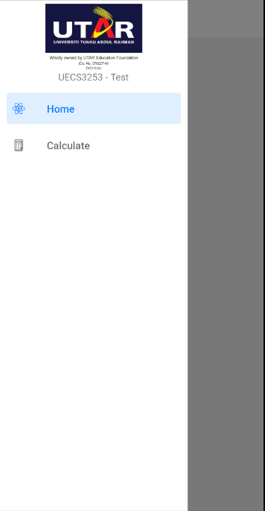
Figure 1. Sample Screenshot of Custom Drawer without changing the ‘UECS3253 – Test’

App.js

Source code:

import React, {Component} from "react";
import { View, StyleSheet, Text, TouchableOpacity, Image } from "react-native";
import HomeScreen from "./screens/Homescreen";
import Calculate from "./screens/CalculateScreen";
import { DrawerContentScrollView, DrawerItemList, createDrawerNavigator } from "@react-navigation/drawer";
import { NavigationContainer } from "@react-navigation/native";
import Ionicons from "react-native-vector-icons/Ionicons";

const Drawer = createDrawerNavigator();

export default class App extends Component{
constructor(props){
super(props);
}

render(){
return(
<NavigationContainer>
<Drawer.Navigator
drawerContent={props=> <CustomDrawerComponent {...props}/>}
>
<Drawer.Screen
name="Home"
component={HomeScreen}
options={{
drawerIcon: ({color}) => (
<Ionicons name="home-outline" size={20} color={color} />
),
drawerLabelStyle:{
fontSize: 23
}
}}
/>
<Drawer.Screen
name="Calculate"
component={Calculate}
options={{
drawerIcon: ({color}) => (
<Ionicons name="man-outline" size={20} color={color} />
),
drawerLabelStyle:{
fontSize: 23
}
}}
/>
</Drawer.Navigator>
</NavigationContainer>
);
}
}

class CustomDrawerComponent extends Component {
constructor(props){
super(props);
}

render(){
return(
<View style={{flex:1}}>
<DrawerContentScrollView>
<View style={{alignItems:'center', backgroundColor: 'pink'}}>
<Image
style={{
width: 80,
height: 80
}}
source={require('./assets/images/utarlogo.png')}
/>
<Text>My Profile Picture</Text>
</View>

<View style={{backgroundColor: '#fff', flex: 1, paddingTop: 10}}>
<DrawerItemList {...this.props} />
</View>
</DrawerContentScrollView>

<DrawerContentScrollView>
<View style={{borderTopWidth: 1, borderTopColor: 'grey'}} />
<TouchableOpacity style={{paddingVertical: 10}}>
<View
style={{
flexDirection: 'row',
alignItems: 'center',
marginLeft: 20,
}}>
<Ionicons name="exit-outline" size={23}/>
<Text
style={{
marginLeft: 20,
fontSize: 23,
}}>
Logout
</Text>
</View>
</TouchableOpacity>
</DrawerContentScrollView>
</View>
);
}
}

const inputStyles = StyleSheet.create({
container: {
flex: 1,
justifyContent: 'flex-start',
//backgroundColor: 'lightblue',
},
text: {
fontSize: 48,
color: 'black'
},
input: {
textAlign: 'center',
marginRight: 20
},
row: {
flexDirection: 'row',
flex: 1,
justifyContent: 'flex-start',
marginBottom: 10
}
});

Emulator Output:

Q2. By referring to the figure 2, develop the SliderWithLabel.js so that it satisfies the following requirements:
- The SliderWithLabel.js consists of ONE (1) native custom component: (i) SliderWithLabel that will be used by CalculateScreen.js.
- The SliderWithLabel consists of a Text and Slider that are used to display the value of the slider and set the value of the slider.
- You are required to use StyleSheet so that the outcome is similar to the sample screenshot.

Remark: You may implement the SliderWithLabel in CalculateScreen.js to show the outcome. (5 marks)

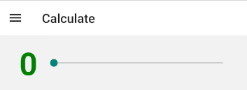
Figure 2. Sample Screenshot of SliderWithLabel in CalculateScreen.js

SliderWithLabel.js

Source code:

import React, { Component } from 'react';
import {
StyleSheet,
Text,
View,
} from 'react-native';
import Slider from '@react-native-community/slider';

export default class slider extends Component {
constructor(props) {
super(props)
this.state = {
value: 0
}
}

render() {
return (
<View style={styles.container}>
<Text style={styles.sliderLabel}>
{this.state.temperature}</Text>
<Slider style={{width: 300}}
step={1}
minimumValue={0}
maximumValue={100}
value={this.state.value}
onValueChange={(value) => this.setState({value})}
/>
</View>
);
}
}

Emulator Output:

Q3. By referring to the figure 3, develop the CalculateScreen.js so that it satisfies the following requirements:
- The CalculateScreen will display TWO (2) SliderWithLabel, ONE (1) Button and ONE (1) Text.
- For each SliderWithLabel, the slider has the minimum value of 0, maximum value of 100 and the step is 1. You are required to use state as the value of the slider.
- By clicking the Button, the sum of values from both sliders are calculated. Then, the sum is displayed through the Text at the bottom.
- You are required to use StyleSheet so that the outcome is similar to the sample screenshot. (15 marks)
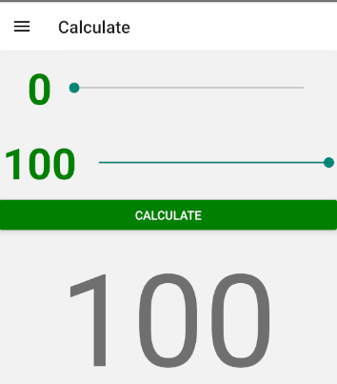
Figure 3. Sample screenshot of CalculateScreen.js

CalculateScreen.js

Source code:
import React, { Component } from 'react';
import {
StyleSheet,
Text,
View,
} from 'react-native';
import slider from './SliderWithLabel';
import { TouchableOpacity } from 'react-native-gesture-handler';

export default class Calculate extends Component {
constructor(props) {
super(props)
this.state = {
value: 0
}
}

handleButtonPress= (slider) => {

}

render() {
return (
<View>
<View>
<div>
<slider/>
</div>
<div>
<slider/>
</div>
</View>
<View>
<TouchableOpacity onPress={() => this.handleButtonPress()}style ={styles.button}>
<Text style ={styles.buttonText}>Calculate</Text>
</TouchableOpacity>
</View>
</View>
);
}
}

Emulator Output:

Q4. By referring to the figure 4 and the code snippet below, develop HomeScreen.js so that it satisfies the following requirements:
- In HomeScreen.js, there is a FlatList to display THREE (3) items, i.e., ITEM 1, ITEM 2 and ITEM 3.
- For each item in the FlatList, the title and image are displayed.
- Whenever the user click on the item, the description will be displayed through the console.
- You are required to use StyleSheet so that the outcome is similar to the sample screenshots. (10 marks)

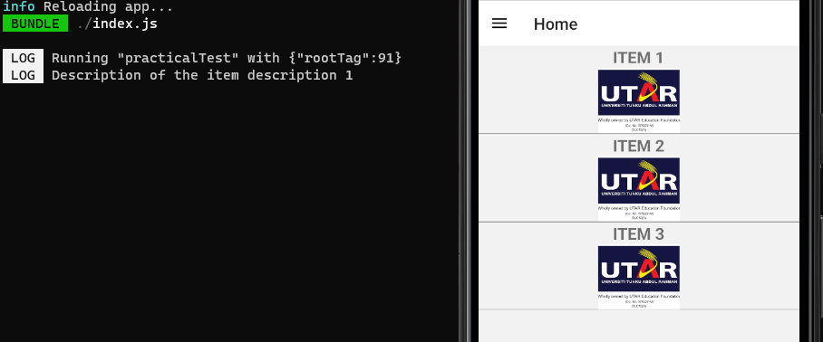
Figure 4. Sample Screenshot of HomeScreen.js and the console

// DO NOT ANSWER HERE
import React, {Component} from "react";
import { View, Text, FlatList, TouchableNativeFeedback, Image } from "react-native";

export default class HomeScreen extends Component{
constructor(props){
super(props);
this.state = {
items: []
}
}

componentDidMount() {
const dataSource = [
{
title: 'ITEM 1',
image: require('../image/utarlogo.png'),
description: 'description 1'
},
{
title: 'ITEM 2',
image: require('../image/utarlogo.png'),
description: 'description 2'
},
{
title: 'ITEM 3',
image: require('../image/utarlogo.png'),
description: 'description 3'
}
]

this.setState({
items: dataSource
})
}

render(){
return(
<View>

</View>
);
}
}

HomeScreen.js

Source code:
import React, { Component } from 'react';
import { View,FlatList,Text,style, } from 'react-native/Libraries/Components/View/View';

export default class HomeScreen extends Component{

renderGridItem = ({ item }) => (
<TouchableOpacity
style={styles.item}
onPress={() => this.handleContainerPress(item.name)}
>
<View>
<Image source={item.image} style={styles.ImageContainer} />
</View>
<Text style={styles.text}>{item.title}</Text>
</TouchableOpacity>
);

render(){
const filteredData = dataSource.filter((item) =>
item.title.toLowerCase().includes(this.state.searchText.toLowerCase())
);
return (
<View style ={{flex:1}}>

<FlatList
data={dataSource}
renderItem={renderItem}
keyExtractor={(item) => item.id.toString()}
/>
</View>
);
}}

Emulator Output:

[Total: 40 marks]

_______________________________________

