**MACM316 Assignment 3 –** Ngawang Kyirong 301312227

K = 150

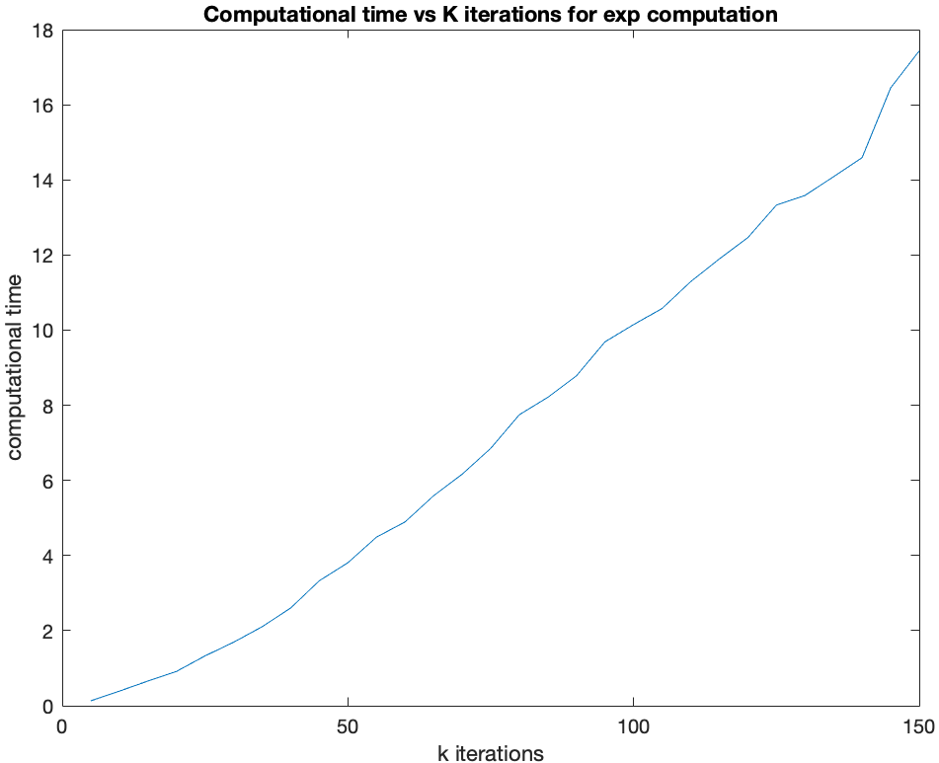

K=50

**b.)** As seen in the “Computational time vs K iterations for exp computation” plot, there is a **linear** relationship between the increasing values of **k** iterations and the increasement in **time**. There also appears to be a linear relationship between **k** and the amount of **flops**. However, the amount of **time** it takes to complete is linear but increases slower because for every increase in k by 5, the number of loops inside is also increased by 5 and the tic is before the inside loop with the toc immediately following afterwards (this is because of the 1 for loop being used for timing). While the number of flops increases linearly to k but quicker because it is also dependant on the number flops: . Therefore, it is in agreement with the assumption that time will be linear, but not in agreement with how fast due to the number of flops. **c.)** As seen in the “Computational error vs K iterations for exp computation” plot, the error increases until k=25 and then starts to decrease until k=80 and then stays constant. The **accuracy** of the algorithm is limited and not very accurate even though the error decreases to As k increases, the error should decrease and go towards machine epsilon but it does not. The **robustness** of the algorithm is good as the calculations do not seem to be effected by floating point errors.

A = load('CA3matrix.mat');

I = eye(500);

k_50 = 50;

k_150 = 150;

expAk = I;

expAk2 = I;

expAk3 = I;

% part a (k=50)

for n = 1:k_50

expAk = expAk + ((1/factorial(n)) * A.A^n);

end

imagesc(real(expAk));

colormap gray

% part a (k=150)

for n = 1:k_150

expAk = expAk + ((1/factorial(n)) * A.A^n);

end

imagesc(real(expAk));

colormap gray

% part b

times = [];

for n = 5:5:150

tic;

for i = 1:n

expAk2 = expAk2 + ((1/factorial(i)) * A.A^i);

end

times = [times toc];

expAk2 = I;

end

plt = plot(5:5:150, times);

xlabel("k iterations");

ylabel("computational time");

title("Computational time vs K iterations for exp computation");

% part c

error = [];

expA = expm(A.A);

for n = 5:5:150

for i = 1:n

expAk3 = expAk3 + ((1/factorial(i)) * A.A^i);

end

error = [error norm(expA - expAk3)/norm(expA)];

expAk3 = I;

end

plt = semilogy(5:5:150, error);

xlabel("k iterations");

ylabel("Computational error");

title("Computational error vs K iterations for exp computation");