HW7 – HEAP

Kyle Cooper

CODE EXECUTION EXAMPLE 1:

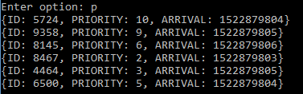

Figure 1

Figure 1 shows six print jobs on the heap.

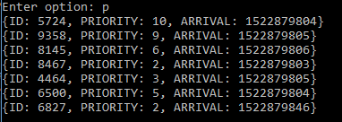

Figure 2

Figure 2 shows 7 print jobs now on the heap after job #6827 was added to the heap.

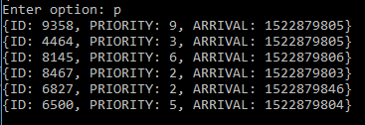

Figure 3

Figure 3 shows 6 print jobs now on the heap, job #5724 was deleted.

CODE EXECUTION EXAMPLE 2:

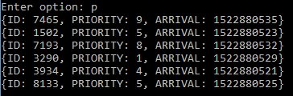

Figure 4

Figure 1 shows six print jobs on the heap.

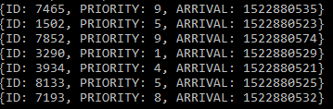

Figure 5

Figure 2 shows 7 print jobs now on the heap after job #7852 was added to the heap.

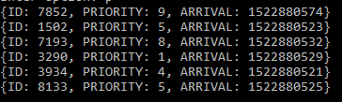

Figure 6

Figure 3 shows 6 print jobs now on the heap, job #7465 was deleted.