SDG indicator metadata

**(Harmonized metadata template - format version 1.1)**

0. Indicator information (SDG_INDICATOR_INFO)

0.a. Goal (SDG_GOAL)

Goal 10: Reduce inequality within and among countries

0.b. Target (SDG_TARGET)

Target 10.7: Facilitate orderly, safe, regular and responsible migration and mobility of people, including through the implementation of planned and well-managed migration policies

0.c. Indicator (SDG_INDICATOR)

Indicator 10.7.2: Proportion of countries with migration policies that facilitate orderly, safe, regular and responsible migration and mobility of people

0.d. Series (SDG_SERIES_DESCR)

Proportion of countries with migration policies to facilitate orderly, safe, regular and responsible migration and mobility of people, by policy domain (%)

Countries with migration policies to facilitate orderly, safe, regular and responsible migration and mobility of people, by policy domain (1 = Requires further progress; 2 = Partially meets; 3 = Meets; 4 = Fully meets)

0.e. Metadata update (META_LAST_UPDATE)

2023-03-31

0.f. Related indicators (SDG_RELATED_INDICATORS)

Indicator 10.7.2 is complementary to several related SDGs indicators. These include, but are not limited to:

Indicator 8.8.1 “Frequency rates of fatal and non-fatal occupational injuries, by sex and migrant status”;

Indicator 8.8.2. “Level of national compliance of labour rights (freedom of association and collective bargaining) based on International Labour Organization (ILO) textual sources and national legislation, by sex and migrant status”;

Indicator 10.7.1. “Recruitment cost borne by employee as a proportion of yearly income earned in country of destination”;

Indicator 10.7.3. “Number of people who died or disappeared in the process of migration towards an international destination”;

Indicator 10.7.4. “Proportion of the population who are refugees, by country of origin”;

Indicator 10.c.1 “Remittance costs as a proportion of the amount remitted”.

Indicator 10.7.2 is also complementary to other national migration monitoring frameworks, including IOM’s MGI, which entered its third phase in 2018. The MGI operates as a policy-benchmarking framework and offers insights into policy levers that countries could use to further develop their migration governance. It contains nearly 90 questions related to countries’ national migration policies, which fall under the same six domains as indicator 10.7.2.

0.g. International organisations(s) responsible for global monitoring (SDG_CUSTODIAN_AGENCIES)

International Organization for Migration (IOM) and United Nations Department of Economic and Social Affairs (DESA) as custodian agencies

1. Data reporter (CONTACT)

1.a. Organisation (CONTACT_ORGANISATION)

International Organization for Migration (IOM) and United Nations Department of Economic and Social Affairs (DESA) as custodian agencies

Organisation for Economic Co-operation and Development (OECD) as partner agency

2. Definition, concepts, and classifications (IND_DEF_CON_CLASS)

2.a. Definition and concepts (STAT_CONC_DEF)

**Definitions:**

SDG Indicator 10.7.2 aims to describe the state of national migration policies and how such policies change over time. The information collected seeks to identify both progress made and gaps, thus contributing to the evidence base for actionable recommendations for the implementation of SDG target 10.7. The indicator also serves for the future thematic reviews at the High-level Political Forum on Sustainable Development (HLPF).

The conceptual framework for indicator 10.7.2 is IOM´s Migration Governance Framework (MiGOF), which was welcomed by 157 countries (IOM Council Resolution C/106/RES/1310). The MiGOF has three principles and three objectives (figure 1).

Figure 1. Principles and objectives of the Migration Governance Framework

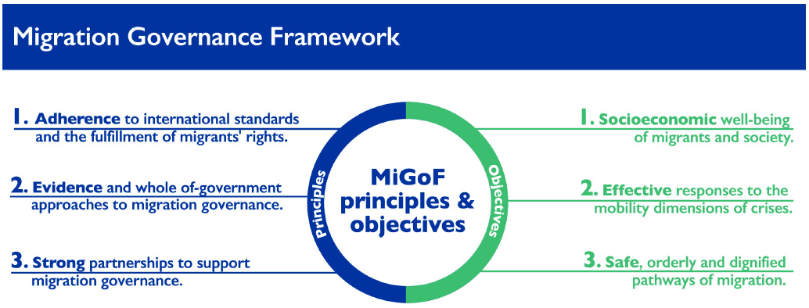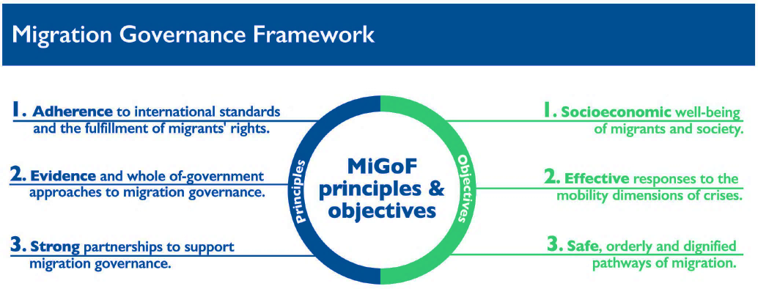

The three principles propose the necessary conditions for migration to be well-managed by creating a more effective environment for maximized results for migration to be beneficial to all. These represent the means through which a State can ensure that the systemic requirements for good migration governance are in place.

The three objectives are specific and do not require any further conventions, laws or practices than the ones that are already existing. Taken together, these objectives ensure that migration is governed in an integrated and holistic way, responding to the need to consider mobile categories of people and address their needs for assistance in the event of an emergency, building resilience of individuals and communities, as well as ensuring opportunities for the economic and social health of the State.

In line with the MiGOF, the proposed methodology for SDG indicator 10.7.2 is comprised of six policy domains, with one proxy measure for each domain (table 1).

**Table 1. Domains and proxy measures for SDG indicator 10.7.2**

|  |  |  |
| --- | --- | --- |
|  | **Domain** | **Proxy measure** |
| 1. | Migrant rights | Degree to which migrants have equity in access to services, including health care, education, decent work, social security and welfare benefits |
| 2. | Whole-of-government/ Evidence-based policies | Dedicated institutions, legal frameworks and policies or strategies to govern migration |
| 3. | Cooperation and partnerships | Government measures to foster cooperation and encourage stakeholder inclusion and participation in migration policy |
| 4. | Socioeconomic well-being | Government measures to maximize the positive development impact of migration and the socioeconomic well-being of migrants |
| 5. | Mobility dimensions of crises | Government measures to deliver comprehensive responses to refugees and other forcibly displaced persons |
| 6. | Safe, orderly and regular migration | Government measures to address regular or irregular immigration |

For each of the domains and corresponding proxy measures, one question was specified, each one of them informed by five sub-categories or responses (table 2), to capture key aspects of the range of migration policies at the national level, while allowing the indicator to detect relevant variations across countries and over time.

**Table 2. Questions and sub-categories for SDG indicator 10.7.2**

|  | **Question** | **Sub-categories** |
| --- | --- | --- |
| **Domain 1:** | Does the Government provide non-nationals equal access to the following services, welfare benefits and rights? | a. Essential and/or emergency health care  b. Public education  c. Equal pay for equal work  d. Social protection  e. Access to justice |
| **Domain 2:** | Does the Government have any of the following institutions, policies or strategies to govern immigration or emigration? | a. A dedicated Government agency to implement national migration policy  b. A national policy or strategy for regular migration pathways, including labour migration  c. A national policy or strategy to promote the inclusion or integration of immigrants  d. Formal mechanisms to ensure that the migration policy is gender responsive  e. A mechanism to ensure that migration policy is informed by data, appropriately disaggregated |
| **Domain 3:** | Does the Government take any of the following measures to foster cooperation among countries and encourage stakeholder inclusion and participation in migration policy? | a. An interministerial coordination mechanism on migration  b. Bilateral agreements on migration, including labour migration  c. Regional agreements promoting mobility  d. Agreements for cooperation with other countries on return and readmission  e. Formal mechanisms to engage civil society and the private sector in the formulation and implementation of migration policy |
| **Domain 4:** | Does the Government take any of the following measures to maximize the positive development impact of migration and the socioeconomic well-being of migrants? | a. Align, through periodic assessments, labour migration policies with actual and projected labour market needs  b. Facilitate the portability of social security benefits  c. Facilitate the recognition of skills and qualifications acquired abroad  d. Facilitate or promote the flow of remittances  e. Promote fair and ethical recruitment of migrant workers |
| **Domain 5:** | Does the Government take any of the following measures to respond to refugees and other persons forcibly displaced across international borders? | a. System for receiving, processing and identifying those forced to flee across international borders  b. Contingency planning for displaced populations in terms of basic needs such as food, sanitation, education and medical care  c. Specific measures to provide assistance to citizens residing abroad in countries in crisis or post-crisis situations  d. A national disaster risk reduction strategy with specific provisions for addressing the displacement impacts of disasters  e. Grant permission for temporary stay or temporary protection for those forcibly displaced across international borders and those unable to return |
| **Domain 6:** | Does the Government address regular or irregular immigration through any of the following measures? | a. System to monitor visa overstays  b. Pre-arrival authorization controls  c. Provisions for unaccompanied minors or separated children  d. Migration information and awareness-raising campaigns  e. Formal strategies to address trafficking in persons and migrant smuggling |

**Concepts:**

SDG target 10.7 is broad in scope and many, but not all, of the terms are well defined. The IOM Glossary on Migration[1] provides a definition of key concepts such as orderly and regular migration, but not others such as safe and responsible migration. According to the Glossary, orderly migration refers to “the movement of a person from his/her usual place of residence, in keeping with the laws and regulations governing exit of the country of origin and travel, transit and entry into the host country”. Regular is defined as “migration that occurs through recognized, legal channels”.

While the concept of “well-managed migration policies” is not explicitly defined, according to the IOM Glossary, it is included in references to migration management, migration governance and facilitated migration. Migration management refers to the planned approach to the development of policy, and legislative and administrative responses to key migration issues. Migration governance is defined as a system of institutions, legal frameworks, mechanisms and practices aimed at regulating migration and protecting migrants. Facilitated migration refers to fostering or encouraging regular migration, for example through streamlined visa application process.

2.b. Unit of measure (UNIT_MEASURE)

Percent (%) (refers to the proportion of countries with values between specific ranges for regional and global aggregates (see also 4.c. Method of computation)).

2.c. Classifications (CLASS_SYSTEM)

Not applicable

3. Data source type and data collection method (SRC_TYPE_COLL_METHOD)

3.a. Data sources (SOURCE_TYPE)

The source of data is the UN Inquiry among Governments on Population and Development, which has been used to survey global population policies since 1963, including policies on international migration. The Inquiry is mandated by the General Assembly in its resolution 1838 (XVII) of 18 December 1962. The Inquiry consists mostly of multiple-choice questions.

Two successive rounds of the Inquiry have been used to collect data on indicator 10.7.2: the Twelfth Inquiry, conducted between September 2018 and October 2019, and the Thirteenth Inquiry, conducted between November 2020 and October of 2021. The Twelfth Inquiry is divided into three thematic modules: Module I on population ageing and urbanization; Module II on fertility, family planning and reproductive health; and Module III on international migration. Module III of the Twelfth Inquiry has been updated to include core questions for all the six migration policy domains mentioned above. The Thirteenth Inquiry is divided into two thematic modules: Module I on reproductive health; and Module II on international migration.

3.b. Data collection method (COLL_METHOD)

The Inquiry is conducted on behalf of the Secretary-General and is sent to all Permanent Missions in New York: 193 Member States, 2 observer States, and 2 non-member States. As per past practice, the Permanent Missions redirect the three thematic modules of the Inquiry to the relevant line ministries or government departments who are tasked with answering the questions. The Inquiry modules can be completed either through an online questionnaire or a fillable questionnaire in PDF. Countries responses are transmitted back to UN DESA for basic consistency checking. The data are then compiled/integrated into the World Population Policies database. The results of the Inquiry are disseminated though the database, updated every two years.

As part of the collaboration on SDG indicator 10.7.2, IOM assisted in garnering country responses to the international migration module of the Inquiry by following up through its respective country or regional counterparts. OECD, as partner agency for this indicator, supported these efforts for its member countries. The collaboration increased response rates from countries and improved the quality of the data.

The data were collected biennially between 2019 and 2021, to ensure that there is sufficient information to monitor progress in the achievement of the target. In the future, the periodicity of the Inquiry will be modified to quadrennial. This will also allow for gathering benchmark data once within each HLPF 4-year cycle.

No adjustments to standard classifications are envisioned.

3.c. Data collection calendar (FREQ_COLL)

Data will be collected and compiled every four years starting in 2024.

3.d. Data release calendar (REL_CAL_POLICY)

Fourth quarter every four years

3.e. Data providers (DATA_SOURCE)

Governments of 193 Member States, 2 observer States, and 2 non-member States

3.f. Data compilers (COMPILING_ORG)

United Nations Department of Economic and Social Affairs (UN DESA), International Organization for Migration (IOM) and Organisation for Economic Co-operation and Development (OECD)

3.g. Institutional mandate (INST_MANDATE)

The Inquiry is conducted on behalf of the Secretary-General. Permanent Missions in New York facilitate the transmission of the Inquiry to the relevant line ministries or government departments. National Statistical Offices are also included in the correspondence from the Permanent Missions.

4. Other methodological considerations (OTHER_METHOD)

4.a. Rationale (RATIONALE)

The main goal of the proposed methodology is to formulate a clear and simple indicator based on an existing data source which can produce meaningful, actionable and timely information on key trends and gaps in relation to migration policies to facilitate orderly, safe, regular and responsible migration and mobility of people (figure 2). The proposed indicator can be used as a synthetic measure for monitoring of SDG target 10.7 and is complementary to other national migration monitoring frameworks, including IOM’s Migration Governance Indicators (MGI)[2].

**Figure 2. Scope and limitations of the proposed indicator**

**SDG indicator 10.7.2**

* + Document the existence and range of migration policies at the country level
  + Monitor progress across comparable policy domains
  + Document policy gaps, allowing to identify countries in need of capacity building
  + Reflect the different realities of countries of origin, transit and destination

**DOES:**

* + Serve as a national monitoring framework for migration policies
  + Provide an exhaustive picture of migration policies
  + Address the implementation of migration policies
  + Assess the impact or effectiveness of migration policies

**DOES NOT:**

4.b. Comment and limitations (REC_USE_LIM)

Developing a synthetic, robust indicator with the breadth and scope of target 10.7 as formulated in the 2030 Agenda for Sustainable Development is challenging. As co-custodians of indicator 10.7.2, UN DESA and IOM recognize that the indicator is neither expected nor designed to be comprehensive (figure 2); hence the importance of other, complementary tools such as IOM’s Migration Governance Indicators (MGI) Project.1

4.c. Method of computation (DATA_COMP)

The indicator includes a total of 30 sub-categories, under 6 questions/domains. All sub-categories, except for those under domain 1, have dichotomous “Yes/No” answers, coded “1” for “Yes” and “0” for “No”. For the sub-categories under domain 1, there are three possible answers: “Yes, regardless of immigration status”, coded “1”; “Yes, only for those with legal immigration status”, coded “0.5”; and “No” coded “0”.

For each domain, the computational methodology is the unweighted average of the values across sub-categories :

Where refers to the value for domain *i*;refers to the sum of the values across sub-categories (indexed by *j*)under domain *i*; and *n* refers to the total number of sub-categories in a domain (n=5). Results are reported as percentages. For each domain, values of range from a minimum of 0 to a maximum of 100 per cent.

The overall summary indicator 10.7.2 for a country is obtained by computing the unweighted average of the values of the 30 sub-categories under the six domains, with values ranging between 0 and 100 per cent.

For ease of interpretation and to summarize results, the resulting country-level averages (for the overall indicator and by domain) are then categorized as follows: values of less than 40 are coded as “Requires further progress”; values of 40 to less than 80 are coded as “Partially meets”, values of 80 to less than 100 are coded as “Meets”; and values of 100 are coded as “Fully meets”.

Data on country-level averages for the overall indicator and by domain used to compute indicator 10.7.2 are accessible through the SDG database, at the country level in the series 3230 (SG_CPA_MIGRS).

The unit of measure of the country-level averages for the overall indicator and by domain is categorical/score (1 = Requires further progress; 2 = Partially meets; 3 = Meets; 4 = Fully meets).

4.d. Validation (DATA_VALIDATION)

The ownership of the data on indicator 10.7.2 rests with the Governments of the 193 Member States, 2 observer States, and 2 non-member States. They are, individually, responsible for validating the quality of the data they provide through the Inquiry.

4.e. Adjustments (ADJUSTMENT)

No adjustments are made.

4.f. Treatment of missing values (i) at country level and (ii) at regional level (IMPUTATION)

**•** **At country level**

To ensure comparability of the indicator across countries and over time, missing values are assigned a value of “0”.

**•** **At regional and global levels**

Not imputed.

4.g. Regional aggregations (REG_AGG)

The regional and global aggregates are calculated and reported as the proportion of countries in that region (or globally) that “Require further progress”, “Partially meet” and “Meet or fully meet” target 10.7 as conceptualized and measured by indicator 10.7.2, among those that responded to the Inquiry module on international migration. The regional and global aggregates can be presented for both the overall indicator and by domain.

4.h. Methods and guidance available to countries for the compilation of the data at the national level (DOC_METHOD)

* The Inquiry questionnaire includes guidance, definitions and instructions. UN DESA, IOM and OECD are available to respond to country queries and provide further clarifications. In addition, IOM and OECD have identified focal points/country offices available to assist with the implementation of the Inquiry at the country level. To facilitate responses and to accommodate requests for material in different languages, the survey tool was translated into the six official languages of the UN (Arabic, Chinese, English, French, Russian and Spanish).
* No new international recommendations and guidelines are proposed. As noted in the previous paragraphs, the methodology is based on an IOM Council resolution regarding the Migration Governance Framework, and an existing data collection mechanism, the Inquiry, mandated by the UN General Assembly.

4.i. Quality management (QUALITY_MGMNT)

The Governments of the 193 Member States, 2 observer States, and 2 non-member States are responsible for the management of the quality of the data related to indicator 10.7.2.

4.j Quality assurance (QUALITY_ASSURE)

* Answers to the Inquiry are provided and validated directly by responding government entities. UN DESA, with support from IOM and OECD as needed, carried out basic consistency checking. Any inconsistencies are flagged to national counterparts for resolution.

* Since the indicator is informed directly by country responses to the Inquiry, no additional consultation process with countries on the national data submitted to the SDGs Indicators Database is envisaged.

4.k Quality assessment (QUALITY_ASSMNT)

Data are checked for internal consistency. In cases where there are concerns about the validity of national responses to the Inquiry, data providers at the country level are contacted and clarification is sought. If deemed necessary, the responding government entity is asked to submit revised data.

5. Data availability and disaggregation (COVERAGE)

**Data availability:**

Thirty countries were invited to take part in a pilot of the proposed methodology for indicator 10.7.2; six from each of the UN regional commissions. Ten countries responded to the pilot: Cote d'Ivoire; Democratic Republic of the Congo; Finland; France; Lesotho; Lithuania; Mexico; Morocco; Sweden and Yemen. Results of the pilot are presented in the addendum “Methodology development narrative”.

As of 31 October 2021, 138 Governments had provided data on SDG indicator 10.7.2 through the international migration module of the Inquiry; equivalent to 70 per cent of all countries globally. Of these, 49 countries responded to the Twelfth Inquiry only, 27 to the Thirteenth Inquiry only and 62 to both the Twelfth Inquiry and the Thirteenth Inquiry.

Coverage of the indicator by SDG region is uneven. In terms of country coverage, three regions (Europe and Northern America, Northern Africa and Western Asia and sub-Saharan Africa) had data available for 75 per cent or more of countries. Although the coverage was lower for other regions, all regions had data for at least 50 per cent of countries.

**Table 3. Coverage of responses to module on international migration of the Inquiry**

|  |  |  |  |  |
| --- | --- | --- | --- | --- |
| SDG region | Number of countries that provided data | Country coverage | Population coverage | Total number of countries by region |
| Sub-Saharan Africa | 37 | 77% | 79% | 48 |
| Northern Africa and Western Asia | 18 | 75% | 71% | 24 |
| Central and Southern Asia | 8 | 57% | 82% | 14 |
| Eastern and South-Eastern Asia | 10 | 63% | 93% | 16 |
| Latin America and the Caribbean | 17 | 52% | 87% | 33 |
| Oceania | 9 | 56% | 97% | 16 |
| Europe and Northern America | 39 | 85% | 69% | 46 |
| World | 138 | 70% | 83% | 197 |

Note: Based on the two rounds of the Inquiry combined. Where Governments replied to both rounds of the Inquiry, data from the Thirteenth Inquiry were used.

**Time series:**

The time series for this indicator refers to the period 2018-2019 and 2020-2021.

**Disaggregation:**

Six policy domains: (i) migrant rights; (ii) whole-of-government/evidence-based policies; (iii) cooperation and partnerships; (iv) socioeconomic well-being; (v) mobility dimensions of crises; and (vi) safe, orderly and regular migration.

6. Comparability / deviation from international standards (COMPARABILITY)

**Sources of discrepancies:**

No discrepancies are envisaged, since data are collected through the UN Inquiry among Governments on Population and Development (the “Inquiry”), directly from Governments.

7. References and Documentation (OTHER_DOC)

URL:

UN DESA : <https://www.un.org/development/desa/pd/data/sdg-indicator-1072-migration-policies>

IOM : <https://www.iom.int/>

OECD : <http://www.oecd.org/migration/>

References:

* Migration Governance Framework (MiGOF): <https://www.iom.int/sites/default/files/about-iom/migof_brochure_a4_en.pdf>
* UN Inquiry among Governments on Population and Development: <https://www.un.org/development/desa/pd/themes/population-policies/inquiry>

1. IOM (2019). *Glossary on Migration*. Available at: <https://publications.iom.int/system/files/pdf/iml_34_glossary.pdf>.
2. For additional information on the MGI see: <https://gmdac.iom.int/migration-governance-indicators>.