SDG indicator metadata

**(Harmonized metadata template - format version 1.1)**

0. Indicator information (SDG_INDICATOR_INFO)

0.a. Goal (SDG_GOAL)

Goal 11: Make cities and human settlements inclusive, safe, resilient and sustainable

0.b. Target (SDG_TARGET)

Target 11.6: By 2030, reduce the adverse per capita environmental impact of cities, including by paying special attention to air quality and municipal and other waste management

0.c. Indicator (SDG_INDICATOR)

Indicator 11.6.1: Proportion of municipal solid waste collected and managed in controlled facilities out of total municipal waste generated, by cities

0.d. Series (SDG_SERIES_DESCR)

EN_REF_COLDIS - Proportion of population served by municipal waste collection [11.6.1]

EN_REF_WASCOL - Municipal Solid Waste collection coverage, by cities (%) [11.6.1]

0.e. Metadata update (META_LAST_UPDATE)

2025-04-23

0.f. Related indicators (SDG_RELATED_INDICATORS)

1.4.1, 6.3.1, 12.3.1.b, 12.5.1

0.g. International organisations(s) responsible for global monitoring (SDG_CUSTODIAN_AGENCIES)

United Nations Human Settlements Programme (UN-Habitat)

United Nations Statistics Division (UNSD)

1. Data reporter (CONTACT)

1.a. Organisation (CONTACT_ORGANISATION)

United Nations Human Settlements Programme (UN-Habitat)

United Nations Statistics Division (UNSD)

2. Definition, concepts, and classifications (IND_DEF_CON_CLASS)

2.a. Definition and concepts (STAT_CONC_DEF)

**Definition:**

SDG 11.6 targets an improved environmental performance of cities and SDG indicator 11.6.1 measures the progress of the performance of a city’s municipal solid waste management. It quantifies the parameters listed below, which are essential for planning and implementing sustainable Municipal Solid Waste (MSW). In most cases, these variables are generally compatible with those collected through the United Nations Statistics Division (UNSD)/United Nations Environment Programme (UNEP) Questionnaire on Environment Statistics (waste section).

1. Total MSW generated in the city (tonnes/day)
2. Total MSW collected in the city (tonnes/day)
3. Proportion of population with access to basic MSW collection services in the city (%)
4. Total MSW managed in controlled facilities in the city (tonnes/day)
5. MSW composition

It is important to realize that part (b) total MSW collected in the city and (c) proportion of population with access to basic MSW collection services in the city are two different concepts. While part (b) refers to amounts of waste reaching waste management facilities, part (c) considers the population who receive waste collection services. In some cities it is common to dump waste ‘collected’ from households into the surrounding areas instead of transporting it to a disposal or recovery facility. In this case the household has waste collection services, but the collected waste is polluting the environment. Therefore, it is possible that a city has a high proportion of population with access to basic waste collection services, but the amount of MSW collected and transported to waste management facilities is low.

Although part (c) is covered by SDG 1 (“End poverty in all its forms everywhere”), under target 1.4 and SDG indicator 1.4.1 which focuses on universal access to basic services, with a particular emphasis on poor and vulnerable groups, this document provides guidelines, quality ladders and household questionnaires to measure the proportion of the population with access to ‘basic’ MSW collection services. The household questionnaire can be integrated into the national census or global household survey mechanism such as Demographic and Health Survey or UNICEF’s Multiple Indicator Cluster Surveys. Due to the lack of standardized concepts and definitions that differentiate these two concepts, many cities report the proportion of collected MSW in their own terms. Therefore, this metadata distinguishes clearly between part (b) and (c) and offers introduction to the approaches to monitor and report on part (c).

**Concepts:**

*Municipal Solid Waste (MSW)***:** MSW includes waste generated from: households, commerce and trade, small businesses, office buildings and institutions (schools, hospitals, government buildings). It also includes bulky waste (e.g. white goods, old furniture, mattresses) and waste from selected municipal services, e.g. waste from park and garden maintenance, waste from street cleaning services (street sweepings, the content of litter containers, market cleansing waste), if managed as waste. The definition excludes waste from municipal sewage network and treatment, municipal construction and demolition waste.

*Generation***:** Total MSW generated is the sum of the amount of municipal waste collected plus the estimated amount of municipal waste from areas not served by a municipal waste collection service.

*Collection***:** Total MSW collected refers to the amount of municipal waste collected by or on behalf of municipalities, as well as municipal waste collected by the private sector. It includes mixed waste, and fractions collected separately for recovery operations (through door-to-door collection and/or through voluntary deposits).

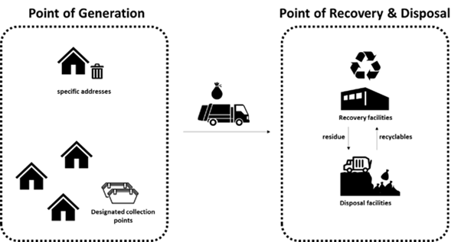

Figure 1: What MSW collected means for SDG indicator 11.6.1

The proportion of the population with access to basic MSW collection services is the proportion of the population who receive waste collection services that are either basic, improved or full, defined by the service ladder of MSW collection service. It considers aspects of frequency, regularity and proximity of the collection points (

Table **1**). This aspect is measured under the SDG indicator 11.6.1 assessment but it is reported through a different indicator, SDG 1.4.1 on access to basic services.

**Table 1: Ladder of MSW collection service that household receives**

|  |  |
| --- | --- |
| **SERVICE LEVEL** | **DEFINITION** |
| Full | * Receiving door-to-door MSW collection service with basic frequency and regularity and MSW is collected in three or more separate fractions; or * Having a designated collection point within 200m distance served with basic frequency and regularity and without major littering and MSW is collected in three or more separate fractions |
| Improved | * Receiving door-to-door MSW collection service with basic frequency and regularity and MSW is collected in a minimum of two, separate fractions (e.g. wet and dry fractions) * Having a designated collection point within 200m distance served with basic frequency and regularity and without major littering and MSW is collected in a minimum of two, separate fractions (e.g. wet and dry fractions) |
| Basic | * Receiving door-to-door MSW collection service with basic frequency and regularity or * Having designated collection point within 200m distance served with basic frequency and regularity |
| Limited | * Receiving door-to-door MSW collection service without basic frequency and regularity; * Having a designated collection point within 200m distance but not served with basic frequency and regularity; or * Having designated collection point in further than 200 m distance |
| No | * Receiving no waste collection service |
| Note: Basic frequency and regularity: served at least once a week for one year | |

*Recovery***:** Recovery means any operation the principal result of which is waste serving a useful purpose by replacing other materials which would otherwise have been used to fulfil a particular function, or waste being prepared to fulfil that function, in the plant or in the wider economy.

Recovery facilities include any facility with recovery activities defined above including recycling, composting, incineration with energy recovery, materials recovery facilities (MRF), mechanical biological treatment (MBT), etc.

**Materials recovery facilities (MRF)** or materials reclamation facility, materials recycling facility, multi re-use facility is a specialized recovery facility that receives, separates and prepares recyclable materials for marketing to further processors or end-user manufacturers.

**Mechanical biological treatment (MBT)** facilities are a type of recovery facility that combines an MRF with a form of biological treatment such as composting or anaerobic digestion.

**Incineration** is the controlled combustion of waste with or without energy recovery.

**Incineration with energy recovery** is the controlled combustion of waste with energy recovery.

**Recycling** is defined under the UNSD/UNEP Questionnaire and further for the purpose of these indicators as “Any reprocessing of waste material in a production process that diverts it from the waste stream, except reuse as fuel. Both reprocessing as the same type of product, and for different purposes should be included. Recycling within industrial plants i.e., at the place of generation should be excluded”. For the purpose of consistency with the Basel Convention reporting and correspondence with EUROSTAT reporting system, Recovery operations R2 to R12 listed in Basel Convention Annex IV, are to be considered as “Recycling” under the UNSD reporting for hazardous waste.

**Recycling value chain** usually involves several steps of the private recycling industry, which purchase, process and trade materials from the point a recyclable material is extracted from the waste stream until it will be reprocessed into products, materials or substances that have market value. In many low and low-to-middle income countries, this involves informal waste pickers, many middlemen, traders, apex traders and end-of-chain recyclers.

**Apex traders** collect recyclable materials from different sources and suppliers (in different cities across municipal or even national boundaries) and supply them to different end-of-chain recyclers (sometimes after pre-processing such as sorting, washing and bailing).

**End-of-chain recyclers** purchase recyclable material from suppliers such as apex traders and reprocess it into products, materials, or substances that have market value.

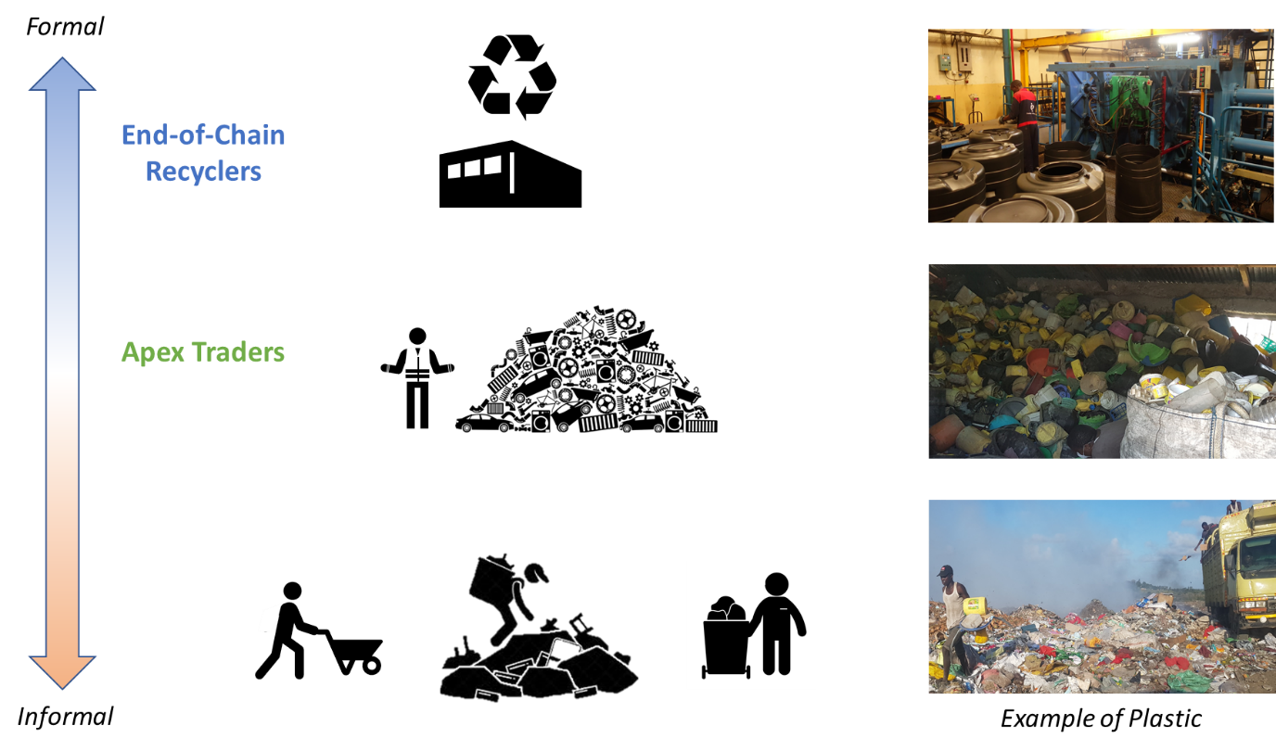

Figure 2: Complexity in the recovery chain (plastic example)

*Disposal***:** Disposal means any operation whose main purpose is not the recovery of materials or energy even if the operation has as a secondary consequence the reclamation of substances or energy.

**Disposal facilities** refer to sites, which are regularly used by the public authorities and private collectors, regardless of their level of control and legality, to dispose of waste. Such sites may or may not have an official recognition, a permit or a license. Disposal sites may be managed in either a controlled or uncontrolled manner. The definition excludes other unrecognized places where waste is deposited occasionally in small amounts which public authorities may organise clean ups to remove the waste from these sites.

**Landfill** is the deposit of waste into or onto land. It includes specially engineered landfill sites and temporary storage of over one year on permanent sites. The definition covers both landfills at internal sites, i.e. where a generator of waste is carrying out its own waste disposal at the place of generation, and at external sites.

Control level of MSW recovery and disposal facilities**:** MSW managed in controlled facilities refers to MSW collected and transported to recovery and disposal facilities with basic, improved or full control according to the ladder of waste management facilities’ control level (**Table 2: Ladder of waste management facilities’ control level.**). The ladder can be used as a checklist for assessing the level of control of a particular recovery or disposal facility. The facility has the level of control, where it checks the most boxes. Note that the emphasis is on operational control rather than engineering/design. A facility that is constructed to a high standard, but not operated in compliance with Level 3 (or above) standard is not regarded as a controlled facility.

**Table 2: Ladder of waste management facilities’ control level.**

|  |  |  |  |
| --- | --- | --- | --- |
| **CONTROL LEVEL** | **Landfill site** | **Incineration with energy recovery** | **Other recovery facilities** |
| Full Control | * Waste daily covered * Waste compacted * Site fenced and full 24-hour control of access * Properly sited, designed and functional sanitary landfill * Leachate containment and treatment (naturally consolidated clay on the site or constructed liner) * Landfill gas collection and flaring and/or utilization * Site staffed * Post closure plan * Weighing and recording conducted * Protection of workers’ health and safety | * Built to and operating in compliance with current national laws and standards including stringent stack and greenhouse gas emission criteria * Emission controls are conducted compliant to environmental standards and results of tests are accessible and transparent to citizens/users * Fly ash managed as a hazardous waste using the best appropriate technology * Weighing and recording conducted * A strong and robust environmental regulator inspects and monitors emissions * Protection of workers’ health and safety | * Built to and operating in compliance with current national laws and standards * Pollution control compliant to environmental standards * Protection of workers’ health and safety * The nutrient value of biologically treated materials utilized for separate organic waste (e.g. in agriculture/horticulture) * Materials are extracted, processed according to market specifications, and sold to recycling markets * Weighing and recording of incoming loads conducted * All outgoing loads registered by weight and type of destination |
| Improved Control | * Waste periodically covered * Waste compacted * Site fenced and control of access * Leachate containment and treatment * Landfill gas collection (depending on landfill technology) * Site staffed * Weighing and recording conducted * Provisions made for workers’ health and safety | Not applicable | * Engineered facilities with effective process control * Pollution control compliant to environmental standards * Protection of workers’ health and safety * Evidence of materials extracted being delivered into recycling or recovery markets * Weighing and recording of incoming and outgoing loads conducted |
| Basic Control | * Some use of cover * Waste compacted * Sufficient equipment for compaction * Site fenced and control of access * No fire/smoke existence * Site staffed * Weighing and recording conducted * The slope of the landfill is stable, landslides not possible * Provisions made for workers’ health and safety | * Emission controls to capture particulates * Trained staff follow set operating procedures * Equipment maintained * Ash management carried out * Weighing and recording conducted * Provisions made for workers’ health and safety | * Registered facilities with marked boundaries * Some environmental pollution control * Provisions made for workers’ health and safety * Weighing and recording of incoming and outgoing loads conducted |
| Limited Control | * No cover * Some compaction * Some equipment for compaction * Some level of access control/fencing * No leachate control * Some fire/smoke existence * Site staffed * Weighing and recording conducted * The slope of the landfill is unstable with high possibility of a landslide | Not applicable | * Unregistered facilities with distinguishable boundaries * No environmental pollution control * No provisions made for workers’ health and safety * Weighing and recording conducted |
| No Control | * No cover * No compaction * No/limited equipment * No fencing * No leachate control * Fire/smoke existence * No staff * The slope of the landfill is unstable with high possibility of a landslide | * Uncontrolled burning * No air/water pollution control | * Unregistered locations with no distinguishable boundaries * No provisions made for workers’ health and safety * No environmental pollution control |

*Formality of* **Municipal Solid Waste Management (***MSWM***):** The formality of MSWM activities is an important aspect to take into consideration when conducting the SDG indicator 11.6.1 assessment. MSWM activities are carried out by formal and informal economic units, both public and private, and by generators for the purpose of prevention, collection, transportation, treatment and disposal of waste.

**Formal waste management** relates to waste management activities undertaken by units working within the context of the formal governmental or non-state actors regulating and operating waste management; that is, organisations or individuals registered as economic units with government authorities and assumed to generally abide by local laws and regulations related to wastes and their management.

**Informal waste management, recycling and recovery** refers to waste management and recovery activities undertaken by individuals, economic units, or enterprises which are not sponsored, financed, recognised, supported, organised or acknowledged by the formal solid waste authorities, or which operate in violation of or in competition with formal authorities (Scheinberg et al., 2010). Informal units are assumed to abide by local waste-related laws and regulations when it is in their interests to do so.

2.b. Unit of measure (UNIT_MEASURE)

Percent (%)

2.c. Classifications (CLASS_SYSTEM)

Not applicable

3. Data source type and data collection method (SRC_TYPE_COLL_METHOD)

3.a. Data sources (SOURCE_TYPE)

Countries and cities/municipalities that have the data already are recommended to answer the UNSD/UNEP Questionnaire on Environment Statistics to provide the data related to SDG 11.6.1. For countries and municipalities/cities that do not have the data, it is recommended to apply UN-Habitat’s***Waste Wise Cities Tool – Step by Step Guide to Assess a City’s MSMW Performance*** ***through SDG indicator 11.6.1 Monitoring***.

3.b. Data collection method (COLL_METHOD)

It is recommended to establish a system where local or municipal governments collect SDG 11.6.1 data utilizing Waste Wise Cities Tool, then the data aggregated by the ministries and agencies in charge of environmental protection. These collected data should be reported to UNSD/UNEP Questionnaire on Environment Statistics every two years from National Statistical Offices (NSOs) of countries. Currently the response rate for the UNSD/UNEP Questionnaire is around 50% and data completeness and quality remain a challenge, especially for developing countries.

Countries may report their data to UNSD via the UNSD/UNEP Questionnaire on Environment Statistics (waste section) following application of the methods specified in this metadata template. UNSD engages in an extensive data validation process including automated checks, and liaisons with the country’s NSO or Ministry of Environment.

3.c. Data collection calendar (FREQ_COLL)

The data for this indicator is updated biennially depending on the data source stated above.

3.d. Data release calendar (REL_CAL_POLICY)

Data for Indicator 11.6.1 is released annually, and the monitoring of the indicator can be repeated at annual intervals, to cater for an anticipated increase in the number of cities/urban areas and countries reporting on the indicator.

3.e. Data providers (DATA_SOURCE)

Ministry of environment or equivalent agency to it, responsible for environmental protection and National statistical offices (NSOs). For the UNSD/UNEP Questionnaire on Environment Statistics (waste section), countries typically specify one of the above two institutions as the preferred focal point.

3.f. Data compilers (COMPILING_ORG)

United Nations Human Settlements Programme (UN-Habitat)

United Nations Statistics Division (UNSD)

3.g. Institutional mandate (INST_MANDATE)

The United Nations Human Settlements Programme (UN-Habitat) is the specialized agency for sustainable urbanization and human settlements in the United Nations. The mandate derives from the priorities established in relevant General Assembly resolutions and decisions, including General Assembly resolution 3327 (XXIX), by which the General Assembly established the United Nations Habitat and Human Settlements Foundation, and resolution 32/162 by which the Assembly established the United Nations Center for Human Settlements (Habitat). In 2001, by its Resolution 56/206, the General Assembly transformed the Habitat into the secretariat of the UN-Habitat, with a mandate to coordinate human settlements activities within the United Nations System. As such, UN-Habitat has been designated the overall coordinator of SDG 11 and specifically as a custodian agency for 9 of the 14 indicators under SDG 11 including indicator 11.6.1. UN-Habitat also supports the monitoring and reporting of four urban specific indicators in other goals.

4. Other methodological considerations (OTHER_METHOD)

4.a. Rationale (RATIONALE)

Urban households and businesses produce substantial amounts of solid waste that must be collected regularly, recycled or treated and disposed properly in order to maintain healthy and sanitary living conditions. Many cities are increasingly facing solid waste management challenges due to rapid urbanization, lack of technical and financial capacity or low policy priority. In addition, the higher the income level of a city, the greater the amount of the solid waste produced. Therefore, the economic growth to be experienced in the developing and emerging countries will pose greater challenges in solid waste management to local governments in the next decades.

Adverse environmental impact of uncollected waste in a city is significant. Uncollected solid waste can end up in drains leading to blocked drainages and cause unsanitary conditions that have a direct health impact on residents. Open burning of uncollected waste produces pollutants that are highly damaging locally and globally. Vectors such as mosquitos usually breed in blocked drainages and blocked drainage contributes to the cause of flooding. In 2015, the Global Waste Management Outlook estimated that at least 2 billion people do not have access to regular waste collection. This is particularly worse in informal settlements and the UN-Habitat’s report Solid Waste Management in World Cities published in 2010 estimated only 5% of waste in squatter areas is regularly collected.

The global scale of urbanization and economic growth are creating a potential “time-bomb” regarding the waste we generate in the world. If not addressed now, the significant negative impact on human health and the environment will be felt by nations at all levels of development. An estimated 2.24 billion tonnes of municipal solid waste (MSW) were generated in 2020, and this number is expected to grow to 3.88 billion tonnes by 2050 under a business-as-usual scenario (World Bank).

There is a need for SDG indicator 11.6.1 monitoring as it provides critical information for cities and countries to establish better waste and resource management strategies. Reliable data and information on MSW generation and management is limited globally, especially in low- and middle-income country settings where waste data is often produced based on international estimates, without having been validated in the local context.

Many developing and transitional country cities still have an active informal sector and micro-enterprise recycling, reuse and repair; often achieve recycling and recovery rates comparable to those in developed countries, resulting in savings to the waste management budget of the cities. There is a major opportunity for the city to build on these existing recycling systems, reducing some unsustainable practices and enhancing them to protect and develop people’s livelihoods, and to reduce still further the costs to the city of managing the residual wastes. The formal and informal sectors need to work together, for the benefit of both. Promoting this indicator also can help formalization of the informal sector in the process of increasing the portion of “solid waste with adequate discharge”.

A global data collection and publication system through the UNSD/UNEP Questionnaire on Environment Statistics has collected data on MSW collection and treatment for about 20 years. The Questionnaire has been sent to more than 160 countries, covering both national and city levels. However, the response rate for the UNSD/UNEP questionnaire is around 50% and data completeness and quality remain a challenge, especially for developing countries. While efforts will continue to collect data from NSOs and Ministries of Environment at the national level, it is also critical to improve the availability and accessibility of waste statistics and increase training for collection of data and capacity development at the national and sub-national levels.

This paucity of evidence-based data hinders the development of waste management strategies and constrains investment decision-making in infrastructure and service expansion, leading to many countries having insufficient or absent MSW management services. Poor MSW collection and management trigger severe threats to public health and pollute air and water. Furthermore, uncollected and mismanaged waste is the main source of marine plastic pollution.

The indicator 11.6.1 will also promote Integrated Solid Waste Management (ISWM). An integrated solid waste management system is strongly connected to three dimensions: urban environmental health, the environment and resource management. Moreover, a regular solid waste management strategy is a clear indicator of the effectiveness of a municipal administration. Good waste governance that is inclusive, financially sustainable and based on sound institutions is one of the key challenges of the 21st century, and one of the key responsibilities of a city government.

SDG indicator 11.6.1 quantifies parameters that will help cities and countries to better manage resources, mitigate and prevent environmental pollution, create business, employment and livelihood opportunities, and shift towards a circular economy. The methodology to monitor SDG indicator 11.6.1 provides guidelines for ladders for MSW collection services and control level of waste management facilities and aims to bring standardization around MSW data points.

The indicator 11.6.1 has strong linkages to other SDG indicators such as 6.3.1 (proportion of wastewater safely treated), 12.3.1 (food waste), 12.4.2 (Hazardous waste generated per capita and proportion of hazardous waste treated and by type of treatment) and 12.5.1 (National recycling rate).

UN-Habitat has also developed an additional document ***Waste Wise Cities Tool – Step by Step Guide to Assess a City’s MSWM Performance through SDG indicator 11.6.1 Monitoring*** which provides detailed methodology for data collection if not available.

4.b. Comment and limitations (REC_USE_LIM)

Collection of data for the indicator has been demonstrated by pilot data collection using UN-Habitat’s Waste Wise Cities Tool in Mombasa (see flow diagram) and many other cities, but continuous training and capacity development for tool application at city level will be required to strengthen the global waste statistics and improve its data quality. In general, developed countries have good Municipal solid waste data collection systems. Some of the best available data for middle- and low-income countries is available from UNSD, though it is relatively sporadic[1]. In countries and cities where data availability is particularly challenging, household surveys and other complimentary surveys are being conducted for the estimation of municipal waste generation per capita. Also, the collection of the data, such as the amount of waste managed in controlled facilities, remains a challenge for many national and local governments.

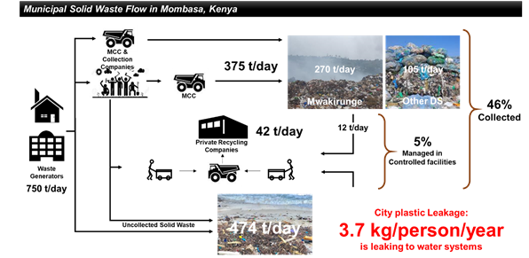

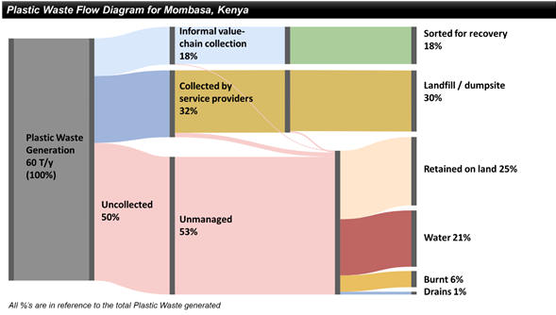

4.c. Method of computation (DATA_COMP)

The numerator of this indicator is “total Municipal Solid Waste (MSW) collected and managed in controlled facilities (tonnes/day)” and the denominator is “total municipal solid waste generated by the city (tonnes/day)”.

SDG indicator 11.6.1 is calculated as follows:

The calculation of SDG indicator 11.6.1. provides two important sub-categories with varying policy implications:

***Applying the national sample of cities/municipalities approach***

When countries collect all data from the municipalities on solid waste, the above methodologies will provide you with the national averages/estimates. However, in cases where countries only have samples of data available from the selected municipalities, data producers are encouraged to use the national sample of cities/municipalities approach which has been developed by UN-Habitat[2].

Figure 3 summarizes the elements measured by SDG indicator 11.6.1. The MSW generated by the city is either collected or uncollected, and the collected MSW is delivered to recovery or disposal facilities. Recovery facilities generate residues that are sent to disposal facilities. In many cities, recyclables are also recovered from disposal facilities and brought back into the recycling value chain. Recovery or disposal facilities can be categorized as either ‘controlled’ or ‘uncontrolled’ depending on the operational measures put in place to minimize the environmental, health and safety impacts from the facilities. When both recovery and disposal occur within the same facility, it is necessary to evaluate the control level of the recovery and disposal operations independently of each other.

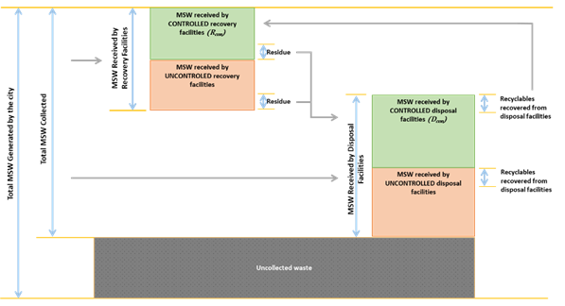

Figure 3: Concept figure of SDG indicator 11.6.1

**Data points**

The data points required to calculate SDG indicator 11.6.1 include:

1. Total MSW generated by the city
2. Total MSW collected
3. Total MSW managed in controlled facilities

These data also help cities to identify the proportion of MSW that remains uncollected.

1. Total MSW generated by the city

For cities that do not have reliable data on MSW generation, it can be estimated through the multiplication of the total population and per capita MSW generation from the household. Detailed methodology for this is provided in Steps 1, 2 and 3 in ***Waste Wise Cities Tool – Step by Step Guide to Assess a City’s MSMW Performance*** ***through SDG indicator 11.6.1 Monitoring*** (UN-Habitat, 2020).

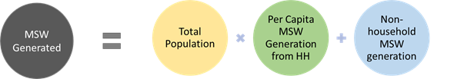

Equation 1: Total MSW generated

1. Total MSW collected

When measuring total MSW collected, there is a risk of double counting, concerning the residue or rejects from recovery facilities and the amount of waste recovered from disposal facilities going to recovery. Therefore, these amounts need to be deducted from the sum of waste received by both recovery and disposal facilities. It is assumed residue of recovery facilities is going to disposal facilities or other recovery facilities. Steps 4 and 5 in ***Waste Wise Cities Tool – Step by Step Guide to Assess a City’s MSMW Performance*** ***through SDG indicator 11.6.1 Monitoring*** provide detailed methodology on how to collect this data if not available.

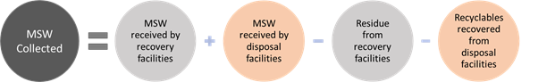

Equation 2: Total MSW[3] collected

1. Total MSW managed in controlled facilities

MSW managed in controlled facilities is MSW collected and transported to recovery and disposal facilities with basic control or above according to the control ladder. Steps 4 and 5 in ***Waste Wise Cities Tool – Step by Step Guide to Assess a City’s MSMW Performance*** ***through SDG indicator 11.6.1 Monitoring*** provide detailed methodology on how to collect this data if not available.

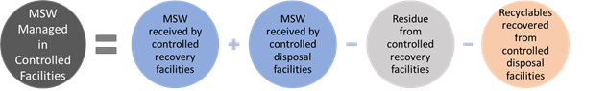

Equation 3: Total MSW managed in controlled facilities

**Additional data points**

The SDG indicator 11.6.1 assessment provides information for the calculation of three more very relevant MSW management data points. Although they are not necessary for the calculation of the SDG indicator, these figures are of interest for city authorities:

1. Per capita MSW generation rate
2. MSW composition
3. Uncollected waste
4. Per capita MSW generation rate

A very relevant parameter that can be derived from the previous formula is the “total per capita MSW generation rate”. Steps 2 and 3 in ***Waste Wise Cities Tool – Step by Step Guide to Assess a City’s MSMW Performance*** ***through SDG indicator 11.6.1 Monitoring*** explain how to calculate this through waste sampling from households, if no reliable or updated data is available. Particularly for cities where a large amount of MSW remains uncollected, it is recommended to sample the waste from households, as provided by the Waste Wise Cities Tool.

1. MSW composition

The SDG indicator 11.6.1 assessment determines the waste composition at the point of generation (i.e. households) and at the point of disposal. Understanding MSW composition at the beginning and end of the MSW service chain is a useful exercise for several reasons; Understanding composition helps identifying how the existing recovery/recycling sector is functioning, it enables further recovery facilities to be identified and planned, and overall assists triangulation (i.e. test validity and reliability) of data collected.

Note that MSW also includes waste from non-household sources. In Step 3 of ***Waste Wise Cities Tool – Step by Step Guide to Assess a City’s MSMW Performance*** ***through SDG indicator 11.6.1 Monitoring***, the quantities of MSW generated from commercial and institutional sources, as well as from public spaces, is estimated. However, specific composition analysis on MSW from non-household sources is beyond the scope of this tool as it is complex and resource intensive.

1. Total uncollected waste

Total uncollected MSW can be calculated by subtracting the total MSW regularly collected from the total MSW generated.

4.d. Validation (DATA_VALIDATION)

As part of the validation process, UN-Habitat developed a template to compile data generated by countries through the NSOs as well as other government agencies responsible for official statistics (<https://data.unhabitat.org/pages/guidance>). Data compiled is then checked against several criteria including the data sources used, the application of internationally agreed definitions, classification and methodologies to the data from that source, etc. Once reviewed, appropriate feedback is then provided to individual countries for further discussion.

4.e. Adjustments (ADJUSTMENT)

Any adjustment to the data is jointly agreed after consultations with the relevant national agencies that share the data points for reporting.

4.f. Treatment of missing values (i) at country level and (ii) at regional level (IMPUTATION)

* **At country level**

Missing values may arise at the reporting of the city level estimates. At the national level, estimates will be derived by relevant national entities from the nationally representative sample of cities, in which case there will be very few missing entries.

* **At regional and global levels**

Regarding promoting data quality assurance through the collection of data via the UNSD/UNEP Questionnaire on Environment Statistics, UNSD carries out extensive data validation procedures that include built-in automated procedures, manual checks and cross-references to national sources of data. Communication is carried out with countries for clarification and validation of data. UNSD does not make any estimation or imputation for missing values so the number of data points provided are actual country data. Only data that are considered accurate or those confirmed by countries during the validation process are included in UNSD’s environment statistics database and disseminated on UNSD’s website.

4.g. Regional aggregations (REG_AGG)

Data at the global/regional levels will be estimated from national figures derived from a weighted aggregation of performance for all cities/urban areas or a sample of nationally representative cities (selected using the national sample of cities approach developed by UN-Habitat). Weighting for regional and global averages is done using urban population sizes from the World Urbanization Prospects. Global monitoring will be led by UN-Habitat with the support of other partners and regional commissions.

4.h. Methods and guidance available to countries for the compilation of the data at the national level (DOC_METHOD)

It is recommended to establish a system where SDG 11.6.1 data is collected at the municipal level using Waste Wise Cities Tool, consolidated at prefecture or province level then further consolidated at national level. This process can be led by Ministry of Environment or any other national agency with environmental control and protection mandate.

UN-Habitat’s***Waste Wise Cities Tool – Step by Step Guide to Assess a City’s MSMW Performance*** ***through SDG indicator 11.6.1 Monitoring*** provides the step-by-step guide for cities to collect relevant parameters necessary to estimate SDG 11.6.1. This also can be utilized as an assessment tool for the environmental performance of city’s solid waste management. The ministries and agencies responsible for environmental protection and waste management is recommended to actively promote and disseminate this tool to collect the fact-based waste data for the policy formulation and infrastructure development for sustainable waste management. The guidance on implementation of the National Sample of Cities Approach is available here: <https://unhabitat.org/sites/default/files/2020/06/national_sample_of_cities_english.pdf>.

4.i. Quality management (QUALITY_MGMNT)

To ensure consistency in data production across countries, UN-Habitat has developed detailed step-by-step tutorials on the computation of indicator 11.6.1, which further explain the steps presented in this metadata. The detailed tutorials, which will be continuously updated are available at <https://unhabitat.org/knowledge/data-and-analytics>, <https://www.urbanagendaplatform.org/learning>, and <https://data.unhabitat.org/>.

Within its Data and Analytics Section which is responsible for the indicator data compilation, UN-Habitat has a team of data experts who check all submitted data and provide direct support to countries in the indicator computation in collaboration with the Agency’s waste management experts. As part of its global custodianship of indicator 11.6.1, UN-Habitat has also worked closely with relevant UN agencies such as UNSD and UNEP, as well as prominent waste management experts and environmental statisticians from all over the world. This helped create a common understanding on the approach for the indicator computation, and to encourage continuous production of high-quality global data that responds to the indicator computation needs.

4.j Quality assurance (QUALITY_ASSURE)

As custodian agencies, we provide national and local level support to data collection and share global tools for data collection with municipalities so that the data is correctly captured. Municipalities are advised to share their data with one national entity for national level compilation before the data is sent to the custodian agencies for consolidation in the global tables.

4.k Quality assessment (QUALITY_ASSMNT)

Once data is received from member states, UN-Habitat uses a checklist specific to each indicator to a) assess whether the data production process followed the metadata provisions, and b) confirm the accuracy of the data sources used for the indicator computation. Both components are captured in the reporting template shared with NSOs, which helps to assess whether computation was done using the proposed indicator inputs or proxies. The reporting template also requests for information that helps understand whether national data for the indicator was produced from a representative sample of the country’s urban systems, or if estimates were done for only select cities/urban areas where data is easily available. In addition, the received data is also checked for other qualities such as data disaggregation, reporting period and consistency with other previously reported trends, which ensures reliable regional estimates.

5. Data availability and disaggregation (COVERAGE)

**Data availability:**

MSW data is available through What a Waste 2.0 by World Bank (World Bank, 2018), the UNSD/UNEP Questionnaire on Environment Statistics and UN-Habitat CPI. These have key MSW data such as MSW generation, MSW generation rate, MSW collection rate, etc., but the aspect of “controlled management” is missing.

The UNSD/UNEP Questionnaire on Environment Statistics has collected data on municipal waste collection and treatment for about 20 years. The Questionnaire has been sent to more than 160 countries, covering both national and city levels. However, the response rate for the UNSD/UNEP questionnaire is hovering around 50% and data completeness and quality remain a challenge, especially for developing countries.

For those variables relevant to this indicator which are collected via the UNSD/UNEP Questionnaire, data for up to 120 cities are available in some years (municipal waste collected), though for other relevant variables, for a given year, data for 30 to 60 cities may be available. In the case of the variable, municipal waste generated (which was only collected for the first time in 2018), data are available for 20 cities. More details on the availability of data obtained from the UNSD/UNEP Questionnaire can be found in the [Report of the Secretary-General on Environment Statistics](https://unstats.un.org/unsd/statcom/51st-session/documents/2020-33-EnvironmentStats-E.pdf)[4] (Part C) and the Background Report[5] (Part 1) submitted to the fifty-first session of the Statistical Commission (New York, 3-6 March 2020). Data received via the UNSD/UNEP Questionnaire have been published on the UNSD website in the form of indicator tables (UNSD Indicator Tables (waste)) (<https://unstats.un.org/unsd/envstats/qindicators>) as well as in country files (<https://unstats.un.org/unsd/envstats/country_files>).

In parallel with the effort to establish a global data reporting outlet establishment according to the SDG indicator 11.6.1, training and capacity development on data production and data quality improvement both for at national and local government level is essential to accelerate the progress towards the achievement of this SDG. UN-Habitat is providing capacity development and trainings through both offline and online for cities and municipalities and NSIs for them to apply the Waste Wise Cities Tool.

**Time series:**

The indicator can be updated annually or biennially depending on the data source stated above. Data is sporadically available on an annual basis in the UNSD Indicator Tables (waste) (<https://unstats.un.org/unsd/envstats/qindicators>).

**Disaggregation:**

Data for this indicator can be disaggregated at various levels in accordance with the country’s policy information needs. For instance:

* Disaggregation by location (intra-urban)
* Disaggregation by source of waste generation e.g. residential, industrial, office, or MSW material received by recovery facilities
* Disaggregation by type of final treatment and disposal
* MSW generation rate of different income level (high, middle, low)
* MSW generation rate in different cities

6. Comparability / deviation from international standards (COMPARABILITY)

**Sources of discrepancies:**

Data on formal Municipal solid waste collection and management may be available from municipal bodies and/or private contractors. Informal collection data may be available from NGOs and community organizations. It is important that all data sources are used for reporting, otherwise discrepancies in forms and guides used are likely to introduce inconsistencies in reported figures. Discrepancies are also likely to arise where geographical jurisdictions are not well marked out for service providers and facilities that manage collected waste.

7. References and Documentation (OTHER_DOC)

**URL:**

[1]: Waste Wise Cities, UN-Habitat: <https://unhabitat.org/waste-wise-cities>

[2] : National Sample of Cities Approach, UN-Habitat : https://unhabitat.org/sites/default/files/2020/06/national_sample_of_cities_english.pdf

**References:**

1. Jambeck et al (2015). *Plastic waste inputs from land into the ocean.* Science 13 Feb 2015: Vol. 347, Issue 6223, pp. 768-771.

* GIZ, University of Leeds, Eawag-Sandec, Wasteaware (2020). *User Manual: Waste Flow Diagram (WFD): A rapid assessment tool for mapping waste flows and quantifying plastic leakage.* Version 1.0. Principal Investigator: Velis C.A. Research team: Cottom J., Zabaleta I., Zurbruegg C., Stretz J. and Blume S. Eschborn, Germany. Obtain from: <http://plasticpollution.leeds.ac.uk>.

1. UN Environment (2015). *Global Waste management Outlook.*
2. Wilson et al. (2015). *“Wasteaware” benchmark indicators for integrated sustainable Waste management in cities.* Waste Management 35, 329-342.
3. Wilson et al (2014). *User Manual for Wasteaware ISWM Benchmark Indicators* Supporting Information to: Wilson et al., 2014 – doi: 10.1016/j.wasman.2014.10.006.
4. World Bank (2018). *What a Waste 2.0: A Global Snapshot of Solid Waste Management to 2050.*
5. UN-Habitat (2010). *Solid Waste Management in World Cities.*
6. Framework for the Development of Environment Statistics (FDES) (<https://unstats.un.org/unsd/environment/FDES/FDES-2015-supporting-tools/FDES.pdf>).
7. Manual on the Basic Set of Environment Statistics (<https://unstats.un.org/unsd/envstats/fdes/manual_bses.cshtml>): Generation and Management of Waste (<https://unstats.un.org/unsd/environment/FDES/MS_3.3.1_3.3.2_Waste.pdf>).
8. UNSD/UNEP Questionnaire on Environment Statistics (waste section) (<https://unstats.un.org/unsd/envstats/questionnaire>).

UNSD Indicator Tables (waste) (<https://unstats.un.org/unsd/envstats/qindicators>).

1. UNSD, UNSD Environmental Indicators. Refer specifically to: “Municipal waste collection at city level in selected cities (latest year)”; “Municipal waste treatment at city level in selected cities (latest year)”; and “Total population served by Municipal Waste Collection”. Available at: <https://unstats.un.org/unsd/envstats/qindicators>.
2. https://unhabitat.org/sites/default/files/2020/06/national_sample_of_cities_english.pdf
3. Note that MSW collected for recovery includes mixed MSW, commingled recyclables or recoverable fractions extracted from MSW.
4. <https://unstats.un.org/unsd/statcom/51st-session/documents/2020-33-EnvironmentStats-E.pdf>
5. <https://unstats.un.org/unsd/statcom/51st-session/documents/BG-item-4e-EnvironmentStats-E.pdf>