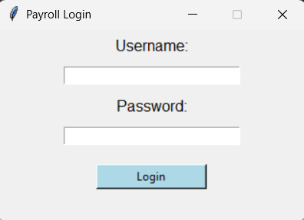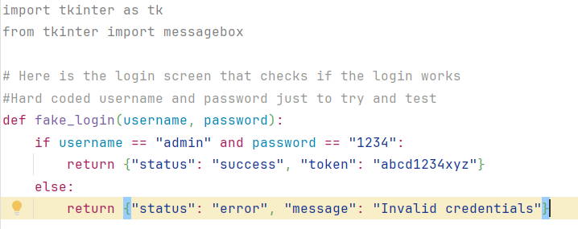
Currently, I only have a login screen that is fully working. That currently just takes a password and a username. That is currently just admin and 1234 for the password, just to make sure that everything is working to at least to make sure that the login works. Currently, I have no security in place; however, I do plan on adding input validation. Also, a lockout timer to prevent spraying attacks. This is going to make the overall delivery much simpler since I already have the login screen with implemented code.
For the first standard, I have consistent and descriptive naming conventions for functions and variables. If we can do this in the code, it would make it much easier to know what everything does and what everything is holding. It also helps with limiting how many comments we need in the code to keep it smaller, because the name of the thing explains what it is. The stakeholders should care because future updates or audits can happen without talking to different developers, and shorten the cost.
Next, we have input validation and error handling. Everything that the user inputs or anything that the system makes, we should make sure that it's secure and safe to use. If not handled correctly with a payroll system, a bad actor could get all the information in the system and, depending on how it's coded, get into the bank's accounts. The reason why stakeholders care is that this helps with making sure that the company maintains legal and financial integrity and avoids a lawsuit for the information being leaked.
Next, we follow the same idea of security with data privacy and implementing correct standards. If we put this in relation to confidentiality, secure coding practices, and the security Triad. No data should appear in logs that any can access, or if there's an error, nothing should be in that error, too. The stakeholder should care for the same reason as above keeps them out of legal trouble.
Next, we have version control and documentation. All code that we maintain needs to be placed in a version control system with meaningful commit messages and documentation, so we know what everything does. This is related to traceability and documentation. This will allow us to know who made changes, why they made changes, and if something ever goes wrong, we can roll back to a safe version of the program. Why the stakeholders should care is that this will allow us to hold accountability to the software developers. So we know who did what work.
Next, we need to test our code and have appropriate code reviews. Before we take anything and put it into production. We need to make sure that we review the code and test it to make sure that everything works and is secure. This is related to Continuous integration and continuous deployment. Why stakeholders should care is that this will reduce bugs, leading to a better product, and this could prevent failures that would cost the company money. Or make their work because they might not get paid.

