**THE ARCHIVAL ALCHEMIST: TRANSFORMING CAPSTONE**

**INTO DISCOVERABLE KNOWLEDGE**

A Final Project Presented to the Faculty of

College of Computer, Information and Communications Technology

Cebu Technological University - Main Campus

In Partial Fulfillment

Of the Requirements for Professional Elective 4

By

Jeylsie A. Caro

Kyla A. Hubahib

Maria Carmel A. Tabada

David Jhonson M. Basnillo

Narcisan S. Galamiton, Ph.D.

Adviser

September 2024

## Rationale of the Study

The estimate from UNESCO suggests that approximately 2.2 million new titles are added to the global shelves each year, contributing to the cumulative number of printed books available worldwide. This does not include e-books, audiobooks nor books without an ISBN, which includes many self-published books (Homer 2022). Using statistical methods, (Giles and Khabsa 2024) estimated that at least 114 million English-language scholarly documents are accessible on the Web. As of 2022, over 5.14 million academic articles are published per year, including short surveys, reviews, and conference proceedings (Curcic 2023). The COVID-19 pandemic has disrupted the traditional operations of academic libraries worldwide, including those in the Philippines. It is estimated that over 28 million Filipino students across all academic levels were affected by the transition to remote online learning adopted in early 2020. Of these, 3.5 million students from 2,400 higher education institutions (HEI) are from the tertiary level (Jeremiah et al., 2020). However, it has also accelerated the adoption of digital libraries and online resources as institutions adapt to remote learning and research. Traditional textbooks can be inconvenient (Lawver 2024). The National Library of the Philippines' initiatives to enhance its services and facilities amidst the pandemic, and the increasing significance and potential of digital libraries in preserving cultural heritage and enabling remote access to information resources ([Hani](https://opengovasia.com/author/aineena-hani/) 2021).

However, with numerous fields of study and courses, students may find it daunting to locate materials directly relevant to their academic pursuits. Additionally, traditional books, including capstone project documents, may not always be easily accessible or available for reference. In some cases, these materials might be stored in cabinets or restricted access areas, limiting their utility for future students. This lack of accessibility can hinder the ability of students to access valuable resources and may necessitate alternative methods of research and learning. According to (Garnham 2024), “Researchers face many challenges. The research process itself can be time-consuming and complex, and the storage, organization, and seamless sharing of that research can be even trickier. Without one organized source of truth, research can be left in silos, making it incomplete, redundant, and useless when it comes to gaining actionable insights.”

To bridge the gap between traditional academic practices and the demands of the digital era, a university-centric initiative known as The Archival Alchemist: Transforming Capstone Into Discoverable Knowledge project has been initiated. It endeavors to develop systems aimed at enhancing both the discoverability and preservation of students' capstone project documents related to the IT industry and emerging technology innovation. It is a web-based system platform dedicated to safeguarding and sharing students' capstone documents online. In today's digital age, many student capstone documents exist as soft copies stored on drives or within various software but often remain undiscovered and inaccessible.

The research endeavors to tackle pressing challenges within the management and execution of capstone projects in academic settings. One such challenge is the fragmented nature of project management, where projects are dispersed across multiple platforms, leading to inefficiencies. Additionally, the absence of a centralized platform hampers collaboration among students, impeding the exchange of ideas and cooperative learning opportunities. Thus, there is a critical need to establish a unified space where students can interact, share insights, and engage in meaningful discussions to enrich their academic journey. Another significant hurdle faced by students is the complexity of selecting a suitable capstone project topic that aligns with their interests, skills, and available resources. This challenge underscores the necessity for guidance in navigating the intricate process of narrowing down broad areas of study into specific and viable research questions. In response, the study proposes the implementation of The Archival Alchemist: Transforming Capstone Into Discoverable Knowledge web-based system. Aligned with the Connect, Collaborate, and Simplify (CCS) strategy, meticulously developed to address the identified issues, this project aims to revolutionize capstone project management. The Connect aspect involves establishing a centralized hub for seamless submission, review, and sharing of academic contributions, thereby eliminating fragmented projects and preserving capstone projects to make them discoverable for future use. Collaborate focuses on creating a centralized space for collaboration and enabling idea exchange within the academic community. Lastly, Simplify aims to provide guided support for students in navigating the complex process of topic selection, empowering them to make informed decisions aligned with their interests and resources. By addressing these challenges, the proposed project aims to enhance the overall learning experience of students, aligning with academic institutions' goals and discipline-specific requirements to foster a more efficient and collaborative environment for capstone projects.

## Objectives of the Study

The primary objective of this study is to develop a comprehensive mobile app for a capstone repository system tailored specifically for universities in Cebu that offer capstone courses. This overarching goal includes the following specific objectives:

1. Create an accessible platform: Develop a user-friendly platform that students from various campuses can easily access.
2. Create a centralized repository: Improve the overall capstone project experience for students by providing a centralized repository for showcasing and preserving their academic achievements such as capstone manuscripts for all to explore.
3. Facilitate collaboration and knowledge exchange: Promote collaboration and knowledge exchange among students and faculty across different universities, enabling a wider dissemination of ideas, and innovations in capstone manuscript projects.

## Program Workflow

The figure below illustrates the program workflow for students. They can engage in various activities, including creating an account, managing their profile, handling capstone projects, bookmarking favorites, engaging in interactive activities like chat and rating, and participating in forums to connect with others.

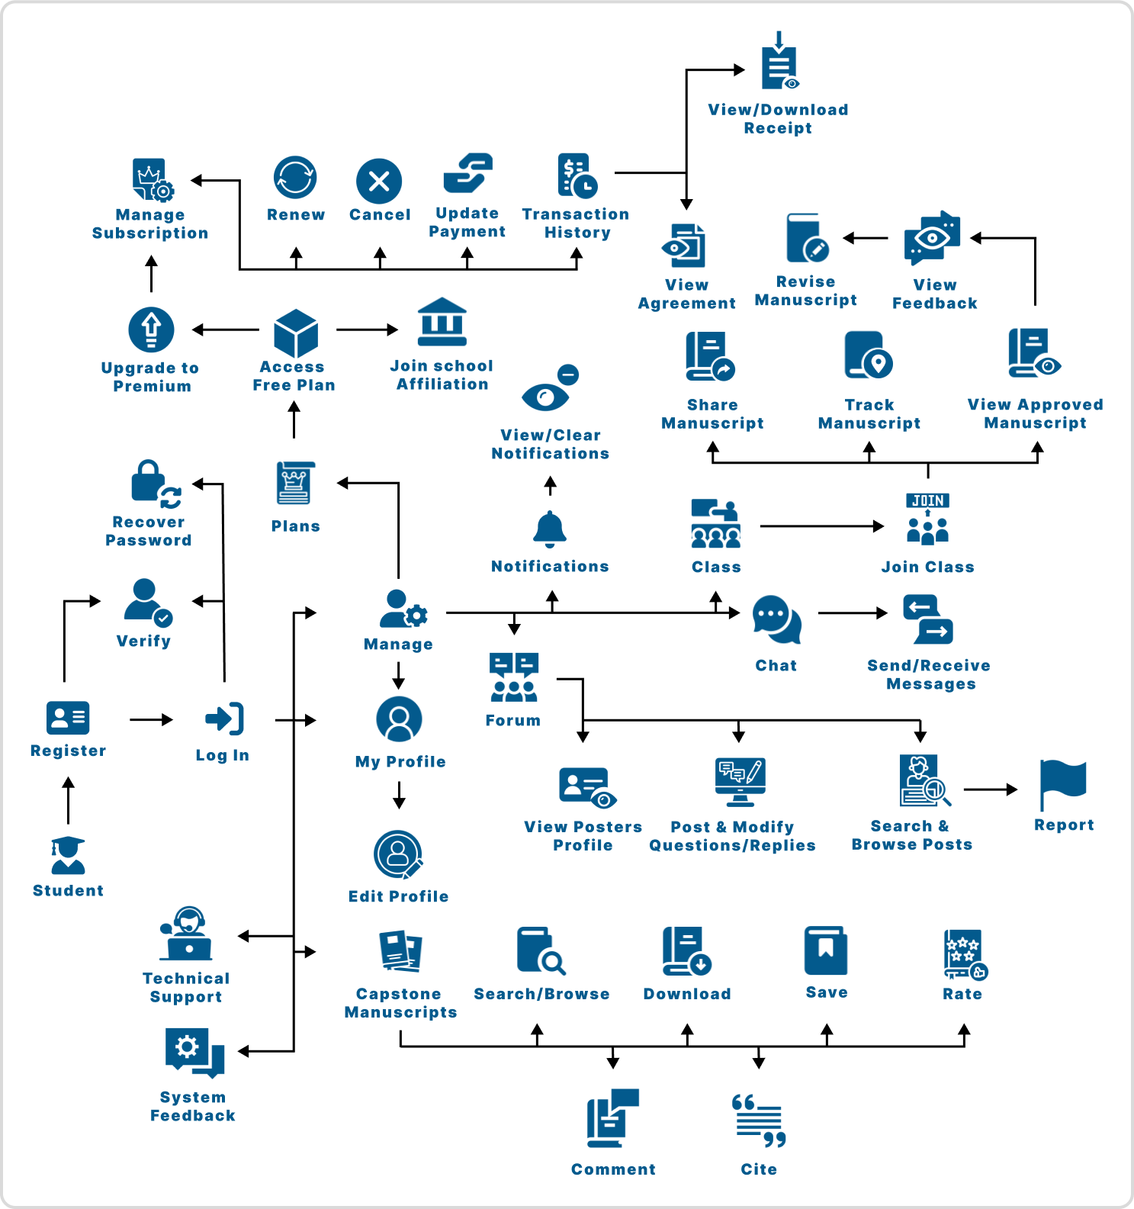

## Functional Decomposition Diagram

The figure below illustrates the functional decomposition diagram of the proposed system within the application. It displays the various tasks users can perform within the application.

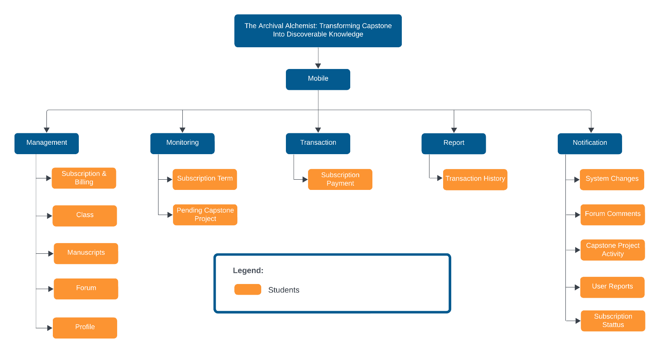

**Entity Relationship Diagram**

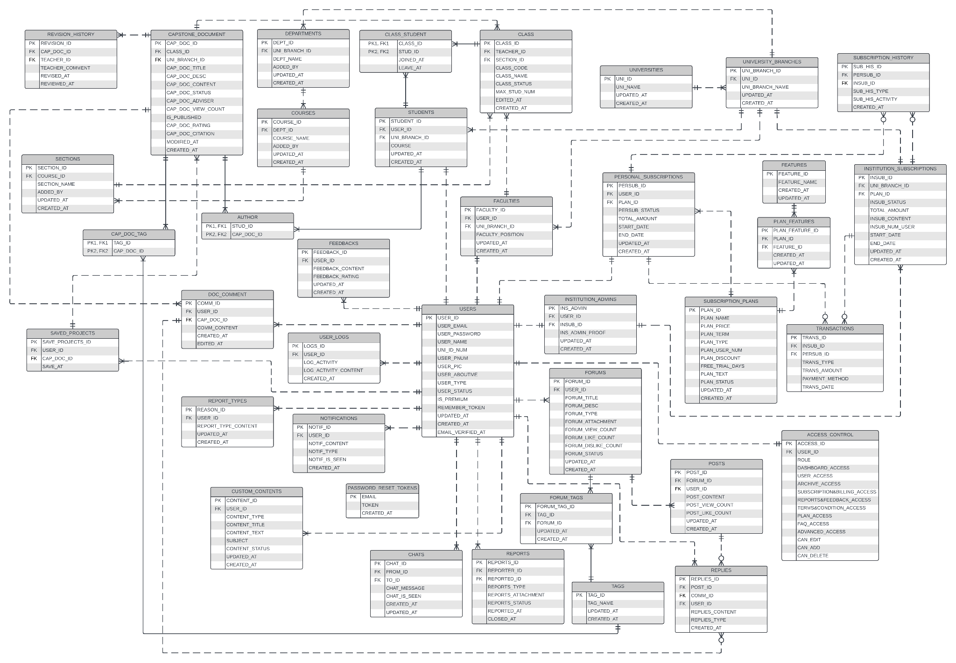

**List of Modules**

|  |  |  |
| --- | --- | --- |
| Programmers | Module | Student |
| Jeylsie Caro  Kyla Hubahib | **Account Management** | |
| 1. Register and login | * |
| 2. Profile Management | * |
| 3. Change Password | * |
| Jeylsie Caro  Kyla Hubahib | **Document Management** | |
| 1. Download projects | * |
| 2. Upload and modify capstone projects | * |
| 3. Save favorite Projects | * |
| Jeylsie Caro  David Jhonson Basnillo | **Client Search and Discovery** | |
| 1. Search and browse projects | * |
| 2. Filter projects such as title, university, author, or tags | * |
| Maria Carmel Tabada  David Jhonson Basnillo | **Notifications** | |
| 1. View Notifications | * |
| 2.Delete Notifications | * |
| Maria Carmel Tabada  David Jhonson Basnillo | **Forum** |  |
| 1. Search and browse discussions | * |
| 2. Filter discussions such as title, author, or tags | * |
| 3. Posting | * |
| 4. Commenting | * |
| 5. Report post | * |
| Maria Carmel Tabada | **Chat** | |
| 1. Send or Receive Message | * |
|  | **Subscription** | |
| Kyla Hubahib | 1. Purchase and renew Subscription | * |
| 2. Cancel Subscription | * |
| No of Points (1 per module per user) | |  |
| Number of Modules per User (equals no.of points per user) | |  |
| Total Number of Modules | |  |