**THE ARCHIVAL ALCHEMIST: TRANSFORMING CAPSTONE**

**INTO DISCOVERABLE KNOWLEDGE**

A Final Project Presented to the Faculty of

College of Computer, Information and Communications Technology

Cebu Technological University - Main Campus

In Partial Fulfillment

Of the Requirements for Professional Elective 4

By

Jeylsie A. Caro

Kyla A. Hubahib

Maria Carmel A. Tabada

David Jhonson M. Basnillo

Narcisan S. Galamiton, Ph.D.

Adviser

September 2024

## Objectives of the Study

The primary objective of this study is to develop a comprehensive mobile app for a capstone repository system tailored specifically for universities in Cebu that offer capstone courses. This overarching goal includes the following specific objectives:

1. Create an accessible platform: Develop a user-friendly platform that students from various campuses can easily access.
2. Create a centralized repository: Improve the overall capstone project experience for students by providing a centralized repository for showcasing and preserving their academic achievements such as capstone manuscripts for all to explore.
3. Facilitate collaboration and knowledge exchange: Promote collaboration and knowledge exchange among students and faculty across different universities, enabling a wider dissemination of ideas, and innovations in capstone manuscript projects.

## Program Workflow

The figure below illustrates the program workflow for students. They can engage in various activities, including creating an account, managing their profile, handling capstone projects, bookmarking favorites, engaging in interactive activities like chat and rating, and participating in forums to connect with others.

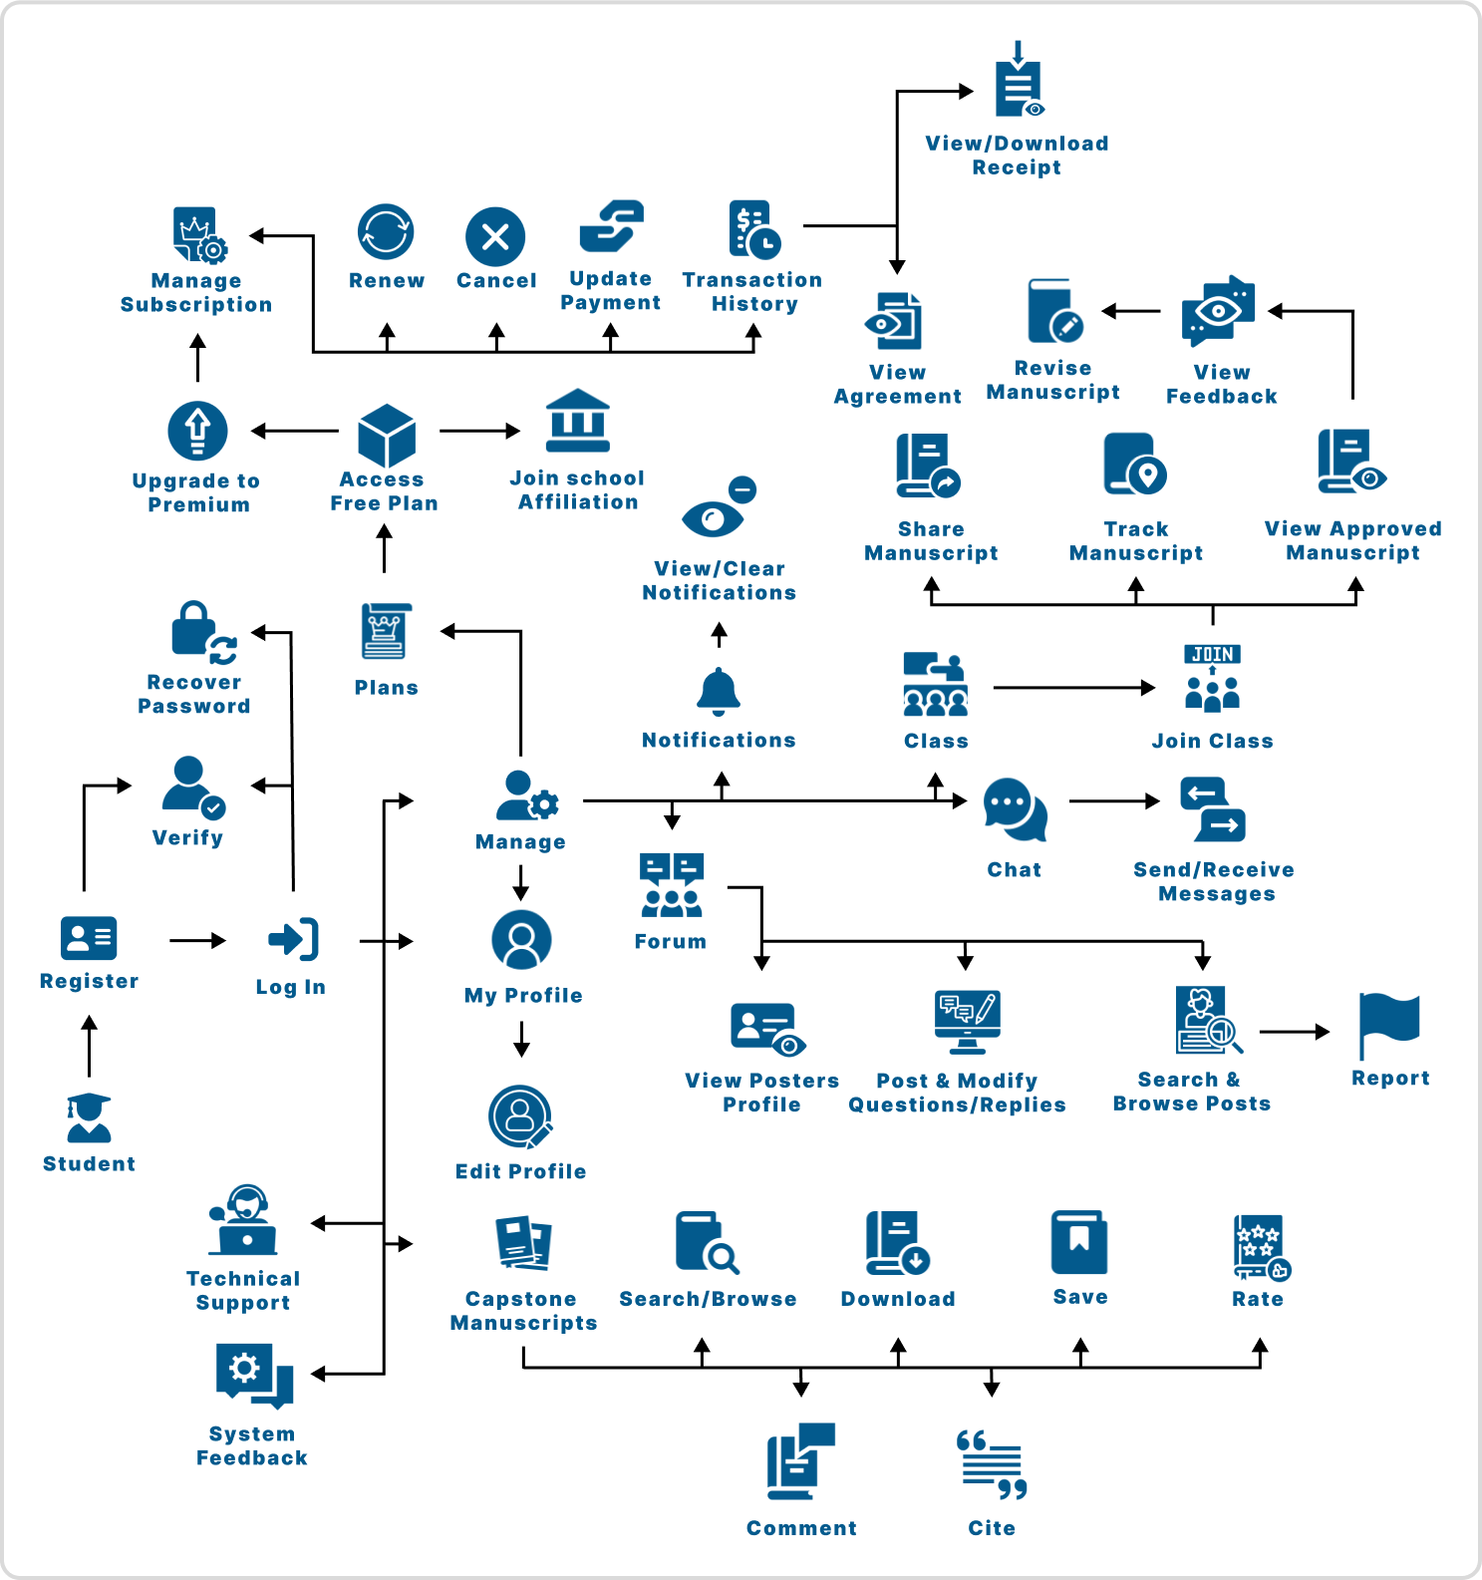

## Functional Decomposition Diagram

The figure below illustrates the functional decomposition diagram of the proposed system within the application. It displays the various tasks users can perform within the application.

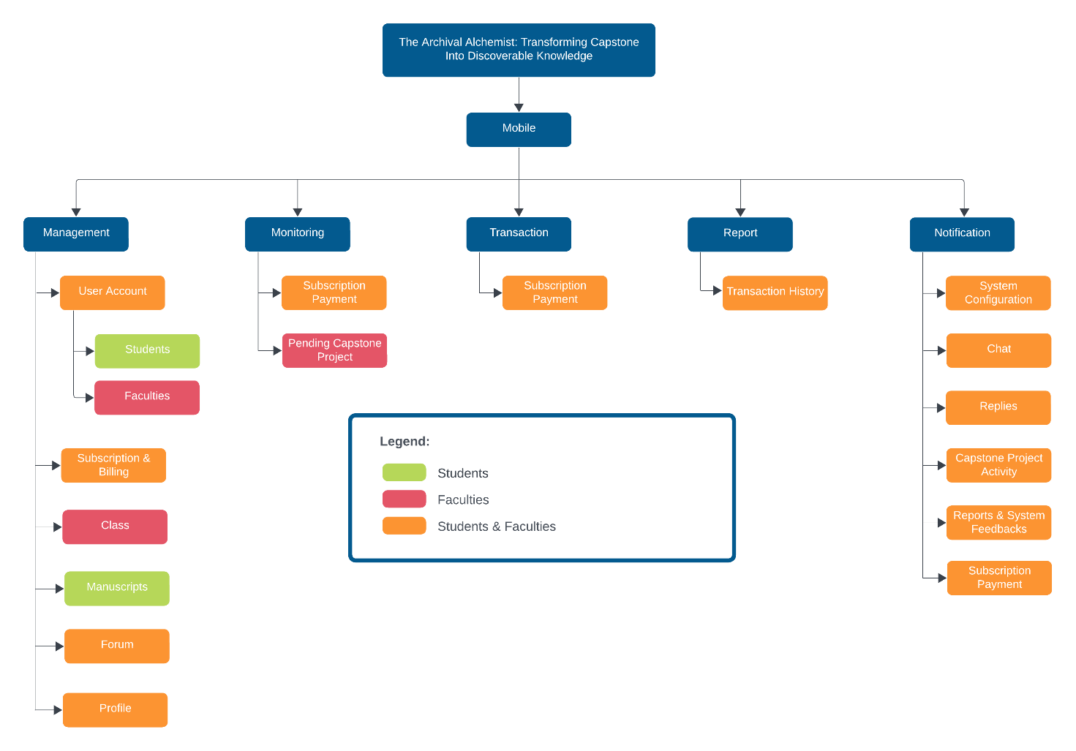

**Entity Relationship Diagram**

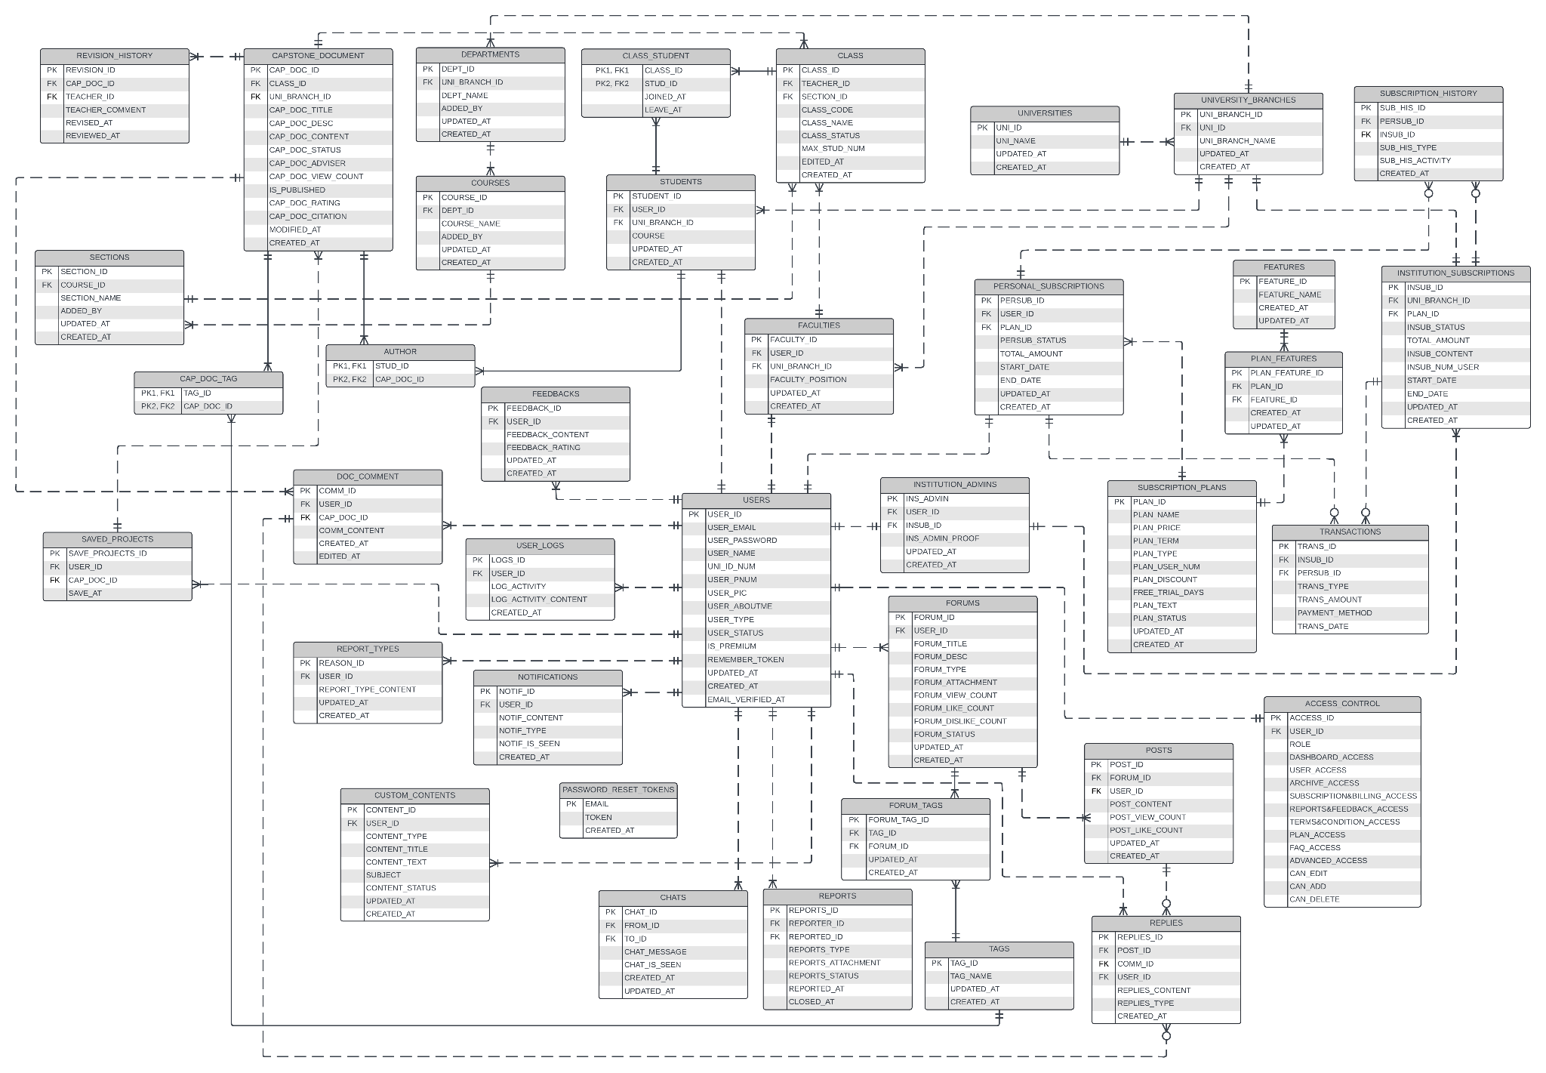

**List of Modules**

|  |  |  |
| --- | --- | --- |
| Programmers | Module | Student |
| Jeylsie Caro  Kyla Hubahib | 1. Register and login | * |
| 2. Profile Management | * |
| 3. Change Password | * |
| Jeylsie Caro  Kyla Hubahib | 1. Download projects | * |
| 2. Upload capstone projects | * |
| 3. Save favorite Projects | * |
| 4. Rate Projects | * |
| 5. Review capstone projects |  |
| Jeylsie Caro  David Jhonson Basnillo | 1. Search projects | * |
| 2. Browse projects |  |
| 3. Filter projects such as title, university, author, or tags | * |
| Maria Carmel Tabada  David Jhonson Basnillo | 1. View Notifications | * |
| 2.Delete Notifications | * |
| Kyla Hubahib | 1. Purchase Subscription | * |
| 2. Renew Subscription | * |
| No of Points (1 per module per user) | |  |
| Number of Modules per User (equals no.of points per user) | |  |
| Total Number of Modules | |  |