Kylan Childers

2/22/2021

Foundations of Programming: Python

Assignment 06

Github Link: https://github.com/kylanchilders/Assignment_06

**Converting CD Inventory to Operate with Classes and Functions**

**Introduction**

This exercise demonstrates working with someone else’s code to understand and modify it. The task here was to:

1. Understand and modify their code in order to fill in the remaining required lines
2. Re-write the code to implement functions and classes to call the appropriate code based on the users input.

**What I did**

Most of the code was already present. My strategy here was to first run the code to make sure it worked as is, and then to understand line by line what was going on. I had previous experience with functions so that helped. However, the concept of classes were entirely new to me, and this exercise was extremely helpful in understanding those.

Essentially for all the ToDo comments, I defined a function to accommodate each of them in the top area in the Data Processing class and the IO class based on what I was trying to achieve.

Then, I copied the code exactly from the user input options code into those functions and called them with class.functionName().

The only one I had to modify was the write option, to pass in the actual variable names instead of the place holder arguments.

**Screenshots**

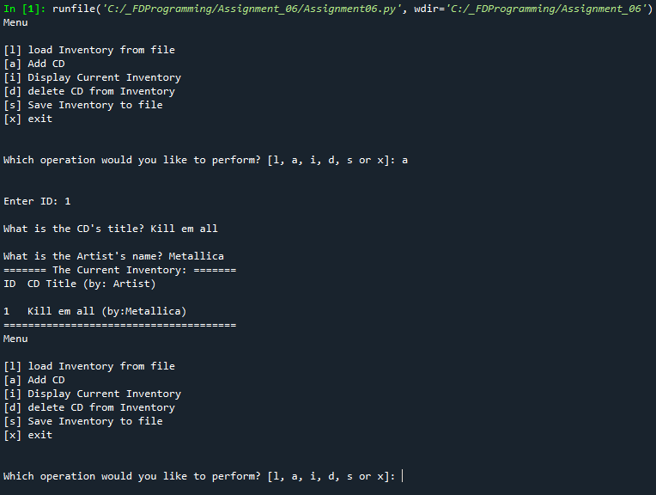

Using the A operation to add CD to inventory

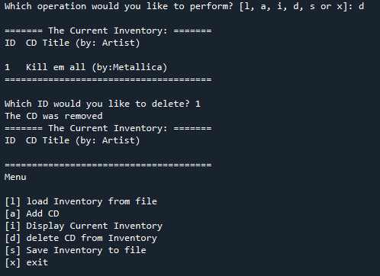

Using the D operation to delete from inventory

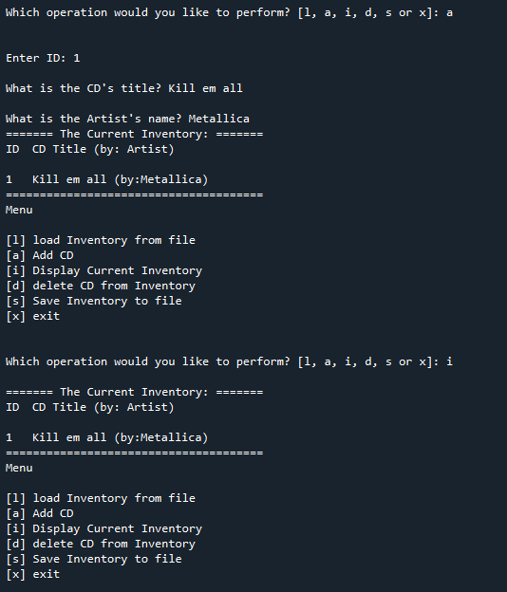

Adding a CD and then displaying inventory

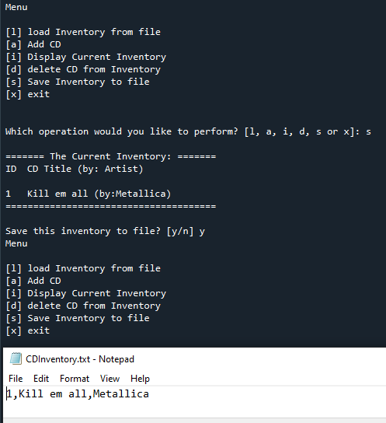

Saving to file with the S command

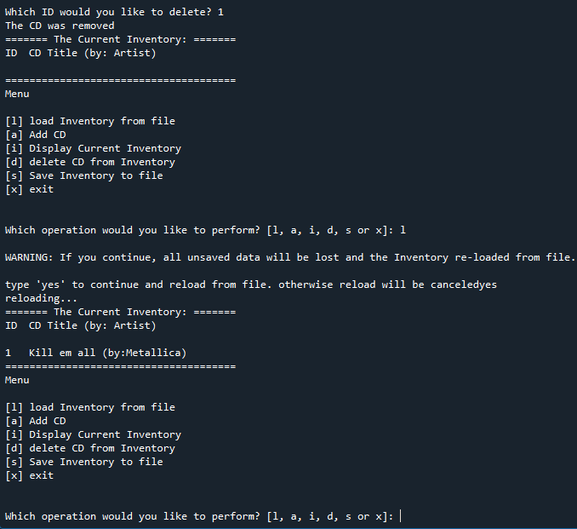

Using first the delete to clear my inventory, and the using l to load entries from the text file