Boston University

Electrical & Computer Engineering

EC463 Capstone Senior Design Project

Problem Definition and Requirements Review

Sailboat Navigation and Docking Assist

‘The Triton’

Submitted to

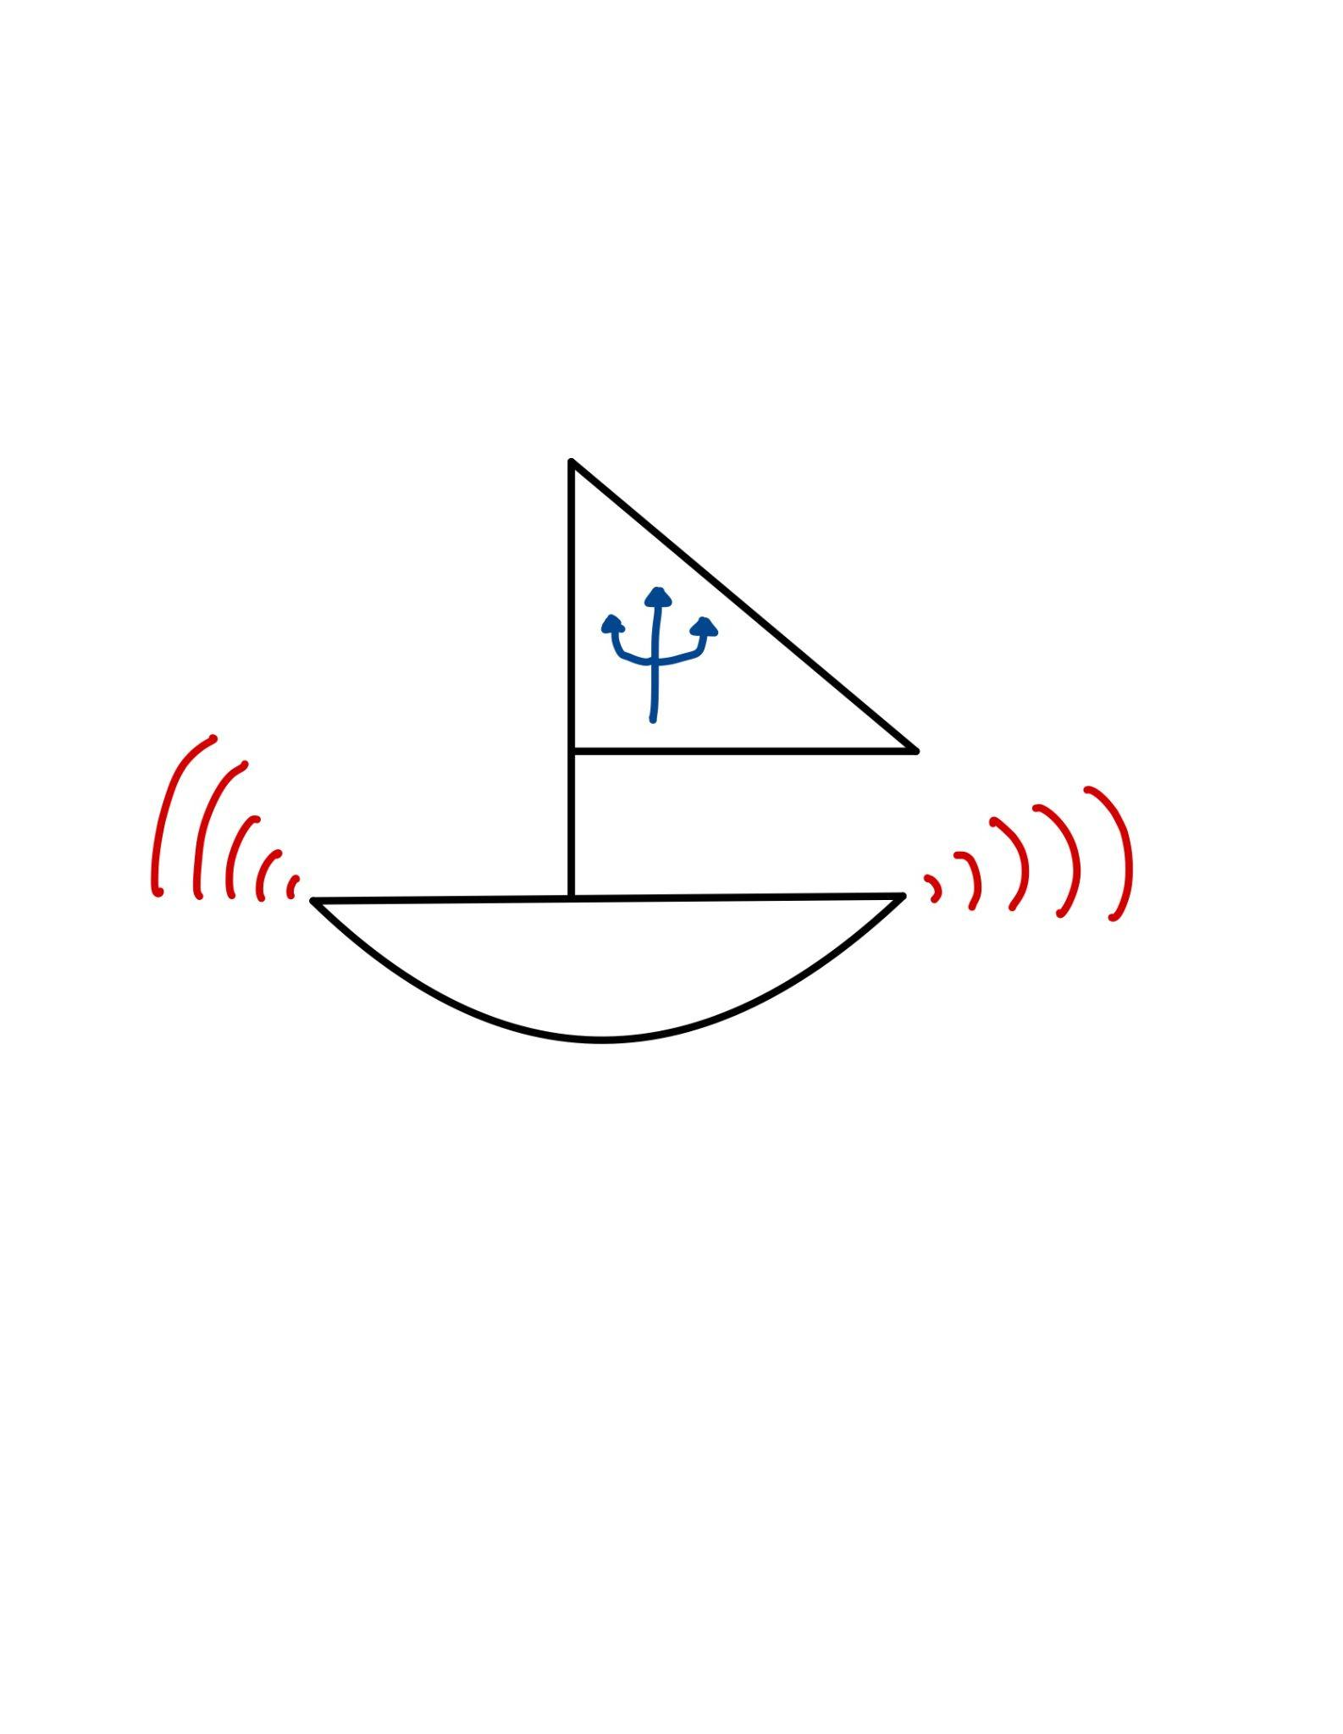
Ryan Lagoy
1 Silber Way
Boston, MA 02215
(617)-877-2569
rlagoy@bu.edu

by

Team 25#
Sail-Nav Technologies

Team Members

Leyandra Burke lburke@bu.edu
Kevin Connell kconn7@bu.edu
Diego D’Angelo-Cosme diegodc@bu.edu
Matthew Guacho mguacho@bu.edu
Kyla Wilson kylaw@bu.edu

Submitted: October 18, 2024

Client Sign-Off _______________________________________

Sailboat Navigation and Docking Assist

Table of Contents

Project Summary 2
1 Need for this Project 3
2 Problem Statement and Deliverables 4
3 Visualization 5
4 Competing Technologies 7
5 Engineering Requirements 9
6 Appendix A References. 10

Project Summary

The Sailboat Navigation and Docking Assistant, titled The Triton, is a tool that will be easily installed and removed on any sailboat. Its chief function is to assist sailors when docking or maneuvering through crowded areas, such as a busy pier, by providing external sensors and alerts via a mobile phone application. The Triton consists of a series of sensors that are attached to accessible parts of the boat, relaying information to a central processing unit through a Bluetooth connection. The processor will then upload the data to a connected phone, providing information such as nearby or oncoming objects, speed through water, speed above land, wind speed, GPS, and recommendations for how to proceed in certain scenarios.

Need for this Project

When sailing alongside other boats in busy and crowded waters, sailors often have to make split second decisions, where any mistake could result in thousands of dollars in damages and potentially death. In 2023 the United States Coast Guard reported that the top three causes for recreational boating accidents were operator inattention, improper lookout, and operator inexperience. Overall in 2023 alone there were 564 deaths and 63 million dollars in damages due to boating related accidents.^{[5]} Sailing often has an incredibly high learning curve for new and experienced sailors alike and leaves little margin for error.
In order to mitigate boating related deaths and accidents, there needs to be
systems to help assist sailors in the event of operator oversight. Sailboats often lack any technology to assist sailors or give feedback to the user regarding navigation, speed, or safety, instead relying solely on the sailors' experience. Additionally, experienced sailors looking to sail different vessels may be unfamiliar with vessel specific equipment and this lack of familiarity can result in accidents, damage to the vessel, and hefty fines.
On a different note, some sailors may have visual or physical disabilities that prevent them noticing potential obstacles in advance. Typically these sailors are forced to rely on expensive equipment or others to assist them. This lack of accessibility for sailboats can reduce a sailor’s personal sense of independence and freedom.
Triton aims to solve some of these issues and help lower the learning curve for sailing by providing sailors with an additional layer of safety and accessibility not often afforded to boats of this kind. The system is designed to be easily integrated into any sailboat, taking only a few minutes to install. Triton aims to assist sailors with docking procedures, sailing protocol, detecting obstacles, accessibility, and recommending course adjustments to the user through a mobile app. Through various sensors, Triton will be able to collect the necessary data to best predict sailing conditions and with the oversight of the sailor, act as a second set of eyes in the event of an operator oversight.

Problem Statement and Deliverables

The Triton is designed so that both new and experienced sailors can more easily navigate heavy traffic areas and perform optimal maneuvers. It will be easily installed and removed and will be usable on any sailboat independent of size. The assistance will come from the sensors that are installed on the boat at the stern, bow, and sides of the boat. These sensors will include proximity sensors, anemometers, temperature sensors, and GPS. In addition, each mount point will use Bluetooth or radio modules to communicate with the central processor. The data collected by the sensors will be organized and processed to a mobile phone application. The application will provide data, alerts, recommendations for maneuvering, and GPS capabilities. This product consists of three primary deliverables:
- A system of sensors with a central processing unit to be installed
- A fully functional code that gathers, organizes, and sends this data to the application
- A working mobile application for smartphones
The sensor system will need to be easily installed and removed, have a long battery life, and be weatherproof. The ease of installation is essential because it enables new sailors to utilize its assistance on any boat that they are able to use. Additionally, a person may sail for a long period of time and it is important that the system can work beyond the longest expected travel time since the data provided is utilized throughout the sailing process from leaving the pier to eventually re-docking. Finally, the system must be entirely weatherproof due to the nature of the environment it will be used in.
The developed code must collect and compute relevant data for the user with quick upload times. It will operate using a state machine architecture consistently transitioning from collecting data to uploading data. The application will have streamlined information for the user with various alerts and notifications for even when they are not actively using it.
It should be noted that this product will not teach a user how to operate a sailboat. Rather it will streamline the relevant information for sailing and provide assistance for scenarios such as avoiding collisions in order to make the activity of sailing easier, safer, and more accessible.

Visualization

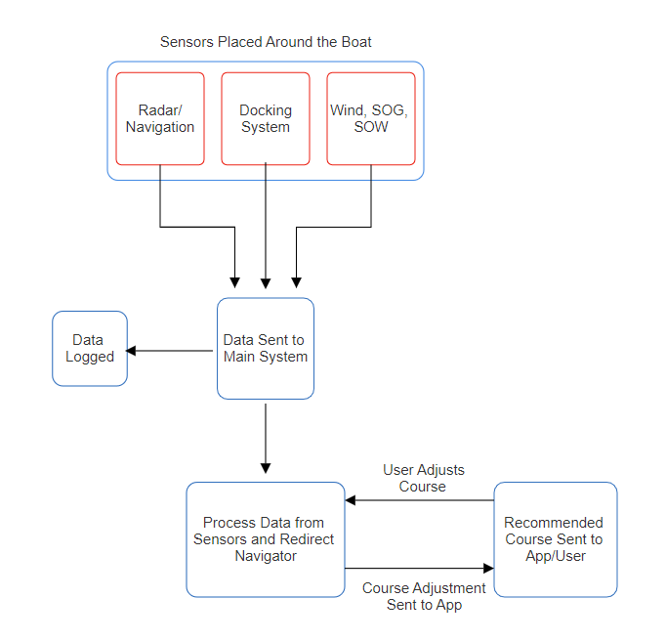
Figure 1.1 FlowChart of System Components working Synchronously. Where the sensors will be mounted and the main system will log the data and process it to then be sent to the mobile application.

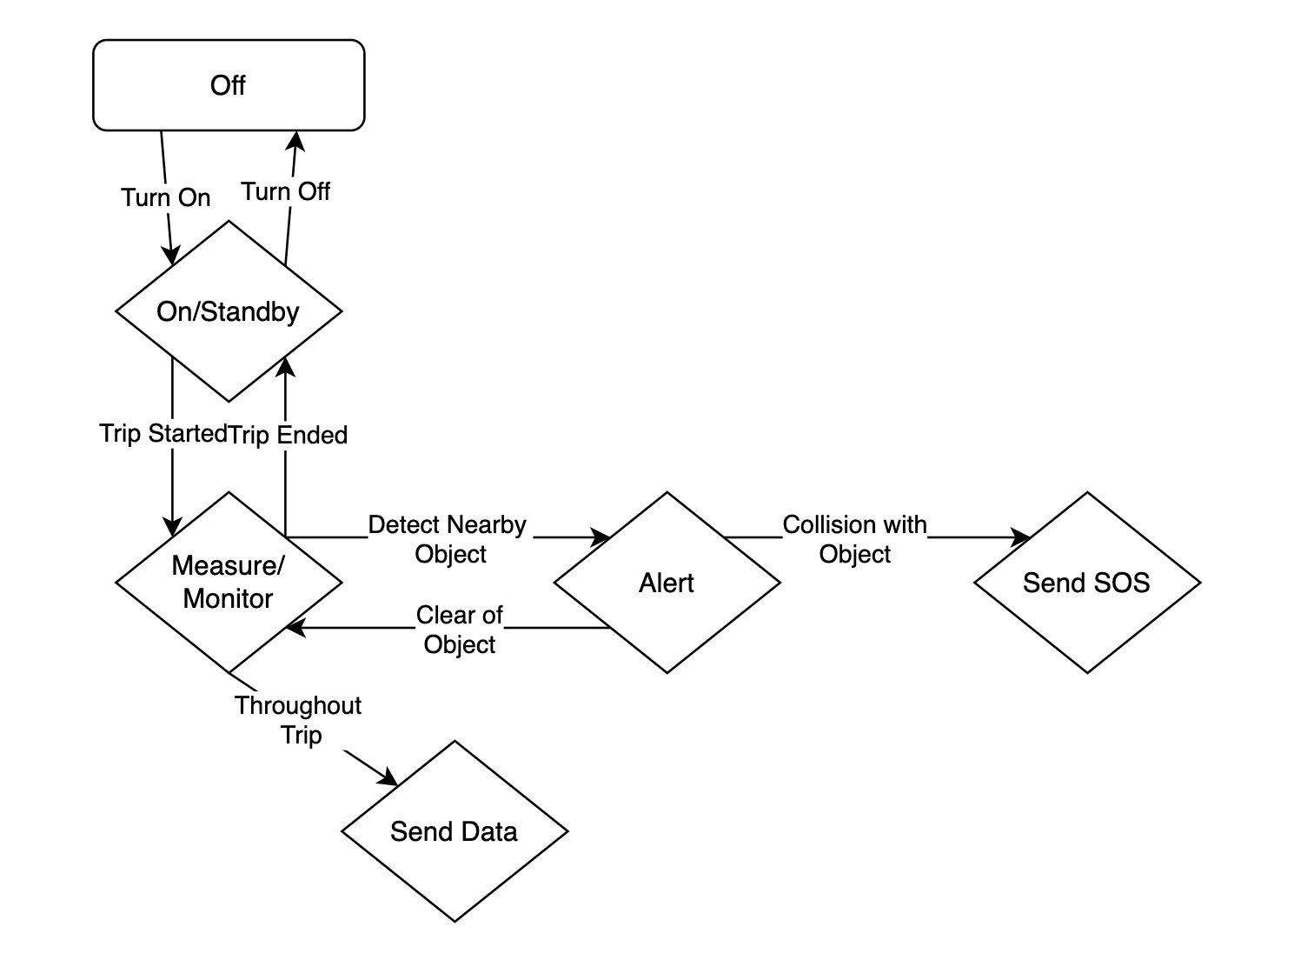
Figure 1.2 State machine defining the general behavior of the system, from start-up to shut-down.

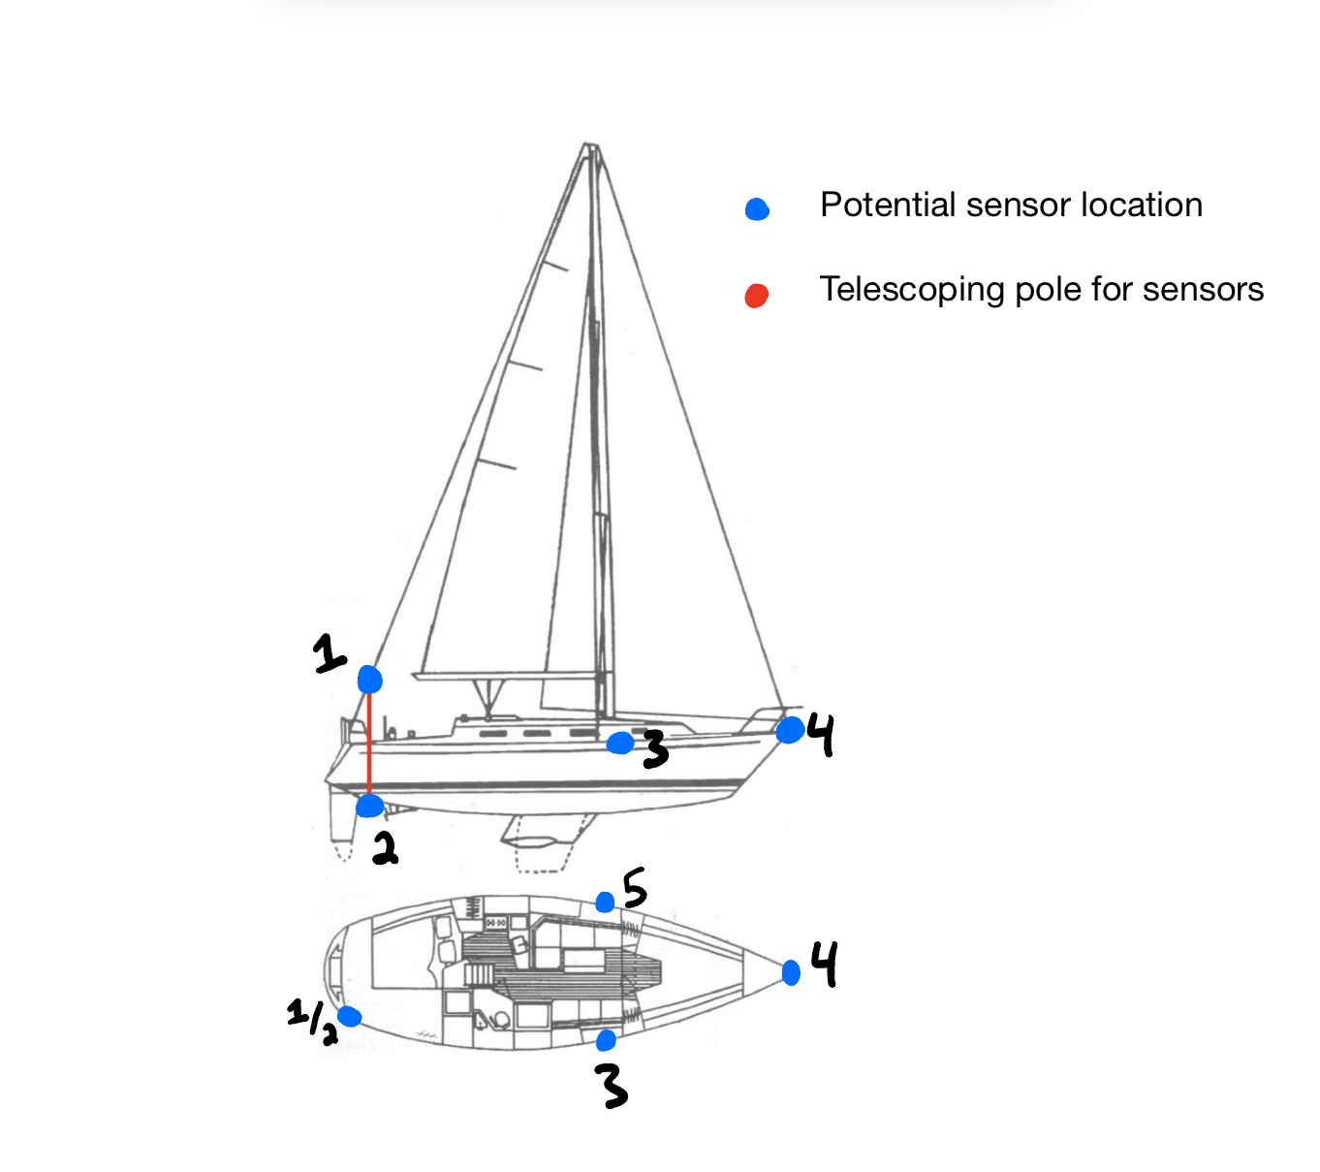
Figure 1.3 This figure shows an example of how we would mount our sensors and organize our system. The sensors in positions 3, 4, and 5 are all proximity sensors (LiDAR, Radar, Cameras, etc.). The sensor system mounted at position 1/2 will be a collection of sensors, including the central processing unit. This system mounted at position 1/2 will include a telescoping pole that expands bi-directionally, so we can easily put sensors into the water and into the air for accurate measurements. Position 2 will include sensors that need to be submerged in water, and position 1 will include sensors that need to be raised in the air, like an anemometer.

.

Competing Technologies

Raymarine
An electronic company that focuses on creating products that assist nautical activities. The most noteworthy product is the Docksense Control, which uses cameras and movement analysis in order to assist the driver in docking their boat. Raymarine’s technology allows Docksense to take over steering and throttle commands when an object enters the vessel’s “virtual bumper” region. The Triton should be able to use similar methods in order to achieve similar objectives. Raymarine’s docksense system is comprised of seven separate parts, their Axion XL Multifunction Display and Joystick, the Docsense control processor, a rear-facing camera, a port-facing camera, a starboard-facing camera, a front-facing camera, and finally an Attitude and Heading Reference System (AHRS) GPS module. Raymarine’s DS Cameras have a waterproof rating of IPx6 ^{[4]}. We would like for our entire system to be able to at least match this rating, if not exceed it. Raymarine’s GPS module can track up to 28 channels simultaneously, with a time to first fix being < 45 seconds or < 120 seconds depending on whether coming from a hot start or cold start ^{[4]}. The position accuracy from their GPS module is within 15m or within 5m with Satellite Based Augmentation System (SBAS)^{[4]}. We would like for our GPS system to have position accuracy within 20 meters, as we will likely not have the budget to match Docksense’s accuracy. The speed accuracy from their GPS module is within 0.3 kts ^{[4]}. We would like for our speed accuracy to be accurate within 1.0 kt, remaining conscious of our budget and time constraints.

Expedition Sailing Software
The Expedition Sailing Software is a program that monitors both weather forecasts and wave data to show the user the best possible route when sailing. This program can be downloaded to your desktop, laptop, or handheld computer, and can connect to multiple peripherals for data acquisition including GPS ^{[1]}. Expedition Sailing Software has prominent features including downloadable maps through C-Map, something that is out of the scope for our project at the moment but may be worth exploring in the future ^{[2]}. Being clear with such information would be ideal for the Triton.

AutoDesk Sailing Technology
A program that helps sailors monitor wind speed and direction while sailing, so the sailor can plan their route accordingly. AutoDesk is currently working on upgrading the system to handle harsher climates. The sensors for this system include internet of things (IOT), inertial measurement unit (IMU), load cell, and lidar modules. The Triton will act similarly, collecting information through physical sensors ^{[6]}. The Triton will also take it one step further and provide limited recommendations to the user in the first release of our mobile application.
Proximity sensing system and method for a marine vessel
The patent outlines a system where proximity sensors would mark incoming objects into an XY graph, and decide boat navigation and propulsion based on the dataset made. While a propulsion system is not needed due to the fact that The Triton is purely for navigation assistance, having an example of how to list nearby objects would be very helpful in both the navigation and the docking assist. Being able to note multiple objects at the same time as well as denote the priority of which object should get the most attention is also something The Triton should be capable of doing for a sailboat.

Engineering Requirements

The engineering requirements for the Triton are as follows:
- The system will collect wind speed, speed over ground, and speed through water.
- The sensors will send updates to the central processor at least every one (1) second while a trip is in progress.
- The system will have at least three (3) proximity sensors to be mounted on the sailboat.
- The proximity sensors will detect obstacles between one (1) meter and five (5) meters, and one that can detect obstacles from five (5) to one hundred (100) meters away.
- The system will have Bluetooth Low Energy and GPS capabilities.
- The Triton will have a mobile app (iOS) that communicates with the physical sensor system.
- The mobile app will provide an auditory alert when the sailboat is approaching an object.
- All physical components of the system, including housing, will weigh less than twenty-five (25) pounds in total.
- The battery for the system will last at least three (3) days on a full charge.
- The system will be easily mounted to any sailboat. It will have adjustable clamps to fit onto different parts of the boat.
- Weatherproof rating of at least IP68.
- The product cost will not exceed one thousand (1000) dollars.
- The system will be resistant to harsh weather conditions.
- GPS accurate within twenty (20) meters.

Appendix A References.
- Expedition. https://www.expeditionmarine.com/. Accessed 17 Oct. 2024.
- Introduction to Expedition. Directed by Campbell Field, 2020. YouTube, https://www.youtube.com/watch?v=yhNeXkuJI28.
- Malouf, Travis C., et al. Proximity Sensing Systema and Method for a Marine Vessel. 12046144, https://patents.justia.com/patent/12046144.
- Raymarine. “DockSense Control Systems | Smart Boating.” Raymarine, https://www.raymarine.com/en-us/our-products/assisted-docking/docksense-control/docksense-control-systems. Accessed 18 Oct. 2024.
- U.S. Department of Homeland Security and United States Coast Guard. “2023 Recreational Boating Statistics.” Commandant Publication P16754.37, May 2024. Zotero, https://www.uscgboating.org/library/accident-statistics/Recreational-Boating-Statistics-2023-Ch1.pdf.
- US Sailing | Technology Centers | Autodesk. https://www.autodesk.com/technology-centers/projects/us-sailing. Accessed 17 Oct. 2024.

