Introduction to embedded systems and IOTs
Lab Name: Embedded Game System
Lab Number: 2
Date: 10/16/2026
Student Name: Kyle Basirico
Student ID: 703230520

Introduction of the lab and report
The purpose of this lab was to design and implement a memory game using an Arduino Uno, LEDs, push buttons, and a buzzer. The system uses multiple colored LEDs to provide visual feedback to the player. Push buttons allow the player to interact with the game by selecting inputs corresponding to the displayed LED sequence. The buzzer provides auditory feedback to enhance the user experience. This project demonstrates fundamental embedded systems concepts, including digital input and output, circuit design, and microcontroller-based programming.

Materials, Devices and Instruments

- Arduino Uno
- 5 Resistors
- 1 Buzzer
- 5 Buttons
- 4 LEDs (Blue, Green, Yellow, Red)
- Wires
- Breadboard

Schematics
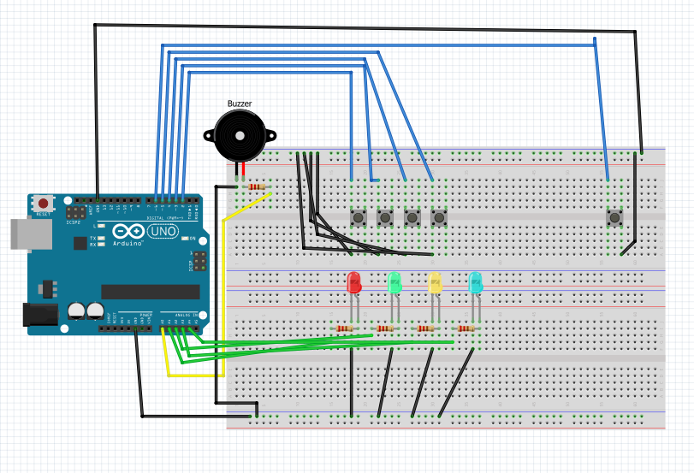

Lab Methods and Procedure
The circuit was designed using an Arduino Uno connected to a breadboard containing four colored LEDs, push buttons, and a buzzer. Each LED was connected to a digital output pin through a current-limiting resistor to prevent excessive current from damaging the components. The push buttons were connected to digital input pins to allow the Arduino to detect user input, while the buzzer was connected to an output pin for sound generation. Jumper wires were used to establish the necessary connections between the Arduino and the breadboard.
After assembling the circuit, the Arduino was programmed to control the LEDs, read button inputs, and operate the buzzer. The program was designed around the memory-game concept, in which the player observes an LED sequence and attempts to reproduce it using the corresponding buttons. The circuit and program were tested to verify that the components responded correctly to the inputs and outputs defined in the code.

Trouble in the lab and how did you solve it
During the lab, troubleshooting was necessary to ensure that all components were connected and operating correctly. One potential source of problems was incorrect breadboard wiring, since components placed in the wrong rows or connected to incorrect Arduino pins could prevent the circuit from functioning as intended. LED connections also required verification to ensure that the anodes and cathodes were oriented correctly and that the current-limiting resistors were connected properly.
To address these issues, the circuit connections were checked against the wiring diagram, and individual components were examined to identify potential wiring errors. The LED connections, button wiring, ground connections, and Arduino pin assignments were reviewed to ensure consistency between the physical circuit and the program. Testing individual components before testing the complete game helped isolate potential faults and simplify debugging.

Results and Conclusion
The completed circuit incorporated four colored LEDs, multiple push buttons, a buzzer, and an Arduino Uno. The hardware configuration provided the necessary inputs and outputs for implementing a basic memory game. The LEDs served as visual indicators, the buttons provided user input, and the buzzer supplied auditory feedback. Testing the system provided an opportunity to evaluate the interaction between the hardware components and the microcontroller program. The results demonstrated how a microcontroller can coordinate several external components to create an interactive embedded system. The project also emphasized the importance of correct circuit assembly, reliable input detection, and consistent communication between the hardware and software.

