WOODSIDE HOA Covenant Enforcement & Fine Timeline Notice
Effective Date: January 15

Why You Are Receiving This Notice
The Board of Directors is providing this notice to clearly explain how covenant enforcement and fines will be handled going forward, including timelines and homeowner rights. This communication is intended to promote transparency, fairness, and voluntary compliance, particularly for matters involving vegetation, tree height, and view protection.

Annual Meeting Notice Coming in January
Please note we will be sending the annual meeting notice out at the start of January.

Updated Website
All this information, as well as all HOA documentation can be found on our new website https://bhamwca.com.

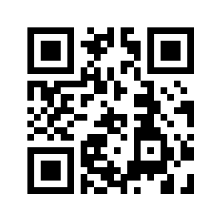

Authority
Under Article 13 of the HOA Bylaws and RCW 64.38 (Washington Homeowners’ Associations Act), the Board is authorized to enforce the Covenants, adopt rules, and impose reasonable fines after notice and an opportunity to be heard. This enforcement process does not amend the Covenants or Bylaws.

Enforcement Timeline
Step 1 – Courtesy Notice
An informal written notice describing the issue and requesting voluntary correction. No fines are imposed at this stage.
Step 2 – Formal Notice of Violation
If the issue is not corrected, a written Notice of Violation will be sent identifying the covenant involved, the corrective action required, the compliance deadline, and hearing rights.
For tree, vegetation, and view-related issues, the standard compliance period is forty-five (45) days.
Step 3 – Hearing Opportunity
Owners may request a hearing within fourteen (14) days of the Notice of Violation. Owners may present information, propose a plan, or request additional time. The Board will issue a written decision.
Step 4 – Fine Schedule Applies
If the violation remains after the compliance period and hearing process:
First violation: $50
Second violation: $150
Continuing violation: $100 per week until corrected
Fines are not retroactive and are imposed only after due process.
Step 5 – Continued Non-Compliance
If a violation continues, the Association may pursue additional remedies available under the Governing Documents and Washington law, including seeking court-ordered compliance.

Important Clarification
The Association’s enforcement process focuses on communication, reasonable timelines, due process, and fairness. The HOA does not intend to enter private property to cut or remove trees as part of routine enforcement.

What This Process Does Not Do
It does not impose automatic fines, remove homeowner rights, apply fines without notice and hearing, require a homeowner vote, or change the Covenants.

Questions
Homeowners are encouraged to contact the Board at bhamwca@googlegroups.com early with questions or to request clarification.
Board of Directors
Woodside HOA

