**Project title:** ATV Off-roading

<https://kyle-west.github.io/CS312-ATV/>

**Group or individual member(s)**

1. Jake Alldredge <Project Leader>
2. Kyle West <Code Monkey>

**1) What did you accomplish for this milestone based on your project proposal?**

*** See comments first *** Since we don’t technically know what was due this milestone, the following is everything we did do.

*ATV Mesh Imported*

Since we switched from Three.js to Babylon.js, we finally were able to import our custom mesh Jake made in Blender. We were able to apply physics to the individual parts of the mesh, but the entire ATV does not yet function as a vehicle.

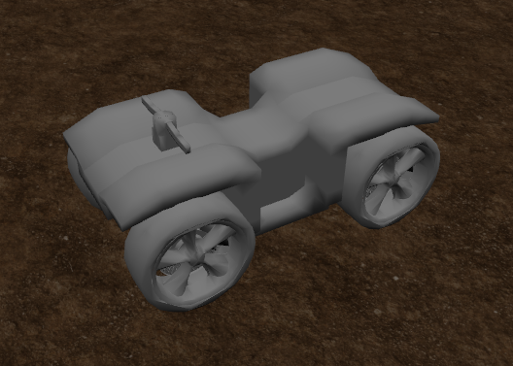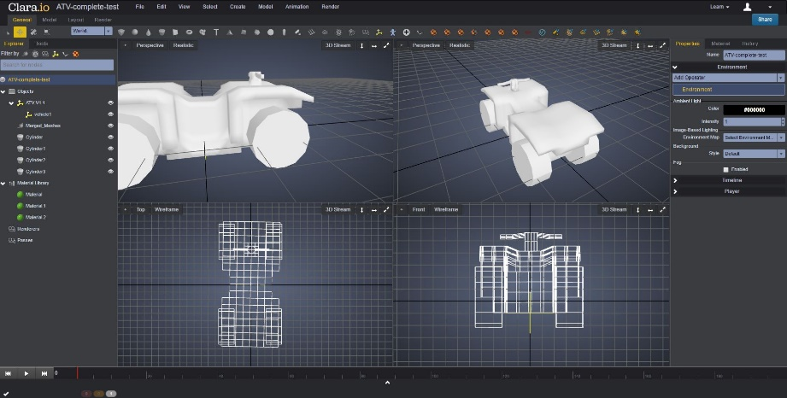

*HeightMap Array*

Kyle was able to create heightMaps in Photoshop that are used to generate a terrain. This pattern is repeated 64 times throughout the environment. We plan on adding several more different heightMaps in the fine-tuning phase of the project.

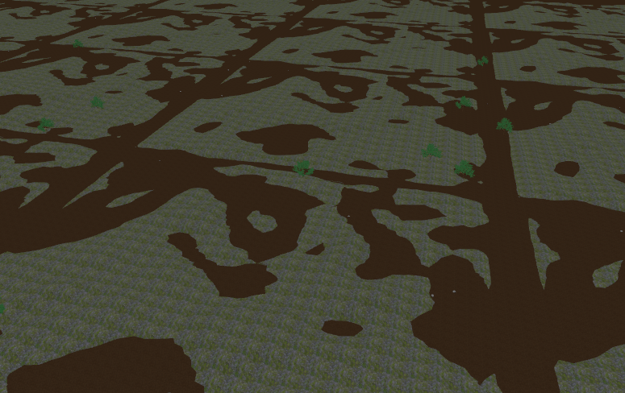

*Particle System & GUI*

Jake created a particle system using Babylon.js’ built in particle engine. We used the particle system to simulate weather, snow in this case, during gameplay. We utilized the DAT.GUI user interface so that variables like wind could be manipulated dynamically. We intend to add several other variables that would control textures, light sources, and the skybox.

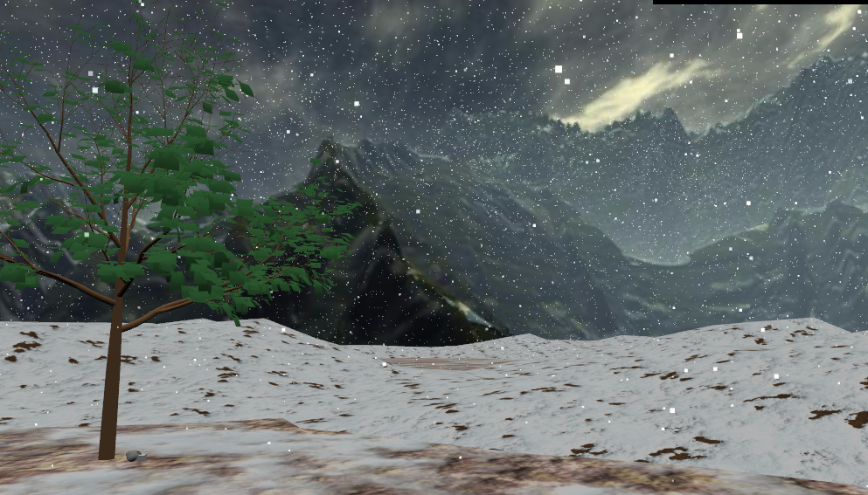

*Trees and Rocks*

Kyle added tree and rock meshes imported from Clara.io. They are randomly placed throughout the scene. We are working on a way to adjust the height of these meshes, that way they are not buried in the hills or floating in the air.

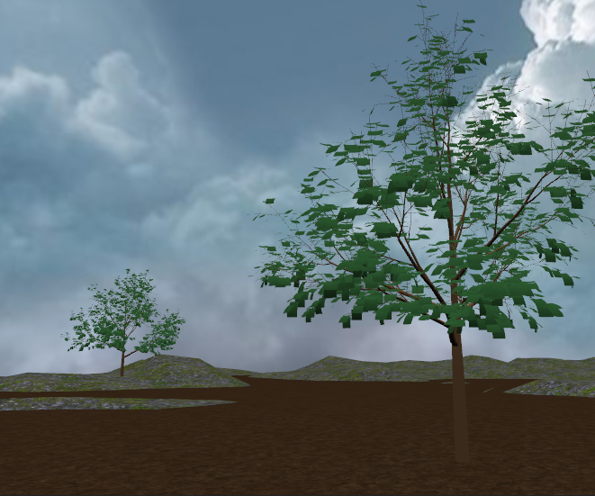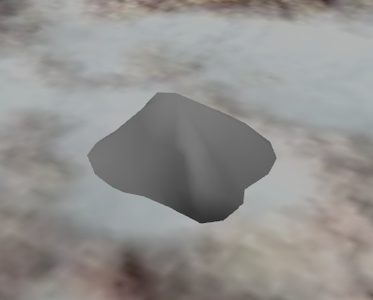

*SkyBox*

Kyle created a skybox from pictures that he borrowed from the internet. Currently we are working with two skyboxes, one that simulates just a blue sky with clouds and the other a mountainous area which we are currently sticking with. As mentioned above we intend to let the user switch between the two environments using the GUI.

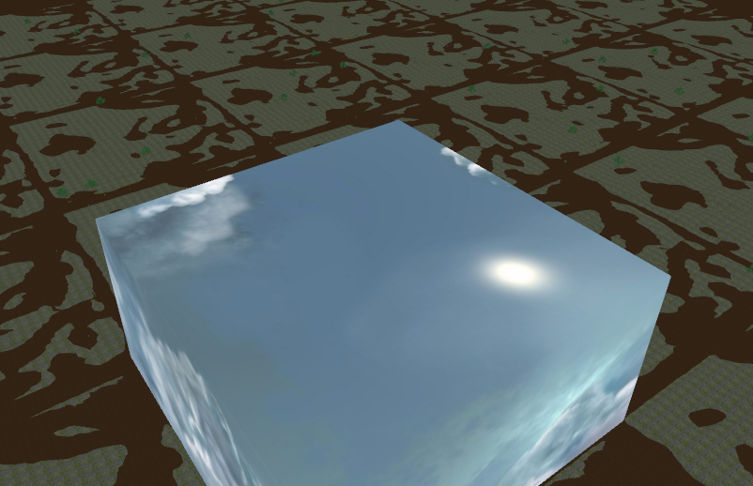

*Music*

Kyle wrote the first draft of our theme music. It was done in GarageBand and loops infinitely. You can’t turn it off yet (sorry). Just mute your computer.

**2) What did you NOT accomplish that you indicated in your project proposal?**

The ATV has physics applied to it, but it does not yet function as a vehicle.

**3) Do you need to change your project?**

No.

**4) Do you need to change milestone 3?**

No.

**5) Self-grade your milestone (You should be spending at least 5 hours per week on it per team member, more for an A).**

We feel we deserve an A.

**6) Other comments or notes**

Somehow, somewhere GitHub ate our milestone document. So, we don’t have a record of what we were “suppose to” have done. That being said, we would really appreciate it if you could please send us a copy of the milestone document submitted by Jake. Thank you. We tried accessing it through iLearn, and were not permitted to do so.